Veteran Card Refresh 2026

Information Kit for veterans

Background
DVA has started issuing new-look Veteran Cards as part of a scheduled card refresh every 6 years. Cards will be mailed out until October, and veterans are asked to update their postal address on MyGov to avoid delays in delivery.
The cards have an updated design however there are no changes to how they function. Veterans’ entitlements, eligibility, and access to concessions remain the same. Veterans can still use their existing Veteran Card while they are waiting for the new look card to arrive, even if the card’s expiry date has passed.
We encourage you to share this information to ensure veterans can continue to access the services they need during the rollout. Thank you for your support.

Sample resources

SOCIAL MEDIA

Suggested copy:
DVA is rolling out updated Veteran Cards between July and October.
Some card holders may not receive their new card before their current card’s printed expiry date.
✅ All Veteran Cards remain valid during this period – even if they appear expired.
While the cards will have a new look, there are no changes to entitlements, eligibility, or how they are used.
Find out more: Confirm your postal address to make sure your Veteran Card arrives without delay. | Department of Veterans' Affairs

Social media tags:
Facebook: @DVAAus
LinkedIn: @australian-government-department-of-veterans’-affairs

Suggested 1080 x 1350 social media tile:
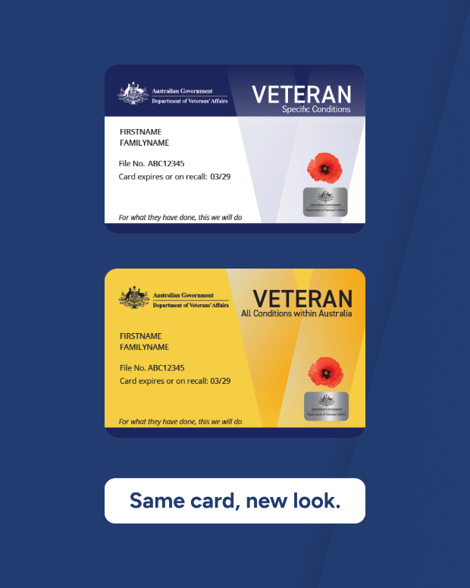

WEB or E-news Article

Short version (43 words):
The Department of Veterans’ Affairs (DVA) has started re-issuing Veteran Cards as part of a scheduled card re-issue carried out every 6 years. If your card’s expiry date has passed, it is still valid and can be used until you receive your new look card. Learn more on the DVA website.

Long version (159 words):
The Department of Veterans’ Affairs (DVA) has started re-issuing new look Veteran Cards as part of a scheduled card refresh carried out every 6 years.
If your new card hasn’t arrived yet, and your current card shows a passed expiry date, you can keep using it. All Veteran Cards will remain valid even if they show as expired and will be accepted by providers.
While the refreshed cards will look different, they will still function in the same way with the same entitlements, eligibility, and processes. There are no changes to the way veterans and health providers use the card.
A dedicated version of the Veteran Card - All Conditions (commonly known as a Gold Card) will still be issued to veterans who are eligible for Totally & Permanently Incapacitated (TPI) status. Clear card markings for specific groups such as War Widow/er, Dependant, and Extreme Disablement Adjustment (EDA) will also remain.
Find out more on the DVA website.

Card images for your use:
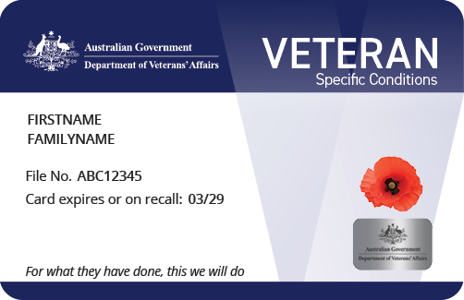
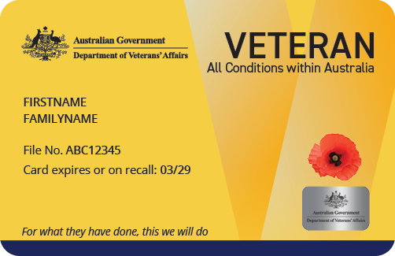
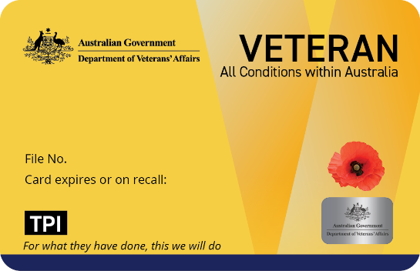

Frequently Asked Questions
Key frequently asked questions (FAQs) are below. You can read the full list of FAQs at the
DVA website.
Q: What is the Veteran Card refresh?
A: The Veteran Card refresh is part of scheduled business-as-usual activity, which happens every 6 years. The refresh includes a card design update, followed by the printing and postal distribution of around 300,000 physical cards. DVA also issues communications regarding digital cards. The refresh does not involve any changes to Veteran Card eligibility and access.
Veteran Cards can be used to access medical and mental health treatment, prescription medicines in Australia. States, territories, and businesses may offer concessions and benefits to Veteran Card holders.
Q: Can I keep using my current Veteran Card until the new one arrives?
A: Yes. You can continue to use your current Veteran Card while waiting for your refreshed card to arrive, even if the expiry date has passed.
Q: When will the Veteran Card refresh happen?
A: DVA started the refresh process. We anticipate all cards will be reissued by the end of October 2026. It is important to note that Veteran Card eligibility and access are not changing.
Q: What should I do if my postal address has changed?
A: Please check that your postal details are up to date in MyService. This will help make sure the refreshed physical card is sent to your correct address. You can also call 1800 VETERAN (1800 838 372) if you need assistance.
Q: Why is DVA investing in a refreshed design?
A: Veteran cards are reissued every 6 years as a business-as-usual activity. The plastic cards can deteriorate over time and replacing them regularly ensures veterans continue to have access to a reliable card to help reduce potential difficulties when accessing services and support. DVA uses the refresh process to help maintain the integrity of Veteran Cards, minimise fraud and make sure that only eligible people are being issued a Veteran Card.

Further assistance
If you have any further questions, please contact DVA.
- Email: Veteran.Card@dva.gov.au
- Phone: 1800 VETERAN (1800 838 372).
To stay in the loop, subscribe to DVA e-news and follow us on Facebook, LinkedIn and Instagram. You can also subscribe to our flagship newspaper, VetAffairs.

