Frequently Asked Questions

Veteran Card Refresh 2026

Q: What is the Veteran Card refresh?
A: The Veteran Card refresh is part of a scheduled business-as-usual activity, which happens every 6 years. The refresh includes a card design update, followed by the printing and postal distribution of around 300,000 physical cards. DVA also issues communications regarding digital cards. The refresh does not include any changes to Veteran Card eligibility and access.
Veteran Cards can be used to access medical and mental health treatment, prescription medicines in Australia. States, territories, and businesses may offer concessions and benefits to Veteran Card holders.

Q: When will the Veteran Card refresh happen?
A: DVA started the refresh process in July 2026. We anticipate that all cards will be reissued by the end of October 2026. It is important to note that Veteran Card eligibility and access are not changing.

Q: Who can I contact if I have questions about the Veteran Card refresh?
A: If you cannot find the answer to your question on this page you can email Veteran.Card@dva.gov.au or call DVA on 1800 VETERAN (1800 838 372).

Q: Why am I receiving a new Veteran Card?
A: You are receiving a refreshed Veteran Card as part of a scheduled card refresh. Cards are refreshed every 6 years because the plastic card base wears over time. The refreshed card has a new look, but your eligibility and access to services and support are not changing. Even though you may have received a new card within the past 6 years, DVA uses the refresh process to help maintain the integrity of Veteran Cards, minimise fraud and make sure that only eligible people are being issued a Veteran Card.

Q: My card has expired. How do I receive services?
A: Providers: please continue to accept expired Veteran Cards. The expiration date on current Veteran Cards may lapse before a veteran receives their new card. All Veteran Cards remain valid, even if they read as expired.
Veterans: you can continue to use your current Veteran Card while waiting for your refreshed card to arrive, even if the expiry date has passed.

Q: When will I receive my refreshed Veteran Card?
A: Refreshed physical cards will be posted between July and October 2026. Cards will be reissued progressively during this period.

Q: Why haven’t I received my re-issued card, what should I do?
A: DVA began a refresh of the Veteran Card in July 2026, with approximately 300,000 cards being reissued. It is anticipated that all cards will be reissued by the end of October 2026.
If you have not received your refreshed physical card by 31 October 2026, please check that your postal details are up to date in MyService. You can keep accessing your digital Veteran Card through MyService and the myGov wallet.
Digital cards will be released on 10 July 2026. For MyService users, you will first see the updated image when you next login after the card release.
For myGov users, you will need to make sure you have the most recent update to the myGov app. If you do not, you should download an update to the app on your phone/device. The update will be available from 10 July 2026. You will only see the updated image after you have downloaded and installed the update.

Q: Do I need to apply for the refreshed card?
A: No. If you are eligible for a replacement card as part of the refresh, it will be issued automatically to you. You do not need to apply for it.

Q: Will my eligibility or entitlements change?
A: No. The Veteran Card refresh process does not change your eligibility, entitlements, or access to treatment, services or support.

Q: Can I keep using my current Veteran Card until the new one arrives?
A: Yes. You can continue to use your current Veteran Card while waiting for your refreshed card to arrive, even if the expiry date has passed.

Q: What should I do if my postal address has changed?
A: Please check that your postal details are up to date in MyService. This will help make sure the refreshed physical card is sent to your correct address. You can also call 1800 VETERAN (1800 838 372) if you need assistance.

Q: What happens if my card is due to expire before I receive the refreshed card?
A: Some card holders who were due to be issued or reissued a card in June 2026 may experience slight delays with their physical card. If this applies to you, you will have received a direct message. The expiry date on the card does not affect your entitlement to services and support.

Q: What is changing about the look of the card?
A: The refreshed design features a clearer layout for improved readability. It also helps create a more consistent look between the physical card and digital card. Following feedback from the veteran community, the refreshed design will include the closing line of the Australian Defence Veterans' Covenant – ‘For what they have done, this we will do’ – which also appeared on the previous design.

Q: Why is DVA investing in a refreshed design?
A: Veteran cards are reissued every 6 years as a business-as-usual activity. The plastic cards can deteriorate over time and replacing them regularly ensures veterans continue to have access to a reliable card to help reduce potential difficulties when accessing services and support. DVA uses the refresh process to help maintain the integrity of Veteran Cards, minimise fraud and make sure that only eligible people are being issued a Veteran Card.

Q: Why is there a new look for the cards?
A: The new look of the card helps differentiate the card run. There have been some minor updates to the design. The cards retain the ‘V’ shadow image and DVA’s blue has been introduced to the design.
The Veteran Card – All Conditions (commonly known as Veteran Gold Card) will maintain its gold colour and ‘V’ shadow motif. A touch of the DVA blue will also be added. You can see an example image of the physical card below.
- 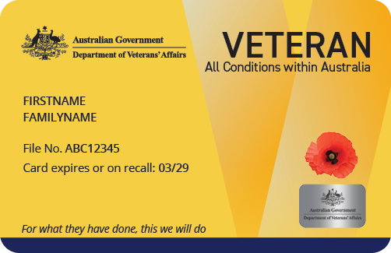

The Veteran Card – All Conditions (Totally & Permanently Incapacitated (TPI)). To support the identification of specific veteran cohorts and the validation of concession eligibility, a dedicated version of the Veteran Card - All Conditions will continue to be issued to veterans who are eligible for Totally & Permanently Incapacitated (TPI) status. Additionally, stamping of cards for specific cohorts such as War Widow/er, Dependant, and Extreme Disablement Adjustment (EDA) will remain. You can see an example of this card below.
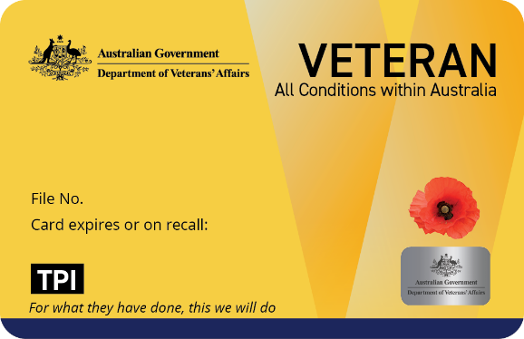

The Veteran Card – Specific Conditions (commonly known as Veteran White Card) features an increased use of the DVA blue while retaining key design elements for continuity with previous card versions, including the ‘V’ shadow motif. You can see an example of this card below.
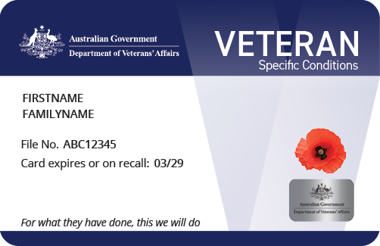
The Veteran Card – Pharmaceuticals Only (commonly known as Veteran Orange Card) is only held by a small number of people and so no changes are being made to this card’s design. This card is not available in digital format.
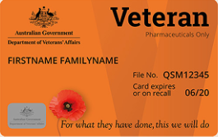

Q: How can I identify special eligibility cohorts?
A: Some concession providers may offer different benefits to specific cohorts of Veteran Card holders. Special eligibility cohorts can be identified by the information displayed in the bottom-left corner of the card. For example:
- Totally & Permanently Incapacitated (TPI) – identified by the black ‘TPI’ box in the bottom-left corner of the card.
- War Widow(er), Prisoner of War (POW), Dependant, Extreme Disablement Adjustment (EDA) Veteran – identified by the relevant cohort name printed in the bottom-left corner of the card.
Please note that some card holders may have more than one cohort special eligibility stamp displayed on their card. For example, a card holder may hold multiple eligibility types or be a War Widow(er) and a Veteran in their own right.

Q: Why are the card names changing from Gold Card, White Card and Orange Card, and what are the new names?
A: The formal card names have been printed on the cards since 2019. For consistency and clarity, DVA will progressively use the formal names in communications and gradually phase out colour-based terms such as Gold, White and Orange Card over time.
The formal card names are:
- Veteran Card – All Conditions (commonly known as the Veteran Gold Card)
- Veteran Card – Specific Conditions (commonly known as the Veteran White Card)
- Veteran Card – Pharmaceuticals Only (known as Veteran Orange Card).

Q: Is the Veteran Orange Card changing as part of the refresh?
A: Only the name is changing, bringing it in line with what is already on the card itself. The card design is not being refreshed due to low numbers in circulation.

Q: Will concession providers still recognise my card?
A: The card can still be used to access concessions where these are provided by state and territory governments and by other service providers. You should continue to check concession arrangements with the relevant provider.

Q: Can I use the digital Veteran Card instead of the physical card?
A: Yes. You can use your digital Veteran Card wherever the physical card is accepted. The digital card is a convenient option and helps protect the privacy and integrity of your card information.

Q: Where can I access my digital Veteran Card?
A: Digital cards will be released on 10 July 2026 and you can access yours through MyService or your myGov wallet.

Q: What is the difference between the digital card in MyService and the myGov wallet?
A: The MyService digital card will display the same design and information as the physical card and can be accessed through the MyService web browser.
The myGov wallet provides a more convenient way to store and access your digital Veteran Card on a mobile device. The card is displayed over two screens: one with a blank card image and another with the card holder’s details. The myGov wallet enables quick access using device authentication features such as Face ID, fingerprint recognition or a PIN, eliminating the need to log in via the MyService web browser each time the card is required.
Both digital versions contain the same card information – the main difference is how the card is accessed and presented to the user.

Q: How does the digital card help protect my privacy?
A: The digital card in the myGov wallet includes security features that help protect your data and support card authenticity. These include a digital ‘myGov’ hologram, a QR code that can be used to verify the card’s validity, and a ‘last updated’ date that refreshes daily to confirm the card is current. These security measures help reduce the risk of fraud and provide confidence to card holders and service providers that the card being presented is valid and up to date.

Q: Can I use a screenshot of the digital Veteran Card?
A: It is recommended you use the live digital card rather than a screenshot whenever possible. The live card includes security features such as a digital hologram to help confirm that the card is authentic and valid.
Health service providers and concession providers have been advised to look for the digital hologram to ensure the card is valid. Using the live digital card helps ensure your card can be readily verified and accepted when accessing services, concessions or entitlements.

Q: Will the digital card show my accepted conditions?
A: MyService can display accepted conditions for people who hold the Veteran Card – Specific Conditions. You can find the accepted conditions under the ‘Conditions Listed’ section. This can help you verify accepted conditions with your health provider.

Q: Will digital cards be accepted as proof of eligibility?
A: Yes. A digital Veteran Card can be accepted as proof of a card holder’s status, subject to the policies of the relevant concession or service provider When a digital card is presented, providers are encouraged to look for:
myGov wallet cards
- The image displayed through the myGov wallet will consist of two screens, one showing a card outline (with no personal details) and a second displaying the card holder details.
- 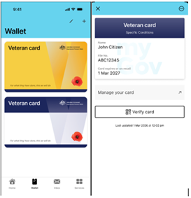
- The details page will include the ‘Last updated’ date, indicating the date and time when the card information was accessed.
- The card includes an animated myGov hologram that moves when the device is tilted. This helps verify that the card is being displayed live and is not a screenshot. Screenshots will not be accepted by providers.
- Card holders will need to will need to install the relevant myGov app update on their phone/device. The update will be available from the schedule released 10 July 2026. Clients will only see the updated image after they’ve downloaded and installed the update to the App. Note this could be some time after the initial release, depending on when the user updates their App.
- MyService digital cards
- Digital MyService cards will display the same information and design as the physical card.
- Card holders will see the updated image when they next login after the card release on 10 July 2026.

