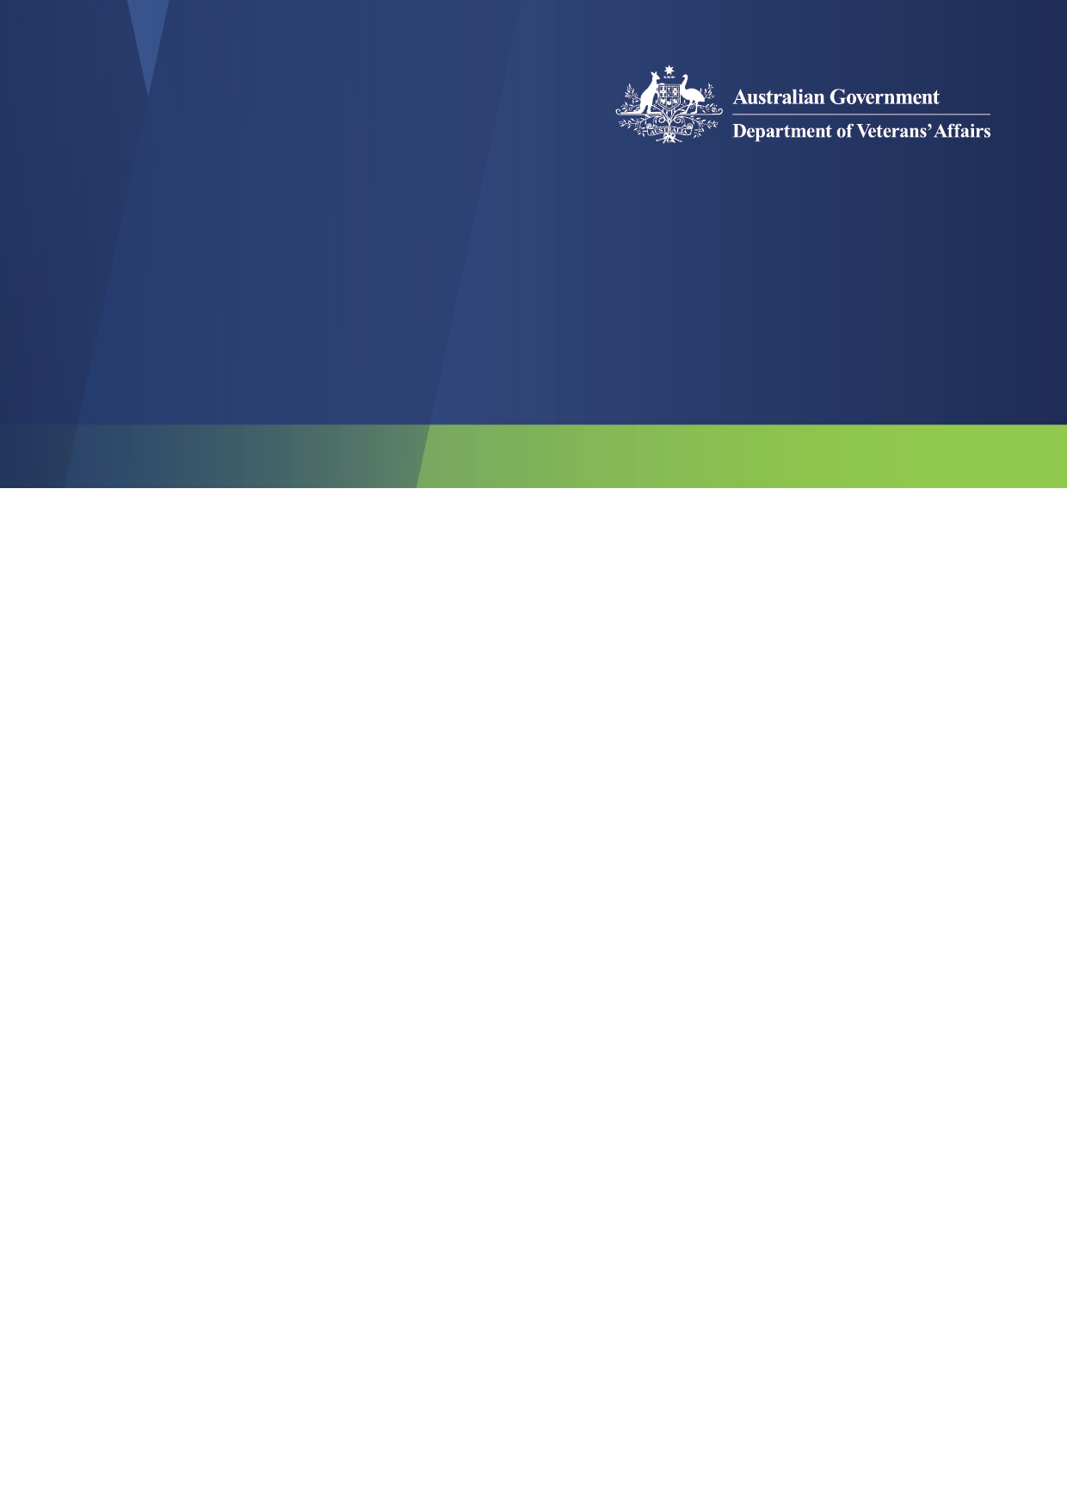
Operating Working Party Meeting

Operating Working Party

May 2026
The Operating Working Party (OWP) met on Wednesday 20 May 2026.

OWP Member Submissions
Claims Lodgment Channels and Independent examinations (VVAA)
Members noted that DVA’s preferred submission of claims is through MyService, however where veterans are submitting claims themselves, there are still a variety of methods available with support and options available via the DVA website.

Members noted that DVA’s preference is always to receive medical advice and reports from a veteran’s treating doctor where possible. Members also noted that where DVA may refuse to fund services by a medical provider DVA will work with the affected veteran to return to their previous treating medical provider where appropriate, or with the veteran’s consent, organise an appointment with an Independent Medical Examiner at DVA expense.

Members noted that veterans’ personal information must be appropriately protected and current MyService arrangements are limited to what a veteran has explicitly provided consent and authorisation for.

Delays of the processing of Incapacity Payment Claims (ASASA)
The OWP considered a submission from the Australian Special Air Service Association regarding delays in the processing of incapacity payment claims. Members acknowledged the impact of processing times on veterans and their families and noted that claims involving financial hardship and medically discharged veterans are prioritised. The Working Party also noted ongoing work to improve timeliness through targeted resourcing, process improvements, and continued engagement with Ex Service Organisations.

DVA Critical Initiatives
Claims Processing Update
The most recent claims reporting data can be accessed through the DVA Claims Processing Webpage: https://www.dva.gov.au/claim-processing, which encompasses all key metrics relating to the claims process.
Should you encounter any difficulties in viewing or downloading the data, please do not hesitate to reach out to us for assistance.

Key Changes to the Building Excellence in Support and Training (BEST) Grants 2026-29
OWP noted the information provided by DVA regarding the changes to the BEST Grants Program addressing Royal Commission into Defence and Veteran Suicide’s Final Report recommendation 99 & the Senate Standing Foreign Affairs, Defence and Trade Legislation Committee Inquiry.
Advocacy Update
Members noted the recent Advocacy Working Group meeting, changes and increased Government investment in the Building Excellence in Support and Training (BEST) grants program, and the conclusion of the public consultation period on further veteran advocacy reform.

OWP Members in attendance:
Tara Cavanagh
FLTLT Rod Hutchings
Vanessa Cheng
Michael Carlon JP
John McNeill
Jenny Gregory OAM
Narelle Bromhead OAM
Scott Jeffrey
Max Ball
Bill Roberts OAM
Apologies:
Clem Russell
Bob Connor
Keely Dreghorn
Andrew Kefford PSM

