PORTFOLIO SUPPLEMENTARY ADDITIONAL ESTIMATES STATEMENTS 2025-26

APPROPRIATION BILL (NO. 5) 2025-26
AND
APPROPRIATION BILL (NO. 6) 2025-26

Defence Portfolio
(department of veterans’ affairs)

Explanations of SUPPLEMENTARY Additional
Estimates 2025-26

© Commonwealth of Australia 2026
ISBN 978-0-6486329-5-5
This publication is available for your use under Creative Commons Attribution 4.0 International licence, with the exception of the Commonwealth Coat of Arms, third-party content and where otherwise stated. The full licence terms are available from http://creativecommons.org/licenses/by/4.0/legalcode.

Use of Commonwealth of Australia material under Creative Commons Attribution 4.0 International licence requires you to attribute the work (but not in any way that suggests that the Commonwealth of Australia endorses you or your use of the work).
Commonwealth of Australia material used ‘as supplied’
Provided you have not modified or transformed Commonwealth of Australia material in any way including, for example, by changing the Commonwealth of Australia text; calculating percentage changes; graphing or charting data; or deriving new statistics from published statistics – then the Commonwealth of Australia prefers the following attribution:
Source: The Commonwealth of Australia.
Derivative material
If you have modified or transformed Commonwealth of Australia material, or derived new material from those of the Commonwealth of Australia in any way, then the Commonwealth of Australia prefers the following attribution:
Based on Commonwealth of Australia data.
Use of the Coat of Arms
The terms under which the Coat of Arms can be used are set out on the Department of the Prime Minister and Cabinet website (see www.pmc.gov.au/
honours-and-symbols/commonwealth-coat-arms)
Other uses
Enquiries regarding this licence and any other use of this document are welcome at:
Chief Financial Officer, Department of Veterans’ Affairs (02) 5163 8491.
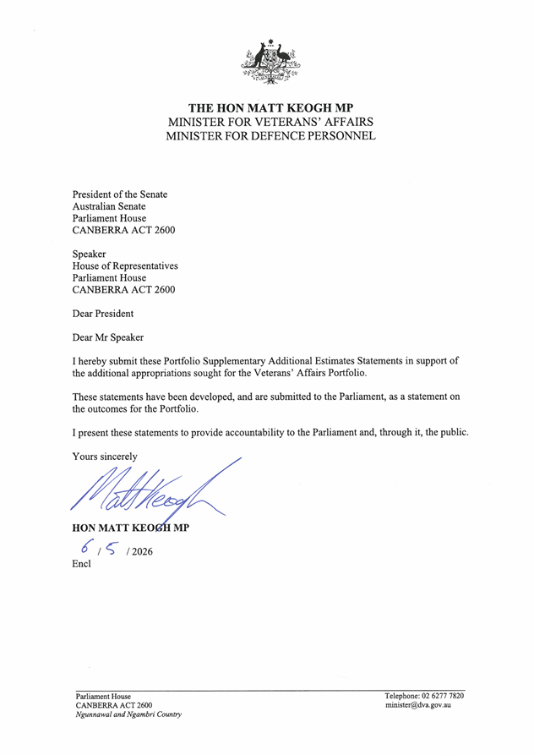

Abbreviations and conventions
The following notations may be used:
NEC/nec not elsewhere classified

- nil

.. not zero, but rounded to zero

na not applicable (unless otherwise specified)

nfp not for publication

$m $ million

Figures in tables and in the text may be rounded. Figures in text are generally rounded to one decimal place, whereas figures in tables are generally rounded to the nearest thousand. Discrepancies in tables between totals and sums of components are due to rounding.

Enquiries
Should you have any enquiries regarding this publication please contact the Chief Finance Officer in the Department of Veterans' Affairs on (02) 5163 8491.
Links to Portfolio Budget Statements (including Portfolio Additional Estimates Statements and Portfolio Supplementary Additional Estimates Statements) can be located on the Australian Government Budget website at www.budget.gov.au.

User guide

to the

Portfolio Supplementary Additional Estimates

Statements
DVA

User Guide
The purpose of the 2025–26 Portfolio Supplementary Additional Estimates Statements (PSAES) is to inform Senators, Members of Parliament and the public of the proposed allocation of additional resources to government outcomes by entities within the portfolio.
The PSAES facilitate understanding of the proposed appropriations in Appropriation Bill (No. 5) 2025-2026 and Appropriation Bill (No. 6) 2025-2026. In this sense the PSAES is declared by the Appropriation Acts to be a ‘relevant document’ to the interpretation of the Acts according to section 15AB of the Acts Interpretation Act 1901.
Appropriation Bill (No. 5) 2025-2026, which follows on from Appropriation Act (No. 1) tabled at Budget and Appropriation Act (No. 3) tabled at Additional Estimates, will provide additional expenditure authority for the ordinary annual services of government in respect of the 2025-26 financial year.
Appropriation Bill (No. 6) 2025-2026, which follows on from Appropriation Act (No. 2) tabled at Budget and Appropriation Act (No. 4) tabled at Additional Estimates, will provide additional expenditure authority in respect of the 2025-26 financial year for capital works and services, payments to or for the states, territories and local government authorities, and new administered outcomes not authorised in specific legislation.

Contents
Entity Additional Estimates Statements xi
Department of Veterans' Affairs 1

Entity Supplementary Additional Estimates Statements

Department of Veterans' Affairs xiii
Department of Veterans' Affairs 1

Department of Veterans' Affairs
Overview of additional appropriations 1
Department of Veterans’ Affairs Measures table 2
Supplementary Additional estimates and variations 3

Department of Veterans' Affairs
Overview of additional appropriations
Funding is being provided to the Department of Veterans’ Affairs in the 2025-26 Appropriation Bill (No.5).
Complete details of resources and performance information can be found in the 2026-27 Portfolio Budget Statements.

Department of Veterans’ Affairs Measures table
Table 1.1 summarises new Government measures taken since the 2025-26 Additional Estimates. The table is split into receipt and payment measures, with the affected program identified.

Table 1.1: Department of Veterans’ Affairs 2025-26 Supplementary additional estimates measures
 | Program | 2025-26  $'000 | 2026-27  $'000 | 2027-28  $'000 | 2028-29  $'000
Payment measures
Continuing to Support Veterans and their Families (a) | various
Administered payments |  | (840) | 1,984 | (160,041) | (209,996)
Departmental payments |  | 113 | 6,936 | 3,263 | 849
Total |  | (727) | 8,920 | (156,778) | (209,147)
Modernising Payment of the Pension Supplement to Recipients Overseas (b) (c) | 1.1
Administered payments |  | – | – | – | –
Departmental payments |  | – | – | – | –
Total |  | – | – | – | –
Total Payment measures
Administered |  | (840) | 1,984 | (160,041) | (209,996)
Departmental |  | 113 | 6,936 | 3,263 | 849
Total |  | (727) | 8,920 | (156,778) | (209,147)
Prepared on a Government Financial Statistics (Underlying Cash) basis. Figures displayed as a negative (-) represent a decrease in funds and a positive (+) represent an increase in funds.
- This measure relates to a decision made following the 2025-26 Mid-Year Economic and Fiscal Outlook (MYEFO). The full measure description and package details appear in the 2026-27 Budget Paper No. 2. This measure includes an impact of -$249.777 million in 2029-30, comprising -$250.638 million administered and $0.861 million departmental funding.
- The lead entity for this measure is the Department of Social Services. The full measure description and package details appear in the 2026-27 Budget Paper No. 2 under the Social Services portfolio.
- This measure was a decision taken but not yet announced in the 2025-26 MYEFO. Amounts previously held in the Contingency Reserve have now been appropriated, with the following impacts for departmental funding (2025-26 $0.312 million; 2026-27 $0.395 million) and administered funding (2026-27 -$0.179 million; 2027-28 -$0.251 million; 2028-29 -$0.270 million and 2029-30 -$0.287 million).

Supplementary additional estimates and variations
The following tables detail the changes to the resourcing for entity Department of Veterans' Affairs at Supplementary Additional Estimates, by outcome. The following table details the estimates and variations resulting from new measures and any other variations (if applicable) since the 2025-26 Additional Estimates in Appropriation Bills (No. 5).
Table 1.2: Supplementary additional estimates and variations to outcomes from measures and other variations
 | Program | 2025-26 $'000 | 2026-27 $'000 | 2027-28 $'000 | 2028-29 $'000
Outcome 1
Administered
Special appropriations
Modernising Payment of the Pension Supplement to Recipients Overseas | 1.1 | – | (179) | (251) | (270)
Net impact on appropriations for Outcome 1 (administered) |  | – | (179) | (251) | (270)
Outcome 1
Departmental
Annual appropriations
Modernising Payment of the Pension Supplement to Recipients Overseas | 1.1 | 312 | 395 | – | –
Net impact on appropriations for Outcome 1 (departmental) |  | 312 | 395 | – | –
Total net impact on appropriations for Outcome 1 |  | 312 | 216 | (251) | (270)
Outcome 2
Administered
Special appropriations
Continuing to Support Veterans and their Families | 2.1, 2.3, 2.6 | – | 2,134 | (159,891) | (209,846)
Net impact on appropriations for Outcome 2 (administered) |  | – | 2,134 | (159,891) | (209,846)
Outcome 2
Departmental
Annual appropriations
Continuing to Support Veterans and their Families | 2.1-2.6 | 113 | 6,936 | 3,263 | 849
Net impact on appropriations for Outcome 2 (departmental) |  | 113 | 6,936 | 3,263 | 849
Total net impact on appropriations for Outcome 2 |  | 113 | 9,070 | (156,628) | (208,997)
Continued on next page

Table 1.2: Supplementary additional estimates and variations to outcomes from measures and other variations (continued)
 | Program | 2025-26 $'000 | 2026-27 $'000 | 2027-28 $'000 | 2028-29 $'000
Outcome 3
Administered
Annual appropriation
Continuing to Support Veterans and their Families | 3.1-3.2 | (840) | (150) | (150) | (150)
Net impact on appropriations for Outcome 3 (administered) |  | (840) | (150) | (150) | (150)
Total net impact on appropriations for Outcome 3 |  | (840) | (150) | (150) | (150)
Prepared on a resourcing (i.e. appropriations available) basis.

The following tables detail the Supplementary Additional Estimates sought for Department of Veterans' Affairs through Appropriation Bills (No. 5).
Table 1.3: Appropriation Bill (No. 5) 2025-26
 | 2024-25 Available  $'000 | 2025-26  Budget  $'000 | 2025-26 Revised  $'000 | Additional  Estimates  $'000 | Reduced  Estimates  $'000
Administered Items
Outcome 1 | 86,481 | 75,932 | 75,932 | – | –
Outcome 2 | 33,726 | 35,847 | 35,847 | – | –
Outcome 3 | 46,893 | 50,056 | 50,056 | – | –
Total administered | 167,100 | 161,835 | 161,835 | – | –
Departmental Items
Outcome 1 ^{(a)} | 383,014 | 436,471 | 436,783 | 312 | –
Outcome 2 | 208,383 | 213,648 | 213,761 | 113 | –
Outcome 3 | 15,996 | 19,277 | 19,277 | – | –
Total departmental | 607,393 | 669,396 | 669,821 | 425 | –
Total administered and  departmental | 774,493 | 831,231 | 831,656 | 425 | –
- Includes $32.7 million that is under administrative quarantine in 2025-26 and is yet to be released.

