


Completing your new
BEST Program application forms
P04920

When you open the application form it may look familiar but there have been several changes for the 2026–27 to 2028–29 round. This Information sheet will take you through the key changes in the application form and important steps not to miss.

IMPORTANT DATES
BEST Program opens 11 March 2026
BEST Program closes 15 April 2026

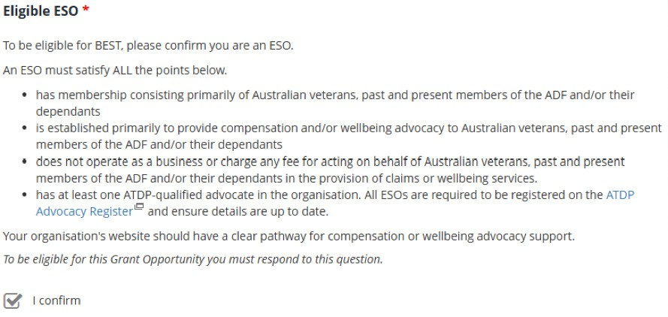
- When you get to the Eligible ESO question please review the dot points to confirm whether your organisation is eligible for the BEST Program. If you are an eligible ESO as per the BEST Program Grant Opportunity Guidelines please tick the “I confirm’ box.

- The Service Standards for Claims Advocacy are included in the Grant Opportunity Guidelines on GrantConnect. Please review the standards and tick the ‘I confirm’ box to confirm your organisation has committed to them in this question.
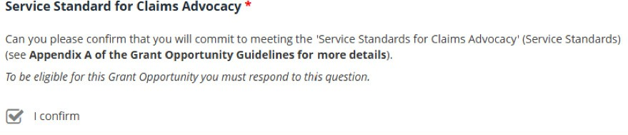

- The new application form asks for an activity title and a brief description of the project or services to be delivered. You do not need to go into great detail here. A simple response is sufficient.
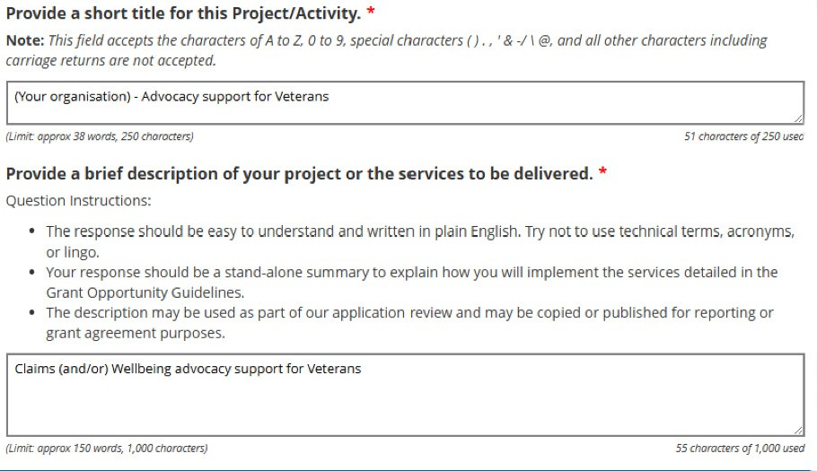

- The application form will ask in which service areas you are proposing to deliver the project/activity. We have restricted the answer field to Australia only. Please complete the form as below.
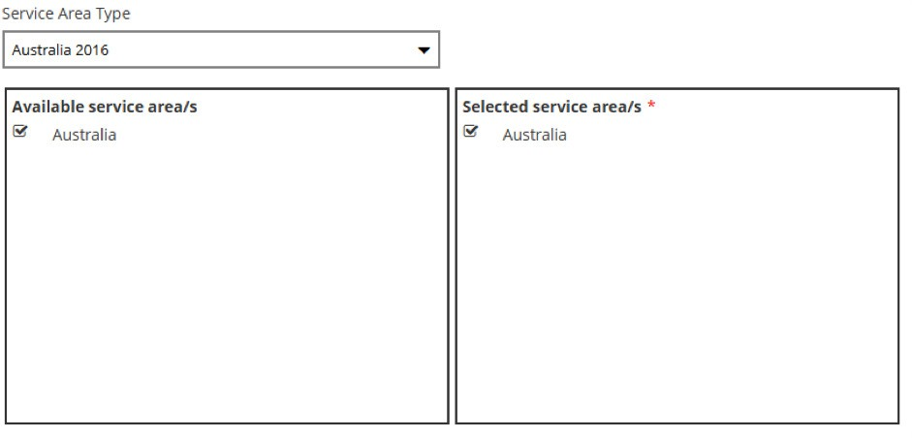

- For the Funding Amount question:
  - Download the mandatory Budget Template from GrantConnect. This will be in Microsoft Word format.
  - Complete the Word document with your annual budget (as per the categories).
  - Make sure the total amount matches the funding amount entered in the Financials tab of the application form.
  - Check Eligible Expenses in section 5.2 of the Grant Opportunity Guidelines.
  - Tick ‘I confirm’ to acknowledge.
  - Upload the document as a mandatory attachment to your application when you get to the attachments page of the application.
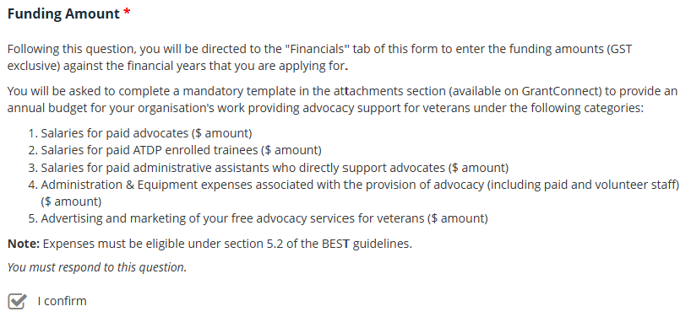

- The Budget Template - mandatory attachment is a separate Microsoft Word document linked to the question above. The template table includes the following categories:
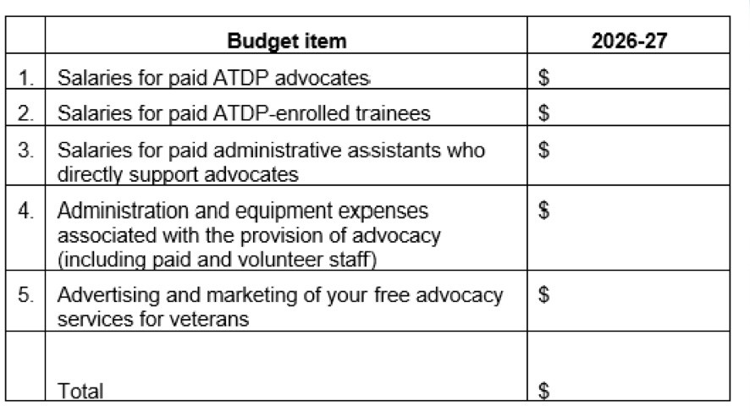
Most eligible admin and equipment expenses fall under this category

Note: There are many eligible expenses under BEST Program (see section 5.2 of the Grant Opportunity Guidelines). Category 4 for administration and equipment expenses is broad. If your expense is eligible and does not fit within the other categories, please include it under category 4.
Please ensure the total of this table is the same amount as you request in the Financials tab of the application form.

- The Financials question asks for your total amount requested under the BEST Program and should be the same as the total of your table in the Budget Template above.
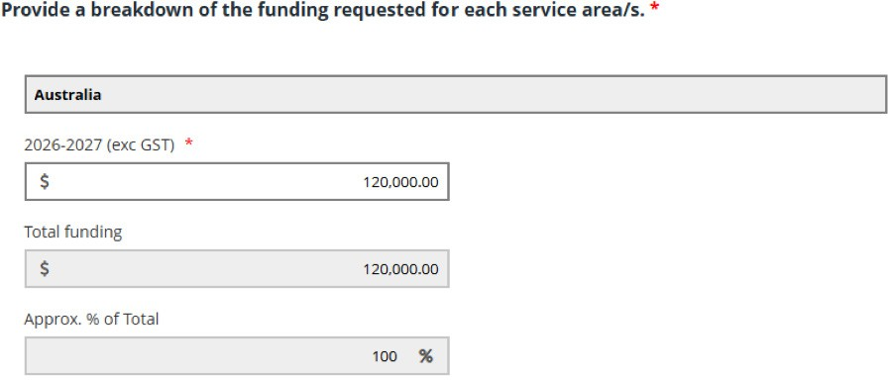
This figure must match the total in the word document Budget Template – mandatory attachment you completed under step 6

- Sponsorship is still an option for sub-branches who are not an eligible entity type. If you are a sponsored organisation, you MUST ask the sponsor to complete and sign off on the application on your behalf. The application form has a button for you to upload the Letter of Declaration - mandatory attachment that is found on GrantConnect.

- You must also upload evidence of your Professional Indemnity Insurance – mandatory attachment.
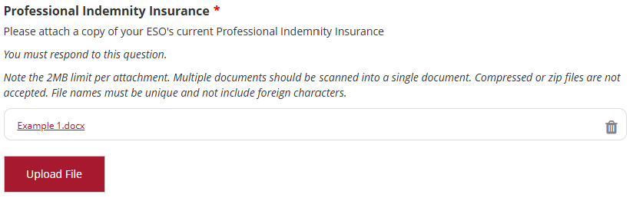

- The Advocate and Wellbeing Support Officer List – mandatory attachment is available on GrantConnect with the Grant Opportunity Guidelines. This is a mandatory attachment that tells us the details that determine the grant amount. This is a Microsoft Excel document that contains instructions on how to complete your list of advocates and wellbeing support officers. You must complete this template and upload it into your application.
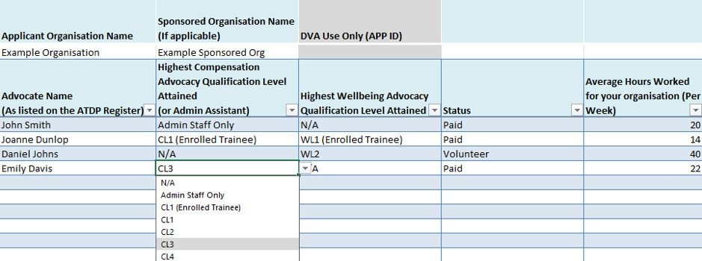

The Advocate, Trainee, Admin staff tab is where you list the names of staff in these roles.
  - Column 1 – Advocate Name - Please provide the names of your ATDP qualified advocates, ATDP trainees, and your administrative assistants supporting them.
  - Column 2 – Highest Compensation Advocacy Level attained - Please select the highest ATDP compensation level attained (against each name) from the drop-down list or select admin staff only if they are an administrative assistant. If none apply please select N/A.
  - Column 3 – Highest Wellbeing Advocacy - Please select the highest ATDP wellbeing level attained (against each name) from the drop-down list. If none apply select N/A.
  - Column 4 – Status - Please select the paid or volunteer status for each individual.
  - Column 5 – Average Hours Worked - Please tell us how many hours per week each individual works on average throughout the year. This is capped at 40 hours per week. You must only include the hours they work for your organisation. Where individuals work across multiple Organisations, the system will make sure their total weekly hours do not exceed 40. If they do we will seek clarification. If you employ someone for only part of the year you should reduce the average weekly hours accordingly – please divide the total planned hours for the year by 52 working weeks.
Note: We do not need salary information for individuals in this form. Funding is allocated using workforce data and the total funding available under the program.

The Wellbeing Support Officer Staff tab at the bottom of the spreadsheet is where you list your wellbeing support officers. You only need to provide their names in this document.

For further information and support you can contact support@communitygrants.gov.au during the application period.

