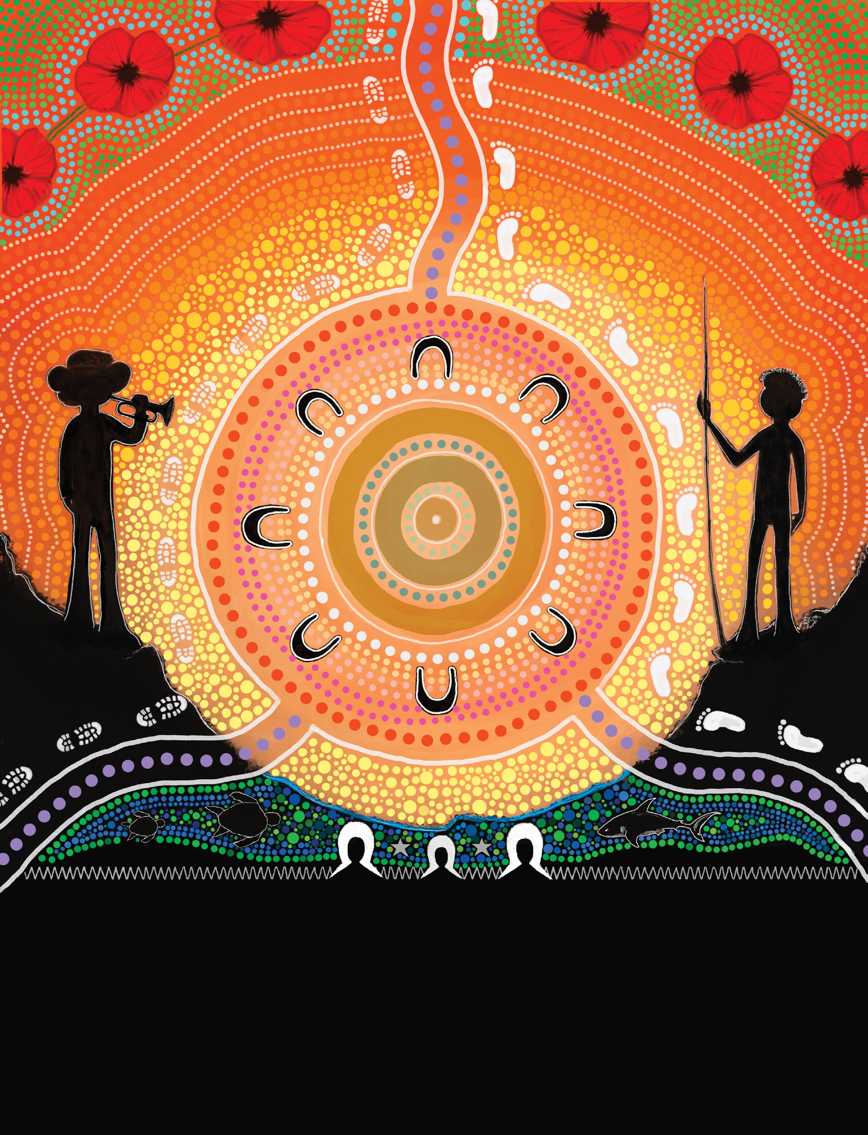
Innovate Reconciliation
Action Plan
November 2025 –
November 2027

Acknowledgements

Acknowledgement of Country
The Department of Veterans’ Affairs (DVA) acknowledges the Traditional Custodians of the land throughout Australia. We pay our respects to Elders past and present. We recognise and celebrate Aboriginal and Torres Strait Islander peoples as the First Peoples of Australia and their continuing spiritual and cultural connection to land, sea and community. DVA also acknowledges the services of First Nations Veterans and their families who served in the defence of our nation.
We acknowledge First Nations peoples have proudly served in almost every conflict and peace operation in which Australia has been involved since the First Boer War (1880–1881), we aim to celebrate important contributions and to keep their stories alive to tell future generations.

Acknowledgement of Contributions

DVA appreciates all contributions to the development of our Innovate Reconciliation Action Plan (RAP) and further acknowledges First Nations employees whose cultural insights and knowledge helped to facilitate the development of this RAP.
DVA’s RAP is endorsed and championed by the:
- Secretary
- Chief Operating Officer
- Chief People Officer
- First Nations Champion
- Galumbany RAP Working Group Chair and members.

CULTURAL DISCLAIMER
The term First Nations Peoples is used throughout this document to refer to Aboriginal and/ or Torres Strait Islander peoples.

Contents
Acknowledgements II
Statement from CEO of Reconciliation Australia 2
Message from the Secretary 3
Introduction 4
Artwork 5
Vision 6
Our Business and People 7
Achievements Timeline 10
DVA’s Galumbany Reconciliation Action Plan Working Group 12
Spotlight and Case Studies 14
Relationships Pillar 16
Opportunities Pillar 21
Contact details 24

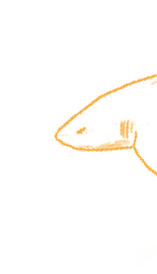

Contents 1

Messages

Statement from CEO of Reconciliation Australia
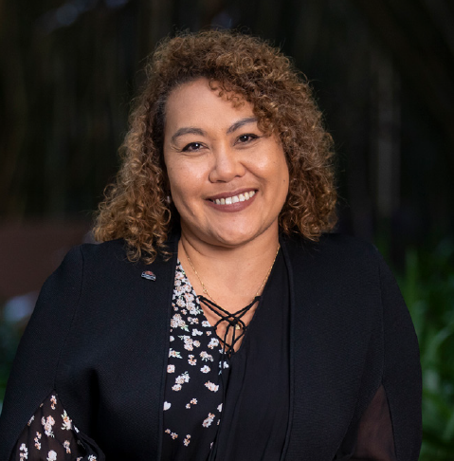
Reconciliation Australia commends the Department of Veterans’ Affairs on the formal endorsement of its second Innovate Reconciliation Action Plan (RAP).
Since 2006, RAPs have provided a framework for organisations to leverage their structures and diverse spheres of influence to support the national reconciliation movement.
With over 5.5 million people now either working or studying in an organisation with a RAP, the program’s potential for impact is greater than ever. Department of Veterans’ Affairs continues to be part of a strong network of more than 3,000 corporate, government, and not-for-profit organisations that have taken goodwill and transformed it into action.
The 4 RAP types — Reflect, Innovate, Stretch and Elevate — allow RAP partners to continuously strengthen reconciliation commitments and constantly strive to apply learnings in new ways.
An Innovate RAP is a crucial and rewarding period in an organisation’s reconciliation journey. It is a time to build the strong foundations and relationships that ensure sustainable, thoughtful, and impactful RAP outcomes into the future.
An integral part of building these foundations is reflecting on and cataloguing the successes and challenges of previous RAPs. Learnings gained through effort and innovation are invaluable resources that Department of Veterans’ Affairs will continuously draw upon to create RAP commitments rooted in experience and maturity.
These learnings extend to Department of Veterans’ Affairs using the lens of reconciliation to better understand its core business, sphere of influence, and diverse community of staff and stakeholders.
The RAP program’s emphasis on relationships, respect, and opportunities gives organisations a framework from which to foster connections with Aboriginal and Torres Strait Islander peoples rooted in mutual collaboration and trust.
This Innovate RAP is an opportunity for Department of Veterans’ Affairs to strengthen these relationships, gain crucial experience, and nurture connections that will become the lifeblood of its future RAP commitments. By enabling and empowering staff to contribute to this process, Department of Veterans’ Affairs will ensure shared and cooperative success in the long-term.
Gaining experience and reflecting on pertinent learnings will ensure the sustainability of Department of Veterans’ Affairs’s future RAPs and reconciliation initiatives, providing meaningful impact toward Australia’s reconciliation journey.
Congratulations Department of Veterans’ Affairs on your second Innovate RAP and I look forward to following your ongoing reconciliation journey.

Karen Mundine
Chief Executive Officer Reconciliation Australia

2 Department of Veterans’ Affairs - Innovate Reconciliation Action Plan

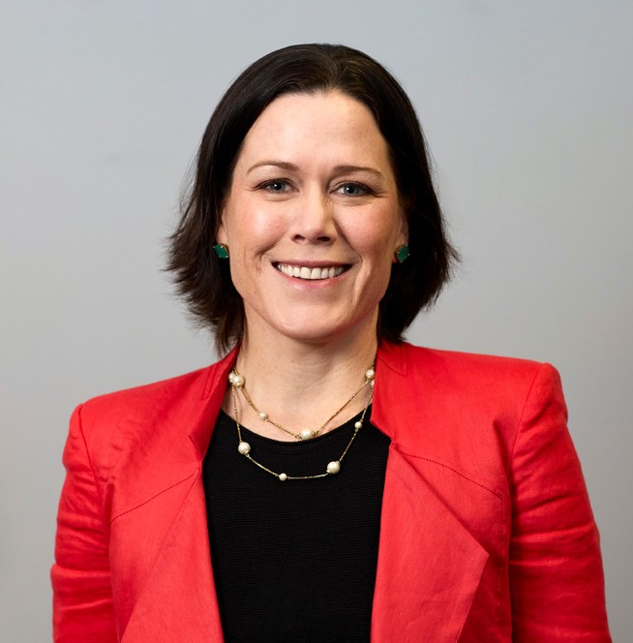

Message from the Secretary
I am pleased to present DVA’s Innovate Reconciliation Action Plan (RAP) 2025–2027.
First Nations Peoples are the oldest continuing civilisations in the world. Aboriginal and Torres Strait Islander peoples have lived on these lands for over 65,000 years – while other civilisations, cultures and empires have come and gone. Their connection to Country is strong and enduring.
At DVA, we recognise the importance of understanding, respecting and valuing that connection – not only as an employer, but in how we work with and for the Australian community. We also recognise the service and sacrifice of First Nations Peoples who are serving or have served in the Australian Defence Force.
DVA is committed to creating an inclusive workplace based on mutual respect, where First Nations Peoples, communities and cultures are recognised, valued and celebrated.
This is the department’s third RAP and builds on the momentum and learnings gained over the implementation of the 2 previous plans. It details our key areas of focus across the 3 pillars of relationships, respect and opportunities.
This RAP is our roadmap to strengthening reconciliation within DVA and the wider veteran community over the next 2 years.
In addition to being an employer, DVA is a service provider. Over the course of this Plan, we will also actively establish and maintain mutually beneficial relationships with First Nations stakeholders and organisations to enable the department to provide improved services and support to our First Nations clients, and their families.
This aligns with the department’s strategic direction to deliver quality services to veterans and families, implement the Australian Government’s response to the Royal Commission into Defence and Veteran Suicide, simplify processes, and improve its enabling services so it can better serve veterans and families.
Reconciliation is the responsibility of us all. I encourage you to think about how you can contribute to achieving the goals and initiatives set out in this Plan, so we can continue to make positive progress on our reconciliation journey.

Alison Frame
Secretary of the Department of Veterans’ Affairs

Messages 3

Introduction

First Nations Champion message
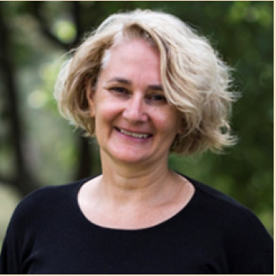
It is a privilege to be DVA’s First Nations Champion.
This Reconciliation Action Plan will help guide our progress in building an inclusive workplace culture where DVA employees and First Nations
veterans and their family members have access to culturally safe services in a supportive environment. I thank everyone who has been involved in developing this plan, and all who have contributed their thoughts, time and expertise. I am very grateful to the members of DVA’s Galumbany
Reconciliation Action Plan Working Group who have given generously of their time, energy and skills.
The outcome is a RAP that is unique to DVA and the veteran community we serve.
I now look forward to seeing the implementation of the Plan and working across the department and with our stakeholders to achieve the RAP’s objectives.
I also hope through the implementation of this RAP and the building of positive relationships between First Nations Peoples and non-Indigenous peoples, DVA can meaningfully contribute to national reconciliation.

Paula Goodwin

Message from the Galumbany Reconciliation Action Plan Working Group Chair
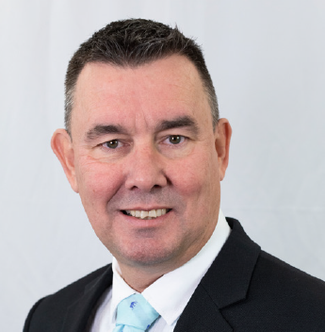
As the Chair of the Galumbany Reconciliation Action Plan Working Group,
I would like to thank all members of this group for their contributions to the development of our new DVA Innovate Reconciliation Action Plan. Each person brought passion for change and their unique experiences to the
Working Group, and I am proud to have been able to collaborate with you all.
Having recently been privileged to represent DVA at the GARMA festival, I was overwhelmed to see the vision and ongoing commitment to close the gap for First Nations Peoples. It was so rewarding to see people from all walks of life and demographic backgrounds come together at this
festival, run by the Yothu Yindi Foundation, to acknowledge that there is a gap between Indigenous and non-Indigenous peoples in Australia, and to strive for change.
Reconciliation is fundamental in our workplace to ensure we continue to honour and celebrate First Nations cultures in a respectful manner while educating our non-First Nations colleagues on our history and ongoing journey. The department’s reconciliation journey has been one of both success and challenges. However, through the development of our new Innovate RAP, what I can say is that reconciliation is very much still a priority at the department. This RAP will act as a roadmap to guide and empower staff on DVA’s reconciliation journey. Each step that we take towards reconciliation, no matter how large or how small, is still a step in the right direction.
Finally, I acknowledge that a RAP can only be as successful as our implementation plan and look forward to working with our key business areas to embed reconciliation in our business-as-usual functions.

Rodger McNally

4 Department of Veterans’ Affairs - Innovate Reconciliation Action Plan

Artwork Story

This painting represents the coming together of different cultures under a common cause. The circles in the middle represent community, with the ‘U’ shapes representing the people of the community.
The 2 purple lines coming in from the bottom move through the Indigenous and veterans’ community circle to come out as one.
The depiction of an Aboriginal man and a soldier, flanked by 3 head-dresses, turtles, and a shark, symbolises the diverse cultures of veterans, Aboriginals, and Torres Strait Islanders. The boot and footsteps show the journey of a coming together.
The colours radiating from the centre circle represent the light and spiritual energy that connect us all. The poppies incorporated at the top symbolise our veterans and their sacrifices. The 3 poppies on each side represent the 3 armed services of the ADF. The blue-green and white at the bottom are associated with the Torres Strait Islands.
The colours of the Torres Strait Islander flag are represented in the artwork. The iconic head-dress and the animals of the sea are depicted to demonstrate the links between the people and the sea. Dot art was used to compliment Troy Gibson’s design and to bring cohesion not only between the 2 styles of artwork, but the 2 Indigenous peoples and their links to the Australian Defence Force.

Our Artist Profiles
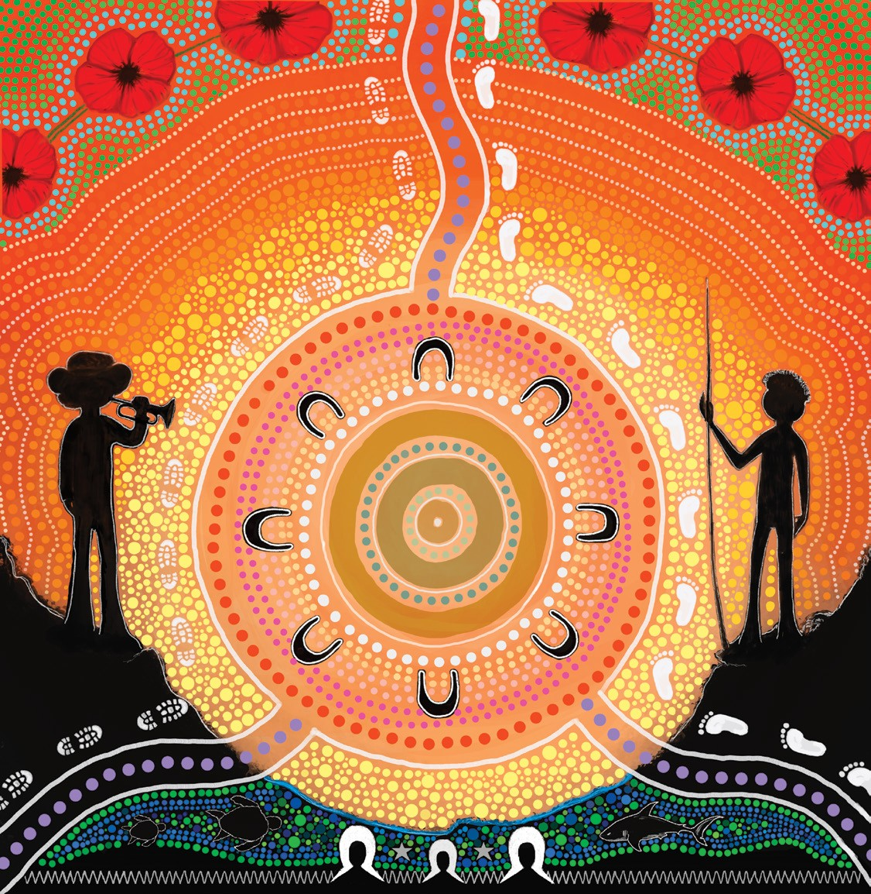
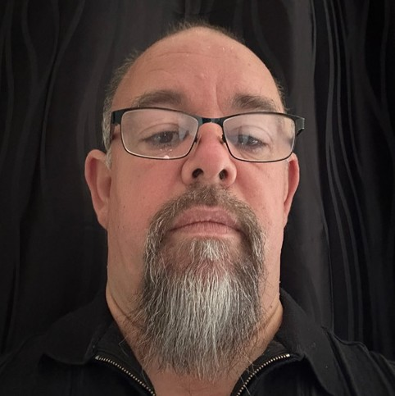

Artist Name: Troy Gibson
Location: DVA Adelaide Office
Country: Adnyamathanha
Inspired by:
I have always loved Aboriginal art with influences coming from artists including Molly Peterson and Clifford Possum Tjapaltjarri. I feel my art designs apply traditional Aboriginal aspects that incorporate
more modern colours.
Artist: Mikki Mills
Location: DVA Brisbane Office
Country: Aboriginal and Torres Strait Islander descent
Inspired by: All artists of the Central Desert as well as Clifford Possum Tjapaltjarri and Minnie Pwerle. Artists of the Torres Strait who carve shell, wood and lino prints.

Artwork Story 5

Vision
Our Vision for Reconciliation
DVA’s vision is for an inclusive workplace built on mutual respect, where First Nations Peoples, communities and cultures are recognised, valued and celebrated. We understand the importance of truth-telling and the necessity of listening to hear the voices of First Nations Peoples.
We strive for a diverse, vibrant and inclusive workplace, where individuals are valued and empowered to achieve their potential. We seek to be part of an Australian community that recognises and celebrates First Nations Peoples’ cultural identity, community, and need for economic empowerment and self-determination.
We believe and role model that reconciliation is everyone’s responsibility. The department’s sphere of influence for reconciliation not only encompasses its employees but also extends across the veteran and family community.
DVA is committed to expanding its understanding of the historical and contemporary experiences of First Nations Peoples to ensure First Nations veterans, their families, and our employees have access to a culturally safe and supportive environment.
DVA acknowledges the impact RAPs have in leading towards a reconciled Australia. As an organisation we strive to continue in our journey of reconciliation by building upon the practical commitments we made in our Innovate RAP 2018–2020.

6 Department of Veterans’ Affairs - Innovate Reconciliation Action Plan

Our Business and People

For more than 100 years, the Australian Government has committed to repatriate, support, and commemorate the service of veterans to our nation. How we have delivered on this has changed over time, but the purpose of DVA is to support the wellbeing of those who serve or have served in the defence of our nation, and their families, by:
- partnering with organisations and individuals to help design, implement and deliver effective programs and benefits which enhance the wellbeing of veterans and families
- providing and maintaining war graves and delivering meaningful commemorative activities to promote community recognition and understanding of the service and sacrifice of veterans.
To enhance the services provided to First Nations veterans and their families, DVA is guided by our Indigenous Veterans Strategy (IVS), ensuring all veterans and their families are aware of, and have access to, their entitlements. The IVS guides DVA’s actions and transformation agenda to enhance the health and wellbeing of First Nations veterans and their families. It also creates pathways to identify, engage and connect with veterans and their families, and work collaboratively to improve DVA services.
DVA is continuing to build an inclusive workplace that improves the experience of employees and enhances our interactions with veterans. We are continuously striving to achieve higher representation across all diversity groups to ensure the workforce reflects the community we serve. We are committed to providing an inclusive workplace which will promote cultural capability, improve recruitment and retention, and continue to develop a culture that values diversity.


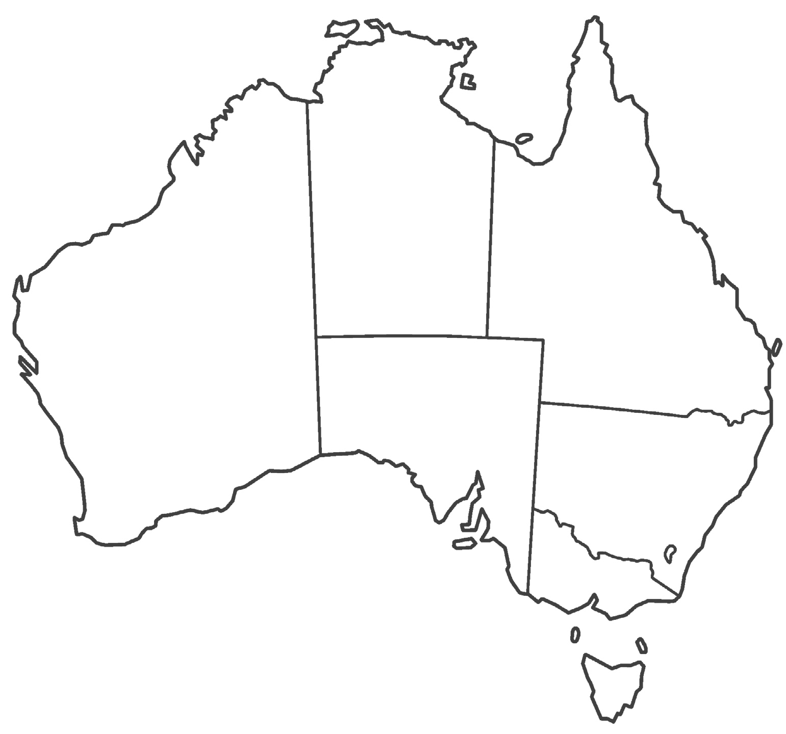
DVA office locations

OA/VAN - WINNELLIE

OA SATELLITE - YARRAWONG
OA SATELLITE - KATHERINE

NT

QLD
OA SATELLITE - CAIRNS

VAN - TOWNSVILLE OA - CRANBROOK
OA SATELLITE - MARYBOROUGH OA/VAN - MOROOCHYDORE

PERTH

WA

OA - PERTH

SA

NSW
OA - ELIZABETH
OA - STAFFORD
BRISBANE
OA - IPSWICH

OA - MOUNT GRAVATT OA - BUNDALL
OA/VAN - BROADBEACH

OA/VAN/SATELLITE - LISMORE

OA/VAN/SATELLITE - NEWCASTLE

OA - ROCKINGHAM OA - MOUNT PLEASANT

STATE OFFICES

ADELAIDE
OA - EASTWOOD OA SATELLITE - DAW PARK
OA SATELLITE - WAGGA

OA/VAN - WODONGA
VIC

SYDNEY
OA SATELLITE - PARRAMATTA
OA SATELLITE - NOWRA
CANBERRA
OA - PHILLIP
OA SATELLITE - GUNGAHLIN OA SATELLITE - QUEANBEYAN

STATE AND NATIONAL OFFICE
MELBOURNE
OA SATELLITE - SEYMOUR

OA - MELBOURNE

OPEN ARMS SITES
VETERANS ACCESS NETWORK SITES OPEN ARMS/VAN JOINT SITES
OPEN ARMS SATELLITE
OA SATELLITE - DEVONPORT OA SATELLITE - BURNIE

TAS
OA SATELLINE - LAUNCESTON VAN - LAUNCESTON

HOBART

Our Business and People 7

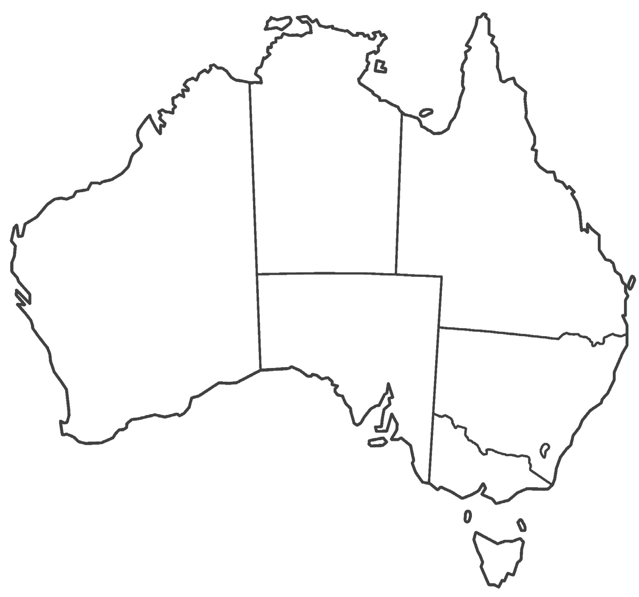

War Cemeteries and Office of Australia

War Graves (OAWG) sites

DARWIN
WINNELLIE

YARRAWONG

KATHERINE

NT

CAIRNS

TOWNSVILLE
CRANBROOK

QLD

OA SATELLITE- MARYBOROUGH
MAROOCHYDORE OA/VAN

War Cemeteries
NSW Cowra
NSW Cowra (Japanese)
NSW Albury
NSW Newcastle (Sandgate)
NSW Wagga
NT Alice Springs
QLD Lutwyche
QLD Atherton
QLD Bundaberg
QLD Cairns
QLD Charters Towers
QLD Ipswich
QLD Rockhampton
QLD Toowoomba
QLD Townsville
SA Mallala
SA Port Pirie
TAS Launceston
VIC Bairnsdale
VIC Mildura
VIC Sale
Tatura German Military VIC Cemetery
WA Perth (Dutch Annexe)
WA Geraldton
Gardens of Remembrance
ACT Woden Cemetery
Thorak Regional Cemetery NT Berrimah
North QLD, Anzac Park,
QLD Townsville

ROCKINGHAM

WA

PERTH

SA

ELIZABETH

NSW
WAGGA
STAFFORD
BRISBANE
IPSWICH

MOUNT GRAVATT BUNDALL BROADBEACH
LISMORE OA/VAN/SATELLITE

NEWCASTLE OA/VAN PARRAMATTA

MOUNT PLEASANT

OAWG sites
NT Adelaide River War Cemetery
Carr Villa War Cemetery & Launceston Garden of
TAS Remembrance
Centennial Park Cemetery & SA
SA Garden of Remembrance
Cornelian Bay War Cemetery & Hobart Garden of
TAS Remembrance
Perth War Cemetery & Garden
WA of Remembrance
Queensland Garden of Remembrance - Pinnaroo
QLD Lawn Cemetery
Springvale War Cemetery &
VIC Garden of Remembrance
Sydney War Cemetery & NSW
NSW Garden of Remembrance

ADELAIDE

EASTWOOD

DAW PARK

WODONGA

VIC

MELBOURNE
DEVONPORT
SYDNEY
NOWRA
CANBERRA
GUNGAHLIN
PHILLIP ACT

SEYMOUR

State & National Offices Open Arms sites
Veterans Access Network sites
Open Arms Satellite
OAWG
War Cemeteries
BURNIE
TAS
LAUNCESTON

HOBART

As of 30 June 2025, DVA employed 3871 people, with 75 employees identifying as a First Nations person, representing 1.9 per cent of our workforce. We remain committed to achieving 3 per cent representation of First Nations employment, through continued participation in whole-of-Australian-Government initiatives and programs, the implementation of a DVA Inclusion Strategy and continued participation in Australian Public Service First Nations employment initiatives.
The DVA footprint operates across most First Nations lands; in addition to the Canberra office hub location, we operate Veteran Access Network offices across 48 locations. The Office of Australian War Graves within DVA manages and maintains 72 Commonwealth War Graves Cemeteries and plots within Australia, 3 in Papua New Guinea and one in the Solomon Islands.
In the spirit of reconciliation, the department has demonstrated its commitment to creating a culturally safe workplace by dedicating spaces for Yarning Circles. Yarning within First Nations culture is about building respectful relationships through a collaborative way of communication. DVA’s Yarning Circles provide a meeting place for both First Nations and non-First Nations communities to come together.
The department has 2 Yarning Circles located in our Adelaide and Brisbane offices, is exploring opportunities to establish more in other locations, and will open a Yarning Circle at the new National Office, intended to launch after the move in November 2025.
Troy Gibson from the Adelaide office describes the Yarning Circles as “a safe space where we can all come together, be proud and share culture”.
Our reconciliation journey has been one of challenges and significant learning opportunities. While we are proud of the achievements to date, we acknowledge we have some way to go to achieve success across all pillars of our RAP. We have learned many lessons during our journey; as an organisation we must
grow capability across our leadership cohort to ensure that our RAP is understood, implemented and successfully delivered.

8 Department of Veterans’ Affairs - Innovate Reconciliation Action Plan

As a service delivery department, we will continue to reflect and learn as we implement our second Innovate RAP. We will strive to find innovative ways to engage our employees to enhance cultural capability and a safe, respectful workplace.
We take our responsibility to progress in our reconciliation journey as a priority and are choosing to actively rise to challenges and drive positive change across the department. We will continue to listen to the voices of First Nations veterans and employees to ensure their voices are reflected as we develop our maturity and earnest engagement in reconciliation. As we continue in our reconciliation journey and build upon achievements, we will strengthen existing initiatives and establish new stretch actions and deliverables.
Our first Reflect RAP, also known as Galumbany, was implemented in 2017. Galumbany is a Ngunnawal word meaning ‘me, you, we, together’. Our Galumbany RAP was a discovery phase in our reconciliation journey. It allowed us to develop relationships with stakeholders, decide on our vision for reconciliation and prepare DVA for future reconciliation initiatives under successive RAPs. Since our first RAP, DVA has progressed through Reconciliation Australia’s RAP structure, achieving Innovate RAP accreditation in 2018–2020.
Lessons learned in our previous RAP include to:
- listen and incorporate the voices of our First Nations employees
- attract and retain more First Nations talent at all levels
- create opportunities for career growth for our current First Nations employees
- create a stronger understanding of cultural awareness and cultural competency.

We acknowledge we must continue with our commitment to reconciliation. We will take the learnings from our 2 previous RAPs and focus on key priority areas as identified below.

Focus topic | Action
Cultural Competency | Continue to develop our cultural maturity and deliver First Nations culturally informed training for all employees.
Collaboration & Meaningful Engagement | Collaborate with First Nations employees and clients when designing policies to ensure a cultural lens is applied.
Meaningful Employment | Commit to achieving meaningful outcomes on recruitment and retention of First Nations employees.
First Nations Procurement | Raise awareness of the opportunities to increase our spend across Indigenous businesses.
There is much progress to celebrate.
By weaving the principles of diversity, inclusion and intersectionality into our Inclusion Strategy, Reconciliation Action Plan, and core people processes (recruitment, development, procurement and work health and safety), we aim to create an organisational culture where every individual is truly valued and can bring their whole self to work, and diversity is celebrated as our collective strength.

Our Business and People 9

Achievements Timeline

More

IDEP
2 participants
put through program
Jawun
3 participants put through program

Strategy published; actions tracked (2020–24).
than 170
candidates engaged since launch; renewed annually.
Bulabul
1 participant put through program since starting

Launched Gurru Ngali Employment Strategy (2020–24)
Set a clear plan to attract, support and progress Aboriginal and Torres Strait Islander employees.

Started Indigenous Skills Talent Register (iSTAR)
Created a standing pathway to identify and engage First Nations candidates
for DVA roles.

Participated in APS First Nations leadership programs
Built capability through IDEP/ Bulabul, EL2 talent programs, Jawun secondments and executive visits.

2020

2020

annual renewals

2022

Developed First Nations Veterans’ Strategy
Promoted DVA services within First Nations veteran and community networks
and honoured service.

Ongoing participation in Indigenous Apprenticeship Program
Opened early-career pathways and supported on-the-job development.

Provided internal mentoring for entry‑level participants
Matched staff with mentors to build confidence, networks and career skills.

Strategy approved/ published 2020

Intakes per year; completions
2022 – 11 started and completed
2023 – 15 started and 14 completed
2024 – 9 started and 6 completed
2025 – 6 have started

Each apprentice is matched with an Aboriginal or Torres Strait Islander mentor for the 12-month
program. Mentors undertake training from Services Australia, so they understand their obligations.

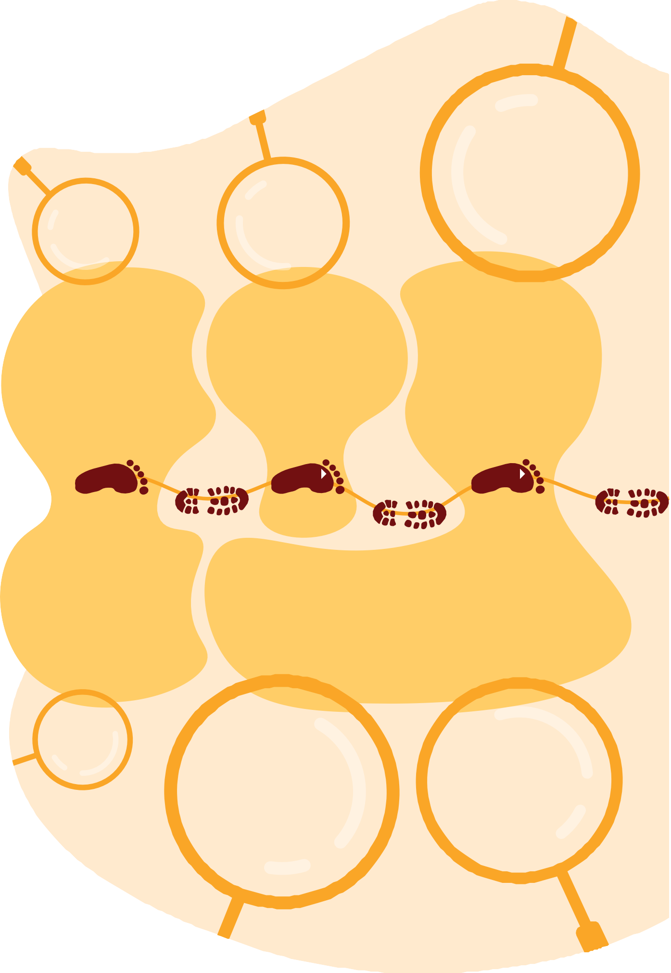

10

The conference
was held over 2 days; over 25 in attendance,
both virtually and in-person on Ngunnawal country. Evaluation feedback overall was a positive experience for attendees.
As of
2 September
2025, 11 suppliers have been engaged.
Spend increased to an expected $4,526,249.26 for the 2024-25 Financial
Year.

750+
attendees

Hosted National Conference for First Nations employees
Brought staff together to share experiences, build networks and shape priorities.

Increased procurement through Supply Nation suppliers (2024‑25)
Directed more spend to First Nations businesses and partnerships.

Held National Reconciliation Week online panel
Shared stories and perspectives to grow understanding and respect across DVA.

2022

2023

2024

June 2025

Established Aboriginal and Torres Strait Islander Peoples Diversity Committee
Created a formal voice to guide priorities and advise leadership.

Meeting minutes that record
participation.

Created Yarning Circle rooms in DVA offices
Provided culturally safe spaces for yarning, reflection
and connection.

Yarning Circle rooms have
been introduced in the Brisbane and Adelaide offices.

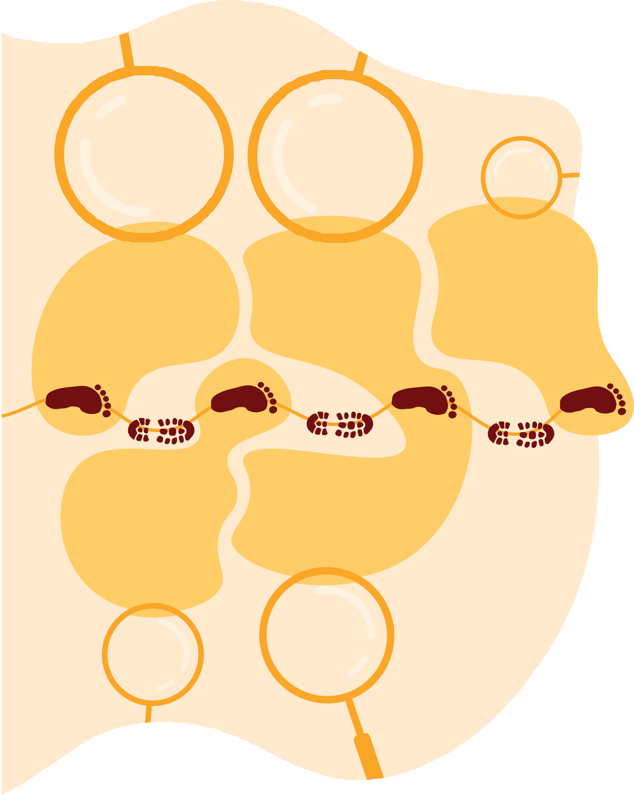

11

DVA’s Galumbany Reconciliation Action Plan Working Group
Galumbany is from the Ngunnawal language meaning ‘me, you, we, together’.
The Galumbany Reconciliation Action Plan Working Group (Working Group) has been responsible for overseeing the development of our second Innovate RAP. The Working Group created a RAP which was specific and unique to DVA and the broader veteran community it represents.
All members of the Working Group are action-oriented and shared a genuine interest in contributing to better outcomes for First Nations Peoples. The Working Group was representative of all DVA business areas, and the broader Australian society and its diversity. Nine members of the Working Group identified as a First Nations person.
The Working Group also consulted with the Nganana Network, the department’s First Nations staff network, in the development and design of this RAP.
We acknowledge the contributions of all Working Group members, some who have left DVA during the development of this RAP.

2 Department of Veterans’ Affairs - Innovate Reconciliation Action Plan

Working Group Membership

Title | Section | Branch
Assistant Secretary |  | Integrity, Information & Security
Director |  | Legislation Improvement Taskforce
Director | Employment Policy | People Services
Director | Research Services | Privacy Assurance
Director | Culture, Strategy & Planning | People Services
Assistant Director | Diversity & Inclusion | People Services
Senior Clinical Programs Officer | Clinical Policy | Clinical Operations
Apprentice | Compensation Offsetting Liability Support | VEA Compensation & Support
Complex Case Manager | Clinical Family Support Program | Clinical Governance & Programs
Veterans Contact Officer | Veterans and Veterans’ Families Counselling Service | Coordinated Client Support
Rehabilitation Delegate | Rehabilitation Services | Rehabilitation and Families
Complex Case Manager | Clinical Triage and Connect - Escalations | Coordinated Client Support
First Assistant Secretary |  | Veteran Experience & Transition
Apprentice | Permanent Impairment | Compensation Processing and Payments
Practice Manager | Finance & Practice Management | Legal & Audit
Senior HR Advisor | HR Connect | People Services
Policy Officer | Mental and Social Health Policy | Wellbeing Policy
Assistant Director | Strategic Communication Section | Communications
Senior HR Advisor | Diversity and Inclusion | People Services
Graduate | Graduate Program Team | People Services
Community and Engagement Officer | Mental Health and Wellbeing Services
Assistant Director | ICT Strategy & Design | Digital Strategy & Design
Veterans Operational Support | Veterans Access and Rehabilitation | Rehabilitation and Families

DVA’s Galumbany Reconciliation Action Plan Working Group 13

Spotlight and Case Studies

Spotlight on Voice and Connection:
First Nations Network and Committee
The Aboriginal and Torres Strait Islander Network is a peer community for First Nations employees,
creating space to connect, yarn, mentor and share culture. The Aboriginal and Torres Strait Islander Peoples Diversity Committee is our formal advisory group that partners with leaders to shape priorities, strengthen policies and programs, and champion cultural safety across DVA.
Together, the Network and Committee amplify First Nations voices, build respectful relationships and turn ideas into action.
Highlights (since inception)
- Brought First Nations employees together through a national conference and regular yarning opportunities.
- Helped deliver practical initiatives (e.g., cultural safety activities, mentoring, inclusive recruitment and Supply Nation partnerships).
- Shared stories and insight across DVA, including a highly engaging Reconciliation Week panel.

Case Studies

Success of our Entry Level Pathways Participants
DVA participates in both the Indigenous Apprenticeship Program (IAP), in partnership with Services Australia, and the Graduate Development Program run by the Australian Public Service Commission.
We have supported 45 IAP participants since 2015, with 37 of those employees remaining with the department.

My name is Riley I am a proud Bundjalung man. Originally from Brisbane, I moved to Canberra when I started with the Department of Veterans’ Affairs in 2019. I successfully applied for the 2019 Graduate Development Program through the First Nations Careers Graduate pathway. I am privileged to be a founding member of the Nganana First Nations Employees Network, which was founded in 2019. I have had several fantastic opportunities throughout my time at DVA, including working in the Mental and Social Health Programs Branch and supporting the Department’s response to the Royal Commission into Defence and Veteran Suicide.
I have a background in psychology and mental health, which lends itself well to my current position in Open Arms – Veterans & Families Counselling. I am currently co-chair of the Nganana First Nations Employees Network and am pleased to see the growing community of First Nations employees within the Department.
Riley
Clinical Governance and Programs Directorate
Open Arms – Veterans & Families Counselling Division

14 Department of Veterans’ Affairs - Innovate Reconciliation Action Plan

I began my journey with the DVA in 2017 as an APS3 through the Indigenous Apprenticeship Program (IAP) within the Brisbane Veterans’ Access Network (VAN). After completing a Diploma of Government, I secured a permanent APS4 role in the VAN, which provided a solid foundation for my career at DVA.
I later transitioned to the executive area, where I supported various SES as an Executive Assistant. These roles significantly enhanced my organisational skills and deepened my experience in stakeholder engagement.
Since 2022, I have stepped into various acting APS6 roles, where I have supported high-level operations, drove process improvements and leveraged my skills in strategic coordination and stakeholder engagement, contributing to initiatives that honour and support our veterans.
Throughout my career at DVA, I have been fortunate to receive steadfast support from my managers, who have offered invaluable mentorship and guidance. The Department has presented me with numerous growth opportunities, including external training, participation in mentoring programs, and accommodating my university studies.
I am immensely grateful for supportive entry-level pathways like the IAP, which demonstrate DVA’s commitment to advancing reconciliation and fostering an inclusive workplace. As a First Nations woman, I am passionate about serving my community and deeply appreciate DVA’s dedication to reconciliation and inclusivity. I am proud to be part of a Department committed to meaningful action and look forward to furthering my career within DVA.
Brittnee
Business Reform and Operations, Veterans Programs Program Delivery Division

I joined DVA as an APS3 through the First Nations Apprenticeship Program. I successfully completed a Diploma in Government before moving into an APS4 role at the end of the program. Working across the Safety, Rehabilitation and Compensation (Defence-related Claims) and Military Rehabilitation and Compensation Permanent Impairment teams I honed my caseload management, attention to detail and investigative skills to become an accredited Delegate.
Soon after I moved into the Incapacity Payments team, where I worked collaboratively with the processing and management teams to develop operational materials and support employees through a large-scale change process.
Currently I serve as a Quality Assurance Officer and am driven by high service delivery standards and a specialist team focused on continual improvement. This role has allowed me to develop an understanding of both core and specialist business operations, all while making significant
contributions to the ongoing improvement of existing resources and procedures. I’m also involved heavily in the training of new employees and enjoy the ongoing mentoring and coaching I can provide to support the success of our team.
All my roles over the course of the program were incredible, with such a variety of experiences, learning and growth. I’ve enjoyed getting to connect, work and collaborate with many different teams, all within the span of one year. It’s been amazing. I’m looking forward to the endless opportunities that the future holds with DVA, and to continue supporting veterans and
their families.
Corey
Housing Programs

DVA’s Galumbany Reconciliation Action Plan Working Group 15

Relationships Pillar
DVA is committed to supporting those who serve or have served in the defence of our nation and commemorate their service and sacrifice.
DVA will actively establish and maintain mutually beneficial relationships with First Nations stakeholders and organisations to enable the department to provide improved services and support to our First Nations Veterans, and their families.
DVA will promote reconciliation through our sphere of influence and strengthen employee awareness of the importance of positive race relations and incorporate this focus into our policies and initiatives.
**refers to a Reconciliation Australia mandatory action.
Action | Deliverable | Timeline | Responsibility
1. Establish and maintain mutually beneficial relationships with First Nations stakeholders and  organisations. | a. Promote our Indigenous Veterans Strategy within First Nations communities to build awareness of the services and programs. | June 2026 | Lead  National Indigenous Liaison Officer
 | b. **Meet with local First Nations stakeholders and organisations to develop guiding principles for future engagement with our DVA clients. | October 2026 | Lead  National First Nations Liaison Officer
 | c. **Develop and implement an engagement plan to work with First Nations veterans and families. | May 2026 | Lead  Business Support Director, Program Delivery Branch
 | d. Develop a resource that links business areas with organisations and resources to assist them to develop relationships with First Nations peoples, organisations, and businesses relevant to their work. | June 2026 | Lead  Director, Procurement

16 Department of Veterans’ Affairs - Innovate Reconciliation Action Plan

Relationships Pillar
2. Build  relationships through celebrating National Reconciliation Week (NRW). | a. **Circulate Reconciliation Australia’s NRW resources and reconciliation materials  to DVA employees and utilise in internal communications. | May 2026–2027 | Lead  Director, Culture, Strategy and Planning
 | b. **Support Galumbany RAP Working Group (RAPWG) members to participate in external NRW events. | May 2026–2027 | Lead Galumbany RAPWG Chair
 | c. **Encourage and support employees, managers and senior leaders to participate in at least one external event to recognise and celebrate NRW. | May 2026–2027 | Lead  First Nations SES Champion
 | d. **Organise at least one NRW event each year for DVA staff to attend. | May 2026–2027 | Lead  Director, Culture, Strategy and Planning
 | e. **Register all our NRW events on Reconciliation Australia’s NRW website. | May 2026–2027 | Lead  Director, Culture, Strategy and Planning
3. Promote reconciliation through our sphere of influence. | a. **Develop and implement an employee reconciliation engagement strategy to raise awareness across our workforce. | March 2026 | Lead  Director, Culture, Strategy and Planning
3. Promote reconciliation through our sphere of influence. | b. Develop a ‘First Steps to Reconciliation’ product that will outline how employees can contribute to our reconciliation journey. | February 2027 | Lead  Director, Culture, Strategy and Planning
3. Promote reconciliation through our sphere of influence. | c. Collaborate with other APS RAP Working Groups to develop innovative approaches to advance reconciliation. | February 2027 | Lead  Galumbany RAPWG members
3. Promote reconciliation through our sphere of influence. | d. Consult with Ex-Service Organisations (ESOs) that have sub- groups/networks of First Nations  members to promote our client services. | February 2027 | Lead  National First Nations Liaison Officer
4. Equip staff to act as everyday allies. | a. Develop and release a plain-language Allyship Toolkit (5–7 everyday actions, do’s/don’ts, meeting tips), co-created with First Nations staff. | February 2027 | Lead  Director, Culture, Strategy and Planning
4. Equip staff to act as everyday allies. | b. Deliver an ‘Allyship in action’ briefing for all people managers, with a simple follow-up practice sheet. | February 2027 | Lead  Director, Culture, Strategy and Planning

DVA’s Galumbany Reconciliation Action Plan Working Group 17

Relationships Pillar
5. Promote positive race relations through anti- discrimination strategies. | a. **Conduct a review of HR policies and procedures to identify existing anti-discrimination provisions, and future needs. | May 2027 | Lead  Director, Workplace Relations and Policy
 | b. Provide training to managers on First Nations cultures, ensuring communication is targeted at staff supervising First Nations employees. | May 2027 | Lead  Director, Learning and Development
 | c. **Develop and implement a DVA anti-discrimination policy. | May 2027 | Lead  Director, Conduct and Performance
 | d. **Engage with First Nations employees to inform our anti-discrimination policy. | May 2027 | Lead  Director, Workplace Relations and Policy
 | e. **Educate senior leaders in DVA on the effects of racism. | May 2027 | Lead  Director, Learning and Development

18 Department of Veterans’ Affairs - Innovate Reconciliation Action Plan

Respect Pillar
DVA recognises that respect for First Nations Peoples and recognition of their wisdom and ancient knowledge systems is central to reconciliation.
DVA recognises the importance of truth-telling and actively listening to the voices of First Nations Peoples, committing to deepen our understanding of historical and contemporary experiences to ensure that First Nations veterans, families, and employees have access to a culturally safe and supportive environment.
DVA will implement genuine actions based on respect, care and connection by listening to those with lived experience.
**refers to a Reconciliation Australia mandatory action.
Action | Deliverable | Timeline | Responsibility
6. Increase understanding, value and recognition of First Nations cultures, histories, knowledge and rights through cultural learning. | a. **Conduct a review of cultural learning needs within our organisation to identify new opportunities. | December 2026 | Lead  Director, Culture, Strategy and Planning
 | b. **Consult First Nations employees to inform our cultural learning strategy and ensure its appropriateness. | December 2026 | Lead  Director, Culture, Strategy and Planning
 | c. **Develop and implement a cultural learning strategy to increase cultural capability within the department. | February 2027 | Collaboration Galumbany RAPWG & Director, Culture, Strategy and Planning
 | d. **Provide opportunities for RAPWG members, HR managers and other key leadership employees to participate in formal and structured cultural learning. | May 2026 | Lead  Director, Culture, Strategy and Planning
 | e. Continue to participate in the APSC Jawun program, an immersive cultural learning experience. | April 2026  April 2027 | Lead  Director, Culture, Strategy and Planning
 | f. Continue participation in the Garma Festival for at least 2 employees annually. | August 2026  August 2027 | Lead  Director, Culture, Strategy and Planning

DVA’s Galumbany Reconciliation Action Plan Working Group 19

Respect Pillar
7. Demonstrate respect to First Nations Peoples by observing cultural protocols. | a. Update DVA’s online office directory to acknowledge the traditional lands in which each office is located. | March 2026 | Lead  Director, Culture, Strategy and Planning
 | b. **Develop and implement a DVA Cultural Protocols Guide for both employees and DVA clients. | November 2026 | Lead  Director, Culture, Strategy and Planning
 | c. Promote the DVA Cultural Protocols guide to educate employees and embed culturally appropriate practices. | January 2027 | Lead  Director, Communications
 | d. **Continue to encourage Acknowledgement of Country at appropriate meetings and forums. | November 2026 | Lead  Director, Culture, Strategy and Planning
 | e. **Continue to educate  and support employees of the purpose and significance behind cultural protocols, including Acknowledgement of Country and Welcome to Country. | February 2026 onwards | Lead  Director, Culture, Strategy and Planning
 | f. Display authentic First Nations artwork with appropriate acknowledgement of artists and related narrative. | November 2026 | Lead  Director, Culture, Strategy and Planning
8. Build respect for First Nations cultures and histories by celebrating NAIDOC Week. | a. **RAPWG to participate in an external NAIDOC Week event. | July 2026  July 2027 | Lead  Galumbany RAPWG members
 | b. **Review HR policies and procedures to remove barriers for employees to participate in NAIDOC Week. | April 2026 | Lead  Director, Workplace Relations and Policy
 | c. Deliver events where cultural experiences, histories, and truth-telling are shared with employees. | July 2026  July 2027 | Lead  Director, Culture, Strategy and Planning
 | d. **Encourage all employees to participate in NAIDOC Week through promoting events via internal communications. | July 2026  July 2027 | Lead  Director, Culture, Strategy and Planning

20 Department of Veterans’ Affairs - Innovate Reconciliation Action Plan

Opportunities Pillar
DVA has long worked with First Nations Peoples as colleagues, providers of support, and as current and former members of the Australian Defence Force. We continue to focus on educating and promoting the First Nations veteran communities’ knowledge and understanding of DVA services, benefits and entitlements through our First Nations Veterans’ Strategy.
DVA aims to provide culturally appropriate services to First Nations veterans, honour their contributions to Australia’s defence, and enhance cultural awareness among its employees. We are committed to boosting First Nations workforce participation through programs to recruit and retain First Nations employees.
We have also grown our procurement through Supply Nation-accredited companies and will continue to increase procurement from First Nations-owned businesses.
**refers to a Reconciliation Australia mandatory action.
Action | Deliverable | Timeline | Responsibility
9. Improve employment outcomes by increasing First Nations recruitment, retention, and professional development. | a. **Build understanding of current First Nations employees to inform future employment and professional development opportunities. | June 2026 | Lead  Director, Learning and Development
 | b. **Review and update DVA’s Gurru Ngali Aboriginal and Torres Strait Islander Employment Strategy. | December 2026 | Lead  Director, Culture, Strategy and Planning
 | c. **Engage with First Nations employees to consult on our recruitment, retention and professional development strategy. | August 2026 | Lead Director, HR Operations  Director, Learning and Development, & Director, Culture,  Strategy and Planning
 | d. Develop a Cultural Leave Policy and promote to people leaders. | February 2026 | Lead  Director, Workplace Relations and Policy
 | e. **Continue to apply our Affirmative Measures – Indigenous recruitment processes to support attraction and recruitment of First Nations candidates. | July 2026 | Lead Director, HR Operations
 | f. Review HR and recruitment procedures and policies to remove barriers to First Nations workforce participation. | February 2027 | Lead Director, HR Operations
 | g. Review the Indigenous Veteran Liaison Officer position description to ensure its is well situated to engage with and support First Nations veterans and their families. | July 2026 | Lead  Director, Culture, Strategy and Planning  National Indigenous Veteran Liaison Officer
 | h. Continue to consider the SES 100 Indigenous merit pool to fill vacancies in senior leadership positions. | November 2025 –  November 2027 | Lead  Director, SES Unit

DVA’s Galumbany Reconciliation Action Plan Working Group 21

Opportunities Pillar
10. Increase  First Nations supplier diversity  to support improved economic and social outcomes. | a. **Develop and implement a DVA First Nations procurement strategy. | February 2027 | Lead Director, Procurement
 | b. Participate in the Supply Nation Jumpstart Program and promote opportunities across the organisation. | July 2026 | Lead Director, Procurement
 | c. Review and update  procurement practices to remove barriers to procuring goods  and services from First Nations  businesses. | July 2026 | Lead Director, Procurement
 | d. **Explore opportunities for commercial relationships with First Nations businesses and promote across organisations. | July 2026 | Lead Director, Procurement

Governance
**refers to a Reconciliation Australia mandatory action.
Action | Deliverable | Timeline | Responsibility
11. Establish and maintain an effective  RAPWG to drive governance of the RAP. | a. **Maintain First Nations representation on the RAPWG. | Quarterly 2026–2027 | Lead  Galumbany RAPWG Chair
 | b. Invite Nganana Network Chair/s to the RAPWG to regularly report RAP progress. | Quarterly 2026–2027 | Lead  Galumbany RAPWG Secretariat
 | c. **Maintain and apply terms of reference for the RAPWG. | February 2026  February 2027 | Lead  Galumbany RAPWG Chair
 | d. **Meet quarterly to drive and monitor RAP implementation. | February, May, August and November 2026–2027 | Lead  Galumbany RAPWG Chair

22 Department of Veterans’ Affairs - Innovate Reconciliation Action Plan

Governance
**refers to a Reconciliation Australia mandatory action.
12. Provide  appropriate support for effective implementation of RAP commitments. | a. **Define resource needs for RAP implementation. | February 2026 | Lead  Director, Culture, Strategy and Planning
 | b. **Engage our senior leaders, managers and employees in the delivery of RAP commitments. | From November 2025 | Lead  Galumbany RAPWG Chair
 | c. Engage with DVA’s governance committees to report RAP progress. | November 2026  November 2027 | Lead Galumbany RAPWG Chair, & Director, Culture, Strategy and Planning
 | d. **Maintain an internal RAP Champion from the senior leadership cohort. | March 2027 | Lead  Director, Culture, Strategy and Planning
 | e. **Implement an appropriate reporting system to track, measure and report on RAP Commitments. | September 2027 | Lead  Galumbany RAPWG Chair
13. Build  accountability and transparency through reporting RAP achievements, challenges and learnings both internally and externally. | a. **Complete and submit the annual RAP Impact Survey to Reconciliation Australia. | 30 September  2026  30 September  2027 | Lead  Director, Culture, Strategy and Planning
 | b. **Promote RAP achievements in DVA’s Annual Report. | August 2026  August 2027 | Collaboration Galumbany RAPWG Secretariat
 | c. **Participate in Reconciliation Australia’s biennial Workplace RAP Barometer. | November 2026 | Lead  Director, Culture, Strategy and Planning
 | d. **Report to Reconciliation Australia at the conclusion of this RAP on its measure of success. | November 2026 | Lead  Director, Culture, Strategy and Planning
14. Continue our reconciliation journey by developing our next RAP. | Continue participation in the RAP program to advance to a stretch RAP. | June 2027 | Lead  Director, Culture, Strategy and Planning

DVA’s Galumbany Reconciliation Action Plan Working Group 23

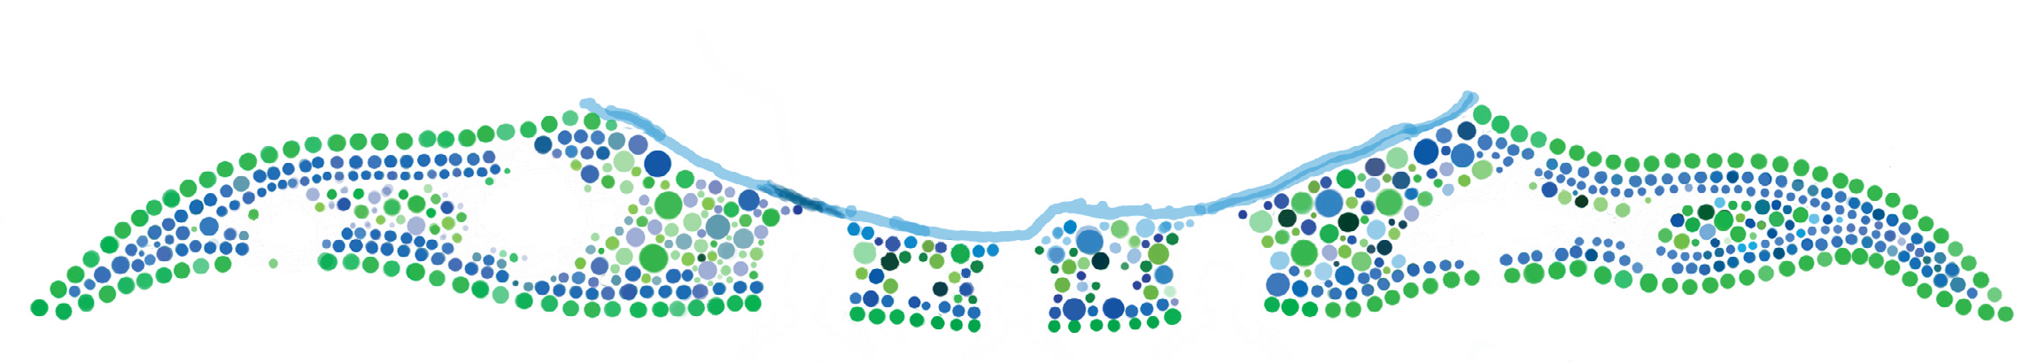


Contact details

If you have any questions about our Innovate Reconciliation Action Plan, please email our Diversity and Inclusion team at diversity@dva.gov.au.

