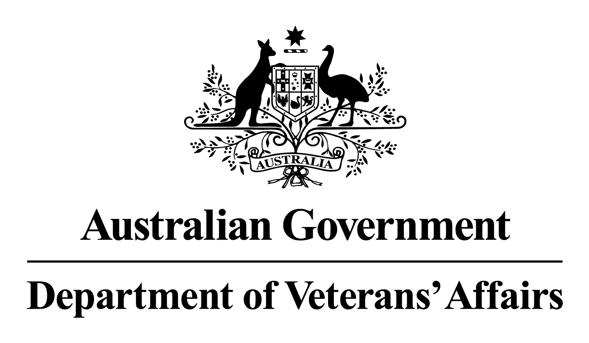

Deputy Commissioners Consultative forum – Tasmania
Meeting Minutes

13 August 2025
Attendees
Name | Organisation
Sally Dennington | Deputy Commissioner Tasmania
Kate Morris | Executive Officer
Tim Hancock | RSL Tasmania
Sandie Wilson | Mates4Mates
Garry Beven | Advocacy Training and Development Program
Kevin Evorall | Legacy Launceston
LTCOL Neil Grierson | Senior Australian Defence Force Officer
Brian Harper | Vietnam Veterans Association Australia – Tas
Don Ryan | Veterans Reference Group
David Waddle | Hobart Legacy
Jenny Robertson | RAAF-Association

Apologies
Name | Organisation
Melissa Foale | Women’s Veteran Network Australia - Tasmania
Brian Ellis | Naval Association Australia
Ray Williams OAM | Totally & Permanently Incapacitation Association
Karelle Logan | Department of Premier and Cabinet

Meeting commenced at 1400

Business arising:
Apologies noted.

Agenda items submitted:

NIL

Bernice Kain - Assistant Director – Residential Aged Care

Presented on residential aged care. Presentation will be emailed to DCCF member after the meeting for future reference.

Deputy Commissioner update:

Gwen Cherne has finished her appointment as the Veteran Family Advocate Commissioner, and the appointment of Annabelle Wilson as her replacement.

Dr Steph Davis as the new DVA Chief Health Officer.

There should be an announcement of the new Director for Office of Australian War Graves (OAWG) in the next few months.

The works have commenced at the Launceston OAWG’s depo, this will have no impact on visitors to the site. The Garden of Remembrance works have not yet started in Hobart, OAWG’s will engage with stakeholders prior to the commencement of works.

Attendee update:

Open Arms (OA):

The new OA office in Hobart will be open to clients on the 8th September 2025. An early DCCF end of year function will be held in November to showcase the space.

Senior Australian Defence Force Officer (SADFO):

BAU. The Fearless Festival is being held in Hobart this week with MAJGEN Natasha Fox attending.

Advocacy:

The MyOrg system is displaying some issues and not working as it should. Feedback on these issues will be provided to the Deputy Commissioner to follow up on.

Veterans Reference Group (VRG):

The new state Veterans’ Affairs Minister has been announced as Gavin Pearce. The VRG are currently reviewing the terms of reference for their group. The state Veterans’ Wellbeing Vouchers are available, including to spouses and families of Veterans.

Returned Services League:

RSL Tasmania will be holding opening events at their Hobart and Launceston hubs.

Royal Australian Air Force Association (RAAFA):

The RAAFA are holding commemorative drinks for the 80th Anniversary of the end of World War II at the end of the months. RAAFA is also ramping up for the Battle of Britian commemorations next month.

Meeting closed at 1545

Next meeting 14 November 2025, 1400

