GUIDELINES

FOR

ASSESSING HEALTH PROVIDERS

for the supply of

MEDICAL GRADE FOOTWEAR

Table of Contents
1 Introduction 1
2 Eligibility 1
3 Medical Grade Footwear Program 1
3.1 Program Aim 1
3.2 Definition of MGF 1
3.3 Ready made depth/width MGF 1
3.4 Custom Made MGF 1
3.5 Technical Criteria 2
4 Prescribing Medical Grade Footwear 2
4.1 Who are assessors for MGF? 2
4.2 Clinical Justification 2
4.3 MGF Prescription Forms D0688 3
4.4 Clinical Pathway for Footwear Assessment 3
4.4.1 Stock footwear: 3
4.4.2 Corrective insoles or adjunct therapies: 3
4.4.3 Modifications to stock footwear: 4
4.4.4. Ready made MGF: 4
4.4.5 Custom MGF: 4
4.5 Footwear Prescription 5
4.5.1 No history of MGF 5
4.5.2 History of DVA MGF 6
4.5.3 MGF Request Details 6
5 Number and frequency of MGF supply 7
5.1 How many shoes can be provided? 7
5.2 Condemning and Replacing Footwear 7
5.3 Repairs and Modification 7
6 Supply of Medical Grade Footwear 7
6.1 Suppliers 7
6.2 Warranties 8
7 Stock Footwear 8
7.1 Supply of Stock Footwear 8
7.2 Modifications to stock footwear 8
8 Complex Cases and Issues Regarding MGF 8
9 Acquittals 8
10 Home Visits by Suppliers 9
11 Transport 9
12 Assessing Health Provider Responsibilities 9
13 Contacts for MGF enquiries 9

Introduction
These guidelines are provided to assist assessing health providers of Medical Grade Footwear (MGF) to gain a better understanding of the Department of Veterans’ Affairs (DVA) requirements relating to prescribing and supplying MGF items.

Eligibility
Eligibility for MGF is determined by assessed clinical need.

Gold Card Holders are eligible for a full range of treatment including footwear where a foot deformity prevents the fitting of suitable stock or modified stock footwear.

White Card Holders are eligible for MGF when the accepted disability relates to being unable to fit into suitable stock or modified stock footwear.

Note: White Card holders require prior approval before podiatry and footwear treatment.

Information is available for viewing and downloading on DVA’s website via: http://www.dva.gov.au/about-dva/dva-factsheets

Medical Grade Footwear Program

Program Aim
The MGF program aims to provide MGF and related services, including modifications and repairs, that are of a high standard and clinically appropriate for the individual entitled person’s assessed needs.

Definition of MGF
Footwear clinically prescribed to accommodate and/or correct abnormal foot and/or ankle structure or significant deformity.

MGF may be prescribed when readily available suitable everyday footwear cannot be used or modified for this purpose.

Ready made depth/width MGF
Footwear that has specific features of extra depth and/or extra width added to the shoe last so the completed shoe can accommodate foot abnormalities. This footwear is listed on the MGF Register http://www.dva.gov.au/providers/provider-programs/rehabilitation-appliances-program-rap#medical-grade. Its acceptance on the MGF Register is determined by DVA according to specific technical criteria.

Custom made MGF
Footwear that is manufactured to individual specifications. Custom MGF is made from lasts or casts built to replicate and accommodate abnormal foot/ankle structure or gross deformities of the feet. Custom MGF is provided where ready made MGF cannot accommodate these conditions.

Technical Criteria
Detailed MGF specifications are provided for MGF contractors. Assessing health providers should manage any issues with regards to quality, fitting and function of MGF supplied.

Overall, MGF should have leather uppers free from marks and blemishes, uniform in colour and grain appearance. All components should be free of permanent wrinkles or creases. The design should allow for easy donning and doffing. The shoe should be lace-up, velcro or buckle closure. The quality and thickness of materials used for soles, uppers, linings and torsional stability should be such that normal wear would not adversely reduce the life of the shoe within twelve months.

Everyday footwear and styles which do not fit the criteria for MGF are not accepted by DVA. For example the MGF program precludes the provision of sports type shoes (e.g. dual density sole), slip-on style shoes, slippers and ‘orthopaedic’ sandals/shoes with moulded foot beds because they cannot by their nature meet MGF specifications.

Prescribing Medical Grade Footwear
MGF can be prescribed when:
- appropriate treatment and other therapies have been tried and failed;
- where appropriate, shoe modifications to the entitled person’s own footwear have been tried and failed; and
- there is significant clinical need and the deformity or condition cannot be managed without the use of ready made or custom MGF.

Who are assessors for MGF?
The contractor is to ensure that prescriptions for MGF (DVA form D0688) have been completed by an approved health provider.

Approved assessing health providers for MGF are:
- Podiatrist; or
- Medical Specialist i.e. Vascular Surgeon, Orthopaedic Surgeon, Rehabilitation Specialist, Rheumatologist.

The majority of prescriptions for MGF will originate from podiatrists.

DVA views assessing health providers as MGF Case Managers and rely on their professional clinical expertise to ensure the MGF Program is effective in its purpose and operation.

Clinical Justification
All MGF is supplied on the primary criteria that there exists sufficient clinical justification for MGF. Clinical pathology including deformities and conditions should be listed on the prescription, outlining the problems accommodating these within stock footwear. There should also be reference to adjunct therapies, alternative shoes and/or shoe modifications tried.

MGF Prescription Forms D0688

Prescriptions for MGF must be in writing on the D0688 form. All prescriptions must include the following information about an entitled person to ensure the MGF supplier understands the entitled person’s medical history and to allow the MGF supplier to claim payment from DVA:
- Name and DVA file number of the entitled person (as shown on the DVA Health Card);
- The treatment entitlement of the person, i.e. Gold Card or White Card (include accepted conditions, if known, for White Card);
- Name and provider number of the assessing health provider;
- Date of the prescription;
- Entitled person’s clinical details (including recent illnesses, injuries and current medication, if applicable); and
- Entitled person’s footwear history

Upon completion this form is to be issued to the entitled person with the details of the preferred contracted supplier to make an appointment for fitting of MGF. Alternatively the assessing health provider can send the form to the preferred contracted supplier who will then contact the entitled person for a fitting appointment.

The prescription forms D0688 are available on the DVA website in pdf format. For downloading go to: http://www.dva.gov.au/providers/forms-service-providers.

Clinical Pathway for Footwear Assessment
Before prescribing MGF please follow the clinical pathway to determine appropriate management.

When assessing entitled persons for appropriate interventions to assist in or maintain their health and mobility, lower limb management should be considered in the following order, as clinically appropriate.

4.4.1 Stock footwear:
Entitled persons should purchase supportive, well-fitting and appropriate footwear. Health providers should be available to provide advice and education on the most suitable footwear for an individual’s needs.

4.4.2 Corrective insoles or adjunct therapies:
Health providers should consider any appropriate additional therapies which may improve the fitting and comfort of stock footwear prior to prescribing MGF. These could include customised ankle, foot and digital devices to re-align and support foot structures or padding to reduce and redistribute excessive forces. Where indicated consultation with the medical practitioner regarding drug therapy, complex care needs and alternative allied health practitioner therapies should be undertaken.

4.4.3 Modifications to stock footwear:
Stock footwear can also be modified upon prescription to aid in accommodating foot abnormalities and assist in better function prior to the consideration and prescription of MGF. This applies to entitled persons who do not meet the criteria for MGF but clinically require modifications to their own suitable self purchased footwear.

4.4.4. Ready made MGF:
Where the preceding interventions cannot accommodate a foot/ankle abnormality or deformity, then ready made MGF should be the next consideration. Primarily this footwear has added depth to the lasts and is available in up to three width fittings.

4.4.5 Custom MGF:
When no other clinically suitable option remains then custom made footwear should be considered. This MGF is constructed from an individual specific shoe last and pattern made by the footwear supplier.

Footwear Prescription
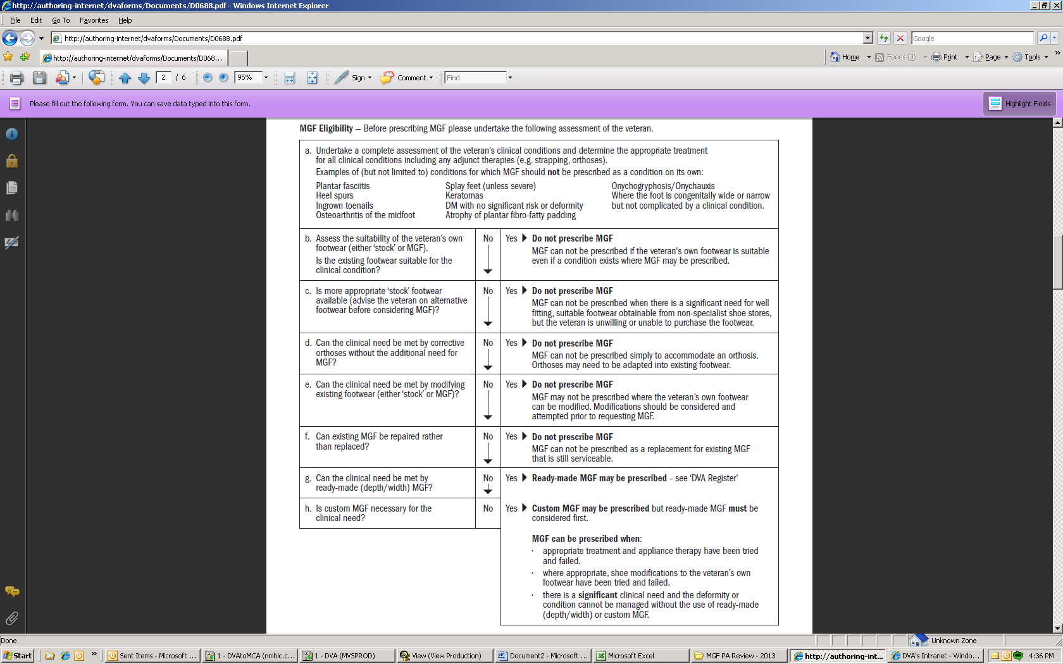Figure 1: Flow chart of clinical pathway for the prescription of Medical Grade Footwear

Prior to prescribing MGF it should be ascertained whether MGF has been supplied by DVA previously. Should the entitled person be unable to confirm previous supply then the assessing health provider should contact DVA for any MGF history (See Section 13) and include this on the prescription form.

4.5.1 No history of MGF
When no previous MGF has been supplied, assessing health providers should undertake a thorough assessment of current stock footwear and ascertain if there are alternative stock footwear which would be suitable for the entitled person. Where this is the case the entitled person should be encouraged to purchase more appropriate footwear on the advice of the assessing health provider. When stock footwear with or without modifications is not suitable then MGF can be prescribed.

4.5.2 History of DVA MGF
As there are limitations on the number of MGF to be in use at any one time it is paramount that the assessing health provider clarifies what MGF has been issued and when. This is so that over-supply does not occur and previous MGF that have been condemned have been discarded (refer to 5.2 Condemning and Replacing Footwear). Assessing health providers are required to keep records of footwear prescriptions and details of footwear supplied to assist in accounting for MGF issued to entitled persons.

The assessing health provider should outline:
1. Previous footwear and how it has accommodated the foot, been tolerated and worn.
2. A description of any existing MGF that is to be condemned.

This is valuable information to assist the footwear supplier in selecting the most appropriate MGF.

There is an expectation that health providers prescribing MGF keep abreast of the types of footwear available on the DVA MGF Register and any changes occurring within the industry. In addition, MGF suppliers and DVA Podiatry Advisers should be contacted for discussion and case conferencing on more difficult or complex cases. This should ensure efficient use of time and resources to adequately meet the needs of entitled persons.

4.5.3 MGF Request Details
The assessing health provider should state clearly the shoe features required in the MGF being requested e.g. contour last, high toebox, extended heel counter, rocker sole, velcro closures. This is preferable to requesting a specific style of shoe – unless it has been supplied previously and its suitability been proven.

A description of any in-shoe devices or outsole modifications to be accommodated by the new shoe should also be included.

MGF is not provided if the provision is for:
- sports type shoes;
- inappropriate styles e.g. slippers, slip-on style shoes, open heeled sandals/shoes; and
- accommodating orthoses only (Additional clinical need e.g. significant foot deformity or abnormal pathology must exist for MGF to be provided).

Number and frequency of MGF supply

How many shoes can be provided?
Up to 2 pairs of day/dress shoes can be provided at any one time from DVA. Existing MGF should only be replaced when it is no longer repairable, serviceable, or an entitled person’s clinical condition changes and different MGF is therefore required.

DVA may provide one additional pair of recreational MGF (i.e. bowling or golf shoes) if the entitled person is a current and active member of a registered sporting club. Recreational MGF requires prior approval. A letter from the club is required and must state both financial and playing status. MGF recreational footwear will only be supplied if the sporting club requires specific soled footwear and the entitled person has been previously supplied with MGF. Separate approvals are required for each supply.

Condemning and Replacing Footwear
When an entitled person has been issued with the maximum number of MGF, at least one previous MGF issue must be condemned prior to a replacement pair being requested. “Condemned” footwear is MGF that is deemed irrepairable or unsuitable for the foot condition. Frequency of supply is based on the condition of the MGF (its wear and tear) or change in foot structure requiring change in prescription. It is imperative that condemned MGF should not be worn as they were deemed no longer supportive and unsafe to wear. Thus for safety reasons the MGF being condemned should be removed from the possession of the entitled person and the brand, style, colour etc be recorded for verification purposes.

5.3 Repairs and Modification
Repairs and modifications to MGF should be requested on the prescription form. They can be done by the original MGF supplier or a general shoe repairer if the footwear is out of warranty. Repairs outside of the warranty period may be claimed directly by MGF suppliers from the Department of Human Services (DHS) according to the MGF Schedule of Fees.

Supply of Medical Grade Footwear

Suppliers
DVA has contractual agreements with MGF suppliers. A list of contracted MGF suppliers is available for viewing and downloading on DVA’s website via:

http://www.dva.gov.au/providers/provider-programs/rehabilitation-appliances-program-rap#medical-grade.

MGF suppliers should work closely with assessing health providers to ensure effective assessment, prescription, selection and fitting of MGF.

After prescribing/requesting MGF from a MGF supplier the appropriate footwear should be issued to the entitled person within a reasonable timeframe taking into consideration where it is being sourced from, and any modifications that are required prior to issuing.

Warranties
New ready and custom made MGF have a 12 month warranty for workmanship, materials and fitting.

Repairs and modifications have a 3 month warranty.

Stock Footwear

Supply of Stock Footwear
Stock footwear can be prescribed and issued for a limb prosthesis e.g. an amputee. This is requested through the Rehabilitation Appliances Program (RAP). The prescription form D0992 is available for downloading on DVA’s website via:

http://www.dva.gov.au/dvaforms/Documents/D0992.pdf

The item for stock footwear is AJ07.

Also through RAP temporary footwear i.e. cast/wound care boots or shoes can be prescribed using item AJ06.

Modifications to stock footwear
Where an entitled person does not meet the criteria for MGF but clinically requires modifications to their own suitable self purchased footwear, the assessing health provider may refer them to a contracted supplier with a prescription outlining the clinical reason and type of modification required. The MGF prescription form should be completed detailing the clinical information for the modifications. Modifications can be made to three pairs of footwear per annum.

Complex Cases and Issues Regarding MGF
Complex cases should be managed jointly by the assessing health provider and MGF supplier to ensure timeliness of the process and cost-effectiveness of the service.

Where issues cannot be resolved between the entitled person, assessing health provider and supplier DVA should be contacted to seek input and advice from managers or podiatry advisers.

Acquittals
The acquittal process is a vital part in the MGF process. It provides accountability for the correct supply of DVA approved MGF and enables the assessing health provider to check the issued shoes for quality, fit and suitability. The acquittal maintains the warranty.

Acquittal of the newly supplied MGF should occur within a suitable timeframe from date of issue. Within one - two months of new MGF being supplied the assessing health provider should record on the entitled person’s case notes they have seen and acquitted the footwear.

Any problems identified at this stage are the responsibility of the assessing health provider to liaise with the MGF supplier to adequately resolve in a timely manner.

Home Visits by Suppliers
MGF suppliers should provide room locations to see entitled persons. Home visits by MGF suppliers must be requested by the assessing health provider for entitled persons with restricted mobility or who for medical reasons are confined to the home – i.e. where either the assessing health provider or the LMO themselves provide home visits for that entitled person.

Transport
Entitled persons who travel for approved medical treatment may be eligible for reimbursement for certain expenses incurred.

DVA Factsheet - HIP80 - Transport Information for Health Providers

Assessing Health Provider Responsibilities

KEY POINTS FOR ASSESSMENT AND PRESCRIPTION FOR MGF

- Conduct a thorough assessment in the first instance, to determine the existence of relevant clinical conditions/pathology to justify the provision of MGF.
- White Card Holders require prior approval before MGF is provided.
- Prescription for MGF exceeding two pairs at any one time requires prior approval.
- Provide all relevant information on the D0688 prescription and refer the entitled person to an appropriate MGF supplier.
- All new footwear must be fitted by the assessing health provider, ensuring that the MGF requested has been supplied.
- Complete an acquittal of the supplied MGF within a suitable timeframe from when the MGF is supplied.
- Assess and condemn previous issues of MGF as required in the course of the assessment for eligibility.
- Manage any issues with timeliness of supply, quality, fitting and function of the product and to notify DVA of ongoing issues that are not resolved in a timely manner with either the entitled person or MGF supplier who provided the footwear.

Contacts for MGF enquiries
To discuss issues relating to supply, quality of product, complex clinical cases please use the following DVA health provider enquiry numbers:
- 1300 550 457 (metropolitan areas)
- 1800 550 457 (non-metropolitan areas)
- Email: rap.mgf.requests@dva.gov.au

