Cooking for One or Two

Session 5: Healthy eating on a budget and safe food storage

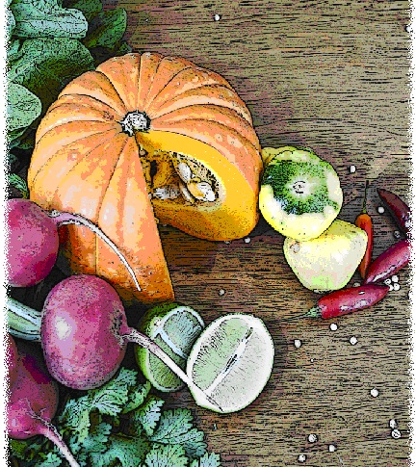

Contents
Objectives and overview 3
Session checklist 4
Ingredients list 5
Equipment 7
Room set up 9
Timeline 10
Introduction 11
Group agreement reminder 12
Discussion: Tips for eating on a budget 12
Discussion: Food temperatures and safety 13
Food preparation 15
Enjoy a meal together 15
Thank you and conclusion 15
Session clean up 16
Recipes 17

Objectives and overview
Session objectives
By the end of this session participants will have:
- Demonstrated an understanding of ways to eat healthy on a budget.
- Demonstrated an understanding of food safety and ways they can implement food safety in their home.
- Developed their food preparation skills.
- Enjoyed a meal with a group of new friends.

Session overview
Today’s discussion topics
- Healthy and economical ways to spend food dollars
- Safe freezing and defrosting
Today you will be cooking
- Pumpkin, potato and parsley soup
- Quiche with green salad
- Pear and sultana rice pudding

Session checklist
Facilitator |  |  | Assistant
Collect groceries using session shopping list |  |  | Assist with grocery shopping where required
Arrive approximately 45 minutes prior to the start of the session |  |  | Arrive approximately 30 minutes prior to the start of the session
Read first aid instructions |  |  | Help with set up of equipment
Set up cooking equipment |  |  | Help with set up of room
Set up room |  |  | Assist the facilitator following all instructions in blue
Print out evaluation sheets |  |  | Help with washing up/cleaning
Facilitate the program following all instructions in green
Wash up/cleaning

Ingredients list
tsp = teaspoon
tb = tablespoon
 | To serve 2 people | To serve 4 people | To serve 6 people | To serve 8 people
Cooking oil | 1 tsp | 2 tsps | 3 tsps | 4 tsps
Onion | 1½ | 3 | 4½ | 6
Garlic (fresh or dried) | 1 tsp | 2 tsps | 3 tsps | 4 tsps
Ginger | ½ tsp | 1 tsp | 1½ tsps | 2 tsp
Curry powder | ¼ tsp | ½ tsp | ¾ tsp | 1 tsp
Pumpkin | 150g | 300g | 450g | 600g
Potato | 1 | 2 | 3 | 4
Salt-reduced stock | 1 cup | 2 cups | 3 cups | 4 cups
Reduced- fat milk | 2¾ cups | 5½ cups | 8¼ cups | 11 cups
Parsley (fresh) | 1 tb | 2 tbs | 3 tbs | 4 tbs
Pepper | Pinch | Pinch | Pinch | Pinch
Reduced-fat natural yoghurt | 2 tbs | 4 tbs | 6 tbs | 8 tbs
Wholegrain bread roll | 2 | 4 | 6 | 8
Eggs | 2 | 4 | 6 | 8
Reduced-fat margarine | 1 tsp | 2 tsps | 3 tsps | 4 tsps
Wholemeal self-raising flour | 2 tbs | 4 tbs | 6 tbs | 8 tbs
Lean ham | 2 slices | 4 slices | 6 slices | 8 slices
Reduced-fat cheese | ⅔ cups | 1⅓ cups | 2 cups | 2⅔ cups
Frozen stir fry vegetables | ⅔ cups | 1⅓ cups | 2 cups | 2⅔ cups
Tomato | 1 | 2 | 3 | 4
Mixed green salad leaves | 1 cup | 2 cups | 3 cups | 4 cups
Sprouts | ½ cup | 1 cup | 1½ cups | 2 cups
Cucumber | ½ | 1 | 1½ | 2
Avocado | ½ | 1 | 1½ | 2
Seed mix | 1 tb | 2 tbs | 3 tbs | 4 tbs
Lemon juice | ½ tb | 1 tb | 1½ tbs | 2 tbs
Olive oil | ¼ cup | ½ cup | ¾ cup | 1 cup
Wholegrain mustard | 1 tsp | 2 tsps | 3 tsps | 4 tsps
Vanilla essence | 1 tsp | 2 tsps | 3 tsps | 4 tsps
Cinnamon | 1 tsp | 2 tsps | 3 tsps | 4 tsps
Honey | 1 tb | 2 tbs | 3 tbs | 4 tbs
Arborio rice | ½ cup | 1 cup | 1½ cups | 2 cups
Sultanas | 1 tb | 2 tbs | 3 tbs | 4 tbs
Brown sugar | 1 tsp | 2 tsps | 3 tsps | 4 tsps
Pear | 1 | 2 | 3 | 4

Equipment
For table one
3 cooks knives |  | Measuring cups
3 vegetable knives |  | Measuring spoons
Bread knife |  | Soup ladle
3 wooden spoons |  | Small, medium and large bowls
3 serving spoons |  | Colander
Vegetable peelers |  | Chopping boards
Spatula |  | Baking tray
Can opener |  | Cling wrap and baking paper
Pastry brush |  | Disposable gloves
Salad bowl |  | Vegetable masher
Whisk |  | Salad bowl
Salad servers
For table two
Place dry ingredients on table; amount dependent on number of people in the group
For Refrigerator
Place ingredients that need to remain cool in the refrigerator; amount dependent on number of people in the group
For table three
2x large saucepan |  | Oven Mitts
Heat proof mats |  | Extension cord (if necessary)
Electrical hotplates |  | Thermometer
For the kitchen and washing up area
Oven |  | Washing up liquid
Dish brush |  | Pot scrub
Dish cloths |  | Tea towels
For food safety and washing hands
Liquid soap |  | Paper hand towels
For dining
Cutlery (knives, forks and spoons) |  | Serviettes
Plates |  | Cups
Bowls |  | Jug (with water)
Table cloth
For refreshments (to be set up wherever deemed suitable)
Tea |  | Sugar
Coffee |  | UHT milk
For discussion sessions and miscellaneous items
Whiteboard |  | Whiteboard markers
Name tags |  | Pens
Recipe cards |  | ‘How you cook can make you and others crook’ poster (see Session 1, Handout 1)
For occupational health and safety
Duct tape to tape down the electrical cords |  | St Johns First Aid Kit

Room set up
TABLE TWO
Place one table to the side for all ingredients to be displayed on.
TABLE THREE
Place electrical equipment here.
Place on side closest to power points. If extension cord is used ensure it is taped to the ground to prevent participants tripping and injuring themselves.
TABLE ONE
Set up a table with enough space for participants to stand around for food preparation in the centre of the room.
Set up all equipment other than electrical appliances at this table.
This table can later be set up for dining.

Timeline
 |  | Set up room, including table with ingredients, food preparation area, dining area and chairs and whiteboard for discussion (45 mins before session)
Start
session
Start  session |  | Introduction and safety (10 mins)
 |  | Group agreement (5 mins)
 |  | Discussion: Tips for eating on a budget (10 mins)
30 mins |  | Discussion: Food temperatures and safety (15 mins)
 |  | Food preparation (70 mins)
1 hr |  | Food preparation (70 mins)
90 mins |  | Food preparation (70 mins)
 |  | Enjoy a meal together (40 mins)
2 hrs |  | Enjoy a meal together (40 mins)
150 mins |  | Enjoy a meal together (40 mins)
150 mins |  | Thank you and conclusion (5 mins)
 |  | Session clean up (approx. 20-30 mins)
3 hrs  End |  | Session clean up (approx. 20-30 mins)
210 mins

Introduction | 10 minutes
The following section is to be conducted by the facilitator
1. Welcome the participants to Session Five of the Cooking for One or Two program.
2. Re-introduce yourself and the assistant to the group.
3. Outline your role as facilitator and the assistant’s role in today’s session (1. facilitating cooking, 2. discussion topic).
4. Ask the participants if any of them tried cooking the rissoles with sweet potato mash and green salad or the pears with crusty crumble made in Session Four (or anything else) at home.
5. Explain to the group that all sessions are well planned to reduce any risks, but it is still important to point out the safety risks. This includes:
- The exits [point out to group] in case of fire.
- Fire blankets and fire extinguishers [point out to group] in case of fire.
- Emergency rally points.
- Electrical equipment and cords have been firmly taped down [point out all].
- The location of the first aid officer is [give location and name].
- The bathrooms [give location].
6. Ask the group to inform you if there are any accidents or incidents or if they are feeling unwell.
7. Address any participants who have previously reported an allergy. Check through ingredients of the recipe to ensure it is safe for any participant with an allergy to consume. If not the participant must be informed they cannot consume the meal today.

Group agreement reminder | 10 minutes
The following section is to be conducted by the assistant
1. Remind the group of their Group agreement from Session One. They all agreed to:
- Follow safe food practices; washing hands when required, not cross-contaminating, checking temperatures, and informing us if you are ill. . Refer the group to the poster ‘How you cook can make you and others crook’ Poster (see Session 1 Handout 1).
- Listen to each other; this means trying to talk one at a time, and letting everyone have their say.
- Support each other; you are all here to learn new skills so support each other in this endeavor.
- Take care (consider your own and others safety) when using knives, hot equipment and food; try to prevent slips, trips, falls and heavy lifting.
- Most importantly have fun, whilst learning. The group should be a time for you to make new friends.
2. Outline the session content
- Preparing pear and sultana rice pudding and quiche.
- Discuss healthy and economical ways to spend your food dollars.
- Discuss safe freezing and defrosting.
- Preparing potato, pumpkin and parsley soup and salad.

Discussion: Tips for eating on a budget |  | 10 minutes
The following section is to be conducted by the facilitator
1. Introduce the discussion topic to participants; ‘Today we will be discussing healthy eating on a budget and safe food storage’.
2. Inform the group that people commonly believe that eating healthy foods is more expensive, however this is untrue. With careful planning before you go shopping you can easily buy healthy foods with your usual food budget-whatever this may be.
3. Explain to the group that you will be giving them some simple tips to help them make budget friendly choices.
4. Read the following explaining the top tips for how to eat healthy on a budget.
 | Top tips for eating healthy on a budget
Buy food according to the season
Buy fresh fruit and vegetables that are in season. If you’re not sure what is in season ask the staff at your local supermarket or large chain stores. These large supermarket chains often have store catalogues which will inform you of the fruit and vegetables in season.
Choose frozen or canned
Buy frozen or canned varieties of fruit and vegetables. These are often cheaper than fresh and they will keep for longer avoiding food spoilage and waste.
Buy dry items in bulk
Rice, pasta, flour, canned goods such as baked beans and tinned tuna are examples of foods that can all be stored in the cupboard. You can often save money buying these items in bulk or choosing the larger size.
Don’t shop hungry
Don’t go to the supermarket hungry, you are more likely to buy things you don’t need.
Keep an eye out for specials
Take advantage of the supermarket specials i.e: buy two for the price of one. Also check for specials in your local newspaper, letterbox pamphlets or supermarket catalogues and flyers.
Organisation is key
Create a shopping list before heading to the grocery store. This ensures you only buy what you need and prevents waste.
Go for five first
Buy from your five food groups before considering buying extra foods. Ask yourself do you really need the extra foods or could your money be spent better elsewhere.
Utilise the leftovers
Either freeze your leftovers or consume them the following day. This prevents food waste and provides convenience for those days you don’t feel like cooking.
Choose affordable recipes
View recipe websites, magazines and supermarket catalogues promoting budget friendly recipes. You can also look at the ingredients list on recipes, this will give you an indication of how much the recipe will cost (the longer the list, usually the more expensive the recipe).
5. Ask the group if they have any questions
6. Ask the group if there are ways in which they think they could save money on their grocery bill and if they will use any of the suggested budgeting tips.
7. Inform the group that it is a great idea if you are only cooking for one or two people to cook meals up in batches to be consumed at a later date, but that it is important that you store the meal correctly and follow safe food storage. Food safety will be discussed now.

Discussion: Food temperatures and safety |  | 15 minutes
The following section is to be conducted by the facilitator
1. Read the following explaining to the group how to store food correctly. The assistant should hold up or attach the ‘How you cook can make you and others crook’ poster to the whiteboard and the facilitator will discuss the food storage topic.
- Most importantly when storing food you need to keep foods out of the Danger Zone.
- Cold foods should be kept at less than 5 degrees Celsius (in the fridge or freezer).
- Hot foods should be kept at greater than 60 degrees Celsius (heated).
- The danger zone is between 5 and 60 degrees Celsius which room temperature falls into.
- When you have cooked food and you want to store it:
  - Put hot food in shallow dishes or serving sizes to cool the food as quick as possible.
  - Don’t put the food in the refrigerator when it is steaming hot, wait until the steam has stopped rising from the food.
  - If you know that you are not going to eat the food for a few days, freeze it rather than storing it in the refrigerator.
  - Label your storage containers with the name of the food and date of preparation so you can keep track of what you have.
  - Frozen foods should be thawed out of the temperature danger zone- so this means not thawing foods by leaving them out on the bench top. Food should be thawed in the refrigerator or using a microwave. If you use the microwave the food should be cooked immediately afterwards.
- Once a frozen food has been thawed out, it should not be refrozen.
- When storing food in the refrigerator or cupboard they should be in leak proof packages. This includes:
  - Food not being stored in the refrigerator in open cans.
  - Using containers with lids, or covering with cling wrap or foil.
  - Using clean containers in good condition that are only used for food storage.
2. Ask the group what they have learnt about food safety and how they can implement some of the tips in their own homes.
3. Thank the group for their participation.

Food preparation | 70 minutes
The following section is to be conducted by the facilitator
1. Introduce the group to the food preparation.
- Firstly we will be cooking the pumpkin soup
- Secondly we will be preparing the quiche and green salad
- Thirdly we will be cooking the pear and sultana rice pudding
2. Ask the participants to view the pumpkin, potato and parsley soup recipe card. Read the recipe card explaining step-by-step the recipe for pumpkin, potato and parsley soup. Read the recipe card explaining step-by-step the recipe. Once you have read these instructions give each participant a role in preparing the recipe according to these steps.
3. Ask the participants to view the quiche and salad recipe cards. Read the recipe cards one by one explaining step-by-step to the recipes. Once you have read these instructions give each participant a role in preparing the recipe according to these steps.
4. Ask the participants to view the pear and sultana rice pudding recipe card. Read the recipe card explaining step-by-step the recipe. Once you have read these instructions give each participant a role in preparing the recipe according to these steps.

Enjoy a meal together | 40 minutes
The following section is to be conducted by the assistant
1. Set each participant, the facilitator and the assistant a place at the dining table. Use the table cloth, serviettes, crockery and cutlery to create an inviting space to share the meal together.
2. Enjoy!

Thank you and conclusion | 5 minutes
The following section is to be conducted by the facilitator
1. Thank the group for attending the program.
2. Congratulate the group for completing the program.
3. If you are evaluating the program, ask the group to complete the evaluation form.
4. Ask two group members to stay and assist with the washing up and packing up of equipment.
5. Remind participants who volunteered to clean up that it shouldn’t take long and their help is appreciated. Direct volunteers on what needs to be cleaned.

Session clean up | 30 minutes
The following section is to be conducted by the assistant
1. When cleaning up, it is important that you use hot soapy water, and refill the sink once the water has become either warm or discolored (dirty). At all stages in the washing up process please be mindful of sharp objects being left in the water.
2. All equipment must be washed and sanitised prior to being packed away for the next session. It is also important that all equipment goes back to where it was found. It is the facilitator’s role to assist the assistant and participants with this.

Recipes
Serves 2
Preparation Time 10 min
Cooking Time 20 min
Pumpkin, potato and parsley soup
Method |  | Ingredients
1. Heat oil in a medium saucepan. Add onion, garlic, ginger and curry powder and gently fry for 2 minutes or until the onion is soft.  2. Add pumpkin and potato and cook for 5 minutes, stirring occasionally.  3. Add stock to the saucepan, cover and bring to the boil. Reduce heat and simmer for 10 minutes or until the pumpkin and potatoes are very soft.  4. Mash or blend pumpkin mixture until smooth.  5. Add milk and heat through. Stir in parsley.  6. Top with pepper and yoghurt, and serve with a crusty bread roll.  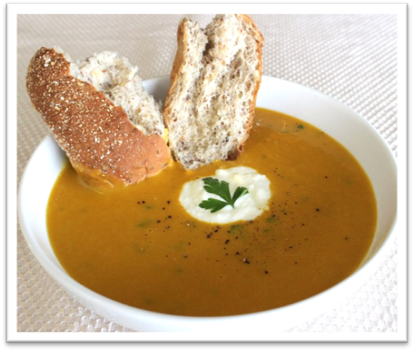 |  | 1 tsp oil  1 medium onion, diced  1 clove garlic, chopped  ½ tsp ground ginger  ¼ tsp curry powder  150g (51/2 oz) pumpkin, cubed  1 medium potato, cubed  1 cup salt-reduced stock  ³/₄ cup reduced-fat milk  1 tb parsley, chopped  Serve with  Pepper  2 tbs low-fat natural yoghurt  2 wholegrain crusty bread rolls

Serves 2
Preparation Time 8 min
Cooking Time 30 min
Quick and easy quiche
Method |  | Ingredients
1. Combine the eggs, margarine, flour and milk in an oven-proof dish and mix well.  2. Add ham, onion, half of the grated cheese, and vegetable stir-fry mix (or corn).  3. Top with sliced tomato and remaining cheese.  4. Bake at 180°C for approximately 30 minutes or until set.  5. Serve with bread and salad vegetables.  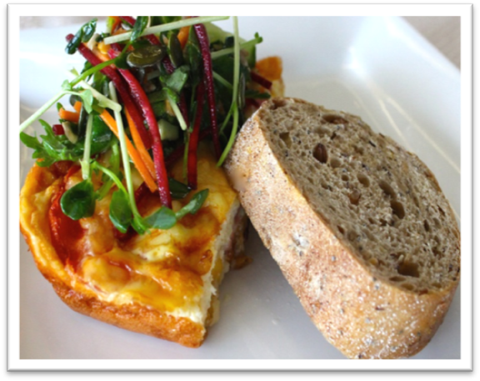 |  | 2 eggs  1 tsp Reduced-fat margarine, melted  2 tbs wholemeal self-raising flour  ¹/₃ cup low-fat milk  2 slices lean ham, diced  ½ medium onion, diced  ²/₃ cup reduced-fat cheese, grated  ²/₃ cup vegetable stir-fry or ¹/₃ x 440g can corn kernels  1 medium tomato, sliced  Serve with  Garden salad (see additional recipe)  2 wholegrain bread rolls

Serves 2
Preparation Time 10 min
Cooking Time Nil
Green salad
Method |  | Ingredients
1. Place all ingredients for the salad in a large salad bowl and toss until combined  2. In a medium screw-top jar, shake up ingredients for the dressing until smooth. Pour over salad, and toss thoroughly.  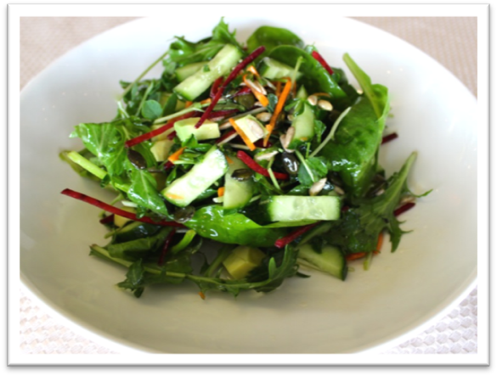 |  | 1 cup mixed green salad leaves  ½ cup sprouts (i.e. sunflower, snow peas, alfalfa or broccoli)  ½ cucumber, chopped  ½ avocado, cubed  1 tb sunflower and pumpkin seeds  Dressing  ½ tb lemon juice  ¼ cup olive oil  1 tsp wholegrain mustard  Salt and pepper to taste

Serves 2
Preparation Time 10 min
Cooking Time 40 min
Pear and sultana rice pudding
Method |  | Ingredients
1. Place milk, vanilla, cinnamon and honey in a large saucepan; bring to the boil over medium to high heat, stirring constantly.  2. Add the rice and sultanas, reduce to medium to low heat and cook, stirring occasionally for 20-30 minutes or until rice has cooked and thickened. Remove from heat.  3. Meanwhile, place the brown sugar and pear in a saucepan. Bring to the boil, then simmer for 5 minutes or until pear has softened.  4. Fold pear mixture through rice and serve.  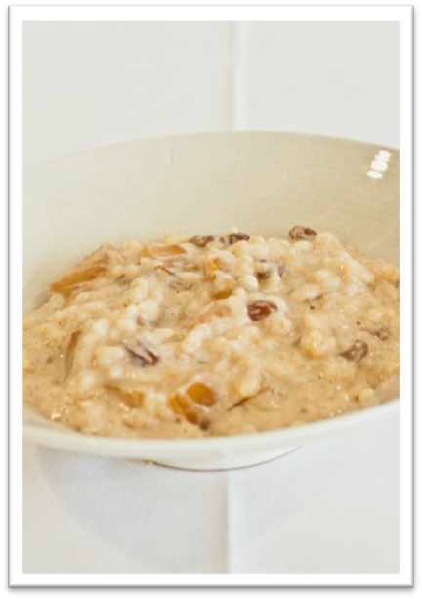 |  | 2½ cups reduced-fat milk  1 tsp vanilla essence  1 tsp dried cinnamon  1 tb honey  ½ cup arborio rice*  1 tb sultanas  1 tsp brown sugar  1 pear, peeled and diced  * Arborio rice: a short-grain, high starch rice. It can be found in the rice section at your supermarket.

