Cooking for One or Two

Session 4: Healthy lifestyle

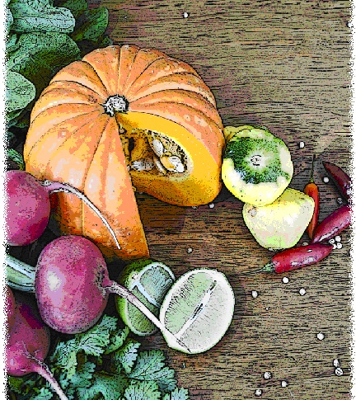

Contents
Objectives and overview 3
Session checklist 4
Ingredients list 5
Equipment 7
Room set up 9
Timeline 10
Introduction 11
Group agreement reminder 12
Food preparation, Part 1 12
Discussion: Physical activity 13
Discussion: Alcohol and healthy ageing 15
Food preparation, Part 2 16
Enjoy a meal together 16
Thank you and conclusion 17
Session clean up 17
Handout 6: Alcohol Guidelines 18
Recipes 19

Objectives and overview
Session objectives
By the end of this session participants will have:
- Demonstrated an understanding of the importance of physical activity to maintain muscle strength and a healthy body weight.
- Demonstrated an understanding of tips for low alcohol drinking.
- Developed their food preparation skills.
- Enjoyed a meal with a group of new friends.

Session overview
Today’s discussion topics
- Healthy Lifestyle
Today you will be cooking
- Rissoles with sweet potato mash and green salad
- Fruit strudel with vanilla yoghurt

Session checklist
Facilitator |  |  | Assistant
Collect groceries using session shopping list |  |  | Assist with grocery shopping where required
Arrive approximately 45 minutes prior to the start of the session |  |  | Arrive approximately 30 minutes prior to the start of the session
Read first aid instructions |  |  | Help with set up of equipment
Set up cooking equipment |  |  | Help with set up of room
Set up room |  |  | Assist the facilitator following all instructions in blue
Print out evaluation sheets |  |  | Help with washing up/cleaning
Facilitate the program following all instructions in green
Wash up/cleaning

Ingredients list
tsp = teaspoon
tb = tablespoon
 | To serve 2 people | To serve 4 people | To serve 6 people | To serve 8 people
Lean mince | 175g | 350g | 525g | 700g
Onion | ½ | 1 | 1½ | 2
Three bean mix or red kidney beans (440g can) | ¼ | ½ | ¾ | 1
Carrot | ½ | 1 | 1½ | 2
Rolled oats | 1 tb | 2 tbs | 3 tbs | 4 tbs
Curry powder | ¼ tsp | ½ tsp | ¾ tsp | 1 tsp
Salt-reduced soy sauce | 2 tsps | 4 tsps | 6 tsps | 8 tsps
Sweet chilli or tomato sauce | 2 tsps | 4 tsps | 6 tsps | 8 tsps
Dried herbs | ½ tsp | 1 tsp | 1½ tsps | 2 tsps
Parsley (fresh or dried) | 1 tb | 2 tbs | 3 tbs | 4 tbs
Pepper | Pinch | Pinch | Pinch | Pinch
Olive Oil | 5¼ tbs | 10½ tbs | 15¾ tbs | 21 tbs
Reduced-fat cheese | 2 slices | 4 slices | 6 slices | 8 slices
Sweet potato | ½ | 1 | 1½ | 2
Reduced-fat margarine | 1 tb | 2 tbs | 3 tbs | 4 tbs
Mixed green salad leaves | 1 cup | 2 cups | 3 cups | 4 cups
Sprouts | ½ cup | 1 cup | 1½ cups | 2 cups
Cucumber | ½ | 1 | 1½ | 2
Avocado | ½ | 1 | 1½ | 2
Seed mix | 1 tb | 2 tbs | 3 tbs | 4 tbs
Lemon juice | ½ tb | 1 tb | 1½ tbs | 2 tbs
Wholegrain mustard | 1 tsp | 2 tsps | 3 tsps | 4 tsps
Filo pastry | 2 sheets | 4 sheets | 6 sheets | 8 sheets
Pie apples (410g can) | ½ | 1 | 1½ | 2
Sultanas | 2 tbs | 4 tbs | 6 tbs | 8 tbs
Dried apricots | 4 | 8 | 12 | 16
Cinnamon | 1 tsp | 2 tsps | 3 tsps | 4 tsps
Sugar | 1 tsp | 2 tsps | 3 tsps | 4 tsps
Reduced-fat milk | 2 tsps | 4 tsps | 6 tsps | 8 tsps
Almond flakes | 1 tb | 2 tbs | 3 tbs | 4 tbs
Nutmeg | ½ tsp | 1 tsp | 1½ tsps | 2 tsps
Reduced-fat vanilla yoghurt | 1½ cups | 3 cups | 4½ cups | 6 cups
Honey | 1 tsp | 2 tsps | 3 tsps | 4 tsps
Vanilla essence | ½ tsp | 1 tsp | 1½ tsps | 2 tsps

Equipment
For table one
3 cooks knives |  | Measuring cups
3 vegetable knives |  | Measuring spoons
3 wooden spoons |  | Small, medium and large bowls
3 serving spoons |  | Colander
Vegetable peelers |  | Chopping boards / Chux
Spatula |  | Baking tray
Can opener |  | Cling wrap and baking paper
Pastry brush |  | Disposable gloves
Salad bowl |  | Vegetable masher
Screw top jar (to shake salad dressing)
For table two
Place dry ingredients on table; amount dependent on number of people in the group
For refrigerator
Place ingredients that need to remain cool in the refrigerator; amount dependent on number of people in the group
For table three
Electric fry pan |  | Oven mitts
Heat proof mats |  | Large saucepan with steamer
Electric hotplates |  | Extension cord (if necessary)
Thermometer
For the kitchen and washing up area
Oven |  | Washing up liquard
Dish brush |  | Pot scrub
Dish cloth |  | Tea towels
For food safety and washing hands
Liquid soap |  | Paper hand Towel
For dining
Cutlery (Knives, forks and spoons) |  | Serviettes
Plates |  | Cups
Bowls |  | Jug (with water)
Table cloth
For refreshments (to be set up wherever deemed suitable)
Tea |  | Sugar
Coffee |  | UHT milk
For discussion sessions and miscellaneous items
Recipe cards |  | Whiteboard
Whiteboard marker |  | Pens
Name tags |  | How you cook can make you and others crook’ Poster (see Session 1, Handout 1)
Alcohol guidelines (Handout 6)
For occupational health and safety
Duct tape to tape down the electrical cords |  | St Johns First Aid Kit

Room set up
TABLE TWO
Place one table to the side for all ingredients to be displayed on.
TABLE THREE
Place electrical equipment here.
Place on side closest to power points. If extension cord is used ensure it is taped to the ground to prevent participants tripping and injuring themselves.
TABLE ONE
Set up a table with enough space for participants to stand around for food preparation in the centre of the room.
Set up all equipment other than electrical appliances at this table.
This table can later be set up for dining.

Timeline
 |  | Set up room, including table with ingredients, food preparation area, dining area and chairs and whiteboard for discussion (45 mins before session)
Start
session
Start  session |  | Introduction and safety (10 mins)
 |  | Group agreement (5 mins)
 |  | Food preparation (30 mins)
30 mins |  | Food preparation (30 mins)
 |  | Discussion: Physical Activity (20 mins)
1 hr |  | Discussion: Physical Activity (20 mins)
 |  | Discussion: Alcohol (15 mins)
 |  | Food preparation (40 mins)
90 mins |  | Food preparation (40 mins)
2 hrs |  | Food preparation (40 mins)
2 hrs |  | Enjoy a meal together (40 mins)
150 mins |  | Enjoy a meal together (40 mins)
 |  | Thank you and conclusion (5 mins)
 |  | Session clean up (approx. 20-30 mins)
3 hrs  End |  | Session clean up (approx. 20-30 mins)
210 mins

Introduction | 10 minutes
The following section is to be conducted by the facilitator
1. Welcome participants to Session Four of the Cooking for One or Two program.
2. Re-introduce yourself and the assistant to the group.
3. Outline your role and the assistant’s role in today’s session (1. facilitating cooking, 2. discussion topic).
4. Ask the participants if any of them tried cooking the vegetable casserole with steamed fish and crusty bread or the banana berry split made in Session Three (or anything else) at home.
5. Explain to the group that all sessions are well planned to reduce any risks, but it is still important to point out the safety risks. This includes:
- The exits [point out to group] in case of fire.
- Fire blankets and fire extinguishers [point out to group] in case of fire.
- Emergency rally points.
- Electrical equipment and cords have been firmly taped down [point out all].
- The location of the first aid officer is [give location and name].
- The bathrooms [give location].
6. Ask the group to inform you if there are any accidents or incidents or if they are feeling unwell.
7. Address any participants who have previously reported an allergy. Check through ingredients of the recipe to ensure it is safe for any participant with an allergy to consume. If not the participant must be informed they cannot consume the meal today.

Group agreement reminder | 10 minutes
The following section is to be conducted by the assistant
1. Remind the group of their Group agreement from Session One.
2. They all agreed to:
- Follow safe food practices; washing hands when required, not cross-contaminating, checking temperatures, and informing us if you are ill. . Refer the group to the poster ‘How you cook can make you and others crook’ Poster (see Session 1 Handout 1).
- Listen to each other; this means trying to talk one at a time, and letting everyone have their say.
- Support each other; you are all here to learn new skills so support each other in this endeavor.
- Take care (consider your own and others safety) when using knives, hot equipment and food; try to prevent slips, trips, falls and heavy lifting.
- Not consume alcohol whilst the program is running.
- Most importantly have fun, whilst learning. The group should be a time for you to make new friends.
3. Outline the session content:
- Prepare rissoles with green salad.
- Discuss Healthy lifestyle.
- Prepare mashed potato, strudel, and cook rissoles.

Food preparation, Part 1 | 30 minutes
The following section is to be conducted by the facilitator
1. Introduce the participants to part one of the food preparation today:
- Firstly a green salad will be prepared.
- Secondly the rissoles will be prepared.
2. Ask participants to wash their hands before commencing the food preparation.
3. Ask the participants to view the green salad recipe card. Read the recipe card explaining step by step to the group the recipe for the green salad. Once you have read these steps give each participant a role in preparing the recipe according to these steps.
4. Ask the participants to view the rissole recipe. Read ONLY step one of the recipe card. Other steps will be completed later in the session.

Discussion: Physical activity |  | 20 minutes
The following section is to be conducted by the facilitator
1. Introduce the discussion topic: ‘Today we will be discussing the benefits of physical activity and how easy it is to fit a little more activity into your day’.
2. Read the following explaining to the group the importance of physical activity in maintaining muscle strength and a healthy body weight.
 | Partaking in physical activity on most days will help you:
- Control your weight.
- Have stronger bones.
- Feel more relaxed and enjoy a sounder sleep.
- Have lower blood pressure.
- Have stronger and more flexible muscles (and less aches and pains!).
- Have a healthier blood cholesterol level.
- Build stamina; keeping your heart and lungs healthy.
- Reduce the risk of getting diabetes.
- Improve concentration by keeping the mind active; have better posture, balance and prevent falls and most importantly feel well.
3. Explain to the group that they should discuss any changes in their physical activity patterns with their GP before they commence exercise. Particularly if they have heart problems (i.e. previous heart attack, or high blood pressure), diabetes or any other chronic disease.
4. Read the following listing the common excuses used for not doing any physical activity and the arguments against these.
 | Common excuses used for not doing any physical activity and the arguments against these
“I feel too tired. I can’t be bothered. I know I should but…
BUT: Physical activity will give you more energy and make you feel better.
It’s too difficult. I have too many things wrong with me and can’t do very much…
BUT: Health problems such as arthritis, diabetes, osteoporosis or heart conditions should not be an excuse for not doing any physical activity. In fact they should probably serve as motivation, because physical activity can be beneficial for these health problems. Your GP should be consulted about what activities would be best for you if you have such conditions.
I can’t afford it, I can’t get there, or I don’t know where to go…
BUT: Physical activity can be free and you don’t have to go anywhere special to do it. Whether you walk the dog, walk your neighbours’ dog, do some stretches, mow the lawn or even if you just hide the TV remote control so you have to get up to change the channel; you will be doing some form of physical activity.
I have no one to do activity with…
BUT: Activity can be done by yourself or there may be a group you can join to make it more enjoyable.
Even if I wanted to, I haven’t got the time, I’m too busy…
BUT: physical activity actually gives you more time to do things because you will be creating extra energy. Plus you can make physical activity part of what you are doing. This includes taking the stairs instead of the lift, parking that little bit further away from where you are going or getting off the bus a few stops earlier.
5. Read the following listing for tips when commencing or starting physical activity
 | Tips when commencing or starting physical activities
- A form of physical activity should be part of life regardless of age, weight, health problems or abilities.
- Include a range of physical activities that incorporate fitness, strength, balance and flexibility.
- For those who have not been active for a while, or who are starting a new type of activity, begin at a level that is easily manageable and build gradually.
- Those who have participated in vigorous physical activity should continue to do so in a manner that is suited to their capability.
- Consider doing activities with a partner, friends, family members or neighbours.
- If activities are outdoors, get up early to beat the heat in summer or late in winter when it is warmer.
- Have a backup plan for indoor activity for when the weather conditions are less suitable outdoors.
- Wear sun protection, comfortable clothing and supportive footwear.
- Try varying activates like changing start time, place or the activity you do.
6. Read the following explaining the recommendations for physical activity and some suggestions on how to meet them.
 | Physical activity recommendations and how to meet them
The National Physical Activity Guidelines recommend at least 30 minutes of moderate intensity physical activity on most, if not all days.
You may be thinking- But how do I do that?
- There are a number of ways you could reach your 30 minute total. It need not be 30 minutes all at the same time. It can be in 5, 10, or 15-minute blocks.
- You may need to start gradual and build up to the 30 minutes a day-.
- Set a goal for yourself, making sure you are realistic. E.g. your goal at first may be to walk as far as you can for two and a half minutes and return to your starting point (5 minute walk), gradually building up to 15 minutes (30 minute walk).
- Take the stairs rather than the lift or escalator.
- Park your car further away from shopping centres etc.
- Get off the bus one stop earlier and walk the rest of the way home.
- If you have stopped physical activity because of a new health problem you may need to discuss resuming physical activity with your GP, or to resume physical activity in a supervised manner at first.
If you experience dizziness, palpitations or chest pain during physical activity the activity should be ceased and you should seek advice from a GP.
7. Ask the group to name one way in which they can include more exercise into their day.

Discussion: Alcohol and healthy ageing |  | 15 minutes
The following section is to be conducted by the facilitator
1. Introduce the discussion topic: The following information relates to alcohol consumption at a safe level.
2. Read the following summarising alcohol in Australia
 | Alcohol in Australia
 | Most Australians drink alcohol for the enjoyment, relaxation and sociability and do so at a level that causes few adverse effects. However, there are some people that drink at levels that increase their risk of alcohol related harm. The 2009 National Health and Medical Research Council (NHMRC) guidelines aim to establish an evidence base to reduce the health risks that arise from drinking alcohol.
3. Read the following from one of the NHMRC guidelines. The assistant should hold up the Australian standard drink poster or handout to the group and the facilitator will discuss what standard drinks (Handout 6).
4. Ask participants if they generally drink more or less than the standard drink serving size.
 | Reduce the risk of alcohol related harm over a lifetime
 | The lifetime risk of harm from drinking alcohol increases with the amount consumed. For healthy men and women drinking no more than two standard drinks on any day reduces the lifetime risk of harm from alcohol related disease or injury.
5. Read the following explaining the tips to lower risky drinking levels.
 | Tips for lowering risky drinking
- Drink low alcohol drinks
- Make every second drink non-alcoholic
- Have one or two alcohol-free days per week
- Refill your own glass
- Do other activities whilst drinking i.e: Play pool, darts, bowls or cards
- Avoid ‘shouts’ so you can drink at your own pace
- Drink out of a wine glass, but fill it with your favourite non-alcoholic beverages
- If you drink wine dilute it with spritzer or soda.
6. Ask the group if they will use any of the suggested tips and whether they can think of any other ways to lower risky drinking levels.

Food preparation, Part 2 | 40 minutes
The following section is to be conducted by the facilitator
1. Introduce the participants to part 2 of the food preparation.
- Firstly the strudel will be prepared,
- Secondly the mashed sweet potato will be prepared,
- Thirdly the rissoles prepared earlier will be cooked.
2. Ask participants to wash their hands.
3. Ask the participants to view the fruit strudel recipe card. Read the recipe card explaining step-by-step the recipe for the fruit strudel with vanilla yoghurt. Once you have read these instructions give each participant a role in preparing the recipe according to these steps.
4. Ask the participants to view the rissole recipe card. Read the section explaining step-by-step the recipe for sweet potato mash. Once you have read these instructions give each participant a role in preparing the sweet potato mash according to these steps.
5. Ask participants to cook the rissoles following the remaining two steps. Give each participant a role in preparing the recipe according to these steps.

Enjoy a meal together | 40 minutes
The following section is to be conducted by the assistant
1. Set each participant, the facilitator and the assistant a place at the dining table. Use the table cloth, serviettes, crockery and cutlery to create an inviting space to share the meal together.
2. Enjoy!

Thank you and conclusion | 5 minutes
The following section is to be conducted by the facilitator
1. Thank the group for attending Session Four.
2. Congratulate the group on a job well done.
3. Outline Session Five content:
- Meal; pumpkin, potato and parsley soup; quiche with green salad and pear and sultana rice pudding.
- Discussion topic; healthy eating on a budget and safe food storage.
4. Ask two group members to stay and assist with the washing up and packing up of equipment.
5. Remind participants who volunteered to clean up that it shouldn’t take long and their help is appreciated. Direct volunteers on what needs to be cleaned.

Session clean up | 30 minutes
The following section is to be conducted by the assistant
1. When cleaning up, it is important that you use hot soapy water, and refill the sink once the water has become either warm or discolored (dirty). At all stages in the washing up process please be mindful of sharp objects being left in the water.
2. All equipment must be washed and sanitised prior to being packed away for the next session. It is also important that all equipment goes back to where it was found. It is the facilitator’s role to assist the assistant and participants with this.

Handout 6: Alcohol Guidelines
Can be downloaded from: http://www.nhmrc.gov.au/_files_nhmrc/file/your_health/healthy/alcohol/std-drinks.pdf

Recipes
Serves 2
Preparation Time 10 min
Cooking Time 15 min
Rissoles with sweet potato mash
Method |  | Ingredients
1. Combine all the ingredients for rissoles in a bowl, EXCEPT oil and cheese and mix well. Shape into four patties and place in the refrigerator (covered) until ready to cook.  2. Heat oil in a fry pan, and cook rissoles turning once, allowing them to cook through (approximately 5 minutes each side).  3. Once cooked, top the rissoles with cheese, cover the fry pan and allow the cheese to melt.  4. Serve with sweet potato mash (see separate recipe) and garden salad (see separate recipe).  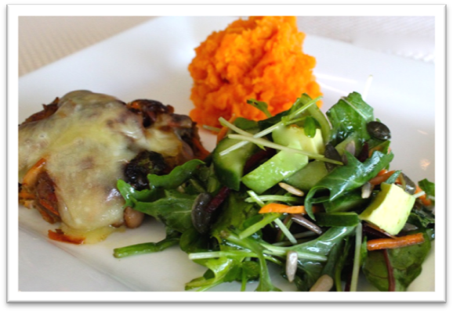 |  | 175g (6oz) lean mince  ½ medium onion, finely diced  ¼ x 440g can beans (three bean mix or red kidney beans) drained, rinsed and mashed  ½ medium carrot, grated  1 tb rolled oats  ¼ tsp curry powder  2 tsps salt-reduced soy sauce  2 tsps sweet chilli sauce or tomato sauce  ½ tsp dried herbs  1 tb parsley, chopped (fresh or dried)  pepper  1 tb oil (for frying)  2 slices reduced-fat cheese  Serve with  Mashed sweet potato (see additional recipe)  Garden salad (see additional recipe)

Serves 2
Preparation Time 10 min
Cooking Time 15 min
Sweet potato mash
Method |  | Ingredients
1. Bring a small pot of water to boil over medium heat.  2. Peel the sweet potato, cutting in half lengthwise, and then each half into quarters. Each sweet potato should end up cut into eight pieces.  3. When the water boils, add the cut sweet potatoes to the water and turn heat to low. Simmer for 15 minutes or until the sweet potatoes can easily be pierced with a knife.  4. Drain the sweet potatoes and return to the pot. Add margarine, and mash lightly with a potato masher. |  | ½ medium sweet potato  1 tb reduced-fat margarine

Serves 2
Preparation Time 10 min
Cooking Time 15 min
Fruit strudel with vanilla yoghurt
Method |  | Ingredients
1. Place one sheet of filo pastry on a lightly oiled tray. Place the next sheet of filo pastry on top. Lightly brush the sheets with oil and place the remaining 2 sheets on top.  2. Place apples along one width of the pastry, and sprinkle with sultanas, apricots, cinnamon and sugar (optional). Fold sides in and brush edges lightly with milk.  3. Roll the pastry, tucking in the edges and keeping the joins underneath i.e. like a parcel, ensuring the join is placed on the tray.  4. Brush top with oil and sprinkle on nut pieces and nutmeg.  5. Bake at 200°C for about 15 minutes or until pastry is golden.  6. Prepare the vanilla yoghurt by combining the natural yoghurt, honey and vanilla essence. Serve with Strudel.  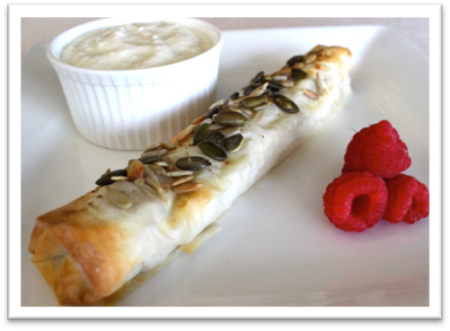 |  | 2 sheets filo pastry, cut in half  1 tsp oil  ½ x 410g can pie apples  2 tbs sultanas  4 dried apricots, quartered  1 tsp cinnamon  1 tsp sugar (optional)  2 tsps reduced-fat milk  1 tb nut pieces (e.g. almond flakes)  ½ tsp nutmeg  Vanilla Yoghurt  1½ cups low-fat natural yoghurt  1 tsp honey  ½ tsp vanilla essence

Serves 2
Preparation Time 10 min
Cooking Time Nil
Green salad
Method |  | Ingredients
1. Place all ingredients for the salad in a large salad bowl and toss until combined  2. In a medium screw-top jar, shake up ingredients for the dressing until smooth. Pour over salad, and toss thoroughly.  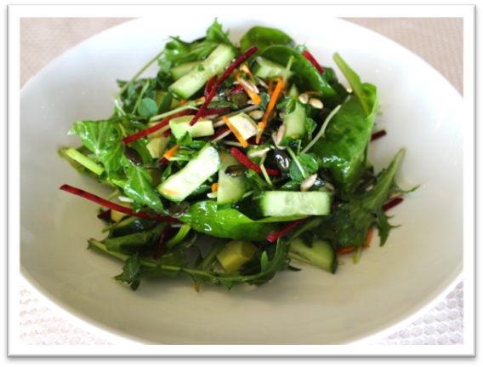 |  | 1 cup mixed green salad leaves  ½ cup sprouts (i.e. sunflower, snowpea, alfalfa or broccoli)  ½ cucumber, chopped  ½ avocado, cubed  1 tb sunflower and pumpkin seeds  Dressing  ½ tb lemon juice  ¼ cup olive oil  1 tsp wholegrain mustard  Salt and pepper to taste

Please note if you are conducting your program within the Veterans’ community, the Department of Veterans’ Affairs have endorsed separate safe alcohol guidelines. Please substitute these for the NHMRC guidelines. For further information, see www.dva.gov.au.

