Cooking for One or Two

Session 2: Malnutrition and creating a dinner with basics in your cupboard

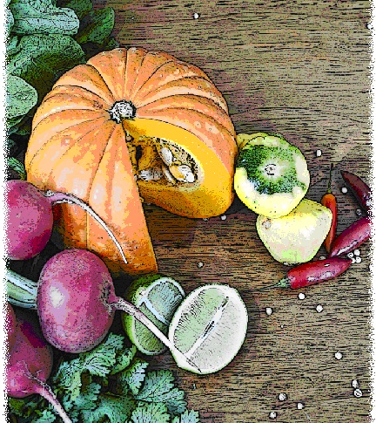

Contents
Objectives and overview 3
Session checklist 4
Ingredients list 5
Equipment 6
Room set up 8
Timeline 9
Introduction 10
Group agreement reminder 11
Food preparation, Part 1 12
Discussion: The importance of being well-nourished 13
Discussion: Pantry staples 16
Any questions? 17
Food preparation, Part 2 17
Enjoy a meal together 17
Thank you and conclusion 18
Session clean up 18
Recipes 19

Objectives and overview
Session objectives
By the end of this session, participants will have:
- Understood of their risk of malnutrition through completion of the Australian Malnutrition Screening Tool (MST).
- Learnt how to create a dinner using the food available in your cupboard.
- Continued to develop their food preparation skills.
- Enjoyed a meal with a group of new friends.

Session overview
Today’s discussion topics
- Risk factors for malnutrition
- Creating a dinner from basics in your cupboard
Today you will be cooking
- Beef and gnocchi casserole
- Pita Pizzas
- Pears with crusty crumble

Session checklist
Facilitator |  |  | Assistant
Collect groceries using session shopping list |  |  | Assist with grocery shopping where required
Arrive approximately 45 minutes prior to the start of the session |  |  | Arrive approximately 30 minutes prior to the start of the session
Read first aid instructions |  |  | Help with set up of equipment
Set up cooking equipment |  |  | Help with set up of room
Set up room |  |  | Assist the facilitator following all instructions in blue
Print out evaluation sheets |  |  | Help with washing up/cleaning
Facilitate the program following all instructions in green
Wash up/cleaning

Ingredients list
tsp = teaspoon
tb = tablespoon
 | To serve 2 people | To serve 4 people | To serve 6 people | To serve 8 people
Lean beef | 250g | 500g | 750g | 1kg
Garlic (fresh or dried) | 2 tsps | 4 tsps | 6 tsps | 8 tsps
Shortcut bacon | 2 pieces | 4 pieces | 6 pieces | 8 pieces
Onion | ½ | 1 | 1 ½ | 2
Gnocchi | 1 ½ cups | 3 cups | 4 ½ cups | 6 cups
Tomatoes (400g can) | 1 | 2 | 3 | 4
Parsley (fresh or dried) | 2 tsps | 4 tsps | 6 tsps | 8 tsps
Basil (fresh) | 1 tsp | 2 tsps | 3 tsps | 4 tsps
Vegetables | 2 cups | 4 cups | 6 cups | 8 cups
Wholemeal pita bread | 2 small | 4 small | 6 small | 8 small
Salt reduced tomato paste | 1 ½ tbs | 3 tbs | 4 ½ tbs | 6 tbs
Ham or chicken | 60g | 120g | 180g | 240g
Variety of vegetables for pizza i.e. sliced onion, capsicum, corn kernels
Reduced-fat cheese | ½ cup | 1 cup | 1 ½ cups | 2 cups
Honey | ¼ cup | ½ cup | ¾ cup | 1 cup
Orange | 1 | 2 | 3 | 4
Breakfast biscuits (i.e. weetbix) | 2 | 4 | 6 | 8
Rolled oats | ¼ cup | ½ cup | ¾ cup | 1 cup
Almond flakes | 1 tb | 2 tbs | 3 tbs | 4 tbs
Cinnamon | ½ tsp | 1 tsp | 1½ tsps | 2 tsps
Pears (fresh or canned, in natural juice) | 2 | 4 | 6 | 8
Reduced-fat natural yoghurt | 1½ cups | 3 cups | 4 ½ cups | 6 cups

Equipment
For table one
3 cooks knives |  | Measuring cups
3 vegetable knives |  | Measuring spoons
3 wooden spoons |  | Small, medium and large bowls
3 serving spoons |  | Colander
Vegetable peelers |  | Chopping boards / Chux
Spatula |  | Oven proof dishes/trays
Can opener |  | Cling wrap and baking paper
Juicer |  | Grater
For table two
Place dry ingredients on table; amount dependent on number of people in the group
For Refrigerator
Place ingredients that need to remain cool in the refrigerator; amount dependent on number of people in the group
For table three
Electric wok |  | Electric hot plates
Large saucepan |  | Oven Mitts
Electric fry pan |  | Thermometer
Heat proof mats |  | Extension cord (if necessary)
For the kitchen and washing up area
Oven |  | Washing up liquid
Dish brush |  | Pot scrub
Dish cloths |  | Tea towels
For food safety and washing hands
Liquid soap |  | Paper hand towels
For dining
Cutlery (knives, forks and spoons) |  | Serviettes & tablecloth
Plates |  | Cups
Bowls |  | Jug (with water)
For refreshments (to be set up wherever deemed suitable)
Tea |  | Sugar
Coffee |  | UHT Milk
For discussion sessions and miscellaneous items
Recipe cards |  | ‘How you cook can make you and others crook’ Poster (see Session 1 Handout 1)
MST checklist |  | Whiteboard marker
White board |  | Pens/pencils
For occupational health and safety
Duct tape to tape down electrical cords |  | St Johns First Aid Kit

Room set up
TABLE TWO
Place one table to the side for all ingredients to be displayed on.
TABLE THREE
Place electrical equipment here.
Place on side closest to power points. If extension cord is used ensure it is taped to the ground to prevent participants tripping and injuring themselves.
TABLE ONE
Set up a table with enough space for participants to stand around for food preparation in the centre of the room.
Set up all equipment other than electrical appliances at this table.
This table can later be set up for dining.

Timeline
 |  | Set up room, including table with ingredients, food preparation area, dining area and chairs and whiteboard for discussion (45 mins before session)
Start
session
Start  session |  | Introduction and safety (10 mins)
 |  | Group agreement (5 mins)
 |  | Food Preparation (30 mins)
30 mins |  | Food Preparation (30 mins)
 |  | Discussion: The importance of being well (40 mins)
1 hr |  | Discussion: The importance of being well (40 mins)
90 mins |  | Discussion: Pantry staples (10 mins)
 |  | Any questions? (5 mins)
 |  | Food preparation (30 mins)
2 hrs |  | Food preparation (30 mins)
 |  | Enjoy a meal together (40 mins)
150 mins |  | Enjoy a meal together (40 mins)
 |  | Thank you and conclusion
3 hrs  End |  | Session clean up (approx. 20-30 mins)
210 mins

Introduction | 10 minutes
The following section is to be conducted by the facilitator
1. Welcome participants to Session Two of the Cooking for One or Two program.
2. Re-introduce yourself and the assistant to the group.
3. Outline facilitator and assistant roles in today’s session (1. facilitating cooking, 2. discussion topic).
4. Ask the participants if any of them have tried cooking the stir-fry or pudding made in session one at home.
5. Explain to the group that all sessions are well planned to reduce any risks, but it is still important to point out the safety risks. This includes:
- The exits [point out to group] in case of fire.
- Fire blankets and fire extinguishers [point out to group] in case of fire.
- Emergency rally points.
- Electrical equipment and cords have been firmly taped down [point out all].
- The location of the first aid officer is [give location and name].
- The bathrooms [give location].
6. Ask the group to inform you if there are any accidents or incidents or if they are feeling unwell.
7. Outline Session Two:
- Today we will be discussing risk factors for malnutrition and creating a dinner from basics in your cupboard.
- We will be cooking beef and gnocchi casserole, pita pizzas and pears with crusty crumble.

Group agreement reminder | 10 minutes
The following section is to be conducted by the assistant
1. Remind the group of their Group agreement from Session One. They all agreed to:
- Follow safe food practices; washing hands when required, not cross-contaminating, checking temperatures, and informing us if you are ill. Refer the group to the poster ‘How you cook can make you and others crook’ Poster (see Session 1 Handout 1).
- Listen to each other; this means trying to talk one at a time and letting everyone have their say.
- Support each other; you are all here to learn new skills so support each other in this endeavor.
- Take care (consider your own and others safety) when using knives, hot equipment and food; try to prevent slips, trips, falls and avoid heavy lifting.
- Most importantly have fun, whilst learning. The group should be a time for you to make new friends.
2. Outline the session content
- Prepare the beef and gnocchi casserole.
- Discuss the risk factors of malnutrition.
- Discuss creating a dinner from basics in your cupboard.
- Prepare the pita pizzas and pears with crusty crumble.

Food preparation, Part 1 | 30 minutes
The following section is to be conducted by the facilitator
1. Introduce the participants to the food preparation session
- Before we begin our discussion topic we will cook the beef and gnocchi casserole
2. Ask all participants to wash their hands.
3. Ask the participants to view the beef and gnocchi casserole recipe card. Read the recipe card explaining step-by-step to the group the recipe for beef casserole. Once you have read these steps give each participant a role in preparing the recipe according to these steps.

Discussion: The importance of being well-nourished |  | 40 minutes
The following section is to be conducted by the facilitator
Some assistance is required by the assistant
1. Introduce the first discussion topic to the group; risk factors of malnutrition.
2. Ask the group if they know what is meant by the term ‘well-nourished’. ANSWER: People who are well-nourished are getting enough ‘energy’ along with vitamins and minerals from the food they eat.
3. Inform the group that a person who is not meeting these needs is said to be undernourished or diagnosed as having malnutrition.
4. Read the following explaining to the group the importance of being ‘well-nourished’
 | Importance of being well-nourished
- Being well-nourished is important for our health.
- We need nutritious foods at all stages of our life to keep us well-nourished
- But why?
- It is important for our health; the way our mind and body functions, which maintains our quality of life.
- It is particularly important, as we grow older with the weakening of bones and muscles and decreasing energy levels for activity.
- By keeping well-nourished you will continue to not only add years to your life, but also life to your years.”
5. Distribute the MST screen (for participants to keep) and a pen to each group member.
6. Read the following explaining to the group about the Australian Malnutrition Screening Tool.
 | The Australian Malnutrition Screening Tool
- The malnutrition screening tool (MST) is a screening tool used to identify individuals at risk of malnutrition. This screening tool uses perimeters such as recent weight loss and poor food intake due to decreased appetite to assess risk.
- Recent weight loss is measured on a score of 0-4 and recent intake is measured on a score of 0-1.
- A total score of >2 = at risk of malnutrition.
- It is important that you are honest with your answers; you do not have to share your score with the group.
- Don’t be alarmed if you score in the moderate or high nutritional risk, as part of this group we hope to help you overcome some of the factors that may be placing you at nutritional risk.
7. If participants score indicates that they are at risk of malnutrition, recommend that they speak to their GP or to a dieititan in the local area for full assessment and intervention.
8. Inform the group that you will now explain the risk factors for malnutrition using the word “determine”.
 | Assistant to write the word “DETERMINE” on the white board vertically.
9. Suggest to the group that they pay particular attention to these risk factors, so they know what they are doing right (and therefore should try and continue) and what they may be able to improve on to reduce their risk.
 | Assistant to follow facilitators lead, and write on the white board what each letter stands for as it is revealed.
10. Read the following explaining to the group what the word DETERMINE means
 | Determine
If you remember the word DETERMINE, you can easily remember the warning signs of poor nutrition.
D is for disease
- If you have a disease, illness or chronic condition that affects how, what or when you eat this can increase your nutritional health risk.
- This includes confusion or memory loss which can make it difficult to remember what, when, or if you have eaten.
- If you feel sad or depressed there may be changes in your appetite, digestion, energy levels, weight and well-being.
- This is one of the risk factors that we can rarely change, therefore it is important that you try and improve on the risk factors that you can change.
E is for eating poorly
- A risk factor, which we can control.
- But why is eating well so important?
- ANSWER - if you do not eat enough or too much it can lead to poor health. It is important to eat enough fruit and vegetables, milk products, breads and cereals, meat and meat alternatives each day, and not too much alcohol, or extra foods such as cakes and biscuits which do not provide you with the nutrients you need.
- We will discuss healthy eating in more detail in Session Three.
T is for tooth loss and mouth pain
- The existence of missing, loose or rotten teeth or dentures that don’t fit properly makes it more difficult to eat and affect appetite.
- It is important to ensure you have a healthy mouth with clean teeth and gums to make eating easier.
- Ensure you have regular visits to the dentist to overcome any teeth or mouth problems. Free services are available to those who have a health care card.
E is for economic hardship
- If you have a low income or are on a pension it is sometimes difficult to buy enough or the right sorts of foods to stay healthy.
- In the last session of this program we will discuss healthy and economical ways to save money when purchasing your food supplies.
R is for reduced social contact
- A lot of older people live alone.
- While it is recognised these people have a reason for eating alone most of the time, being with people can have a positive impact on eating.
- A group such as Cooking for One or Two is a great way to increase social contact.
- Those who do live alone should use groups such as Cooking for One or Two to meet new people and start friendships that can hopefully continue after the end of the program.
M is for multiple medicines
- Health problems can require the need for multiple medications.
- The greater the number of medications taken the more likely the chance of the medication causing side effects such as reduced or enhanced appetite, tastes alterations, constipation and/or diarrhea and nausea and/or vomiting.
- If you are someone who is on multiple medications it is important to keep an eye out for such side effects and make an increased effort to make sure that you are eating regularly.
- If you’re unsure discuss this with your GP or pharmacist for further advice.
I is for involuntary weight loss or gain
- Being underweight or overweight places you at increased risk of poor health.
- It is important to keep track of your weight; losing or gaining weight when you are not trying to should not be ignored.
- Weight loss or gain isn’t always noticeable on the scales, but rather in how your clothes are fitting (for example, if you have to start using a different notch on your belt).
- If you are concerned that you have recently lost or gained a lot of weight, you should speak to your doctor or visit a community dietitian for free at a Community Health Centre.
N is for needs assistance with self-care.
- People who have trouble walking and shopping and cooking food are at increased risk of poor nutritional health.
- Such problems increase as we got older and should be something you are aware of.
- If you are having trouble with shopping, cooking or feeding yourself, or any other activities around the home there are services available to help you (for example, meals on wheels, Home and Community Care/Veterans’ Home Care). It is recommended that you contact your GP to find out more information about such services.
E is for elder years above age 80
- As we get older the risk of health problems increases, and this includes nutritional health.
It is important to continue to check your nutritional health regularly; the MST is an easy way to do this.

Discussion: Pantry staples |  | 10 minutes
The following section is to be conducted by the facilitator
1. Read the following explaining the top three pantry essentials
 | Top three pantry essentials
Sometimes you don’t feel like cooking a main meal or you don’t have immediate access to the shops. For this reason it is a great idea to stock up on some ‘pantry essentials’ so you can make a quick, convenient, healthy and delicious meal. Here are the top three pantry essentials, their health benefits and how to include them in your day to day life.
1. Canned tuna
Why? Tuna is low in fat, high in protein and a good source of Omega-3
Three ways with canned tuna:
- Combine tuna with low sodium tomato pasta sauce and wholegrain pasta.
- Cook frozen vegetables in microwave and serve with tuna and grated reduced fat cheese
- Serve as a snack with wholegrain crackers
2. Tinned tomatoes
Why? Tomatoes are a good source of vitamins and minerals, they are also high in lycopene which is an antioxidant.
Three ways with tinned tomatoes:
- Use as a base for casseroles or pasta dishes such as spaghetti bolognaise
- Puree your tinned tomatoes to make a pizza base. Use wholemeal pita bread to make a healthy pizza add toppings of your choice ie: leftover vegetables, lean meat and reduced fat cheese
- Make salsa by draining tomatoes and adding chopped onion and herbs
3. Canned beans
Why? Beans are rich in protein, carbohydrate and fibre
Three ways with canned beans
- Toss them in a salad with your choice of lean meat, tomatoes, lettuce and red onion
- Create a guacamole. Blend reduced fat yoghurt and avocado in blender and mix beans through. Serve on wrap
- Make homemade baked beans. Add onion, garlic, one tin of beans and one tin of canned tomatoes to a saucepan and cook until onion is tender. Serve on wholegrain toast or in a jacket potato (serve with reduced fat cheese)

Any questions? | 5 minutes
The following section is to be conducted by the assistant
1. Ask the group if they have any questions or comments on the discussion topics.
2. Ask the group that they keep in mind the issues discussed related to malnutrition, as these are issues that will remain important for the rest of their lives.
3. Ask the group if there are any other pantry staples they buy and use regularly.
4. Thank the group for their involvement in the discussion topic and pass the session back over to the group facilitator to continue food preparation.

Food preparation, Part 2 | 30 minutes
The following section is to be conducted by the facilitator
1. Introduce the participants to the food preparation part two
- Firstly we will cook the pears with crusty crunchy crumble
- Secondly we will cook the pita pizzas
2. Ask the group to re-wash their hands before continuing with the food preparation.
3. Inform the group that you will firstly be making the pear crumble followed by pita pizza.
4. Ask the participants to view the Pears with crunchy crumble recipe card. Read the recipe card explaining the step-by-step recipe for the pear crumble. Once you have read these steps give each participant a role in preparing the recipe according to these steps.
5. Ask the participants to view the pita pizza recipe card. Read the recipe card explaining step-by-step recipe for the pizzas. Once you have read these steps give each participant a role in preparing the recipe according to these steps.

Enjoy a meal together | 40 minutes
The following section is to be conducted by the assistant
1. Set each participant, the facilitator and the assistant a place at the dining table. Use the table cloth, serviettes, crockery and cutlery to create an inviting space to share the meal together.
2. Enjoy!

Thank you and conclusion | 5 minutes
The following section is to be conducted by the facilitator
1. Thank the group for attending Session Two.
2. Congratulate the group on a job well done.
3. Outline Session Three:
- Meal; Vegetable casserole with steamed fish and crusty bread. Served with banana split.
- Discussion topic; healthy eating.
4. Ask two group members to stay and assist with the washing up and packing up of equipment.
5. Remind participants who volunteered to clean up that it shouldn’t take long and their help is appreciated. Direct volunteers on what needs to be cleaned.

Session clean up | 30 minutes
The following section is to conducted by the assistant
1. When cleaning up, it is important that you use hot soapy water, and refill the sink once the water has become either warm or discoloured (dirty). At all stages in the washing up process please be mindful of sharp objects being left in the water.
2. All equipment must be washed and sanitised prior to being packed away for the next session. It is also important that all equipment goes back to where it was found. It is the facilitator’s role to assist the assistant and participants with this.

Recipes
Serves 2
Preparation Time 20 min
Cooking Time 1h 25 min
Beef and gnocchi casserole
Method |  | Ingredients
1. Preheat the oven to 200°C (180°C fan-forced).  2. Combine beef, garlic, bacon, onion, gnocchi and tomatoes in a casserole dish. Bake for approximately 1 hour.  3. Remove from oven, add the parsley and basil and return to oven for approximately 20 minutes.  4. Serve with steamed vegetables.  * Gnocchi: small dumplings made from potato and flour. You can find gnocchi in the pasta aisle or fridge section of your supermarket.  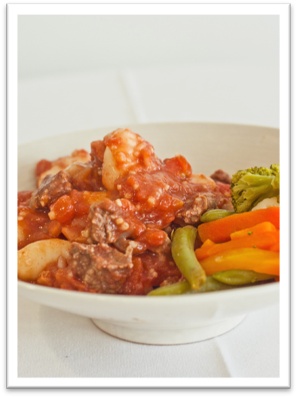 |  | 250g lean beef, diced  2 tsps garlic (fresh or dried)  2 pieces shortcut bacon, trimmed and diced  ½ onion, diced  1½ cups gnocchi*  400g can of diced tomatoes  2 tsps parsley (fresh or dried), coarsely chopped  1 tsp fresh basil, coarsely

Serves 2
Preparation Time 20 min
Cooking 20 min
Pita pizza
Method |  | Ingredients
1. Preheat oven to 200 degrees Celsius  2. Spread tomato paste onto the pita bread. Top the pita with your choice of toppings.  3. Bake for 10-15 minutes or until cheese is golden brown. Remove from oven and allow to cool slightly.  4. Cut pizza into 6 slices and sprinkle with dried mixed herbs (optional).  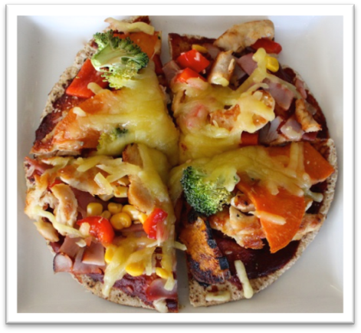 |  | Pita breads  Pineapple  Ham  Vegetables (e.g. sliced onion, mushrooms, zucchini, capsicum, corn kernels or leftover cooked potato)  Cheese  Mixed dried herbs
Variation
Another delicious idea is to cover the pizza or muffin base with leftover cooked chicken and vegetables, sprinkle with cheese and drizzle with sweet chilli sauce.

Serves 2
Preparation Time 10 min
Cooking Time 15 min
Pears and crusty crunchy crumble
Method |  | Ingredients
1. Preheat the oven to 180°C.  2. In a saucepan bring honey and orange juice to the boil. Reduce heat and allow to simmer for 2 minutes, before removing from the heat and setting aside.  3. Add breakfast biscuits, oats, nut pieces and cinnamon, stir well to combine.  4. Grease an oven-proof dish and place the pears in the dish.  5. Cover pears with topping mixture and bake at 180ºC for 15 minutes or until brown.  6. Serve with yoghurt.  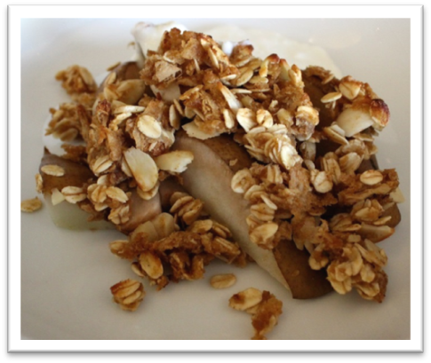 |  | ¼ cup honey  juice of 1 large orange  2 breakfast biscuits, lightly crushed (e.g. Weet-Bix®)  ¼ cup rolled oats  1 tb nut pieces (eg almond flakes)  ½ tsp cinnamon  2 pears (fresh/canned, in natural juice), halved  Serve with  1½ cups low-fat natural yoghurt

