Cooking for One or Two

Session 1: Food safety

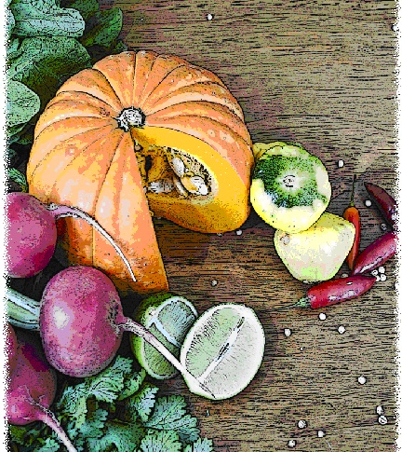

Contents
Objectives and overview 3
Session checklist 4
Ingredients list 5
Equipment 6
Room set up 8
Timeline 9
Introduction 10
Evaluation 12
Discussion: The importance of food safety 14
Group agreement 16
Discussion: Basic cooking skills 17
Food preparation 20
Enjoy a meal together 21
Thank you and conclusion 22
Session clean up 23
Handout 1: ‘How you cook can make you and others crook’ 24
Handout 2: How to read a recipe 25
Recipes 26

Objectives and overview
Session objectives
By the end of this session, participants will have:
- Demonstrated skills in safe food handing.
- Implemented safe food handling practices.
- Developed their food preparation skills through learning how to correctly hold a knife and chop ingredients.
- Enjoyed a meal with a group of new friends.

Session overview
Today’s discussion topics
- Food safety
- Practical cooking tips
Today you will be cooking:
- Beef stir-fry with rice
- Apple bread and butter pudding

Session checklist
Facilitator |  |  | Assistant
Collect groceries using session shopping list |  |  | Assist with grocery shopping where required
Arrive approximately 45 minutes prior to the start of the session |  |  | Arrive approximately 30 minutes prior to the start of the session
Read first aid instructions |  |  | Help with set up of equipment
Set up cooking equipment |  |  | Help with set up of room
Set up room |  |  | Assist the facilitator following all instructions in blue
Print out evaluation sheets |  |  | Help with washing up/cleaning
Facilitate the program following all instructions in green
Wash up/cleaning

Ingredients list
tsp = teaspoon
tb = tablespoon
 | To serve 2 people | To serve 4 people | To serve 6 people | To serve 8 people
Rice | ¾ cup | 1 ½ cups | 2 ¼ cups | 3 cups
Canola oil | 1 tb | 2 tbs | 3 tbs | 4 tbs
Lean beef | 250g | 500g | 750g | 1kg
Garlic (fresh or dried) | ½ tsp | 1 tsp | 1 ½ tsps | 2 tsps
Red chilli | ½ | 1 | 1 ½ | 2
Onion | ½ | 1 | 1 ½ | 2
Capsicum | ½ | 1 | 1 ½ | 2
Broccoli | ½ cup | 1 cup | 1 ½ cups | 2 cups
Corn (400g can) | 1/2 | 1 | 1 ½ | 2
Carrot | ½ | 1 | 1 ½ | 2
Cabbage | ¼ | ½ | ¾ | 1
Reduced-salt soy sauce | 1 tb | 2 tbs | 3 tbs | 4 tbs
Fish sauce | 2 tsps | 4 tsps | 6 tsps | 8 tsps
Spicy fruit loaf | 3 slices | 6 slices | 9 slices | 12 slices
Reduced-fat margarine | 2 tsps | 4 tsps | 6 tsps | 8 tsps
Sultanas | 2 tbs | 4 tbs | 6 tbs | 8 tbs
Pie apples(410g can) | ¼ | ½ | ¾ | 1
Cinnamon | ½ tsp | 1 tsp | 1 ½ tsps | 2 tsps
Reduced-fat milk | 1 cup | 2 cups | 3 cups | 4 cups
Egg | 1 | 2 | 3 | 4
Sugar | 2 tsps | 4 tsps | 6 tsps | 8 tsps
Vanilla essence | 1 tsp | 2 tsps | 3 tsps | 4 tsps
Nutmeg | ¼ tsp | ½ tsp | ¾ tsp | 1 tsp
Ice-cream | 2 scoops | 4 scoops | 6 scoops | 8 scoops

Equipment
For table one
3 cooks knives |  | Measuring cups
3 vegetable knives |  | Measuring spoons
3 wooden spoons |  | Small, medium and large bowls
3 serving spoons |  | Colander
Vegetable peelers |  | Chopping boards / Chux
Spatula |  | Oven proof dishes
Can opener |  | Cling wrap and baking paper
Whisk
For table two
Place dry ingredients on table; amount dependent on number of people in the group
For Refrigerator
Place ingredients that need to remain cool in the refrigerator; amount dependent on number of people in the group
For table three
Electric wok |  | Electric hot plates
Large saucepan |  | Oven Mitts
Heat proof mats |  | Extension cord (if necessary)
Thermometer
For the kitchen and washing up area
Oven |  | Pot scrub
Dish brush |  | Tea towels
Dish cloths |  | Washing up liquid
For food safety and washing hands
Liquid soap |  | Paper hand towels
For dining
Cutlery (knives, forks & spoons) |  | Serviettes
Plates |  | Cups
Bowls |  | Jug (with water)
Table Cloth
For refreshments (to be set up wherever deemed suitable)
Tea |  | Sugar
Coffee |  | UHT Milk
For discussion sessions and miscellaneous items
‘How you cook can make you and others crook’ Poster (Handout 1) |  | Recipes for Healthy Ageing Cookbook
How to read a recipe (Handout 2) |  | White board markers
Recipe cards |  | Pens
White board |  | Name tags
For occupational health and safety
St Johns First Aid Kit |  | Duct Tape to tape down electrical cords

Room set up
TABLE TWO
Place one table to the side for all ingredients to be displayed on.
TABLE THREE
Place electrical equipment here.
Place on side closest to power points. If extension cord is used ensure it is taped to the ground to prevent participants tripping and injuring themselves.
TABLE ONE
Set up a table with enough space for participants to stand around for food preparation in the centre of the room.
Set up all equipment other than electrical appliances at this table.
This table can later be set up for dining.

Timeline
 |  | Set up room, including table with ingredients, food preparation area, dining area and chairs and whiteboard for discussion (45 mins before session)
Start
session
Start  session |  | Introduction and safety (10 mins)
 |  | Evaluation (15 mins)
30 mins |  | Discussion: The importance of food safety (15 mins)
 |  | Group agreement (10 mins)
 |  | Discussion: Basic cooking skills (15 mins)
1 hr |  | Discussion: Basic cooking skills (15 mins)
 |  | Food Preparation (80 mins)
90 mins |  | Food Preparation (80 mins)
2 hrs |  | Food Preparation (80 mins)
150 mins |  | Enjoy a meal together (40 mins)
3 hrs  End |  | Enjoy a meal together (40 mins)
 |  | Thank you and conclusion (5 mins)
 |  | Session clean up (approx. 20-30 mins)
210 mins |  | Session clean up (approx. 20-30 mins)

Introduction |  | 10 minutes
The following section is to be conducted by the facilitator
1. Welcome the participants to Session One of the Cooking for One or Two program and ask them to sign the attendance sheet (Appendix C).
2. Introduce yourself and the assistant to the group.
3. Explain to the group that you will be facilitating each session of the Cooking for One or Two program.
4. Introduce the assistant. State they are kindly offering their time to assist with the sessions by helping with registration, evaluation, setting up and cleaning up.
5. Read the following explaining to the group what the Cooking for One or Two program is and the aims of the program:
 | What is the Cooking for One or Two program?
Cooking for One or Two is a program for older people living in the community. The program aims to improve your cooking skills. Whether you:
- Have never had the need to cook previously but now for your own reason find yourself cooking but do have the skills to do so.
- Have cooked throughout or at some stage of your life for family or friends but now are finding it difficult to adapt to cooking for one or two people.
- Want a refresher course.
Each session the group will cook an easy, quick and nourishing meal, including a main meal and dessert. It is not a cooking demonstration, but an opportunity for you to develop your cooking skills in a supportive environment. We will then enjoy the meal together. A different nutrition or health related topic will be discussed each week. The discussion aims to provide information on how to grow older healthily and add life to your years.
6. Explain to the group that all sessions are well planned to reduce risks, but it is still important to point out the safety risks including:
- The exits [point out to group] in case of fire.
- Fire blankets and fire extinguishers [point out to group] in case of fire.
- Emergency rally points.
- Electrical equipment and cords have been firmly taped down [point out all].
- The location of the first aid officer is [give location and person’s name].
- Being mindful of safe procedures when cutting and chopping food.
- Ask the group members if anyone has a food allergy [talk to them individually regarding their allergy].
- The bathrooms [give location].
7. Ask the group to inform you if there are any accidents or incidents or if they are feeling unwell.
8. Ask each participant to introduce themselves to the group and tell the group why they were interested in attending the program.
9. Thank the group for sharing their reasons for joining the program.
10. Outline Session One:
- Today we will be talking about evaluation of the program, food safety and basic cooking skills.
- We will be cooking beef stir-fry with rice and apple bread and butter pudding.
11. Reintroduce the assistant who will now be speaking about the evaluation.

Evaluation |  | 15 minutes
The following section is to be conducted by the assistant
1. Read the following explaining the evaluation to the group (this is only necessary if you choose to evaluate the program):
 | Purpose of evaluation
As part of conducting the Cooking for One or Two program we are interested in finding out what impact it has on your health and well-being. Therefore we need to ask you a series of questions, in a process called ‘evaluation’.
As part of this evaluation we are asking you to fill out a series of questionnaires about what you did before the program and asking the same questions at the end, so we can know what difference the program made to you.
Whether or not you complete these questions is totally up to you and you can choose not to complete them. You won’t be penalised in any way for not completing them.
Please do not put your name on any of the questionnaires as the evaluation will remain anonymous. We won’t even identify you in any way as having participated in the group when we present the results of the evaluation.
At this first session, your final session and eight weeks after the program, you will be given a questionnaire to complete. At eight weeks after the program you will either meet back as a group or receive the questionnaire in the mail. We ask that you please complete this form and return to your group facilitator or assistant.
Please note that as part of your consent to participate in the program (that form you signed) you have agreed to be recontacted for evaluation purposes but that doesn’t mean that you have to complete the questionnaires. You have the choice of whether or not to complete them.
2. Ask the participants if they have any questions about this.
3. Ask the participants to refer to the evaluation survey Session One. The second evaluation survey will be given out later (Session Five and eight weeks post-program). Continue to explain:
 | Evaluation questions
The first questionnaire consists of a series of questions that are broken down into general topics. These topics include questions about:
- You and your living situation
- Health and behaviour
- Skills and confidence in cooking
- Social networks and social engagement
The follow up questionnaire (to be conducted at the end of the program and eight weeks post program) consists of 20 questions and asks the above questions as well as some qualitative questions and questions related to the Recipes for Life cookbook.
If you don’t understand a question, please ask and I’ll explain it further.
4. Ask the participants to read through the questionnaires if they have not yet done so and continue to explain:
If you decide to fill them out, please complete each question, and we will allow plenty of time for you to do so.
If you decide not to fill them out, please turn to the last page and tick the box saying you do not wish to complete them.
5. Allow participants time to complete and collect. Check that every question has been completed and only one option for each question has been selected. If completed incorrectly ask participant to clarify.
6. Thank the participants for completing the evaluation and reintroduce the facilitator who will be presenting the discussion topic: Food Safety.

Discussion: The importance of food safety |  | 15 minutes
The following section is to be conducted by the facilitator
1. Introduce the discussion topic: “Today we will be discussing food safety…”
2. Read the following explaining to the group why food safety is important:
 | The importance of food safety
- It is important to have an understanding of how to prepare and store food correctly.
- Food has the potential to be very dangerous if it is not handled and prepared correctly, and can cause illness commonly known as food poisoning.
- If care is taken with the selection, handling, storage and preparation of food, food poisoning can be prevented.
- As you get older it becomes harder for your body to overcome food poisoning, therefore it is even more important to prevent it.
- It is important before cooking as a group to be aware of safe food practices that the group should follow.
3. Inform the group that food safety is also important when cooking at home, but today we will discuss food safety from the perspective of the group. A discussion on food safety in the home will follow in Session Five.
4. Read the following explaining to the group that food needs to be stored in ideal conditions:
 | Ideal conditions
- Food poisoning is caused by a multiplication of bacteria in food.
- Bacteria multiply in ideal conditions. Ideal conditions are dependent on three things; the food, the temperature and moisture.
- Food - certain foods, known as ‘high risk foods’ are more susceptible to growth of bacteria. This includes; chicken, fish, other seafood, eggs, meat, pâté, dairy food and cooked rice.
- Temperature - Bacteria also thrive in foods at temperatures between 5 and 60 degrees Celsius. This is known as the “danger zone”. Room temperature falls within this zone.
- Moisture - Bacteria need moisture to grow, so foods such as soups and stews are at greater risk.
5. Read the following out to explain to the participants how they can reduce the risk of food poisoning in the sessions of Cooking for One or Two using the poster on “How you cook can make you and others crook” (Handout 1)
 | Reducing the risk: Safe food practices for Cooking for One or Two
Beware the danger zone
- We must make sure high-risk foods stay in the right temperature zone as much as possible to slow down or prevent bacteria growth.
  - Hot foods should be kept above 60 degrees Celsius.
  - Cold foods should be kept between 0 and 5 degrees Celsius.
  - Frozen foods should be kept at -15 degrees Celsius.
  - Foods should not be kept between 5 and 60 degrees Celsius because this is the temperature at which bacteria thrive.
- In the group we will always keep cold foods in the refrigerator until needed for the recipe. We will also be testing the temperature of foods prior to serving to ensure they are above 60 degrees Celsius if a hot food and below 5 degrees Celsius if it is a cold food.
Don’t cross contaminate
- Raw foods such as raw meat and chicken should not come into contact with ready-to-eat foods such as fruits and vegetables. This means:
  - Thoroughly washing hands and utensils after handling raw foods.
  - Storing raw foods so they cannot make contact with other foods.
Wash your hands
- Wash hands and nails in warm, soapy water for 30 seconds before preparing food.
- Dry hands on a hand or paper towel - NOT the tea towel because they harbour bacteria.
- If you have any cuts or abrasions ensure they are covered by a waterproof band-aid or disposable gloves.
- Make sure you re-wash your hands and nails in warm soapy water for 30 seconds if you:
  - Handle raw meats, chicken, seafood, eggs and unwashed vegetables.
  - Cough, sneeze, blow or wipe your nose, or touch your ear, nose or mouth.
  - Go to the toilet.
  - Place rubbish in the garbage bin or touch the garbage bin.
  - Use any chemicals (e.g. oven cleaners, bleach, Windex etc).
Tell us if you are ill
- People handling food that are ill cause many food poisoning incidents.
- If you have or have recently had food poisoning, or symptoms of food poisoning including sore throat, vomiting and/or diarrhoea it is important that you tell us at the start of the session.
- If you have or have recently had such symptoms you will not be able to be directly involved in the food preparation, but are welcome to come to the session and observe.
6. Ask participants if they have any questions or comments regarding the discussion topic. Ask if anyone feels unwell or has recently had any of the described symptoms. If so, they will only be able to observe today.
7. Thank the group for their involvement in the discussion topic and pass back over to assistant.

Group agreement |  | 10 minutes
The following section is to be conducted by the assistant
1. Read the following explaining to the group that throughout the program all group members are to follow these tips for working together as a group.
 | Group agreement
- It is very important that we all agree to follow the safe food practices outlined today as we cook each meal over the next five weeks.
- It is very easy to forget some of the important steps to ensure foods are prepared safely, so we will all have to work as a group to do this.
- There are also some other important things we can do to ensure the group runs smoothly. This includes:
  - Listening to each other; this means trying to talk one at a time, and letting everyone have their say.
  - Supporting each other; you are all here to learn new skills so support each other in this endeavour.
  - Take care (consider your own and others safety) when using knives, hot equipment and food; try to prevent slips, trips, falls and heavy lifting.
  - The most important thing is for us all to have fun, whilst learning. The sessions should be a time for you to make friends.
It is important before we start the food preparation today that we all agree to work this way in our group.
2. Ask the group if they think these points sound fair.
3. If you have a whiteboard available, you might like to write the main points from the Group agreement up so the group can review them throughout the session.
4. Ask the group if they can think of any other important things we can do to work together as a group or make the most of the group and add any new points to the whiteboard.
5. Hand back over to the facilitator.

Discussion: Basic cooking skills |  | 15 minutes
The following section is to be conducted by the facilitator
1. Inform the group that you will first be going over some basic cooking skills before commencing food preparation.
2. Ask the group to stand around the food preparation table for this section and distribute the recipe cards they will be preparing today.
3. Read the following from the figure below explaining step-by-step how to read a recipe. Provide a copy to participants (Handout 2).
 | How to read a recipe
Method  Gives step by step instructions of how to complete a recipe  The steps should be followed in order from 1 to the last number. No steps should be skipped. | 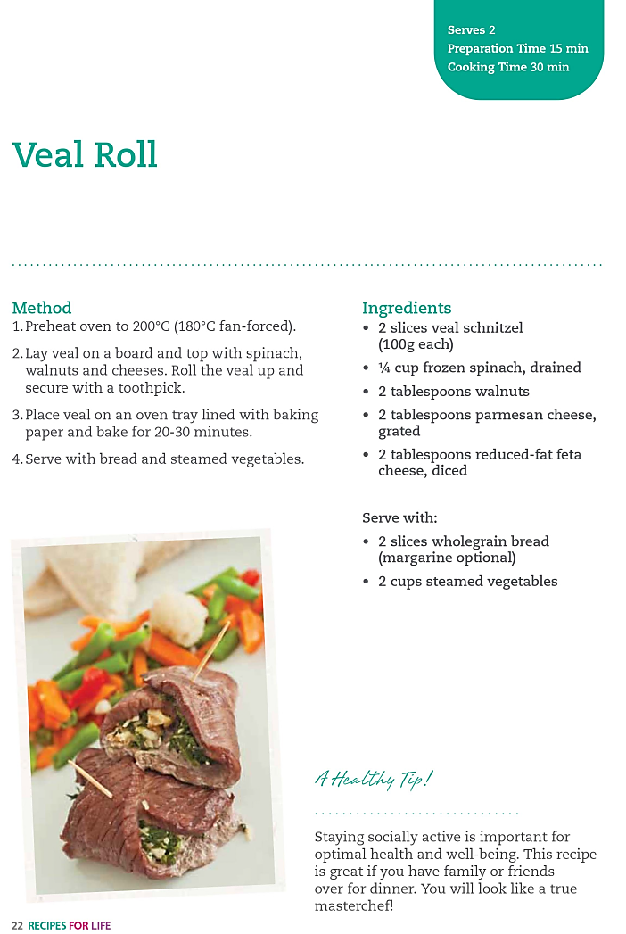  Ingredients list  Lists each of the required ingredients and what quantities of each are needed to make the dish.  All ingredients should be sat out onto a bench top or table prior to commencing cooking, except for those that need to be kept cold or hot.  Cooking time  Provides an estimate of how long the meal should take to cook following the instructions  Serving size  Provides an estimate of how many serves the recipe supplies  Preparation time  Provides an estimate of how long it should take to prepare the meal following the instructions.
4. Ask the participants to view the beef stir-fry with rice recipe handout and read out the following section out about preparing your ingredients and equipment:
 | Preparing your ingredients and equipment
- Before commencing cooking you should ensure you have all the ingredients in appropriate amounts for the group (see table at the start of the session for amounts for 2, 4, 6 and 8 group participants). This is quite easy as they are all listed in the ingredients list on the recipe.
- Before commencing cooking you should also ensure you have all the appropriate equipment required. This is a bit more difficult as it is often not listed in the recipe.
- Looking at the recipe for beef stir-fry with rice, if we go through the ingredient list and step-by-step instructions we can easily work out what equipment we need. For example; the recipe requires 250g lean beef, sliced. This will require scales to measure the beef, a knife to cut the beef into slices and a chopping board.
- Go through the recipe with the group; make sure they pick up all the equipment necessary for preparation and cooking. Show the participants the equipment from the cooking kit that they list.
5. Explain to the group that it is important that they use the equipment safely and that this is particularly important for knives.
6. Explain the importance of using the correct grip when using a knife to ensure you have control over the knife and secondly show the group how to hold a knife correctly (see below)
 | How to correctly hold a knife
The grip should be firm but relaxed. All fingers should be wrapped around the knife
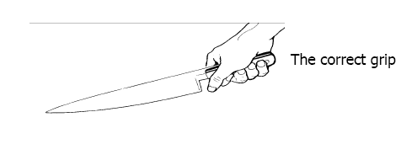
From Creating a Stir Kitchen Kit Teachers Manual Available at www.chdf.org.au/i-cms_file?page=4/KIKmanual2005.pdf Accessed 19/12/2005
7. Show the group how to use a knife correctly.
 | Using a knife correctly
Use your free hand to hold onto the piece of food so it will not slip.
The free hands fingers should be curled over so they cannot get caught under the blade.
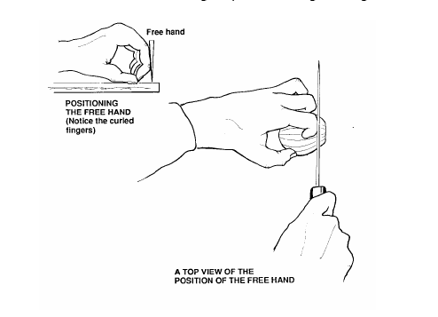
From Creating a Stir Kitchen Kit Teachers Manual Available at www.chdf.org.au/i-cms_file?page=4/KIKmanual2005.pdf Accessed 19/12/2005
8. Explain to the group to place a damp tea towel or small cloth under the chopping board to prevent any slipping
9. Ask the participants if they have any questions.

Food preparation |  | 80 minutes
The following section is to be conducted by the facilitator
While the facilitator leads the food preparation, the assistant can help participants with meal preparation and washing any equipment.
1. Introduce the participants to the food preparation session:
- Firstly we will be cooking beef stir-fry with rice
- Secondly we will be cooking apple bread and butter pudding.
2. Explain to the group that:
- Each member of the group will be assisting with the cooking process.
- You are there to guide the food preparation, but the group will be doing most of the work.
- If anyone has any questions or problems, please ask for help.
3. Ask the group to wash their hands before commencing food preparation.
 | As the theme of the discussion was food safety and also because it is the first session, participants may need reminding about the food safety practices they should follow.
4. Ask all participants to wash their hands.
5. Ask the participants to view the beef stir-fry with rice recipe card. Read the following recipe card explaining step-by-step to the group the recipe. Once you have read these steps give each participant a role in preparing the recipe according to these steps.
6. Ask participants to view the apple bread and butter pudding recipe card. Read the following recipe card explaining step-by-step to the group the recipe. Once you have read these steps give each participant a role in preparing the recipe according to these steps.

Enjoy a meal together | 40 minutes
The following section is to be conducted by the assistant
1. Set each participant, the facilitator and the assistant a place at the dining table. Use the table cloth, serviettes, crockery and cutlery to create an inviting space to share the meal together.
2. Enjoy!

Thank you and conclusion | 5 minutes
The following section is to be conducted by the facilitator
1. Congratulate the group on a job well done.
2. Ask the group to reflect on what they have learnt in their first session of Cooking for One or Two. Ask the group to share any new information or skills they have learnt.
3. Outline Session Two:
- Meal; Beef and gnocchi casserole; pita pizzas and pear with crusty crumble.
- Discussion topic; Malnutrition and creating a dinner with basics in your cupboard.
4. Ask two group members to stay and assist with the washing up and packing up of equipment.
5. Remind participants who volunteered to clean up that it shouldn’t take long and their help is appreciated. Direct volunteers on what needs to be cleaned.

Session clean up | 30 minutes
The following section is to conducted by the assistant
1. When cleaning up, it is important that you use hot soapy water, and refill the sink once the water has become either warm or discoloured (dirty). At all stages in the washing up process please be mindful of sharp objects being left in the water.
2. All equipment must be washed and sanitised prior to being packed away for the next session. It is also important that all equipment goes back to where it was found. It is the facilitator’s role to assist the assistant and participants with this.

Handout 1: ‘How you cook can make you and others crook’
from the Food Safety Information Council Australia (http://www.foodsafety.asn.au/wp-content/uploads/2012/02/NewcrookPoster_A2.pdf)

Handout 2: How to read a recipe
 | How to read a recipe
Serving size  Provides an estimate of how many serves the recipe supplies  Method  Gives step by step instructions of how to complete a recipe  The steps should be followed in order from 1 to the last number. No steps should be skipped. | 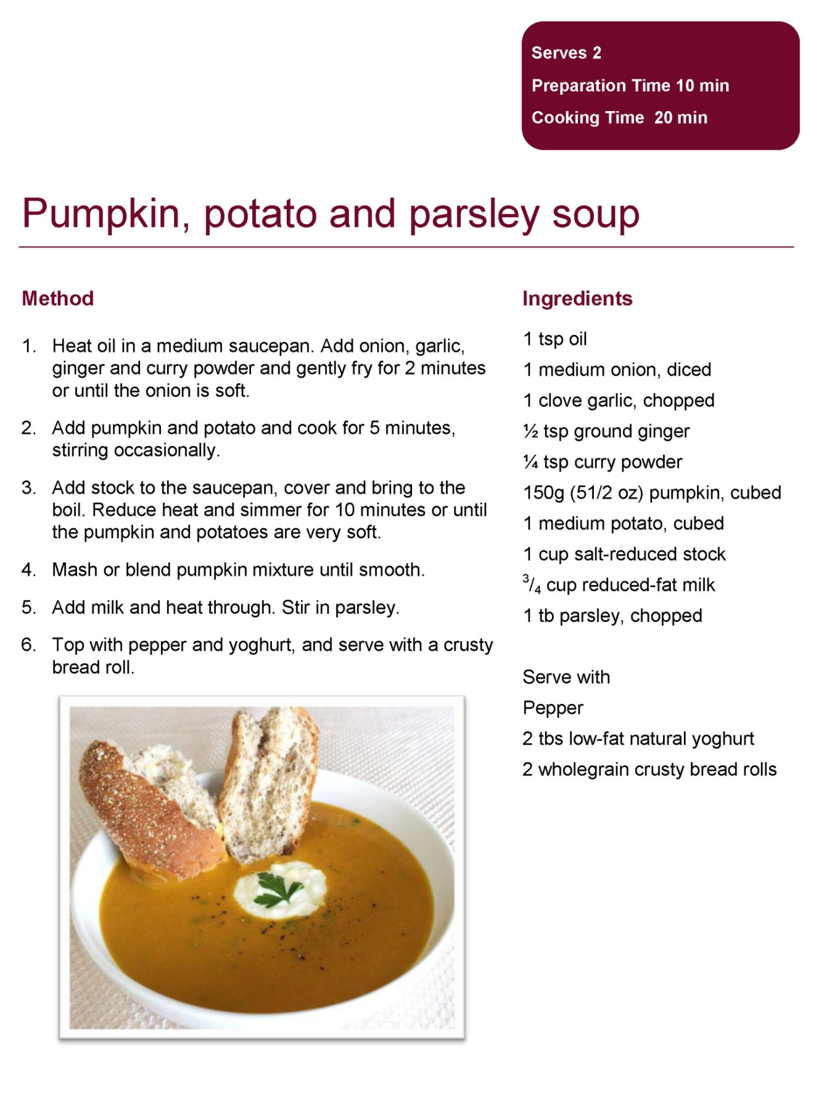  Preparation time  Provides an estimate of how long it should take to prepare the meal following the instructions.  Ingredients list  Lists each of the required ingredients and what quantities of each are needed to make the dish.  All ingredients should be sat out onto a bench top or table prior to commencing cooking, except for those that need to be kept cold or hot.  Cooking time  Provides an estimate of how long the meal should take to cook following the instructions

Recipes
Serves 2
Preparation Time 20 min
Cooking Time 20 min
Beef stir-fry
Method |  | Ingredients
1. Follow rice cooking instructions in the rice cooking recipe card.  2. Heat oil in a wok or fry pan over high heat, add beef and cook until browned. Remove and set aside.  3. Add the garlic, chilli, onion, capsicum, broccoli, corn and carrot to the wok and cook for 3 minutes.  4. Return the beef to the wok. Add cabbage, soy sauce and fish sauce. Cook for 2 minutes.  5. Serve stir fry with rice.  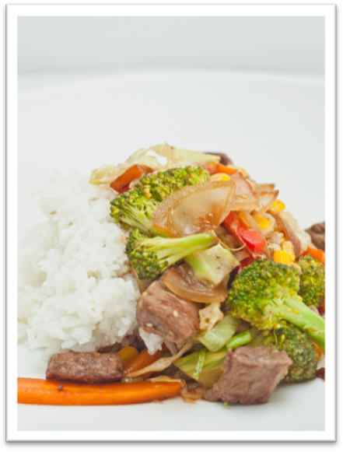 |  | ³/₄$\frac{3}{4}$ cup rice  1 tb canola oil  250g lean beef, sliced  ½ tsp garlic (fresh or dried)  ½ red chilli, thinly sliced*  ½ onion, sliced  ½ capsicum, sliced  ½ cup broccoli, chopped  200g canned corn  ½ carrot, sliced  ¼ cabbage, shredded  1 tb reduced-salt soy sauce  2 tsps fish sauce

Serves 2 cups cooked rice
Preparation Time see options
Cooking Time see options
Cooked rice (makes 2 cups)
On the Stove Top |  | In the Microwave
1. Place 1 cup (200g) of rice in a saucepan. Add 1½ cups (375mL) of cold water.  2. Reduce heat and simmer covered for 12-14 minutes.  3. Remove from heat and set aside, covered for 5-10 minutes.  4. Use a fork to separate the grains and serve. |  | 1. Place 1 cup (200g) of rice in a microwave-safe bowl. Add 1½ cups (375mL) of cold water. Place lid on top.  2. Cook on High (800 watts or 100%) for 5 minutes, then cook on Medium (500 watts or 50%) for a further 7 minutes.  3. Set aside, covered, for 3 minutes. Use a fork to separate the grains and serve.

Apple bread and butter pudding
Method |  | Ingredients
1. Preheat oven at 180ºC  2. Spread bread with margarine, cut into quarters and place half in a small greased ovenproof dish.  3. Sprinkle sultanas, apples and cinnamon on the bread, and add the remaining slices of bread on top.  4. Combine milk, egg, sugar and vanilla in a bowl, beat and pour over bread.  5. Sprinkle with nutmeg and bake at 180ºC for 30-40 minutes or until custard has set.  6. Serve hot.  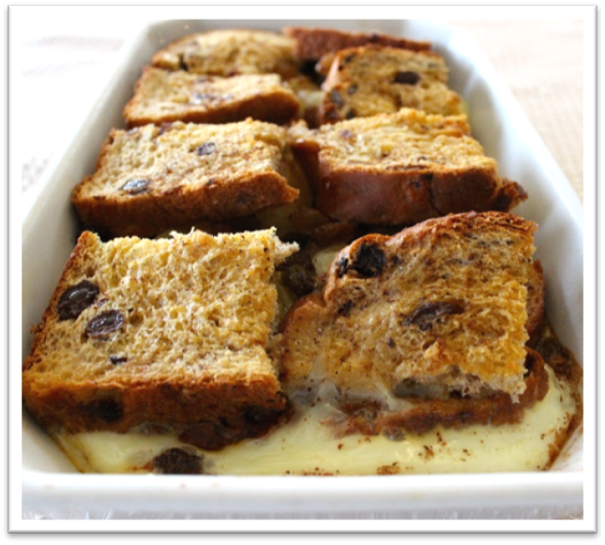 |  | 3 slices of spicy fruit loaf  2 tsps reduced-fat margarine  2 tbs sultanas  ¼ x 410g can pie apples  ½ tsp cinnamon  1 cup reduced-fat milk  1 egg  2 tsps sugar  1 tsp vanilla essence  ¼ tsp nutmeg  Serve with:  200g low-fat yoghurt or 2 scoops of reduced-fat ice-cream

