Cooking for One or Two
Masterclasses

Slow Cooking
Session 2

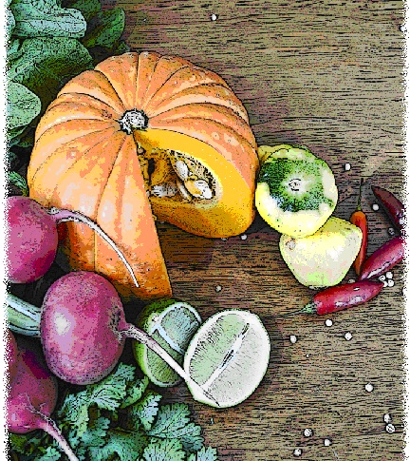

Contents
Objectives and overview 3
Session checklist 4
Ingredients list 5
Equipment 6
Room set up 8
Timeline 9
Introduction 10
Group agreement 11
Food preparation 12
Discussion: Food temperatures and safety 14
Discussion: Converting traditional recipes into those suitable for the slow cooker 16
Food preparation 18
Enjoy a meal together 18
Evaluation 19
Thank you and conclusion 20
Session clean up 20
Recipes 21
Handouts 24
Handout 1: How you cook can make you and others crook 24
Handout 2: Conversion of traditional to slow cooker recipes 25
Handout 3: Additional recipes 26

Objectives and overview
Session objectives
By the end of this session, participants will have:
- Understood how to store cooked food.
- Learnt how to adapt traditional recipes into recipes suitable for the slow cooker.
- Developed their cooking skills on using a slow cooker.
- Developed food preparation skills.
- Enjoyed a meal with new friends.

Session overview
Today’s discussion topics
- Food temperatures and safety
- How to convert traditional recipes into those cooked in a slow cooker
Today you will be cooking:
- Vegetable and lentil curry
- Chicken korma
- Mixed berry cobbler

Session checklist
Facilitator |  |  | Assistant
Collect groceries using session shopping list |  |  | Assist with grocery shopping where required
Arrive approximately 45 minutes prior to the start of the session |  |  | Arrive approximately 30 minutes prior to the start of the session
Read first aid instructions |  |  | Conduct safety checklist for the venue
Set up cooking equipment |  |  | Help with set up of equipment
Set up room |  |  | Help with set up of room
Print handouts for each participant |  |  | Facilitate the program following all instructions in blue
Download the video clips prior to the session |  |  | Help with washing up/cleaning
Photocopy appropriate evaluation sheets for session (if required; Appendix A)
Facilitate the program following all instructions in green
Wash up/cleaning

Ingredients list
tsp = teaspoon
tb = tablespoon
 | To serve 2 people | To serve 4 people | To serve 6 people | To serve 8 people
Cooking oil | 1 tb | 2 tbs | 3 tbs | 4 tbs
Chicken breast | 250g | 500g | 750g | 1kg
Brown onion | 1 ½ | 3 | 4 | 5
Garlic cloves | 2 ½ | 5 | 7 ½ | 10
Chilli powder | ¼ tsp | ½ tsp | ¾ tsp | 1 tsp
Ginger powder | 1 tsp | 2 tsps | 3 tsps | 4 tsps
Korma paste | 2 tbs | ¼ cup | 1/3 cup | ½ cup
Carrot (medium) | 1 | 1½ | 2 | 2½
Zucchini (medium) | ½ | 1 | 1½ | 2
Broccoli | ½ | 1 | 1½ | 2
Salt reduced chicken stock | ½ cup | 1 cup | 1½ cups | 2 cups
Salt-reduced tomato paste | 2 tbs | ¼ cup | 1/3 cup | ½ cup
Extra light thickened cream | ¼ cup | ½ cup | ¾ cup | 1 cup
Wholemeal self-raising flour | ¼ cup | ½ cup | ¾ cup | 1 cup
Caster sugar | ¼ cup | ½ cup | ¾ cup | 1 cup
Cinnamon | Pinch | Pinch | Pinch | ½ Tsp
Salt | Pinch | Pinch | Pinch | Pinch
Egg | ½ | 1 | 1½ | 2
Reduced-fat milk | 3 tsps | 2 tbs | 3 tbs | ¼ cup
Vanilla extract | ¼ tsp | ½ tsp | ¾ tsp | 1 tsp
Frozen mixed berries | 1 cup | 2 cups | 3 cups | 4 cups
Cooking oil spray | Light spray | Light spray | Light spray | Light spray
Capsicum | ¼ | ½ | ¾ | 1
Celery | 1 | 2 | 3 | 4
Curry powder | ¼ tsp | ½ tsp | ¾ tsp | 1 tsp
Diced tomatoes (410g can) | 1 | 2 | 3 | 4
Red lentils | ¼ cup | ½ cup | ¾ cup | 1 cup

Equipment
For table one
3 cooks knives |  | Measuring cups
3 vegetable knives |  | Measuring spoons
3 wooden spoons |  | Small, medium and large bowls
3 serving spoons |  | Colander
Vegetable peelers |  | Chopping boards / Chux
Spatula |  | Oven proof dishes
Can opener |  | Cling wrap and baking paper
Whisk |  | Foil
Juicer |  | Microwave safe bowls
Grater
For table two
Place dry ingredients on table; amount dependent on number of people in the group
For refrigerator
Place ingredients that need to remain cool in the refrigerator; amount dependent on number of people in the group
For table three
Electric wok |  | Electric hot plates
Large saucepan |  | Oven
Heat proof mats |  | Oven Mitts
Thermometer |  | Slow cookers
Extension cord (if necessary)
For the kitchen and washing up area
Tea towels |  | Washing up liquid
Dish brush |  | Pot scrub
Dish cloths
For food safety and washing hands
Liquid soap |  | Paper hand towels
For dining
Cutlery (knives, forks & spoons) |  | Serviettes
Plates |  | Cups
Bowls |  | Jug (with water)
Table Cloth
For refreshments (to be set up wherever deemed suitable)
Tea |  | Sugar
Coffee |  | UHT Milk
For discussion sessions and miscellaneous items
Printed copy of evaluation form (if required; Appendix A) |  | Name tags
White board |  | Attendance sheet
White board markers |  | Recipe cards
Pens |  | Handout 1: “How you cook can make you and others crook”
Handout 2: “Conversion of traditional to slow cooker recipes” |  | Handout 3: Additional recipes
For occupational health and safety
St Johns First Aid Kit |  | Duct tape to tape down electrical cords

Room set up
TABLE TWO
Place one table to the side for all ingredients to be displayed on.
TABLE THREE
Place electrical equipment here.
Place on side closest to power points. If extension cord is used ensure it is taped to the ground to prevent participants tripping and injuring themselves.
TABLE ONE
Set up a table with enough space for participants to stand around for food preparation in the centre of the room.
Set up all equipment other than electrical appliances at this table.
This table can later be set up for dining.

Timeline
 |  | Set up room, including table with ingredients, food preparation area, dining area and chairs and whiteboard for discussion (45 mins before session)
Start
session
Start  session |  | Introduction and safety (10 mins)
 |  | Group agreement (5 mins)
 |  | Food preparation (80 mins)
30 mins |  | Food preparation (80 mins)
1 hr |  | Food preparation (80 mins)
90 mins |  | Food preparation (80 mins)
 |  | Food temperature and safety (35 mins)
2 hrs |  | Food temperature and safety (35 mins)
 |  | Converting traditional recipes into those suitable for the slow cooker (35 mins)
150 mins
 |  | Food preparation (20 mins)
3 hrs |  | Food preparation (20 mins)
 |  | Enjoy a meal together (40 mins)
210 mins |  | Enjoy a meal together (40 mins)
 |  | Evaluation (5 mins)
4 hrs |  | Thank you and conclusion (5 mins)
4 hrs |  | Session clean up (approx. 20-30 mins)

Introduction | 10 minutes
The following section is to be conducted by the facilitator
1. Welcome the participants to Session two of the ‘Slow cooking’ masterclass as part of the Cooking for One or Two program. Ask all participants to sign the attendance sheet (see main manual for more information).
2. Re-introduce yourself and the assistant to the group.
3. Explain to the group that all sessions are well planned to reduce risks, but it is still important to point out the safety risks including:
- The exits [point out to group] in case of fire.
- Fire blankets and fire extinguishers [point out to group] in case of fire;
- Emergency rally points.
- Electrical equipment and cords have been firmly taped down [point out all].
- The location of the first aid officer (if the facility has one).
- Being mindful of safe procedures when cutting and chopping food.
- The bathrooms [give location].
4. Ask the group to inform you if there are any accidents or incidents or if they are feeling unwell.
5. Outline the content of session two:
- Food temperatures and safety.
- How to convert traditional recipes into those cooked in a slow cooker.

Group agreement |  | 5 minutes
The following section is to be conducted by the assistant
1. Read the following explaining to the group that throughout the program all group members are to follow these tips for working together as a group.
 | Group agreement
- It is very important that we all agree to follow the safe food practices outlined today as we cook each meal over the next two weeks.
- It is very easy to forget some of the important steps to ensure foods are prepared safely, so we will all have to work as a group to do this.
- There are also some other important things we can do to ensure the group runs smoothly. This includes:
  - Listening to each other; this means trying to talk one at a time, and letting everyone have their say.
  - Supporting each other; you are all here to learn new skills so support each other in this endeavour.
  - Take care (consider your own and others safety) when using knives, hot equipment and food; try to prevent slips, trips, falls and heavy lifting.
  - The most important thing is for us all to have fun, whilst learning. The sessions should be a time for you to make friends.
It is important before we start the food preparation today that we all agree to work this way in our group.
2. Ask the group if they think these points sound fair.
3. If you have a whiteboard available, you might like to write the main points from the group agreement up so the group can review them throughout the session.
4. Ask the group if they can think of any other important things we can do to work together as a group or make the most of the group and add any new points to the whiteboard.
5. Hand back over to the facilitator.

Food preparation |  | 80 minutes
The following section is to be conducted by the facilitator
While the facilitator leads the food preparation, the assistant can help participants with meal preparation and washing any equipment.
1. Introduce the participants to the food preparation session:
- Firstly we will be starting the chicken korma
- Secondly we will start the vegetable and lentil curry
- Thirdly we will start the mixed berry cobbler
2. Explain to the group that:
- Each member of the group will be assisting with the cooking process;
- You are there to guide the food preparation, but the group will be doing most of the work;
- If anyone has any questions or problems, please ask for help.
3. Ask the participants to view the chicken korma recipe card. Read the recipe card explaining step-by step the recipe. Once you have read these instructions give each participant a role in preparing the recipe according to these steps.
4. Ask the group to wash their hands before commencing food preparation.
 | Chicken korma
1. Heat oil in a saucepan on medium heat. Brown the chicken and then place in the slow cooker.
2. In a separate bowl, add onion, garlic, chilli powder, ginger and korma paste. Mix well. Add the mixture into the slow cooker. Stir well with chicken.
3. Add the carrots, zucchini, broccoli, chicken stock and tomato paste into the slow cooker.
4. Cover and cook on HIGH for 2 hours.
5. Ask participants to view the lentil and vegetable curry recipe card. Read the recipe card explaining step-by-step the recipe. Once you have read these instructions give each participant a role in preparing the recipe according to these steps.
 | Lentil and vegetable curry
1. Place onion, celery, carrot, capsicum, garlic, lentils, curry powder and tinned tomatoes in slow cooker.
2. Cover and cook on high for 3 hours.
6. Ask participants to view the mixed berry cobbler recipe card. Read the recipe card explaining step-by-step the recipe. Once you have read these instructions give each participant a role in preparing the recipe according to these steps.
 | Mixed berry cobbler
1. Defrost mixed berries and drain excess liquid.
2. Combine the flour, sugar, cinnamon and salt in a bowl and mix well.
3. Stir in the eggs, cooking oil, milk and vanilla.
4. Grease the slow cooker bowl with cooking spray.
5. Spread batter evenly into the slow cooker, and place berries over batter.
6. Cook on HIGH for 1½ hours.

Discussion: Food temperatures and safety |  | 35 minutes
The following section is to be conducted by the facilitator
1. Inform the group that we will be talking about food temperatures and safety.
2. Ask the participants to refer to Handout 1 “How you cook can make you and others crook”.
3. Read the following information taken from the food temperatures and safety discussion in session 5 in the Cooking for One or Two manual to the group:
 | Food temperatures and safety
- Most importantly when storing food you need to keep foods out of the Danger Zone.
- Cold foods should be kept at less than 5 degrees Celsius (in the fridge or freezer).
- Hot foods should be kept at greater than 60 degrees Celsius (heated).
- The danger zone is between 5 and 60 degrees Celsius which room temperature falls into.
- When you have cooked food and you want to store it:
  - Put hot food in shallow dishes or serving sizes to cool the food as quick as possible;
  - Don’t put the food in the refrigerator when it is steaming hot, wait until the steam has stopped rising from the food;
  - If you know that you are not going to eat the food for a few days, freeze it rather than storing it in the refrigerator;
  - Label your storage containers with the name of the food and date of preparation so you can keep track of what you have;
  - Frozen foods should be thawed out of the temperature danger zone- so this means not thawing foods by leaving them out on the bench top. Food should be thawed in the refrigerator or using a microwave. If you use the microwave the food should be cooked immediately afterwards.
- Once a frozen food has been thawed out, it should not be refrozen.
- When storing food in the refrigerator or cupboard they should be in leak proof packages. This includes:
  - Food not being stored in the refrigerator in open cans;
  - Using containers with lids, or covering with cling wrap or foil;
  - Using clean containers in good condition that are only used for food storage.
4. The facilitator will now demonstrate how to label food correctly for safe storage.
Step 1: Write in permanent marker on a white sticker or piece of paper
- the name of food and date of packaging
i.e. lentil and vegetable curry 16/11/2013.
Step 2: Place the sticker or paper on the lid of the freezer container that will hold the food.
Step 3: Secure the sticker or paper with clear adhesive tape to the container.
Step 4: Fill the container (~3/4 full) and place in the freezer.
5. Ask the group if they have any questions.

Discussion: Converting traditional recipes into those suitable for the slow cooker |  | 35 minutes
The following section is to be conducted by the facilitator
1. Ask participants to refer to Handout 2 “Conversion of traditional to slow cooker recipes”.
2. Read the following, explaining how to convert traditional recipes to those that can be cooked in a slow cooker:
 | Converting traditional recipes into those suitable for the slow cooker
There are a few things that you will need to consider when you alter your favourite recipe to be slow cooked. You need to be aware that not all dishes will successfully be re-created in the slow cooker. If an original recipe is supposed to be cooked or baked uncovered, it is more than likely that the recipe won’t be successfully transformed to a slow cooker recipe, even if the recipe has liquid in it. This is because the food won’t brown or the liquid evaporate in a slow cooker.
Before converting recipes, you may want to locate a recipe similar to the one you want to convert and use it as a guide. You should pay particular attention to the quantity and size of meat and vegetable pieces, whether it is uses a low or high heat setting and the amount of cooking time and liquid required.
The dry ingredients in your favourite recipe will remain the same when cooked in the slow cooker, however the proportion of liquid will change as there is no evaporation. For stews and braised dishes you will need to reduce the amount of liquid by half. For soups if your original recipe says to simmer uncovered, reduce the amount of liquid by 1/3, however if the original recipe says to simmer covered, reduce the liquid by 1/4.
The cooking time on your original recipe will also need to be adjusted. In general, 1 hour of simmering on the stove top or baking at 180°C in the oven is equal to 6-8 hours on low or 3-4 hours on high in a slow cooker. See the chart on your handout.
Other hints when on converting your recipes are:
- Brown your meat on the stove top before placing in the slow cooker. This will enhance the flavour and keep the meat succulent.
- If the original recipe uses ground herbs, replace these and use the leaf varieties as when you use the slow cooker and cook food for a long period of time the herbs lose their flavour. Also add more herbs before serving to increase the flavour.
- Place root vegetables such as carrot, sweet potato and potato in your slow cooker first and put at the bottom of your slow cooker as these take longer to cook
- Add dairy products in the last hour of cooking to prevent it from curdling. If this isn’t possible you can replace with evaporated milk at the start of the cooking process as this won’t curdle.
- Add fish and seafood in the last hour of cooking to prevent it from overcooking and falling apart.
- To ensure everything cooks correctly make sure the slow cooker is filled between half to three-quarters full.
- If the original recipe contains rice or pasta, cook this separately and stir through the slow cooked dish prior to serving.
- If your dish contains a lot of liquid near the end of the cooking time, add some corn flour to thicken.
3. Ask the group if they have any questions.

Food preparation |  | 20 minutes
The following section is to be conducted by the facilitator
While the facilitator leads the food preparation, the assistant can help participants with meal preparation and washing any equipment.
1. Introduce the group to the second part of the food preparation where they will finish preparing the lentil and vegetable curry, chicken korma and mixed berry cobbler.
2. Ask the group to get their copies of the recipe cards, and wash their hands before commencing food preparation.
3. Give each participant a role in preparing the lentil and vegetable curry recipe according to these steps.
 | Vegetable and lentil curry
1. When the curry becomes thick and vegetables are tender it is ready to be served.
2. Serve with bread.
4. Give each participant a role in preparing the chicken korma recipe according to these steps.
 | Chicken korma
1. Cook the rice according to the recipe handout.
2. Add the cream once the chicken korma is cooked and stir well.
3. Serve korma with rice.
5. Give each participant a role in preparing the mixed berry cobbler recipe according to these steps.
 | Mixed berry cobbler
1. When you think the cobbler is ready insert a fork in the centre. If this comes out clean the cobbler is ready to serve.
2. Serve with yoghurt or ice-cream.

Enjoy a meal together | 40 minutes
The following section is to be conducted by the assistant
1. Set each participant, the facilitator and the assistant a place at the dining table. Use the table cloth, serviettes, crockery and cutlery to create an inviting space to share the meal together.
2. Enjoy!

Evaluation |  | 5 minutes
The following section is to be conducted by the assistant
1. Read the following explaining the evaluation to the group (this is only necessary if you choose to evaluate the program):
 | Purpose of evaluation
As part of conducting the Cooking for One or Two program we are interested in finding out what impact it has on your health and well-being. Therefore we ask a series of questions at the end of the two week program, in a process called ‘evaluation’.
Whether or not you complete these questions is totally up to you and you can choose not to complete them. You won’t be penalised in any way for not completing them.
Please do not put your name on any of the questionnaires as the evaluation will remain anonymous. We won’t even identify you in any way as having participated in the group when we present the results of the evaluation.
Please note that as part of your consent to participate in the program (that form you signed) you have agreed to be recontacted for evaluation purposes but that doesn’t mean that you have to complete the questionnaires. You have the choice of whether or not to complete them.
2. Ask the participants if they have any questions about this.
3. Ask the participants to refer to the evaluation survey. Continue to explain:
 | Evaluation questions
The questionnaire consists of three questions on general topics. These topics include questions about:
- Variety in your diet
- Cooking ability
- Social interactions
If you don’t understand a question, please ask and I’ll explain it further.
4. Ask the participants to read through the questionnaire if they have not yet done so and continue to explain:
 | If you decide to fill them out, please complete each question, and we will allow plenty of time for you to do so.
5. Allow participants time to complete and collect. If completed incorrectly ask participant to clarify.
6. Thank the participants for completing the evaluation and reintroduce the facilitator who will close the session.

Thank you and conclusion | 5 minutes
The following section is to be conducted by the facilitator
1. Congratulate the group on a job well done and for completing the program.
2. Ask the group to reflect on what they have learnt in their second session of ‘Slow Cooking’. Ask the group to share any new information or skills they have learnt.

Session clean up | 30 minutes
The following section is to conducted by the assistant
1. When cleaning up, it is important that you use hot soapy water, and refill the sink once the water has become either warm or discoloured (dirty). At all stages in the washing up process please be mindful of sharp objects being left in the water.
2. All equipment must be washed and sanitised prior to being packed away. It is also important that all equipment goes back to where it was found.

Recipes
Serves 8
Preparation Time 20 mins
Cooking Time 2 hours
Chicken korma
Method |  | Ingredients
1. Heat oil in a saucepan on medium heat. Brown the chicken and then place in the slow cooker.  2. In a separate bowl, add onion, garlic, chilli powder, ginger and korma paste. Mix well. Add the mixture into the slow cooker. Stir well with chicken.  3. Add the carrots, zucchini, broccoli, chicken stock and tomato paste into the slow cooker.  4. Cover and cook on HIGH for 2 hours.  5. Add the cream once cooked and stir well.  6. Serve with rice.  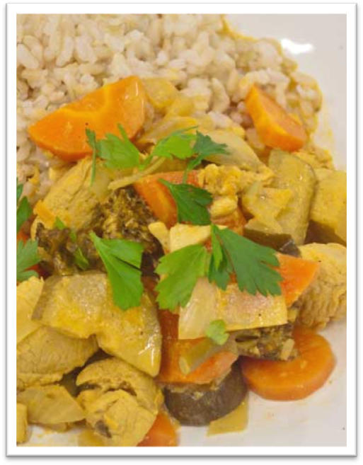 |  | 2 tablespoons cooking oil  1kg chicken breast, diced  3 medium brown onions, diced  6 cloves garlic, diced  1 teaspoon chilli powder  4 teaspoons ginger powder  ½ cup korma paste  2 medium carrots, sliced  2 medium zucchinis, sliced  3 cups broccoli  2 cups salt-reduced chicken stock  ½ cup salt-reduced tomato paste  1 cup extra light thickened cream  Serve with:  4 cups cooked brown rice

Serves 8
Preparation Time 25 minutes
Cooking Time 3 hours
Mixed berry cobbler
Method |  | Ingredients
1. Defrost mixed berries and drain excess liquid.  2. Combine the flour, sugar, cinnamon and salt in a bowl and mix well.  3. Stir in the eggs, cooking oil, milk and vanilla.  4. Grease the slow cooker bowl with cooking spray. Spread batter evenly into the slow cooker. Spread berries over batter.  5. Cook on HIGH for 1.5 hours or until a fork inserted into cobbler comes out clean.  6. Serve with yoghurt or ice-cream.  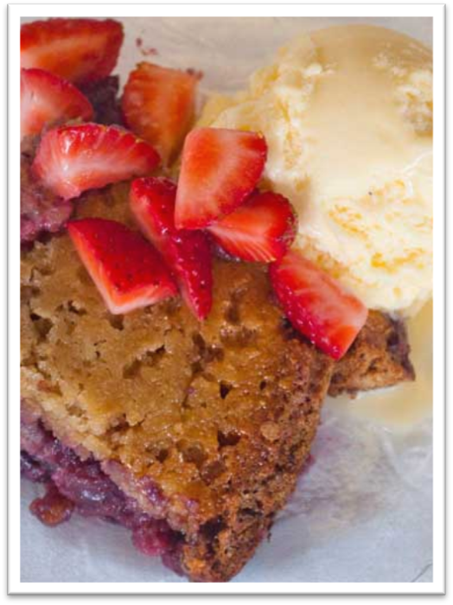 |  | 1 cup wholemeal self-raising flour  1 cup caster sugar  ½ teaspoon ground cinnamon  Pinch of salt  2 large eggs, lightly beaten  2 tablespoons cooking oil  ¼ cup reduced-fat milk  1 teaspoon vanilla extract  Cooking oil spray  4 cups frozen mixed berries, thawed  Serve with:  400g low-fat yoghurt or 8 scoops of reduced-fat ice-cream

Serves 8
Preparation Time 25 mins
Cooking Time 3 hours
Vegetable and lentil curry
Method |  | Ingredients
1. Place onion, celery, carrot, capsicum, garlic, lentils, curry powder and tinned tomatoes in slow cooker.  2. Cover and cook on high for 3 hours or until curry becomes thick and vegetables are tender.  3. Serve with bread.  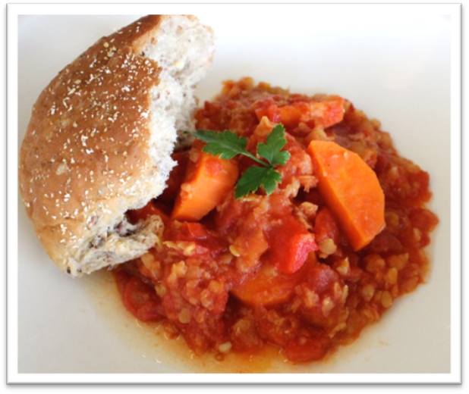 |  | 1 large capsicum, diced  3 carrots, peeled and sliced  2 medium onions, diced  3 stalks of celery, sliced  4 cloves garlic, crushed  1 teaspoon curry powder  4x 400g can diced tomatoes  230g (1 cup) red lentils  Serve with:  1 whole grain bread stick or 8 small wholemeal crusty bread rolls

Handouts

Handout 1: How you cook can make you and others crook
from the Food Safety Information Council Australia (http://www.foodsafety.asn.au/wp-content/uploads/2012/02/NewcrookPoster_A2.pdf)

Handout 2: Conversion of traditional to slow cooker recipes

How to convert your favourite traditional recipe for the slow cooker
The dry ingredients in your favourite recipe will remain the same when cooked in the slow cooker, however the proportion of liquid will change as there is no evaporation.
For stews and braised dishes
- reduce the amount of liquid by half.
For soups
- if your original recipe says to simmer uncovered, reduce the amount of liquid by 1/3
- if the original recipe says to simmer covered, reduce the liquid by 1/4.
Other hints when on converting your recipes are:
- Brown your meat on the stove top before placing in the slow cooker. This will enhance the flavour and keep the meat succulent.
- If the original recipe uses ground herbs, replace these and use the leaf varieties as when you use the slow cooker and cook food for a long period of time the herbs lose their flavour. Also add more herbs before serving to increase the flavour.
- Place root vegetables such as carrot, sweet potato and potato in your slow cooker first and put at the bottom of your slow cooker as these take longer to cook
- Add dairy products in the last hour of cooking to prevent it from curdling. If this isn’t possible you can replace with evaporated milk at the start of the cooking process as this won’t curdle.
- Add fish and seafood in the last hour of cooking to prevent it from overcooking and falling apart.
- To ensure everything cooks correctly make sure the slow cooker is filled between half to three-quarters full.
- If the original recipe contains rice or pasta, cook this separately and stir through the slow cooked dish prior to serving.
- If your dish contains a lot of liquid near the end of the cooking time, add some corn flour to thicken.
Cooking time for conventional recipe | Cooking time for slow cooker
15 to 30 minutes | Low: 4 to 6 hours  High: 1½ to 2 hours
35 to 45 minutes | Low: 6 to 8 hours  High: 3 to 4 hours
50 minutes or more | Low: 8 to 10 hours  High 4 to 6 hours

Handout 3: Additional recipes
Serves: 8
Preparation Time: 25 mins
Cooking Time: 4-8 hours
Thai Style massaman beef curry
Method |  | Ingredients
1. Heat oil in a frying pan on medium heat. Add the beef and cook until browned. Remove beef from frying pan and place in slow cooker.  2. In a small bowl, add the garlic, curry paste, coconut milk and stock. Mix well.  3. Add mixture and potatoes to slow cooker.  4. Cover and cook on HIGH for 4 hours or LOW for 8 hours.  5. Stir in the fish sauce at the end of the cooking time.  6. Serve with rice and steamed vegetables.  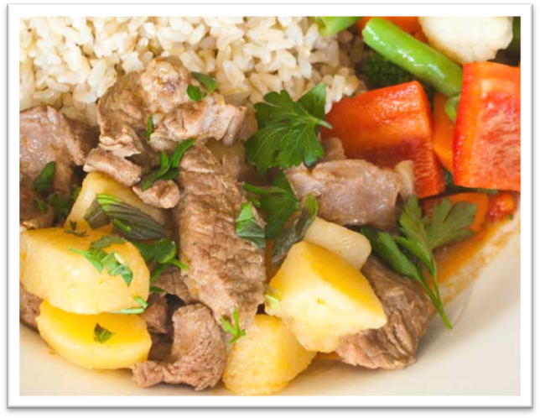 |  | 2 tablespoons cooking oil  1kg chuck or boneless shin beef, diced  3 cloves garlic, crushed  ¹/₃ cup massaman curry paste  2 1/2 cups salt-reduced beef stock  200ml coconut milk  3 medium potatoes, peeled and cubed  2 teaspoons fish sauce  Serve with:  4 cups cooked brown rice  6-8 cups steamed vegetables

Serves: 8
Preparation Time: 20 mins
Cooking Time: 4-8 hours
Moroccan beef casserole
Method |  | Ingredients
1. Heat oil in a frying pan on medium heat. Brown the beef in the pan.  2. Add the Moroccan spice mix, garlic, onion and carrots in to the slow cooker with the beef.  3. In the slow cooker combine the beef stock, diced tomatoes, tomato paste and sugar.  4. Cover and cook on LOW for 8 hours or HIGH for 4 hours.  5. Add the zucchini and the chickpeas in the last hour of cooking time.  6. Serve with couscous, potatoes or rice.  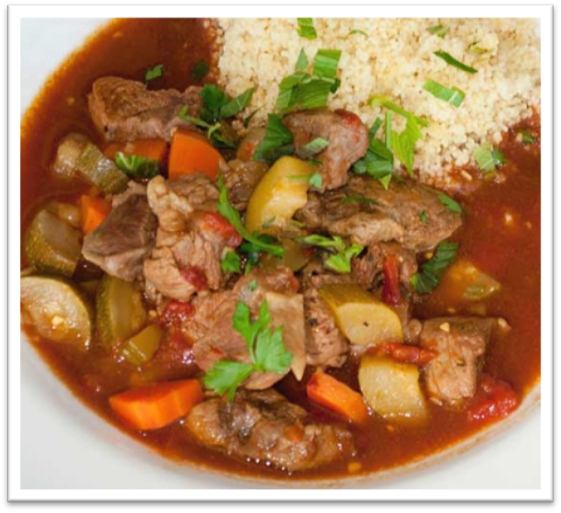 |  | 2 tablespoons oil  1kg chuck or boneless shin beef, diced  2 tablespoons Moroccan spice mix  2 cloves garlic, diced  2 medium onions, diced  2 carrots, diced  3 cups salt-reduced beef stock  400g can diced tomatoes  ¹/₄ cup salt-reduced tomato paste  2 teaspoons caster sugar  2 zucchinis, diced  400g canned chickpeas, drained  Serve with:  Couscous, potatoes or rice

Serves: 8
Preparation Time: 20 mins
Cooking Time: 8 hours
Lamb shanks
Method |  | Ingredients
1. Heat oil in saucepan on medium heat, add the lamb in small batches and cook until browned. Transfer the lamb to slow cooker.  2. In the same saucepan fry the garlic and onion for 2 minutes until the onion is softened.  3. Add the garlic, onions, carrots, tomatoes, tomato paste, beef stock and rosemary leaves into the slow cooker with the lamb. Stir until well combined  4. Cover and cook on HIGH for 4 hours.  5. Serve with couscous or mashed potato.  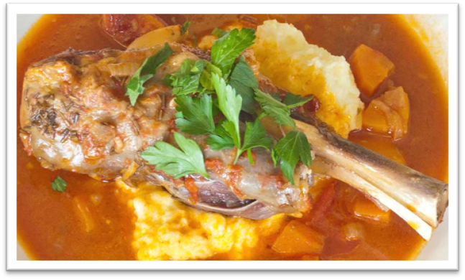 |  | 2 tablespoons cooking oil  6 lamb shanks  2 medium brown onions, diced  3 cloves garlic, crushed  3 carrots, diced/ 1 cm cubes  400g canned tomatoes, drained  6 tablespoons salt-reduced tomato paste  1 cup salt-reduced beef stock  1 tablespoon rosemary leaves, fresh or dried  Serve with:  4 cups dried couscous or 4 cups mashed potato

