Cooking for One or Two
Masterclasses

Slow Cooking
Session 1

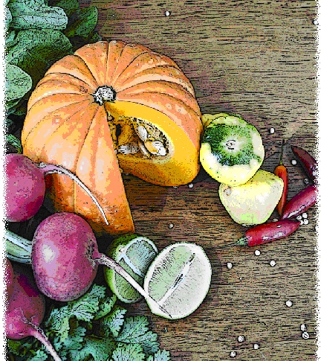

Contents
Objectives and overview 3
Session checklist 4
Ingredients list 5
Equipment 6
Room set up 8
Timeline 9
Introduction 10
Group agreement 12
Food preparation 13
Discussion: Benefits of using a slow cooker 15
Discussion: How to buy and use a slow cooker 16
Discussion: Safety precautions when using a slow cooker 17
Discussion: Types of meat suitable to slow cook 18
Activity: How to host a dinner party using your slow cooker 19
Food preparation 21
Enjoy a meal together 22
Thank you and conclusion 22
Session clean up 22
Recipes 23
Handouts 26
Handout 1: Different cuts of meat to use when slow cooking 26
Handout 2: Party planning checklist 27

Objectives and overview
Session objectives
By the end of this session, participants will have:
- Understood the benefits of using a slow cooker.
- Learnt how to buy and use a slow cooker.
- Identified safety precautions when using a slow cooker.
- Implemented safe food practices when using a slow cooker.
- Developed slow cooking skills.
- Developed food preparation skills.
- Enjoyed a meal with a group of new friends.

Session overview
Today’s discussion topics
- Benefits of using a slow cooker
- How to buy and use a slow cooker
- Safety precautions when using a slow cooker
- Types of meat suitable to slow cook
- How to host a slow cooking dinner party
Today you will be cooking:
- Pumpkin soup
- Beef and bean casserole
- Lemon-sauced pudding

Session checklist
Facilitator |  |  | Assistant
Collect groceries using session shopping list |  |  | Assist with grocery shopping where required
Arrive approximately 45 minutes prior to the start of the session |  |  | Arrive approximately 30 minutes prior to the start of the session
Read first aid instructions |  |  | Conduct safety checklist for the venue
Set up cooking equipment |  |  | Help with set up of equipment
Set up room |  |  | Help with set up of room
Print handouts for each participant |  |  | Facilitate the program following all instructions in blue
Download the video clips prior to the session |  |  | Help with washing up/cleaning
Photocopy appropriate evaluation sheets for session (if required; Appendix A)
Facilitate the program following all instructions in green
Wash up/cleaning

Ingredients list
tsp = teaspoon
tb = tablespoon
 | To serve 2 people | To serve 4 people | To serve 6 people | To serve 8 people
Pumpkin | 1¼ cups | 2½ cups | 3¾ cups | 5 cups
Potatoes (medium) | 1½ | 3 | 4½ | 6
Onion (medium) | 1 | 2 | 3 | 4
Chicken stock | 250ml | 500ml | 750ml | 1L
Thyme | ½ tb | 1 tb | 1½ tbs | 2 tbs
Cooking oil | 1 tb | 2 tbs | 3 tbs | 4 tbs
Lean beef mince | 200g | 400g | 600g | 800g
Salt reduced tomato paste | 2 tbs | 1/3 cup | ½ cup | ²/₃ cups
Honey | ½ tb | 1 tb | 1½ tbs | 2 tbs
Mustard powder | ¼ tsp | ½ tsp | ¾ tsp | 1 tsp
Baked beans (420g can) | ¼ | ½ | ¾ | 1
Green capsicum | ¼ | ½ | ¾ | 1
Celery stalks | ½ | 1 | 1½ | 2
Salt | ¼ tsp | ½ tsp | ¾ tsp | 1 tsp
Pepper | Pinch | ¼ tsp | ½ tsp | ¾ tsp
Reduced-fat tasty cheese | 1 tb | 2 tbs | 3 tbs | 4 tbs
Wholemeal pasta | 1 cup | 2 cups | 3 cups | 4 cups
Wholemeal self-raising flour | ½ cup | ²/₃ cup | ¾ cup | 1¹/₃ cups
Caster sugar | ¼ cup | ½ cup | ¾ cup | 1 cup
Lemon zest | ½ tsp | 1 tsp | 1½ tsp | 2 tsps
Reduced fat milk | 2 tbs | ¹/₃ cup | ½ cup | ²/₃ cup
Cooking oil spray | Light spray | Light spray | Light spray | Light spray
Hot water | ¾ cup | 1½ cups | 2 cups | 2¾ cups
Lemon juice | 3 tsps | 2 tbs | ¼ cup | ¹/₃ cup

Equipment
For table one
3 cooks knives |  | Measuring cups
3 vegetable knives |  | Measuring spoons
3 wooden spoons |  | Small, medium and large bowls
3 serving spoons |  | Colander
Vegetable peelers |  | Chopping boards / Chux
Spatula |  | Oven proof dishes
Can opener |  | Cling wrap and baking paper
Foil |  | Grater
Juicer |  | Microwave safe bowl
For table two
Place dry ingredients on table; amount dependent on number of people in the group
For Refrigerator
Place ingredients that need to remain cool in the refrigerator; amount dependent on number of people in the group
For table three
Electric wok |  | Electric hot plates
Large saucepans |  | Kettle
Heat proof mats |  | Oven Mitts
Thermometer |  | Blenders
Baking tray |  | Slow cookers
Extension cord (if necessary)
For the kitchen and washing up area
Tea towels |  | Washing up liquid
Dish brush |  | Pot scrub
Dish cloths
For food safety and washing hands
Liquid soap |  | Paper hand towels
For dining
Cutlery (knives, forks & spoons) |  | Serviettes
Plates |  | Cups
Bowls |  | Jug (with water)
Table Cloth
For refreshments (to be set up wherever deemed suitable)
Tea |  | Sugar
Coffee |  | UHT Milk
For discussion sessions and miscellaneous items
White board |  | Name tags
White board markers |  | Attendance sheet
Pens |  | Recipe cards
Handout 1: Different cuts of meat to use when slow cooking |  | Handout 2: Party planning checklist
For occupational health and safety
St Johns First Aid Kit |  | Duct tape to tape down electrical cords

Room set up
TABLE TWO
Place one table to the side for all ingredients to be displayed on.
TABLE THREE
Place electrical equipment here.
Place on side closest to power points. If extension cord is used ensure it is taped to the ground to prevent participants tripping and injuring themselves.
TABLE ONE
Set up a table with enough space for participants to stand around for food preparation in the centre of the room.
Set up all equipment other than electrical appliances at this table.
This table can later be set up for dining.

Timeline
 |  | Set up room, including table with ingredients, food preparation area, dining area and chairs and whiteboard for discussion (45 mins before session)
Start  session |  | Introduction and safety (10 mins)
 |  | Group agreement (5 mins)
 |  | Food preparation (60 mins)
30 mins |  | Food preparation (60 mins)
1 hr |  | Food preparation (60 mins)
 |  | Discussion: Benefits of using a slow cooker (15 mins)
90 mins |  | Discussion: Benefits of using a slow cooker (15 mins)
90 mins |  | Discussion: How to buy and use a slow cooker (15 mins)
 |  | Discussion: Safety precautions when using a slow cooker (15 mins)
2 hrs
2 hrs |  | Discussion: The types of meats suitable to slow cook (25 mins)
150 mins |  | Activity: How to host a slow cooker dinner party (25 mins)
 |  | Food preparation (20 mins)
3 hrs |  | Food preparation (20 mins)
 |  | Enjoy a meal together (40 mins)
210 mins |  | Enjoy a meal together (40 mins)
4 hrs |  | Thank you and conclusion (5 mins)
4 hrs |  | Session clean up (approx. 20-30 mins)

Introduction |  | 10 minutes
The following section is to be conducted by the facilitator
1. Welcome the participants to Session One of ‘Slow cooking’ as part of the Cooking for One or Two program. Ask all participants to sign the attendance sheet (see main manual for more information).
2. Introduce yourself and the assistant to the group.
3. Explain to the group that you will be facilitating both sessions of the slow cooking program.
4. Introduce the assistant. State they are kindly offering their time to assist with the sessions by helping with registration, evaluation, setting up and cleaning up.
5. Read the following explaining to the group what the Cooking for One or Two masterclass is and the aims of the program:
 | What is the Slow cooking Module?
- The Slow cooking masterclass is a two-session program.
- The program is designed for older people living in the community who have previously participated in Cooking for One or Two and want to develop additional cooking skills in slow cooking.
- Each session the group will cook an easy, quick and nourishing meal, including a light meal, a main meal and dessert. It is not a cooking demonstration, but an opportunity for you to develop your cooking skills in a supportive environment. We will then enjoy the meal together. A cooking skill and health related topic will be discussed in each of the sessions. The discussion aims to improve your cooking skills and teach you new techniques.
6. Explain to the group that all sessions are well planned to reduce risks, but it is still important to point out the safety risks including:
- The exits [point out to group] in case of fire.
- Fire blankets and fire extinguishers [point out to group] in case of fire.
- Emergency rally points.
- Electrical equipment and cords have been firmly taped down [point out all].
- The location of the first aid officer is [give location and person’s name].
- Being mindful of safe procedures when cutting and chopping food;
- Ask the group members if anyone has a food allergy [talk to them individually regarding their allergy].
- The bathrooms [give location].
7. Ask the group to inform you if there are any accidents or incidents or if they are feeling unwell.
8. Ask each participant to introduce themselves to the group and tell the group why they were interested in attending this Slow Cooking masterclass.
9. Thank the group for sharing their reasons for joining the program.
10. Outline the content of Session One:
- Benefits of using a slow cooker.
- How to buy and use a slow cooker.
- Safety precautions when using a slow cooker.
- Types of meat suitable to slow cook.
- How to host a slow cooking dinner party.
11. Reintroduce the assistant who will now be speaking about the group agreement.

Group agreement |  | 5 minutes
The following section is to be conducted by the assistant
1. Read the following explaining to the group that throughout the program all group members are to follow these tips for working together as a group.
 | Group agreement
- It is very important that we all agree to follow the safe food practices outlined today as we cook each meal over the next two weeks.
- It is very easy to forget some of the important steps to ensure foods are prepared safely, so we will all have to work as a group to do this.
- There are also some other important things we can do to ensure the group runs smoothly. This includes:
  - Listening to each other; this means trying to talk one at a time, and letting everyone have their say.
  - Supporting each other; you are all here to learn new skills so support each other in this endeavour.
  - Take care (consider your own and others safety) when using knives, hot equipment and food; try to prevent slips, trips, falls and heavy lifting.
  - The most important thing is for us all to have fun, whilst learning. The sessions should be a time for you to make friends.
It is important before we start the food preparation today that we all agree to work this way in our group.
2. Ask the group if they think these points sound fair.
3. If you have a whiteboard available, you might like to write the main points from the group agreement up so the group can review them throughout the session.
4. Ask the group if they can think of any other important things we can do to work together as a group or make the most of the group and add any new points to the whiteboard.
5. Hand back over to the facilitator.

Food preparation |  | 80 minutes
The following section is to be conducted by the facilitator
While the facilitator leads the food preparation, the assistant can help participants with meal preparation and washing any equipment.
1. Introduce the participants to the food preparation session:
- Firstly we will be cooking pumpkin soup.
- Secondly we will be cooking lemon-sauced pudding.
- Thirdly we will be preparing beef and bean casserole.
2. Explain to the group that:
- Each member of the group will be assisting with the cooking process.
- You are there to guide the food preparation, but the group will be doing most of the work, and that
- If anyone has any questions or problems, please ask for help.
3. Ask participants to view the pumpkin soup recipe card. Read the recipe card explaining step-by-step the recipe. Once you have read these instructions give each participant a role in preparing the recipe according to these steps
4. Ask the group to wash their hands before commencing food preparation.
 | Pumpkin soup
1. Place pumpkin and potato in a microwave-safe bowl with ½ cup of water. Microwave for 5-10 minutes or until tender. Drain water.
2. Add pumpkin, potato, onion and chicken stock to slow cooker.
3. Cover and cook on HIGH for 3 ½ hours.
5. Ask the group to view the lemon-sauced pudding recipe card. Read the recipe card explaining step-by-step the recipe. Once you have read these instructions give each participant a role in preparing the recipe according to these steps.
 | Lemon-sauced pudding
1. Combine the flour, half the sugar, lemon zest, salt, milk and cooking oil in a bowl and mix well.
2. Grease the slow cooker bowl with cooking oil spray and pour in the batter.
3. In a separate bowl combine hot water, lemon juice and remaining sugar.
4. Pour the liquid mixture onto the batter. Do not stir.
5. Cook on HIGH for 2 hours.
6. Ask participants to view the beef and bean casserole recipe card. Read the recipe card explaining step-by-step the recipe. Once you have read these instructions give each participant a role in preparing the recipe according to these steps.
 | Beef and bean casserole
1. Heat oil in a saucepan on medium heat. Add the mince and cook until brown.
2. Remove mince from and add to slow cooker with tomato paste, honey, mustard, beans, capsicum, onion celery, salt and pepper. Mix well.
3. Cook on HIGH for 2 hours.

Discussion: Benefits of using a slow cooker |  | 15 minutes
The following section is to be conducted by the facilitator
1. Inform the group that we will be talking about the benefits of using a slow cooker.
2. Read the following explaining to the group the benefits of using a slow cooker:
 | Benefits of using a slow cooker
Firstly, you may ask what a slow cooker is?
A slow cooker is an appliance that sits on your bench top, which maintains a constant temperature (when turned on) to cook a meal.
The long cooking time and constant heat makes a slow cooker perfect for those people wanting minimal fuss or preparation in the kitchen. A slow cooker provides a healthy, low fat method of cooking, as you trim the visible fat from the meat and do not need to add oil as there is enough liquid to ensure the meal will cook adequately. A slow cooker also requires minimal effort, aside from preparing the ingredients.
Slow cookers are relatively cheap to buy, great for making use of budget cuts of meat, as well as being economical and cheaper to use when compared to using your oven. Using budget cuts of meat is ideal for slow cooking as the long cooking times soften the meat to make it tender and easier to eat when compared to using the same budget cuts when stewing. The low temperature and long cooking times used when slow-cooking makes it almost impossible to burn, even if it is cooked for too long.
When heating food, nutrients are lost in the cooking process, and mostly to the surrounding water which is often thrown away and not consumed. Using a slow cooker maximises your intake of nutrients, as the nutrients “usually” lost from your food remain in the liquid in the slow cooker, which can be incorporated into your meal as the sauce component. Another benefit is that using a slow cooker to cook with, means that there is less washing up to be done at the end of your meal as you can only use a single pot.
3. Ask the group if they have any questions.

Discussion: How to buy and use a slow cooker |  | 15 minutes
The following section is to be conducted by the facilitator
1. Inform the group that we will be talking about how to buy and use a slow cooker.
2. Read the following explaining to the group what to look for when buying a slow cooker and how to use one:
 | Buying a slow cooker
Slow cookers can be purchased from a variety of department and kitchenware shops. They range in size from 3.5 to 6.5 litres, and depending on your budget, you will be able to purchase one that does the job, as prices start from about $30 and can be as high as $200.
Most slow cookers have “low” and “high” settings. Some more advanced slow cookers have a timer that clicks to "keep warm" mode when the food is ready to prevent overcooking. For safety and convenience, look for slow cookers that have a glass lid, cool-touch handles, and a dishwasher-safe removable insert.
 | How to use a slow cooker
As we now know, slow cookers are a convenient and easy way to prepare and cook your food. Generally all you need to do is add the prepared ingredients, plug in the appliance and turn it on to cook. However there are some general rules to follow to ensure your slow cooking meal is a success:
1. Make sure all ingredients are cut into similar sized pieces to ensure they cook evenly, if not you will have some ingredients that are over cooked and some under cooked.
2. Remove the skin and trim excess fat from meat and poultry.
3. Follow the layering instructions of the recipe to ensure food is completely cooked. Vegetables particularly root vegetables such as potato and carrot should be placed at the bottom of the pot under the meat as they take longer to cook.
4. To maintain the heat of the slow cooker always make sure the lid stays on. If you need to stir the meal do it quickly as it can take up to 20 minutes to recover the lost heat after the lid has been removed, and will increase the cooking time.
5. Make sure you fill your slow cooker half to three quarters full. If it is too full the food may not cook properly, and if it is not full enough the food may undercook.
4. Ask the group if they have any questions.

Discussion: Safety precautions when using a slow cooker |  | 15 minutes
The following section is to be conducted by the facilitator
1. Inform the group that we will now be talking about the safety precautions when using a slow cooker.
 | Safety precautions when using a slow cooker
To ensure good food safety when using your slow cooker there are a number of tips that you should be aware of and follow.
1. Thaw meat, poultry or frozen vegetables before cooking. Frozen food prolongs the cooking process, increasing the possibility of harmful bacteria growth and subsequent risk of food poisoning. Large pieces of foods like meat and poultry should be safely thawed a day or two before in the refrigerator. Whilst frozen vegetables should be thawed before being added.
2. Remove cooked food from the slow cooker before placing in the fridge. The insert is designed to retain heat; therefore it won't cool quickly enough to stop bacteria growing. The ceramic insert reacts to extreme temperatures and can crack or break if placed in the fridge when it is still hot.
3. Reheat slow cooked food at a safe temperature in a microwave or on the stove top. A slow cooker takes too long to reach a safe temperature, therefore increasing the possibility of harmful bacteria growth and subsequent risk of food poisoning.
2. Ask the group if they have any questions.

Discussion: Types of meat suitable to slow cook |  | 25 minutes
The following section is to be conducted by the facilitator
1. Inform the group that we will now be talking about the types of meat suitable to slow cook.
2. Ask the participants to refer to Handout 1 “Different cuts of meat to use when slow cooking”. Read the following explaining about the different cuts of meat:
 | Meats suitable for slow cooking
Slow cooking is a versatile way to cook a variety of different types and cuts of meat. We will highlight a few possibilities, however our list is not endless and checking with your local butcher or following a recipe will ideally provide you with the most appropriate type and cut of meat for the dish you want to create.
- Beef is the most versatile meat for slow cooking. The best cuts to use when slow cooking are: round or blade steak, chuck, shoulder and brisket.
- Lamb is another great addition to your slow cooker, resulting in a tender dish when cooked. The best cuts to use when slow cooking are: boneless shoulder or forequarter, shanks and neck chops.
- Pork can add depth of flavour and sweetness to your slow cooked meal. The best cuts to use when slow cooking include: diced pork shoulder, forequarter chops, pork neck and ribs.
- Chicken although not the most popular meat to slow cook is a good choice to add to classic recipes such as curries and stews. The best cuts to use when slow cooking are: thigh pieces, drumsticks, Maryland and whole chicken.
- Veal is one of the best meats to use in the slow cooker; however it is the most underrated type of meat. The best cuts to use when slow cooking are osso bucco or shanks.
3. Ask the group if they have any questions.

Activity: How to host a dinner party using your slow cooker |  | 25 minutes
The following section is to be conducted by the facilitator
1. Inform the group that we will now do an activity on hosting a dinner party.
2. Ask the participants to refer to Handout 2 “Party planning checklist”. Read the following describing how to host a dinner party:
 | Dinner party
Hosting a dinner party among your friends or family is both simple and easy when using a slow cooker. Before you have a dinner party there are a number of things you will need to consider. Generally most people will be available on the weekend, for a Friday or Saturday evening. You will need to invite your guests approximately 2 weeks before the anticipated party date to ensure they are available and that you have enough time to both prepare and plan for the party.
The first thing you might consider when planning a dinner party is the guests you would like to invite. Write a guest list in advance and ask that those invited respond one week prior to the event. This is important as you will need to:
- Know how many people you will be serving on the night.
- Calculate the amount of ingredients for each dish required before you do the grocery shopping.
Event
The type of event will influence your decision on what food and theme you are planning. For example, if you are planning a dinner for your grandchild’s birthday you will need recipes suitable for both children and adults.
Theme
The theme of the party will depend on what you are celebrating. For instance, if you select “foods from another country such as Italy” as your theme you will require Italian cuisine for your dinner. You may also decide that you don’t want a theme, but want to cook a variety of different foods and decorate the party instead, which is fine.
Recipes
Choose the food and drinks you want to serve at your dinner for your guests. The recipes should be simple, easy to prepare and in appropriate portions to feed all guests.
Shopping list
Once you have chosen the recipes for the food you want to cook, and you know how many people will be attending, you need to write down the ingredients needed to purchase the food. You should always check your pantry first and mark off any items that you already have, as you won’t need to purchase these at the supermarket. This will save you money and prevent food waste.
3. Now we want to work through the example using your handout as a guide.
4. Ask the participants to fill in the date on the checklist.
5. Once they have filled this in, ask them to fill in the type and theme of the event they are planning.
6. For the next section, we will say that there is a total of 8 people for dinner, including yourself and the recipes will be the recipes from today’s session
- Pumpkin soup
- Beef and bean casserole
- Lemon-sauced pudding
7. For the next part, participants will need to refer to today’s recipe cards to write down the ingredients for one of the recipes, entrée, main or dessert.
8. Allow participants time to share their planning with others after the discussion.
9. Ask the group if they have any questions

Food preparation |  | 20 minutes
The following section is to be conducted by the facilitator
While the facilitator leads the food preparation, the assistant can help participants with meal preparation and washing any equipment.
1. Introduce the group to the second part of the food preparation where they will finish preparing the pumpkin soup, beef and bean casserole and the lemon-sauced pudding.
2. Ask the group to get their copies of the recipe cards, and wash their hands before commencing the food preparation.
3. Give each participant a role in preparing the pumpkin soup recipe according to these steps.
 | Pumpkin soup
1. Once the soup has finished cooking, allow to cool slightly.
2. Place the soup in a blender and blend until smooth.
3. Add thyme, and if necessary, reheat the soup in the microwave.
4. Top with salt, pepper and sour cream and serve with a bread roll.
4. Give each participant a role in preparing the beef and bean casserole recipe according to these steps.
 | Beef and bean casserole
1. Cook the pasta by following the directions on the packet.
2. Once the casserole has finished cooking, remove from the slow cooker, add to the cooked pasta and sprinkle the tasty cheese on top before serving.
5. Give each participant a role in preparing the lemon-sauced pudding recipe according to these steps.
 | Lemon-sauced pudding
1. Remove lemon pudding from the slow cooker.
2. Serve with fruit, and yoghurt or ice-cream.

Enjoy a meal together | 40 minutes
The following section is to be conducted by the assistant
1. Set each participant, the facilitator and the assistant a place at the dining table. Use the table cloth, serviettes, crockery and cutlery to create an inviting space to share the meal together.
2. Enjoy!

Thank you and conclusion | 5 minutes
The following section is to be conducted by the facilitator
1. Congratulate the group on a job well done.
2. Ask the group to reflect on what they have learnt in their first session of slow cooking. Ask the group to share any new information or skills they have learnt.
3. Outline the next session’s content.
- Meal; Vegetable and lentil curry, chicken korma and mixed berry cobbler.
- Discussion topic; food temperature and safety, converting traditional recipes into recipes for the slow cooker.

Session clean up | 30 minutes
The following section is to conducted by the assistant
1. When cleaning up, it is important that you use hot soapy water, and refill the sink once the water has become either warm or discoloured (dirty). At all stages in the washing up process please be mindful of sharp objects being left in the water.
2. All equipment must be washed and sanitised prior to being packed away for the next session. It is also important that all equipment goes back to where it was found.

Recipes
Serves: 8
Preparation Time: 20 min
Cooking Time: 2 hours
Lemon-sauced pudding
Method |  | Ingredients
1. Combine the flour, half the sugar, lemon zest, salt, milk and cooking oil in a bowl and mix well.  2. Grease the slow cooker bowl with cooking oil spray and pour the batter in.  3. In a separate bowl combine hot water, lemon juice and remaining sugar.  4. Pour the liquid mixture onto the batter. Do not stir.  5. Cook on HIGH for 2 hours.  6. Serve with fruit, and yoghurt or ice-cream.  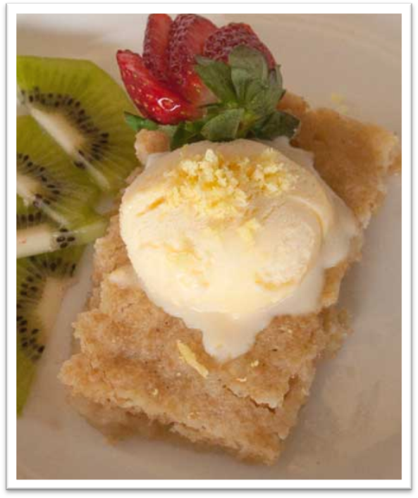 |  | 1¹/₃ cup wholemeal self-raising flour  1 cup caster sugar  2 tsps lemon zest  Pinch of salt  ²/₃ cup reduced-fat milk  2 tbs cooking oil  Cooking oil spray  2½ cups hot water  ¹/₃ cup lemon juice  Serve with:  400g low-fat yoghurt or 8 scoops of reduced-fat ice-cream  4 cups thawed frozen mixed berries or other seasonal fruit

Serves: 8
Preparation Time: 20 mins
Cooking Time: 3.5 hours
Pumpkin soup
Method |  | Ingredients
1. Place pumpkin and potato in a microwave-safe bowl with ½ cup of water. Microwave for 5-10 minutes or until tender. Drain water.  2. Add pumpkin, potato, onion and chicken stock to the slow cooker.  3. Cover and cook on HIGH for 3 ½ hours. Cool a little.  4. Place the soup in a blender and blend until smooth and add thyme.  5. Reheat the soup in microwave and top with salt, pepper and sour cream. Serve with a bread roll.  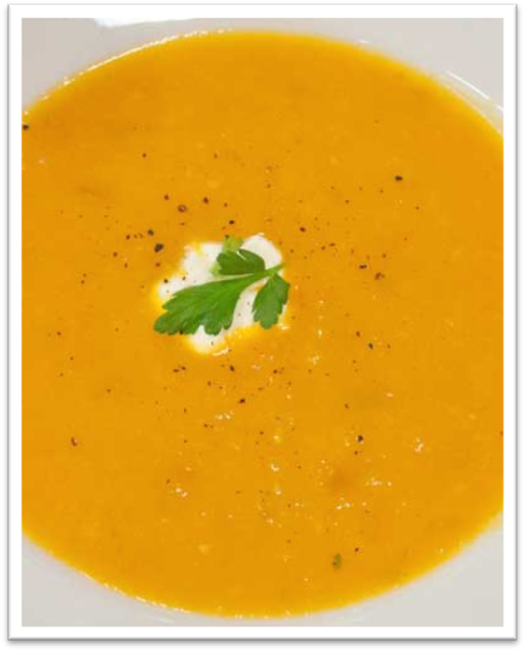 |  | 1.5kg pumpkin cut into 2cm pieces  6 medium potatoes, diced  2 medium onions, chopped  1 litre salt-reduced chicken stock  2 tbs thyme, chopped  Serve with:  Salt and pepper  8 tbs sour cream (1 each)  8 wholegrain bread roll (1 each)

Serves: 8
Preparation Time: 25 mins
Cooking Time: 2 hours
Beef and bean casserole
Method |  | Ingredients
1. Heat oil in a saucepan on medium heat. Add the mince and cook until brown.  2. Remove mince from and add to slow cooker with tomato paste, honey, mustard, beans, capsicum, onion celery, salt and pepper. Mix well.  3. Cook on HIGH for 2 hours.  4. Serve with pasta, mashed potato or bread, and sprinkle the tasty cheese on the top of casserole before serving.  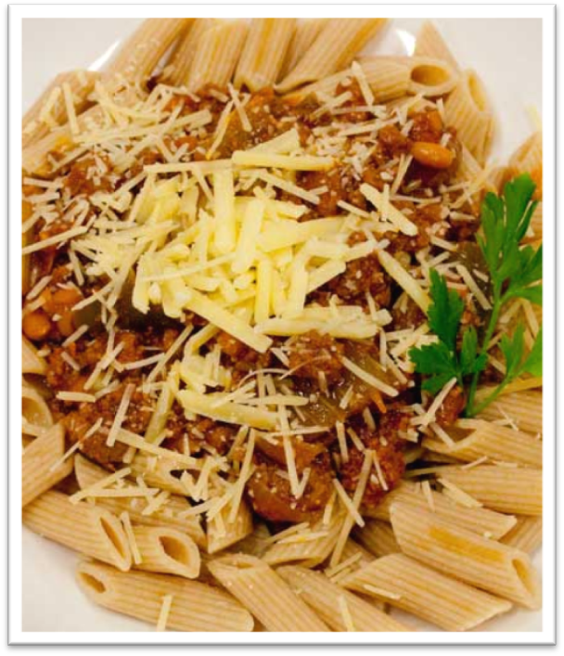 |  | 2 tablespoons cooking oil  800g lean beef mince  ²/₃ cup salt-reduced tomato paste  2 tbs honey  1 tsp mustard powder  420g can baked beans  1 large green capsicum, chopped  2 stalks celery, sliced  2 medium onions, chopped  1 tsp salt  3/4 tsp black pepper  4 tbs reduced-fat tasty cheddar cheese, shredded  Serve with:  4 cups cooked wholemeal pasta (¹/₂ cup each), 8 slices whole grain bread or 4 cups mashed potato  Special tip  If time permits, cook on low for approximately 8 hours.

Handouts

Handout 1: Different cuts of meat to use when slow cooking
Beef  Round  Blade/chuck/shoulder  Brisket | Lamb    Neck  Forequarter  Shank
Pork  Shoulder  Forequarter  Neck  Ribs | Chicken  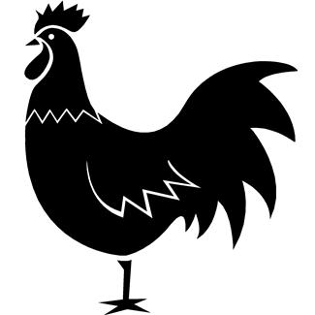  Drumstick  Thigh  Whole chicken  Maryland
Veal

Shank
Osso bucco

Handout 2: Party planning checklist
Date: | ___________________________
Event: | ___________________________
Theme: | ___________________________
Guests: | ___________________________
Menu: | Entrée | ___________________________
 | Main | ___________________________
 | Dessert | ___________________________
Shopping List:

