Cooking for One or Two
Masterclasses

Italian Cuisine
Session 2

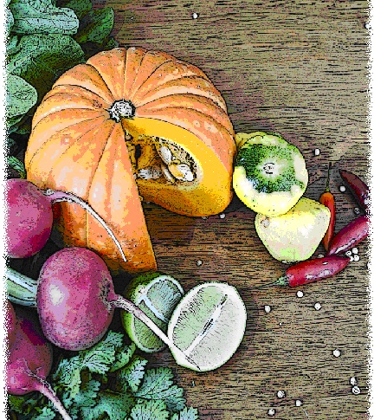

Contents
Objectives and overview 3
Session checklist 4
Ingredients list 5
Equipment 6
Room set up 8
Timeline 9
Introduction 10
Group agreement reminder 10
Discussion: The history of pizza 11
Discussion: Making risotto 13
Food preparation 14
Enjoy a meal together 15
Evaluation 16
Thank you and conclusion 17
Session clean up 17
Recipes 18
Handouts 21
Handout 1: Mix and match your pizza 21
Handout 2: Useful tips when making risotto 22
Handout 3: Additional recipes 23

Objectives and overview
Session objectives
By the end of this session, participants will have:
- Identified the type of ingredients used in creating homemade pita pizzas.
- Demonstrated the correct method of cooking risotto.
- Developed food preparation skills.
- Enjoyed a meal with new friends.

Session overview
Today’s discussion topics:
- The history and making of pizza
- How to make risotto
Today you will be cooking:
- Pita pizza
- Chicken and mixed vegetable risotto
- Fruit pizza

Session checklist
Facilitator |  |  | Assistant
Collect groceries using session shopping list |  |  | Assist with grocery shopping where required
Arrive approximately 45 minutes prior to the start of the session |  |  | Arrive approximately 30 minutes prior to the start of the session
Read first aid instructions |  |  | Conduct safety checklist for the venue
Set up cooking equipment |  |  | Help with set up of equipment
Set up room |  |  | Help with set up of room
Print handouts for each participant |  |  | Facilitate the program following all instructions in blue
Download the video clips prior to the session |  |  | Help with washing up/cleaning
Photocopy appropriate evaluation sheets for session (if required; Appendix A)
Facilitate the program following all instructions in green
Wash up/cleaning

Ingredients list
tsp = teaspoon
tb = tablespoon
 | To serve 2 people | To serve 4 people | To serve 6 people | To serve 8 people
Salt-reduced tomato paste | 1 tb | 2 tbs | 3 tbs | 4 tbs
Wholemeal pita bread (small) | 2 | 4 | 6 | 8
Turkey breast | 50 | 100 | 150 | 200
Onion | ¾ | 1½ | 2¼ | 3
Tomato | ½ | 1 | 1½ | 2
Zucchini | 1 | 2 | 3 | 4
Baby spinach | 1 cup | 2 cups | 3 cups | 4 cups
Reduced fat tasty cheese | ½ cup | 1 cup | 1½ cups | 2 cups
Dried herbs and pepper | Pinch | Pinch | Pinch | Pinch
Salt-reduced chicken stock | 2½ cups | 5 cups | 7½ cups | 10 cups
Olive oil | 1 tb | 2 tbs | 3 tbs | 4 tbs
Chicken breast (large) | 1 | 2 | 3 | 4
Thyme | 1 tsp | 2 tsps | 3 tsps | 4 tsps
Frozen mixed vegetables | 2 cups | 4 cups | 6 cups | 8 cups
Low-fat parmesan cheese | 2 tsps | 4 tsps | 6 tsps | 8 tsps
Salt | Pinch | Pinch | Pinch | Pinch
Pepper | Pinch | Pinch | Pinch | Pinch
Reduced-fat natural yoghurt | ½ cup | 1 cup | 1½ cups | 2 cups
English muffins (wholemeal) | 2 | 4 | 6 | 8
Frozen raspberries | ½ cup | 1 cup | 1½ cups | 2 cups
Strawberries | 4 | 8 | 12 | 16
Peach slices (canned) | ½ cup | 1 cup | 1½ cups | 2 cups
Honey | 2 tsps | 4 tsps | 6 tsps | 8 tsps

Equipment
For table one
3 cooks knives |  | Measuring cups
3 vegetable knives |  | Measuring spoons
3 wooden spoons |  | Small, medium and large bowls
3 serving spoons |  | Colander
Vegetable peelers |  | Chopping boards / Chux
Pastry brush |  | Cling wrap and baking paper
Can opener |  | Foil
Whisk |  | Measuring jugs
Juicer
For table two
Place dry ingredients on table; amount dependent on number of people in the group
For refrigerator
Place ingredients that need to remain cool in the refrigerator; amount dependent on number of people in the group
For table three
Electric wok |  | Electric hot plates
Large saucepan |  | Oven
Heat proof mats |  | Oven Mitts
Thermometer |  | Oven proof dishes
Baking tray |  | Extension cord (if necessary)
For the kitchen and washing up area
Tea towels |  | Washing up liquid
Dish brush |  | Pot scrub
Dish cloths
For food safety and washing hands
Liquid soap |  | Paper hand towels
For dining
Cutlery (knives, forks & spoons) |  | Serviettes
Plates |  | Cups
Bowls |  | Jug (with water)
Table Cloth
For refreshments (to be set up wherever deemed suitable)
Tea |  | Sugar
Coffee |  | UHT Milk
For discussion sessions and miscellaneous items
Printed copy of evaluation form (if required; Appendix A) |  | Recipe cards
Pens |  | White board markers
White board |  | Name tags
Attendance sheet |  | Handout 1: Mix and match your pizza
Handout 2: Useful tips when making risotto |  | Handout 3: Additional recipes
For occupational health and safety
St Johns First Aid Kit |  | Duct tape to tape down electrical cords

Room set up
TABLE TWO
Place one table to the side for all ingredients to be displayed on.
TABLE THREE
Place electrical equipment here.
Place on side closest to power points. If extension cord is used ensure it is taped to the ground to prevent participants tripping and injuring themselves.
TABLE ONE
Set up a table with enough space for participants to stand around for food preparation in the centre of the room.
Set up all equipment other than electrical appliances at this table.
This table can later be set up for dining.

Timeline
 |  | Set up room, including table with ingredients, food preparation area, dining area and chairs and whiteboard for discussion (45 mins before session)
Start
session
Start  session |  | Introduction and safety (10 mins)
 |  | Group agreement (5 mins)
 |  | Discussion: The history of pizza making (15 mins)
30 mins |  | Discussion: The history of pizza making (15 mins)
30 mins |  | Discussion: Making risotto (20 mins)
 |  | Food preparation (80 mins)
1 hr |  | Food preparation (80 mins)
90 mins |  | Food preparation (80 mins)
2 hrs |  | Food preparation (80 mins)
 |  | Enjoy a meal together (40 mins)
150 mins |  | Enjoy a meal together (40 mins)
 |  | Evaluation (5 mins)
3 hrs |  | Thank you and conclusion (5 mins)
3 hrs |  | Session clean up (approx. 20-30 mins)
210 mins

Introduction | 10 minutes
The following section is to be conducted by the facilitator
1. Welcome the participants to Session Two of the Italian cuisine masterclass as part of the Cooking for One or Two program. Ask all participants to sign the attendance sheet (see main manual for more information).
2. Re-introduce yourself and the assistant to the group.
3. Explain to the group that it is important to know the safety risks and point out to the group important information regarding the venue, including:
- The exits [point out to group] in case of fire.
- Fire blankets and fire extinguishers [point out to group] in case of fire;
- Emergency rally points.
- Electrical equipment and cords have been firmly taped down [point out all].
- The location of the first aid officer is [give location and person’s name].
- Being mindful of safe procedures when cutting and chopping food;
- Ask the group members if anyone has a food allergy [talk to them individually regarding their allergy].
- The bathrooms [give location].
4. Ask the group to inform you if there are any accidents or incidents or if they are feeling unwell.
5. Ask the participants if anyone has any food allergies.
6. Ask participants if anyone has tried preparing the recipes from last session.
7. Outline the content of Session Two:
- The history and making of pizza.
- Making risotto.

Group agreement reminder | 5 minutes
The following section is to be conducted by the assistant
1. Remind the group of their group agreement from session one. They all agreed to:
- Follow safe food practices; washing hands when required, not cross-contaminating, checking temperatures, and informing us if you are ill.
- Listen to each other; this means trying to talk one at a time and letting everyone have their say.
- Support each other; you are all here to learn new skills so support each other in this endeavor.
- Take care (consider your own and others safety) when using knives, hot equipment and food; try to prevent slips, trips, falls and avoid heavy lifting.
- Most importantly have fun, whilst learning. The group should be a time for you to make new friends.

Discussion: The history of pizza |  | 15 minutes
The following section is to be conducted by the facilitator
1. Inform the group that we will be talking about the history and ingredients used in making pizza.
2. Ask if anyone in the group has tried making pizza?
3. Read the following on the history of pizza:
 | History of pizza
- Pizza originated in Naples around the eighteenth-century.
- Pizza was originally considered food for the poor, as it could be consumed quickly.
- Legend has it that in 1861, King Umberto I and Queen Margherita became bored with their French cuisine and requested pizzas from the city’s Pizzeria. They were served a pizza topped with tomato, white cheese and green basil (coincidentally this is also the colour combination of the Italian flag). This pizza was said to be Queen Margherita’s favourite and from then on the pizza was named pizza margherita.
4. Ask the participants to refer to Handout 1 “Mix and match your pizza”.
5. Read the following from the handout explaining the ingredients that can be used in making a pizza:
 | Ingredients for pizza
The basic ingredients you will need to make a pizza include a pizza base, cheese, toppings and sauce.
Pizza base:
There are a range of pizza bases to choose from, for example English muffins, bread slices, readily available pita bread, fresh pre-made pizza bases, frozen pre-made pizza bases or making your own base from scratch are some of the possibilities.
Pizza bases can be found in various sizes, and the size you choose may depend on what you are cooking the pizzas for. If you are having friends over, you may like to use big pizza bases.
Toppings:
To make your pizza nutritious and balanced, your pizza should include two or more serves of vegetables and one serve of protein.
You might like to include leftover vegetables and meat, cheese or legumes on your pizza, which can be spread over the pizza base. Using leftovers on your pizza is a great way to avoid food waste.
Cheese:
The most common cheese used on a pizza is mozzarella but you can use other cheeses such as feta, ricotta or cheddar cheese depending on your taste.
Sauce:
The sauce used on the base of your pizza is typically tomato or barbeque, however depending on what toppings you add to your pizza you can use a number of different ones. Some suggestions include: sweet chilli, pesto, hummus, and tzatziki.
Making pizza is a great activity to enjoy with family and friends, particularly grandchildren. Next time you have someone visit you may want to make them pizza and make the pizza dough from scratch.

Discussion: Making risotto |  | 20 minutes
The following section is to be conducted by the facilitator
1. Inform the group that we will be talking about how to make risotto.
2. Ask the participants to refer to Handout 2 “Useful tips when making risotto”.
3. Read the following from the handout explaining the useful tips when making a risotto:
 | Useful tips when making risotto
Tip 1: It is essential to use Arborio rice. Arborio rice can absorb three to four times its volume in liquid and therefore won’t break down when it is cooked.
Tip 2: It is important to stir your risotto continuously while gradually adding stock. This creates a creamy consistency and stirring rubs the starch off the surface of the rice, helping it to dissolve in the stock.
Tip 3: Don’t wash Arborio rice. The rice starch helps to make the risotto creamy.
Tip 4: Make sure your stock is hot when you add it to the rice.
Tip 5: Follow the recipe instructions which will indicate when to add each different ingredient. This will ensure you dish comes out perfectly, with each ingredient cooked ‘just right’.
Tip 6: Taste test your rice to see if it is ready to serve. It should be firm to bite.
4. Ask the group if they have any questions.

Food preparation |  | 80 minutes
The following section is to be conducted by the facilitator
While the facilitator leads the food preparation, the assistant can help participants with meal preparation and washing any equipment.
1. Introduce the participants to the food preparation session:
- Firstly we will be preparing the pita pizza
- Secondly we will be cooking the chicken risotto
- Thirdly we will be preparing the fruit pizza
2. Explain to the group that:
- Each member of the group will be assisting with the cooking process; and
- You are there to guide the food preparation, but the group will be doing most of the work;
3. If anyone has any questions or problems, please ask for help.
4. Ask the participants to view the pita pizza recipe card. Read the recipe card explaining step-by-step the recipe. Once you have read these instructions give each participant a role in preparing the recipe according to these steps.
5. Ask the group to wash their hands before commencing food preparation.
 | Pita pizza
1. Preheat oven to 200°C (180ºC fan-forced).
2. Spread the tomato paste on the pita bread.
3. Spread the baby spinach onion, tomato, zucchini and turkey on the pita bread and top with reduced-fat tasty cheese.
4. Bake the pizza for 10-15 minutes or until the crust is golden.
5. Sprinkle dried herbs and pepper before serving.
6. Ask participants to view the chicken risotto recipe cards. Read the recipe card explaining step-by-step the recipe. Once you have read these instructions give each participant a role in preparing the recipe according to these steps.
 | Chicken risotto
1. Add stock to saucepan on medium heat
2. Meanwhile, heat oil in a frying pan. Add the onion and chicken breast and cook until browned. Transfer to a bowl, cover and put in the oven at 70°C (50°C fan-forced) to keep warm.
3. Add ½ cup of stock and rice to fry pan. Gradually add the remaining stock (1/2 cup at a time). Stir constantly for 30 minutes or until liquid is absorbed and rice is tender and the risotto is creamy.
4. Add the chicken, thyme and mixed vegetables. Stir and cook for further 5-10 minutes or until vegetables are tender.
5. Season with salt and pepper. Stir in parmesan. Serve hot.
7. Ask participants to view the fruit pizza recipe card. Read the recipe card explaining step-by-step the recipe. Once you have read these instructions give each participant a role in preparing the recipe according to these steps.
 | Fruit pizza
1. Preheat oven to 180°C (160oC fan-forced).
2. Mix the honey and water in a bowl.
3. In a separate bowl combine the honey and yoghurt.
4. Split the muffins in half and brush with honey and water mixture. Place in toaster until golden.
5. Spread the yoghurt mixture on muffin and arrange fruit on top.

Enjoy a meal together | 40 minutes
The following section is to be conducted by the assistant
1. Set each participant, the facilitator and the assistant a place at the dining table. Use the table cloth, serviettes, crockery and cutlery to create an inviting space to share the meal together.
2. Enjoy!

Evaluation |  | 5 minutes
The following section is to be conducted by the assistant
1. Read the following explaining the evaluation to the group (this is only necessary if you choose to evaluate the program):
 | Purpose of evaluation
As part of conducting the Cooking for One or Two program we are interested in finding out what impact it has on your health and well-being. Therefore we ask a series of questions at the end of the two week program, in a process called ‘evaluation’.
Whether or not you complete these questions is totally up to you and you can choose not to complete them. You won’t be penalised in any way for not completing them.
Please do not put your name on any of the questionnaires as the evaluation will remain anonymous. We won’t even identify you in any way as having participated in the group when we present the results of the evaluation.
Please note that as part of your consent to participate in the program (that form you signed) you have agreed to be recontacted for evaluation purposes but that doesn’t mean that you have to complete the questionnaires. You have the choice of whether or not to complete them.
2. Ask the participants if they have any questions about this.
3. Ask the participants to refer to the evaluation survey. Continue to explain:
 | Evaluation questions
The questionnaire consists of three questions on general topics. These topics include questions about:
- Variety in your diet
- Cooking ability
- Social interactions
If you don’t understand a question, please ask and I’ll explain it further.
4. Ask the participants to read through the questionnaire if they have not yet done so and continue to explain:
 | If you decide to fill them out, please complete each question, and we will allow plenty of time for you to do so.
5. Allow participants time to complete and collect. If completed incorrectly ask participant to clarify.
6. Thank the participants for completing the evaluation and reintroduce the facilitator who will close the session.

Thank you and conclusion | 5 minutes
The following section is to be conducted by the facilitator
1. Congratulate the group on a job well done and for completing the program.
2. Ask the group to reflect on what they have learnt in their second session of Italian cuisine. Ask the group to share any new information or skills they have learnt.

Session clean up | 30 minutes
The following section is to conducted by the assistant
1. When cleaning up, it is important that you use hot soapy water, and refill the sink once the water has become either warm or discoloured (dirty). At all stages in the washing up process please be mindful of sharp objects being left in the water.
2. All equipment must be washed and sanitised prior to being packed away. It is also important that all equipment goes back to where it was found.

Recipes
Serves 2
Preparation Time 20 mins
Cooking Time 10-15 mins
Pita pizza
Method |  | Ingredients
1. Preheat oven to 200°C (180ºC fan-forced).  2. Spread the tomato paste on the pita breads.  3. Spread the baby spinach onion, tomato, zucchini and turkey on the pita breads and spread reduced-fat tasty cheese on top.  4. Bake the pizza for 10-15 minutes or until the crust is golden.  5. Sprinkle dried herbs and pepper before serving.  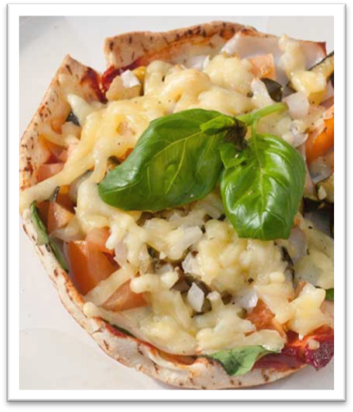 |  | 1 tablespoon of salt-reduced tomato paste  2 small wholemeal pita breads  50g turkey breast sliced  ¼ onion, diced  ½ tomato, diced  1 zucchini (chargrilled) diced  1 cup of baby spinach, washed  ½ cup of reduced-fat tasty cheese  Dried herbs and pepper

Serves 2
Preparation Time 15-20 mins
Cooking Time 30 mins
Chicken and mixed vegetable risotto
Method |  | Ingredients
1. Add stock to saucepan on medium heat  2. Meanwhile, heat oil in a frying pan. Add the onion and chicken breast and cook until browned. Transfer to a bowl, cover and put in the oven at 70°C (50°C fan-forced) to keep warm.  3. Add ½ cup of stock and rice to fry pan. Gradually add the remaining stock (1/2 cup at a time). Stir constantly for 30 minutes or until liquid is absorbed and rice is tender and the risotto is creamy.  4. Add the chicken, thyme and mixed vegetables. Stir and cook for further 5-10 minutes or until vegetables are tender.  5. Season with salt and pepper. Stir in parmesan. Serve hot.  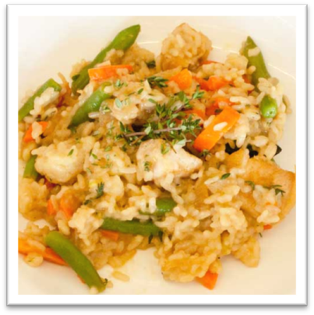 |  | 2½ cups salt-reduced chicken stock  1 tablespoon olive oil  ½ onion, sliced  1 large chicken breast, diced  ¾ cup Arborio rice  1 teaspoon of fresh thyme leaves  2 cup of frozen mixed vegetable  2 teaspoon low-fat parmesan cheese, finely grated  Salt and pepper to taste

Serves 2
Preparation Time 10-15 mins
Cooking Time 8 mins
Fruit pizza
Method |  | Ingredients
1. Preheat oven to 180°C (160oC fan-forced).  2. Mix the honey and water in a separate bowl.  3. Split the muffins in half and brush with 1 teaspoon honey and water mixture. Place in toaster until golden.  4. Spread the yoghurt mixture on muffin and arrange fruits on top.  5. Mix honey and yoghurt, spread on base. Add strawberries, peaches then raspberries.  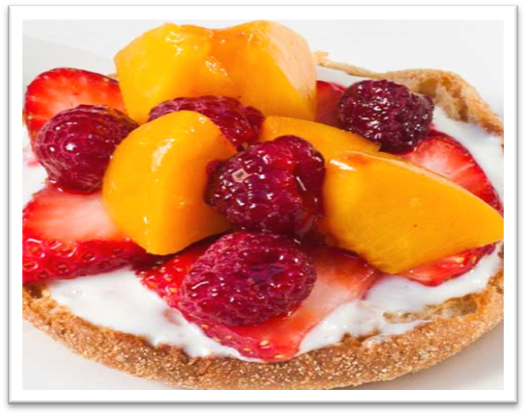 |  | ½ cup reduced-fat natural yoghurt  2 whole meal English muffins  ½ cup frozen raspberries  4 fresh strawberries, sliced  ½ cup canned or fresh peach slices  1 teaspoon water  2 teaspoons honey

Handouts

Handout 1: Mix and match your pizza
Pizza base | Sauce  (choose 1–2) | Cheese  (choose 1) | Protein  (choose 1) | Vegetables  (choose 2+)
Pita bread | Pesto | Mozzarella | Minced meat | Capsicum
Premade pizza base | Tomato paste or sauce | Cheddar | Seafood | Baby spinach
English Muffin | Satay sauce | Tasty | Chicken breast | Zucchini
Wholemeal bread | Hummus | Parmesan | Shaved ham | Carrot
Homemade pizza dough | Sweet chilli sauce | Feta | Pepperoni | Mushroom
Tortilla | Barbeque sauce | Cottage | Shaved turkey breast | Roasted sweet potato
Bagels | Tzatziki | Romano | Nuts i.e. cashews, pine | Sundried or fresh tomatoes

Handout 2: Useful tips when making risotto
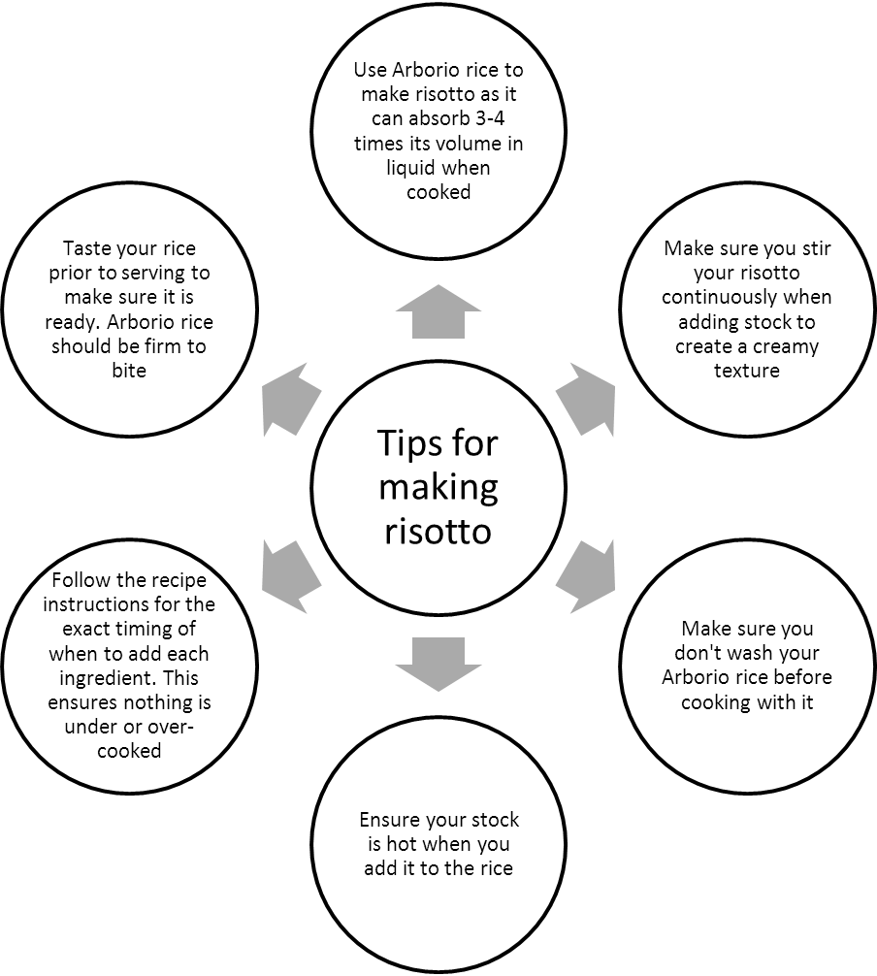

Handout 3: Additional recipes
Serves 2
Preparation Time 15 mins
Cooking Time: 20 mins
Creamy chicken pasta carbonara
Method |  | Ingredients
1. Fill a saucepan with water and bring to boil. Cook pasta for 10-15 minutes. Drain well.  2. Meanwhile, microwave broccoli and peas in a microwave safe bowl with some water. Microwave for 5 minutes.  3. Heat oil in frying pan. Add and cook onion, garlic, and chicken breast. Cook chicken until brown.  4. Blend in stock, cream and skim milk, bring to boil and reduce heat; simmer until begin to thicken.  5. Blend in egg, broccoli, peas, pepper and herbs, stirring constantly, simmer for 30 seconds. Stir through cooked pasta when done.  6. Serve hot.  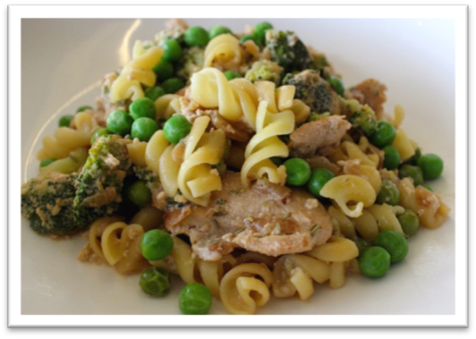 |  | ½ cup fusilli wholemeal pasta  1 cup broccoli, chopped  ½ cup peas (fresh or frozen)  1 tablespoon of olive oil  ½ onion, diced  1 garlic clove, chopped  200g chicken breast, diced  ¼ cup salt reduced chicken stock  ¼ cup extra light thickened cream  100ml skim milk  1 medium egg

Serves 6
Preparation Time 15 mins
Cook time 20 mins
Berry brownie pizza
Method |  | Ingredients
1. Preheat oven to 180°C and grease a round baking pan.  2. Prepare the brownie mix according to the box directions and pour mix to the baking pan. Bake for 20 minutes or until done.  3. Whisk the yoghurt and honey well.  4. Spread mixture on the cooled brownie crust.  5. Arrange the raspberries and blueberries over the yoghurt mixture. Sprinkle with the chopped almonds.  6. Serve with ice-cream.  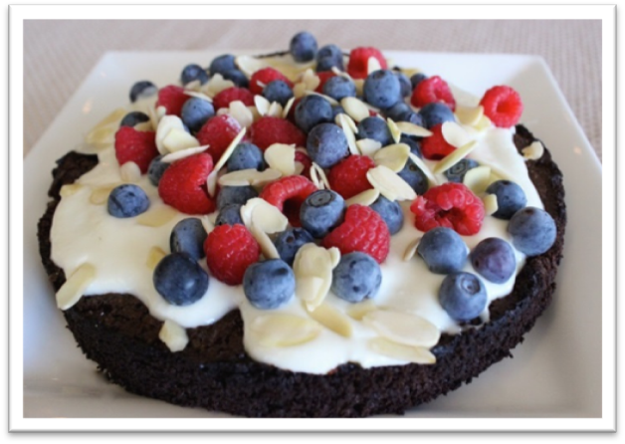 |  | 1 box brownie mix  2½ cups fat free yoghurt  1½ tablespoons honey  1 cup fresh raspberries  1 cup blueberries  1 cup chopped almonds (optional)  Serve with:  6 scoops reduced fat ice-cream

Serves 2
Preparation Time 15 mins
Cooking Time 40 mins
Oven baked mince and cheese risotto
Method |  | Ingredients
1. Preheat oven at 180°C and grease the oven proof dish.  2. Heat oil in a saucepan. Cook the onion and garlic till tender, add soy sauce and minced beef. Cook till mince browns.  3. Add the tomato and zucchini, cook for 2-3 minutes. Transfer this is a bowl, cover and put in microwave to keep warm.  4. Add the rice into the hot stock and let it simmer for 8-10 minutes until it is almost cooked. Mix the minced mixture into the rice stock mixture and stir in parmesan.  5. Pour the rice mixture into the oven proof dish. Even the surface. Bake at 180°C for 30 minutes.  6. Serve hot with steamed broccoli.  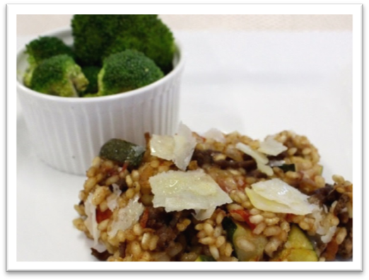 |  | 1 teaspoon olive oil  ½ onion, diced  1 garlic clove, chopped  ½ tablespoon soy sauce  120g lean beef minced  1 cup zucchini, diced  1 tomato, diced  ¾ cups beef stock  ¾ cup Arborio rice  ¹/₃ cup low fat grated parmesan cheese  Serve with:  1 cup broccoli (steamed)

