Cooking for One or Two
Masterclasses

Italian Cuisine
Session 1

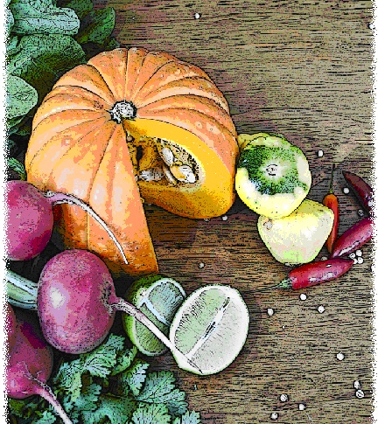

Contents
Objectives and overview 3
Session checklist 4
Ingredients list 5
Equipment 7
Room set up 9
Timeline 10
Introduction 11
Group agreement 12
Discussion: Brief history of Italian cuisine and common ingredients used in Italian cooking 13
Discussion: Cooking, preparing and storing pasta 15
Discussion: Making pasta nutrient dense 17
Food preparation 18
Enjoy a meal together 19
Thank you and conclusion 19
Session clean up 20
Recipes 21
Handouts 25
Handout 1: Common ingredients in Italian cuisine 25
Handout 2: Useful tips when boiling pasta 26

Objectives and overview
Session objectives
By the end of this session, participants will have:
- Identified common ingredients used in Italian cooking.
- Understood the correct method of cooking and storing pasta.
- Understood how to make nutrient dense pasta.
- Developed food preparation skills.
- Enjoyed a meal with a group of new friends.

Session overview
Today’s discussion topics:
- Brief history of Italian Cuisine
- Common ingredients used in Italian cooking
- Cooking, preparing and storing pasta
- How to make your pasta nutrient dense
Today you will be cooking:
- Bruschetta
- Bolognese pasta bake with green salad
- Tiramisu

Session checklist
Facilitator |  |  | Assistant
Collect groceries using session shopping list |  |  | Assist with grocery shopping where required
Arrive approximately 45 minutes prior to the start of the session |  |  | Arrive approximately 30 minutes prior to the start of the session
Read first aid instructions |  |  | Conduct safety checklist for the venue
Set up cooking equipment |  |  | Help with set up of equipment
Set up room |  |  | Help with set up of room
Print handouts for each participant |  |  | Facilitate the program following all instructions in blue
Download the video clips prior to the session |  |  | Help with washing up/cleaning
Photocopy appropriate evaluation sheets for session (if required; Appendix A)
Facilitate the program following all instructions in green
Wash up/cleaning

Ingredients list
tsp = teaspoon
tb = tablespoon
 | To serve 2 people | To serve 4 people | To serve 6 people | To serve 8 people
Tomatoes | 2 | 4 | 6 | 8
Red onion | ½ | 1 | 1½ | 2
Basil | ½ cup | 1 cup | 1½ cups | 2 cups
Garlic | ½ tsp | 1 tsp | 1½ tsps | 2 tsps
Balsamic vinegar | 1 tb | 2 tbs | 3 tbs | 4 tbs
Olive oil | ⅓ cup | ⅔ cup | 1 cup | 1⅓ cups
Brown onion | ½ onion | 1 onion | 1½ onion | 2 onions
Lean beef mince | 150g | 300g | 450g | 600g
Salt-reduced tomato paste | 2 tbs | 4 tbs | 6 tbs | 8 tbs
Italian tomatoes with basil and garlic (410g can) | ¼ | ½ | ¾ | 1
Carrot | 1 | 2 | 3 | 4
Zucchini | 1 | 2 | 3 | 4
Cracked pepper | Pinch | Pinch | Pinch | Pinch
Dried macaroni pasta | 1 cup | 2 cups | 3 cups | 4 cups
Reduced-fat tasty cheese | ½ cup | 1 cup | 1½ cups | 2 cups
Mixed green salad leaves | 1 cup | 2 cups | 3 cups | 4 cups
Sprouts | ½ cup | 1 cup | 1½ cups | 2 cups
Cucumber | ½ | 1 | 1½ | 2
Avocado | ½ | 1 | 1½ | 2
Sunflower and pumpkin seeds | 1 tb | 2 tbs | 3 tbs | 4 tbs
Lemon juice | ½ tb | 1 tb | 1½ tbs | 2 tbs
Wholegrain mustard | 1 tsp | 2 tsps | 3 tsps | 4 tsps
Extra light cream | 1 tb | 2 tbs | 3 tbs | 4 tbs
Reduced fat ricotta | 50g | 100g | 150g | 200g
Light custard | 250ml | 500ml | 750ml | 1 litre
Caster sugar | 1 tb | 2 tbs | 3 tbs | 4 tbs
Vanilla essence | 1 tsp | 2 tsps | 3 tsps | 4 tsps
Instant espresso coffee | 100ml | 200ml | 300ml | 400ml
Sponge finger biscuits | 4 | 8 | 12 | 16
Frozen mixed berries | ½ cups | 1 cup | 1½ cups | 2 cups
Grated chocolate (optional) | 1 tb | 2 tbs | 3 tbs | 4 tbs

Equipment
For table one
3 cooks knives |  | Measuring cups
3 vegetable knives |  | Measuring spoons
3 wooden spoons |  | Small, medium and large bowls
3 serving spoons |  | Colander
Vegetable peelers |  | Chopping boards / Chux
Pastry brush |  | Oven proof dishes
Can opener |  | Cling wrap and baking paper
Whisk |  | Foil
Juicer |  | Measuring jugs
Dessert glasses
For table two
Place dry ingredients on table; amount dependent on number of people in the group
For refrigerator
Place ingredients that need to remain cool in the refrigerator; amount dependent on number of people in the group
For table three
Electric wok |  | Electric hot plates
Large saucepan |  | Oven
Heat proof mats |  | Oven Mitts
Thermometer |  | Oven proof dishes
Extension cord (if necessary) |  | Baking tray
For the kitchen and washing up area
Tea towels |  | Washing up liquid
Dish brush |  | Pot scrub
Dish cloths
For food safety and washing hands
Liquid soap |  | Paper hand towels
For dining
Cutlery (knives, forks & spoons) |  | Serviettes
Plates |  | Cups
Bowls |  | Jug (with water)
Table Cloth
For refreshments (to be set up wherever deemed suitable)
Tea |  | Sugar
Coffee |  | UHT Milk
For discussion sessions and miscellaneous items
White board |  | Name tags
White board markers |  | Attendance sheet
Pens |  | Recipe cards
Handout 1: Common ingredients in Italian cuisine |  | Handout 2: Useful tips when boiling pasta
For occupational health and safety
St Johns First Aid Kit |  | Duct tape to tape down electrical cords

Room set up
TABLE TWO
Place one table to the side for all ingredients to be displayed on.
TABLE THREE
Place electrical equipment here.
Place on side closest to power points. If extension cord is used ensure it is taped to the ground to prevent participants tripping and injuring themselves.
TABLE ONE
Set up a table with enough space for participants to stand around for food preparation in the centre of the room.
Set up all equipment other than electrical appliances at this table.
This table can later be set up for dining.

Timeline
 |  | Set up room, including table with ingredients, food preparation area, dining area and chairs and whiteboard for discussion (45 mins before session)
Start
session
Start  session |  | Introduction and safety (10 mins)
 |  | Group agreement (5 mins)
 |  | Discussion: Brief history of Italian cuisine and common ingredients used in Italian cooking (15 mins)
30 mins
30 mins |  | Discussion: Cooking, preparing and storing past (15 mins)
 |  | Discussion: Making pasta nutrient dense (5 mins)
 |  | Food preparation (80 mins)
1 hr |  | Food preparation (80 mins)
90 mins |  | Food preparation (80 mins)
2 hrs |  | Food preparation (80 mins)
 |  | Enjoy a meal together (40 mins)
150 mins |  | Enjoy a meal together (40 mins)
 |  | Thank you and conclusion (5 mins)
3 hrs |  | Session clean up (approx. 20-30 mins)
210 mins

Introduction |  | 10 minutes
The following section is to be conducted by the facilitator
1. Welcome the participants to Session One of the ‘Italian cuisine’ masterclass as part of the Cooking for One or Two program. Ask all participants to sign the attendance sheet (see main manual for more information).
2. Introduce yourself and the assistant to the group.
3. Explain to the group that you will be facilitating both sessions of the Italian cuisine program.
4. Introduce the assistant. State they are kindly offering their time to assist with the sessions by helping with registration, evaluation, setting up and cleaning up.
5. Read the following explaining to the group what the Cooking for One or Two masterclass is and the aims of the program:
 | What is the cook your own Italian cuisine masterclass?
- The Italian cuisine masterclass is a two-session program.
- The program is designed for older people living in the community who have previously participated in Cooking for One or Two and want to develop additional cooking skills in Italian cooking.
- Each session the group will cook an easy, quick and nourishing meal, including a light meal, a main meal and dessert. It is not a cooking demonstration, but an opportunity for you to develop your cooking skills in a supportive environment. We will then enjoy the meal together. A cooking skill and health related topic will be discussed in each of the sessions. The discussion aims to improve your cooking skills and teach you new techniques”
6. Explain to the group that all sessions are well planned to reduce risks, but it is still important to point out the safety risks including:
- The exits [point out to group] in case of fire.
- Fire blankets and fire extinguishers [point out to group] in case of fire.
- Emergency rally points.
- Electrical equipment and cords have been firmly taped down [point out all].
- The location of the first aid officer (if the facility has one).
- Being mindful of safe procedures when cutting and chopping food.
- The bathrooms [give location].
7. Ask the group to inform you if there are any accidents or incidents or if they are feeling unwell.
8. Ask each participant to introduce themselves to the group and tell the group why they were interested in attending this Italian cuisine masterclass.
9. Thank the group for sharing their reasons for joining the program.
10. Outline the content of Session One:
- Brief history of Italian cuisine and common ingredients used in Italian cooking.
- Cooking, preparing and storing pasta.
- Making pasta nutrient dense.
11. Reintroduce the assistant who will now be speaking about the group agreement.

Group agreement |  | 5 minutes
The following section is to be conducted by the assistant
1. Read the following explaining to the group that throughout the program all group members are to follow these tips for working together as a group.
 | Group agreement
- It is very important that we all agree to follow the safe food practices outlined today as we cook each meal over the next two weeks.
- It is very easy to forget some of the important steps to ensure foods are prepared safely, so we will all have to work as a group to do this.
- There are also some other important things we can do to ensure the group runs smoothly. This includes:
  - Listening to each other; this means trying to talk one at a time, and letting everyone have their say.
  - Supporting each other; you are all here to learn new skills so support each other in this endeavour.
  - Take care (consider your own and others safety) when using knives, hot equipment and food; try to prevent slips, trips, falls and heavy lifting.
  - The most important thing is for us all to have fun, whilst learning. The sessions should be a time for you to make friends.
It is important before we start the food preparation today that we all agree to work this way in our group.
2. Ask the group if they think these points sound fair.
3. If you have a whiteboard available, you might like to write the main points from the group agreement up so the group can review them throughout the session.
4. Ask the group if they can think of any other important things we can do to work together as a group or make the most of the group and add any new points to the whiteboard.
5. Hand back over to the facilitator.

Discussion: Brief history of Italian cuisine and common ingredients used in Italian cooking |  | 15 minutes
The following section is to be conducted by the facilitator
1. Inform the group we will be talking about the history of Italian cuisine and common ingredients used in Italian cooking.
2. Ask the group if anyone has been to Italy and if someone has, would they mind describing some of the culture and their favourite meal.
3. Ask the participants to refer to Handout 1 “Common ingredients in Italian cuisine”.
4. Read the following explaining to the group the history of Italian cuisine and common ingredients used in Italian cooking:
 | Italian cuisine in Australia
- Italy is officially known as the Italian Republic is situated in southern Europe.
- Rome is the capital of Italy.
- The official language is Italian.
- After the Second World War, there was a large migration of Italians to Australia, with the greatest concentration of Italians being in Victoria. The migration of Italians meant that there was an increase in awareness of Italian cuisine, with Australians subsequently starting to embrace Italian cooking in their homes.
- Italian cuisine is part of the Mediterranean diet which has been found to have the following health benefits when these foods are consumed regularly:
  - Reduced risk of heart disease
  - Lower blood pressure
  - Reduced risk of type 2 diabetes
  - Reduced incidence of cancer
  - Reduced incidence of Parkinson’s and Alzheimer’s diseases
 | Common ingredients in Italian cooking
There are a number of common ingredients that appear regularly in Italian cooking. We will now discuss those ingredients and what they are used for.
- Balsamic vinegar: a dark, thick vinegar with a sweet taste. It is often used in salads or as a side with bread.
- Basil: a herb that often appears in sauces, salads and on pizzas (after cooking). You can buy it fresh or dried in supermarkets or you can try growing it in your garden at home.
- Bread: a staple food in Italy and is often served with cheese and prosciutto (a type of dry-cured ham). Bread is also the base of a very popular Italian entrée known as bruschetta, which we will make in today’s session.
- Olive oil: the main oil used in Italian cooking. It is usually added to salads or pastas and as a side with bread. This oil has one of the richest levels of monounsaturated fat, which has been shown to reduce cardiovascular risk factors.
- Cheese: very versatile in Italian cooking; it can be used in entrees, mains and desserts. You can find a wide range of cheeses used in Italy in your local supermarket.
- Olives: used widely in Italian dishes and many types are available in your local supermarket. They are the perfect starter to your Italian meal.
- Tomatoes: are one of the most versatile foods in Italian cooking. They are used in soups, salads, pastas and stews. An interesting fact is that Italians originally thought that tomatoes were poisonous when they were first introduced into Italy. In Australia, you can buy these either tinned or fresh.
- Pasta: a staple food in Italy. You can buy pasta dried or fresh, or make your own. Many of the Italian ingredients we have discussed are often used in pasta dishes such as basil, olive oil, cheese and tomato.
5. Ask the group if they have any questions.

Discussion: Cooking, preparing and storing pasta |  | 15 minutes
The following section is to be conducted by the facilitator
1. Inform the group we will be talking about cooking, preparing and storing pasta.
2. Ask the participants to refer to Handout 2 “Useful tips when boiling pasta”.
3. Read the following explaining to the group tips on how to cook pasta:
 | Tips on how to cook pasta
Step 1: Add water and a pinch of salt to a large saucepan, and bring the water to the boil. The salt is added to increase the boiling point of the water and enhance the flavour of the pasta.
Step 2: Add the pasta to the boiling water and stir. This prevents the pasta from sticking together or to the bottom of the pan.
Step 3: It is important to follow the instructions on the packet for the specific directions to cook your pasta.
Step 4: Cook your pasta until al dente (this is Italian for “to the tooth”). You can test to see whether the pasta is al dente by removing a piece and taking a bite. It should be cooked but slightly firm in the centre.
Step 5: Drain pasta but do not rinse. Rinsing your pasta will drain the starch needed to absorb the flavour of your sauce.
Step 6: Once you have cooked your pasta you will need to add your sauce, meat and/or vegetables.
4. Read the following explaining the common types of pasta, and sauce used in Italian cuisine:
 | Common pasta and sauces used in Italian cuisine
There are many types of pasta to choose from in the supermarket. Some common types include: spaghetti, bowtie, fusilli, macaroni, fettuccine and linguine.
The type of pasta you choose may influence the ingredients you choose to add to the dish, for example:
- Spaghetti is often served with a tomato or pesto sauce and either meat or seafood.
- Fusilli is often served with a tomato or pesto sauce and seafood.
- Linguine is often served with tomato or pesto sauce and seafood.
- Pasta can also be made with either meat or vegetables and cheese stuffed inside, which is known as ravioli and tortellini, and served with either a cream or tomato based sauce.
- Lasagne is another type of pasta. Lasagne sheets are used to layer vegetables and/or meat, tomato based sauces and cheese.
There are three main types of pasta sauces used in Italian cooking:
- Tomato based
- White sauces
- Pesto
These sauces are versatile, with different ingredients able to be added to change the dish such as seafood, meat or vegetables, as well as cheese, olives, and herbs.
5. Read the following explaining how to store pasta:
 | Storing your pasta
Uncooked pasta can be stored in your cupboard for up to two years, however be sure to check the use-by or best before dates on the package. Ensure the pasta is kept in a cool, dry place.
Cooked pasta must be kept in an airtight container in the fridge and stored for no more than 3 to 5 days. A little bit of olive oil can be added to prevent the pasta from sticking.
If you cook pasta and freeze it, make sure you put it in an airtight container or freezer bag. To reheat, put the pasta straight into boiling water for a few seconds and then drain.
6. Ask the group if they have any questions.

Discussion: Making pasta nutrient dense |  | 15 minutes
The following section is to be conducted by the facilitator
1. Inform the group we will be talking about how to make pasta nutrient dense.
2. Read the following explaining the tips for making pasta nutrient dense:
 | Tips for making pasta nutrient dense
- Choose wholegrain pasta. Wholegrain pasta contains more fibre than white varieties.
- Add legumes such as beans or lentils. Legumes are a good source of protein, they are cheap to buy, and convenient to use as there is no cooking required. Legumes are a fantastic protein source for vegetarians.
- Make your own sauce using fresh ingredients such as tomatoes, or fresh herbs for a pesto sauce.
- Adding vegetables to the sauce and overall pasta dish will help to increase your fibre and vegetable serves.
Pasta is a convenient and easy meal to make. You can get creative by adding your favourite ingredients to a dish or trying new ingredients.
3. Ask the group if they have any questions.

Food preparation |  | 80 minutes
The following section is to be conducted by the facilitator
While the facilitator leads the food preparation, the assistant can help participants with meal preparation and washing any equipment.
1. Introduce the participants to the food preparation session:
- Firstly we will be preparing the bruschetta
- Secondly we will be cooking the pasta
- Thirdly we will be preparing the tiramisu
2. Explain to the group that:
- Each member of the group will be assisting with the cooking process.
- You are there to guide the food preparation, but the group will be doing most of the work.
- If anyone has any questions or problems, please ask for help.
3. Ask the group to view the bruschetta recipe card. Read the recipe card explaining step-by-step the recipe. Once you have read these instructions give each participant a role in preparing the recipe according to these steps.
4. Ask the group to wash their hands before commencing food preparation.
 | Bruschetta
1. Preheat oven to 220°C (200ºC fan-forced).
2. Brush bread with oil, and bake for approximately 3-5 minutes.
3. Meanwhile, combine tomato, onion, basil, garlic and vinegar in a bowl.
4. Top crunchy bread with tomato mixture and grate low-fat parmesan cheese on top.
5. Ask participants to view the bolognaise pasta bake recipe card and green salad recipe card. Read the recipe cards explaining step-by-step the recipe. Once you have read these instructions give each participant a role in preparing the recipe according to these steps.
 | Bolognese pasta bake
1. Preheat oven to 220°C (200ºC fan-forced).
2. Heat oil in a frying pan on medium heat. Add onion, garlic and beef mince. Cook until mince is brown.
3. Stir in the tomato paste and canned tomatoes, add carrot and zucchini and reduce the heat to simmer for 10 minutes.
4. Meanwhile, cook the pasta in a pot of boiling water until ‘al-dente’.
5. Once the pasta is cooked, drain and stir into the tomato and mince mixture.
6. Spoon the mixture into ovenproof ramekins, sprinkle the mixture with pepper and cheese and bake for 20 minutes.
7. Meanwhile, place all ingredients for the salad in a large salad bowl and toss until combined.
8. In a medium screw-top jar, shake up ingredients for the dressing until smooth.
9. Place both salad and dressing in refrigerator, until ready to serve the meal.
10. Serve pasta bake with green salad.
6. Ask participants to view the tiramisu recipe card. Read the recipe card explaining step-by-step the recipe. Once you have read these instructions give each participant a role in preparing the recipe according to these steps.
 | Tiramisu
1. Add the cream, ricotta cheese, custard, caster sugar and vanilla essence to a mixing bowl. Whisk the mixture until smooth.
2. Make espresso coffee. Add each teaspoon of instant espresso coffee into 30ml of boiling water and let it sit until the coffee dissolves and cools. Place each sponge finger in the coffee, making sure all sponge fingers are coated in full.
3. Line serving glasses with the sponge finger biscuits, breaking them in half if needed.
4. Spoon the cream mix into the glasses until you reach the top. Refrigerate for 1 hour.
5. Top with mixed berries and grated chocolate. Serve cold.

Enjoy a meal together | 40 minutes
The following section is to be conducted by the assistant
1. Set each participant, the facilitator and the assistant a place at the dining table. Use the table cloth, serviettes, crockery and cutlery to create an inviting space to share the meal together.
2. Enjoy!

Thank you and conclusion | 5 minutes
The following section is to be conducted by the facilitator
1. Congratulate the group on a job well done.
2. Ask the group to reflect on what they have learnt in their first session of Italian. Ask the group to share any new information or skills they have learnt.
3. Outline the next session’s content.
- Meal; Pita pizza, chicken and mixed vegetable risotto and fruit pizza
- Discussion topic; the history and making of pizza, safety measures when making a pizza, making risotto

Session clean up | 30 minutes
The following section is to conducted by the assistant
1. When cleaning up, it is important that you use hot soapy water, and refill the sink once the water has become either warm or discoloured (dirty). At all stages in the washing up process please be mindful of sharp objects being left in the water.
2. All equipment must be washed and sanitised prior to being packed away for the next session. It is also important that all equipment goes back to where it was found.

Recipes
Serves 2
Preparation Time 10-15 mins
Cooking Time 5-10 mins
Bruschetta
Method |  | Ingredients
1. Preheat oven to 220°C (200ºC fan-forced).  2. Brush bread with oil, and bake for approximately 3-5 minutes.  3. Meanwhile, combine tomato, onion, basil, garlic and vinegar in a bowl.  4. Top crunchy bread with tomato mixture.  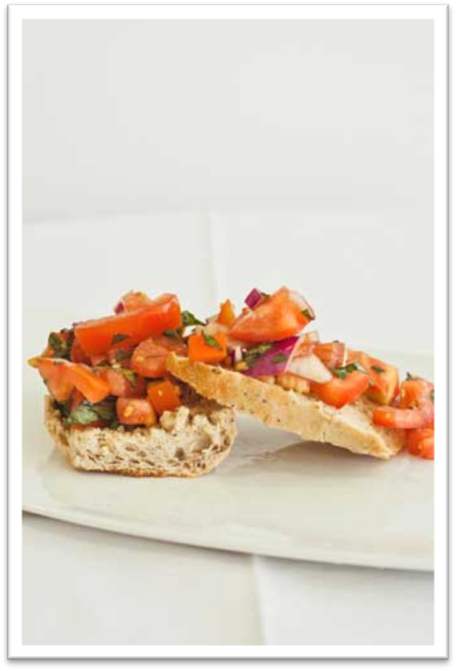 |  | ½ wholegrain French bread stick, sliced  1 tablespoon olive oil  2 tomatoes, diced  ¼ red onion, diced  ½ cup fresh basil leaves, coarsely chopped  ½ teaspoon garlic (fresh or dried)  1 tablespoon balsamic vinegar

Serves 2
Preparation Time 10-15 mins
Cooking Time 30 mins
Bolognese pasta bake
Method |  | Ingredients
1. Preheat oven to 220°C (200ºC fan-forced).  2. Heat oil in a frying pan on medium heat. Add onion, garlic and beef mince. Cook until mince is brown.  3. Stir in the tomato paste and canned tomatoes, add carrot and zucchini and reduce the heat to simmer for 10 minutes.  4. Meanwhile, cook the pasta in a pot of boiling water until ‘al-dente’*. Drain the pasta and stir into the tomato and mince mixture.  5. Spoon the mixture into 2 ovenproof ramekins. Sprinkle the mixture with pepper and cheese. Bake for 20 minutes.  6. Serve pasta bake with green salad.  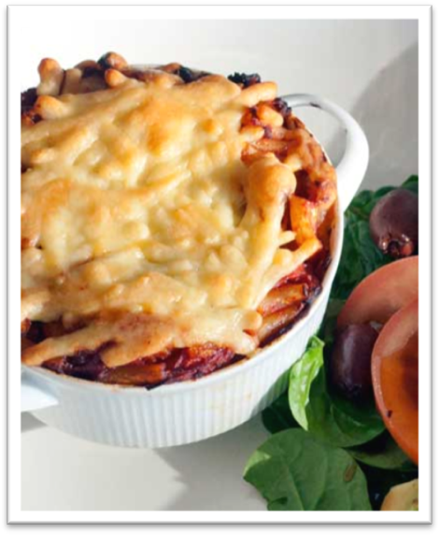 |  | ½ tablespoon olive oil  ½ brown onion, diced  150g lean beef minced  2 tablespoons salt-reduced tomato paste  ½ cup of canned Italian tomatoes with basil and garlic  1 carrot, coarsely grated  1 zucchini, diced  Cracked black pepper  1 cup dried macaroni pasta  ½ cup reduced-fat tasty cheese  Serve with:  Green salad (see following recipe)  Special tip  *Al-dente is a term to describe pasta, meaning that it is cooked to be firm but not hard

Serves 2
Preparation Time 10 min
Cooking Time Nil
Green salad
Method |  | Ingredients
1. Place all ingredients for the salad in a large salad bowl and toss until combined  2. In a medium screw-top jar, shake up ingredients for the dressing until smooth. Pour over salad, and toss thoroughly.  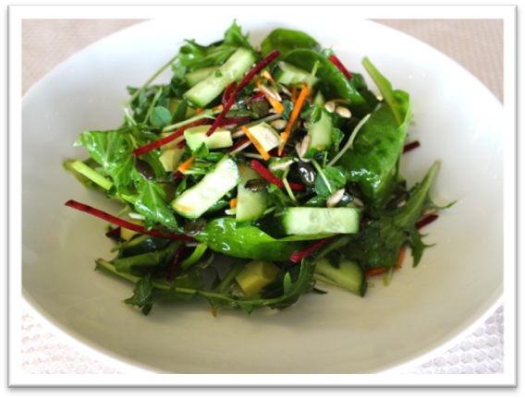 |  | 1 cup mixed green salad leaves  ½ cup sprouts (i.e. sunflower, snow pea, alfalfa or broccoli)  ½ cucumber, chopped  ½ avocado, cubed  1 tbs sunflower and pumpkin seeds  Dressing  ½ tbs lemon juice  ¼ cup olive oil  1 tsp wholegrain mustard  Salt and pepper to taste

Serves 2
Preparation Time 15-20 mins
Cooking Time 1 hour
Tiramisu
Method |  | Ingredients
1. Add the cream, ricotta cheese, custard, caster sugar and vanilla essence to a mixing bowl. Whisk the mixture until smooth.  2. Make espresso coffee. Add one teaspoon of instant espresso coffee into 30ml of boiling water and let sit until coffee dissolves and cools. Place each sponge finger in coffee (Make sure all sponge fingers are coated in full).  3. Line 2 serving glasses with the sponge finger biscuits, breaking them in half if needed.  4. Spoon the cream mix in to the glasses until you reach the top. Refrigerate for 1 hour.  5. Top with mixed berries and grated chocolate.  6. Serve cold.  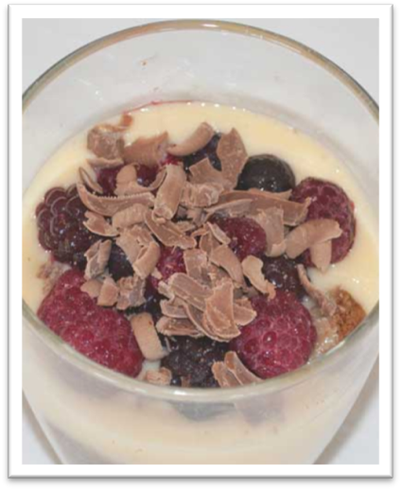 |  | 1 tablespoon extra light thickened cream  50g reduced-fat ricotta cheese  250ml light custard  1 tablespoon caster sugar  1 teaspoon vanilla essence  100mL instant espresso coffee  4 sponge-finger biscuits  ½ cup frozen mixed berries  1 tablespoon grated chocolate

Handouts

Handout 1: Common ingredients in Italian cuisine
 | Balsamic vinegar: a dark, thick vinegar with a sweet taste. It is often used in salads or as a side with bread.
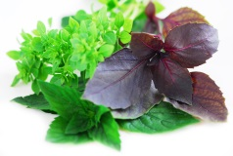 | Basil: a herb that often appears in sauces, salads and on pizzas (after cooking). You can buy it fresh or dried in supermarkets or you can try growing it in your garden at home.
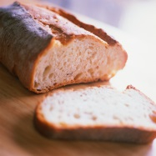 | Bread: a staple food in Italy and is often served with cheese and prosciutto (a type of dry-cured ham). Bread is also the base of a very popular Italian entrée known as bruschetta.
 | Olive oil: the main oil used in Italian cooking. It is usually added to salads or pastas and as a side with bread. This oil has one of the richest levels of monounsaturated fat, which has been shown to reduce cardiovascular risk factors.
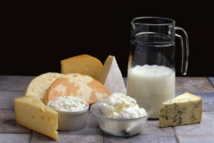 | Cheese: very versatile in Italian cooking; it can be used in entrees, mains and desserts. You can find a wide range of cheeses used in Italy in your local supermarket, such as mozzarella, cheddar, Romano, parmesan, feta and mascarpone.
 | Olives: used widely in Italian dishes and many types are available in your local supermarket. They are the perfect starter to your Italian meal.
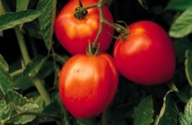 | Tomatoes: one of the most versatile foods in Italian cooking. They are used in soups, salads, pastas and stews. In Australia, you can buy these either tinned or fresh
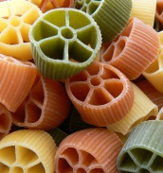 | Pasta: a staple food in Italy. You can buy pasta dried or fresh, or make your own. Many of the above Italian ingredients are often used in pasta dishes such as basil, olive oil, cheese and tomato.

Handout 2: Useful tips when boiling pasta
