Cooking for One or Two
Masterclasses

Fabulous fish and sensational seafood
Session 2

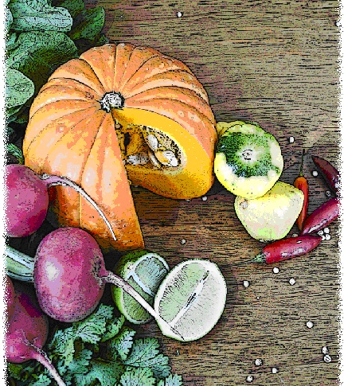

Contents
Objectives and overview 3
Session checklist 4
Ingredients list 5
Equipment 6
Room set up 8
Timeline 9
Introduction 10
Group agreement reminder 11
Discussion: Storing and transporting seafood 12
Discussion: Catching your own seafood 13
Food preparation 15
Enjoy a meal together 16
Evaluation 17
Thank you and conclusion 18
Session clean up 18
Recipes 19
Handouts 22
Handout 1: Transporting and storing seafood 22
Handout 2: How to peel a prawn 23
Handout 3: Additional recipes 24

Objectives and overview
Session objectives
By the end of this session, participants will have:
- Learnt how to store and transport seafood when purchasing it.
- Understood the basic equipment to use when fishing.
- Understood how social activities can be planned around fishing.
- Learnt how to peel a prawn.
- Continued to develop food preparation skills.
- Learnt how to prepare and cook seafood.
- Enjoyed a meal with new friends.

Session overview
Today’s discussion topics
- Storing and transporting seafood
- Basic guide to fishing
- How to peel a prawn
Today you will be cooking:
- Grilled fish fillet and Greek salad
- Chilli prawn and mango salad
- Mango ice-cream

Session checklist
Facilitator |  |  | Assistant
Collect groceries using session shopping list |  |  | Assist with grocery shopping where required
Arrive approximately 45 minutes prior to the start of the session |  |  | Arrive approximately 30 minutes prior to the start of the session
Read first aid instructions |  |  | Conduct safety checklist for the venue
Set up cooking equipment |  |  | Help with set up of equipment
Set up room |  |  | Help with set up of room
Print handouts for each participant |  |  | Facilitate the program following all instructions in blue
Photocopy appropriate evaluation sheets for session (if required; Appendix A) |  |  | Help with washing up/cleaning
Facilitate the program following all instructions in green
Wash up/cleaning

Ingredients list
tsp = teaspoon
tb = tablespoon
 | To serve 2 people | To serve 4 people | To serve 6 people | To serve 8 people
Olives | 15 | 30 | 45 | 60
Tomato | 2 | 4 | 6 | 8
Reduced-fat feta cheese | 100g | 200g | 300g | 400g
Bag of mixed lettuce leaves | 200g | 400g | 600g | 800g
Canola oil | 1 tsp | 2 tsps | 3 tsps | 4 tsps
White fish fillet (80g each) | 2 | 4 | 6 | 8
Reduced-fat balsamic dressing | 2 tbs | 4 tbs | 6 tbs | 8 tbs
Wholemeal bread | 2 slices | 4 slices | 6 slices | 8 slices
Prawns (unpeeled and cooked) | 100g  (~ 8 prawns) | 200g  (~ 16 prawns) | 300g  (~ 24 prawns) | 400g  (~ 32 prawns)
Mangoes in natural juice (400g can) | 1 | 2 | 3 | 4
Avocado | ½ | 1 | 1½ | 2
Cucumber (small) | 1 | 2 | 3 | 4
Iceberg lettuce leaves | 4 | 8 | 12 | 16
Reduced fat coleslaw dressing | 2 tbs | 4 tbs | 6 tbs | 8 tbs
Sweet chilli sauce | 2 tsps | 4 tsps | 6 tsps | 8 tsps
Icing sugar | ¼ cup | ½ cup | ¾ cup | 1 cup
Reduced-fat yoghurt | ¾ cup | 1½ cups | 2¼ cups | 3 cups
Reduced-fat milk | 200ml | 400ml | 600ml | 800ml

Equipment
For table one
3 cooks knives |  | Measuring cups
3 vegetable knives |  | Measuring spoons
3 wooden spoons |  | Small, medium and large bowls
3 serving spoons |  | Colander
Vegetable peelers |  | Chopping boards / Chux
Spatula |  | Oven proof dishes
Can opener |  | Cling wrap and baking paper
Whisk |  | Foil
Juicer
For table two
Place dry ingredients on table; amount dependent on number of people in the group
For Refrigerator
Place ingredients that need to remain cool in the refrigerator; amount dependent on number of people in the group
For table three
Large saucepan |  | Oven
Heat proof mats |  | Oven Mitts
Thermometer |  | Oven proof dishes
5 ice cube trays |  | Colander/strainer
Extension cord (if necessary)
For the kitchen and washing up area
Tea towels |  | Washing up liquid
Dish brush |  | Pot scrub
Dish cloths |  | Paper hand towel
For food safety and washing hands
Liquid soap |  | Paper hand towels
For dining
Cutlery (knives, forks & spoons) |  | Serviettes
Plates |  | Cups
Bowls |  | Jug (with water)
Table Cloth
For refreshments (to be set up wherever deemed suitable)
Tea |  | Sugar
Coffee |  | UHT Milk
For discussion sessions and miscellaneous items
Printed copy of evaluation form (if required; Appendix A) |  | Name tags
White board |  | Attendance sheet
White board markers |  | Recipe cards
Pens |  | Handout 1: Storing and transporting seafood
Handout 2: How to peel prawns |  | Handout 3: Additional recipes
For occupational health and safety
St Johns First Aid Kit |  | Duct Tape to tape down electrical cords

Room set up
TABLE TWO
Place one table to the side for all ingredients to be displayed on.
TABLE THREE
Place electrical equipment here.
Place on side closest to power points. If extension cord is used ensure it is taped to the ground to prevent participants tripping and injuring themselves.
TABLE ONE
Set up a table with enough space for participants to stand around for food preparation in the centre of the room.
Set up all equipment other than electrical appliances at this table.
This table can later be set up for dining.

Timeline
 |  | Set up room, including table with ingredients, food preparation area, dining area and chairs and whiteboard for discussion (45 mins before session)
Start
session
Start  session |  | Introduction and safety (10 mins)
 |  | Group agreement (5 mins)
 |  | Discussion: Storage and transport (20 mins)
30 mins |  | Discussion: Storage and transport (20 mins)
 |  | Discussion: Catching your own seafood (15 mins)
 |  | Food preparation (80 mins)
1 hr |  | Food preparation (80 mins)
90 mins |  | Food preparation (80 mins)
2 hrs |  | Food preparation (80 mins)
 |  | Enjoy a meal together (40 mins)
150 mins |  | Enjoy a meal together (40 mins)
 |  | Evaluation (5 mins)
3 hrs |  | Thank you and conclusion (5 mins)
3 hrs |  | Session clean up (approx. 20-30 mins)
210 mins

Introduction | 10 minutes
The following section is to be conducted by the facilitator
*Prior to the participants arriving for the session. The facilitator should place the milk and yoghurt in the ice cube trays as part of the preparation for the mango ice-cream.
1. Welcome the participants to Session Two of the ‘Fabulous fish and sensational seafood’ masterclass as part of the Cooking for One or Two program. Ask all participants to sign the attendance sheet (see main manual for more information).
2. Re-introduce yourself and the assistant to the group.
3. Explain to the group that it is important to know the safety risks and point out to the group important information regarding the venue, including:
- The exits [point out to group] in case of fire.
- Fire blankets and fire extinguishers [point out to group] in case of fire;
- Emergency rally points.
- Electrical equipment and cords have been firmly taped down [point out all];
- The location of the first aid officer is [give location and person’s name].
- Being mindful of safe procedures when cutting and chopping food.
- Ask the group members if anyone has a food allergy [talk to them individually regarding their allergy].
- The bathrooms [give location].
4. Ask the group to inform you if there are any accidents or incidents or if they are feeling unwell.
5. Ask the participants if anyone has any food allergies.
6. Ask participants if anyone has tried preparing the recipes from last session.
7. Outline the content of Session Two:
- Storing and transporting seafood.
- Basic guide to fishing.
- Learning how to peel a prawn.
8. Reintroduce the assistant who will now be speaking about the group agreement.

Group agreement reminder | 5 minutes
The following section is to be conducted by the assistant
1. Remind the group of their group agreement from session one. They all agreed to:
- Follow safe food practices; washing hands when required, not cross-contaminating, checking temperatures, and informing us if you are ill.
- Listen to each other; this means trying to talk one at a time and letting everyone have their say.
- Support each other; you are all here to learn new skills so support each other in this endeavor.
- Take care (consider your own and others safety) when using knives, hot equipment and food; try to prevent slips, trips, falls and avoid heavy lifting.
- Most importantly have fun, whilst learning. The group should be a time for you to make new friends.

Discussion: Storing and transporting seafood |  | 20 minutes
The following section is to be conducted by the facilitator
1. Inform the group that we will be talking about how to store and transport your seafood once you’ve purchased it from the supermarket, fish co-op or fish and chip takeaway shop.
2. Ask the participants to refer to Handout 1 “Storing and transporting seafood”. Read the following from the handout explaining the principles of storing and transporting seafood:
 | Storing and transporting seafood
Once you have purchased your seafood it is important that you transport and store it correctly to prevent any food spoilage from occurring, as seafood is a highly perishable food.
The key to maintaining the freshness of your seafood is by ensuring it is kept well chilled. If you are shopping and have other food and groceries to purchase or jobs to do, it is a good idea to leave your seafood purchase until last. If you purchase fresh or frozen seafood from a fish co-op ask the vendor to mix the seafood with ice before wrapping to ensure it remains cool. If you purchase fresh or frozen seafood from the supermarket you should transport it home in an esky or cooler bag containing ice or freezer bricks. If you choose to transport your seafood on ice, make sure the seafood is packaged so it does not end up sitting in a pool of melted ice.
Fresh, cooked or uncooked seafood should only be kept for one or two days in the coldest, non-freezing section of your fridge. When storing fish or crustaceans (i.e. crabs and lobsters) in your fridge, it is best to unwrap them from the bag you purchased them in and store them on a non-plastic (glass or Pyrex) plate, bowl or container. The container should be covered with a lid or cling wrap to prevent the seafood from drying out and to stop the distinctive fish smell from tainting other food.
If you purchase frozen seafood and don’t plan to cook with it straight away, make sure you keep it frozen. Prior to placing the frozen seafood into your freezer, it is a good idea to write the date on the package so you can be sure to use the oldest seafood first when cooking. Make sure when you go to use the seafood in the freezer that you thaw it overnight in the refrigerator.
3. Ask the group if they have any questions.

Discussion: Catching your own seafood |  | 15 minutes
The following section is to be conducted by the facilitator
1. Read the following explaining to the group how they can catch their own seafood to cook:
 | How to source and catch your own seafood
As an alternative to buying your seafood, you may like to try and catch your own, as fishing can be a great social activity. Why not get together with a group of friends and make your own fishing club, arranging to fish together a few times a month, or more frequently if your group is keen.
After you fish, you can get together and have a barbecue to cook what you caught. You may like to delegate food to other members of the group so you can have a small feast i.e. one person brings a salad, another brings the drinks and cups, another person the cutlery and bread rolls.
If you are unable to get a group together, try asking your local Men’s shed or fishing supply store and they might be able to provide you with details of fishing clubs already in operation around your local area.
Catching your own fish is a great way to make sure that the fish you are eating is fresh, whilst also saving you some money.
There is a large array of fishing equipment on the market, however despite the type of fishing that you choose to do, there is a simple list of basic tools that will meet most of your beginner needs. To get the basic set up so you can start fishing, you will need:
- Fishing rod – there are a large number of fishing rods on the market depending on the type of fishing you want to get involved with. Ask at your local fishing supply or camping shop to determine what rod will be the most suitable for your needs, budget and the type of fishing you want to do.
- Hook – these come in a variety of sizes, with the size depending on the type of fish you want to catch. Your local fishing supply or camping shop should also be able to advise you on the types of hooks you need.
- Line – the type of line varies according to the sort of fishing you do. Your local fishing supply or camping shop will be able to advise you on the most appropriate line you will need.
- Reel – sits on your fishing rod to assist in storing and winding your fishing line. It comes in a variety of types, depending on the type of fishing you want to get involved with. Again, your local fishing supply or camping shop will be able to advise you on the most appropriate reel you need.
- Float – sits on top of the water, when this sinks below the surface it indicates that you have a bite.
- Sinker – stops the fishing line from floating on the water’s surface, and pulls the hook down to the bottom of the water.
- Lure or bait – important to attract the fish. The type you use will depend on the type of fish you want to catch.
- Esky or cooler with ice or ice bricks – used for transporting your catch home and preventing it from spoiling.
- A fishing license – these can be purchased from most fishing supply or camping stores.
Initially purchasing fishing equipment can be quite expensive. You may like to purchase second hand fishing equipment to save money. Ask at your local fishing supply or camping store, look for ads in your local paper or search the internet using Gumtree or eBay to pick up second hand fishing equipment. Alternatively, you can easily fish off the end of a jetty using a hand reel, line, sinker and bait. This is one of the most inexpensive and easiest ways to fish.
2. Ask the group if they have any questions.

Food preparation |  | 80 minutes
The following section is to be conducted by the facilitator
While the facilitator leads the food preparation, the assistant can help participants with meal preparation and washing any equipment.
1. Introduce the participants to the food preparation session:
- Firstly we will be starting the mango ice-cream
- Then we will start the chilli prawn mango salad
- Then we will start the Greek salad and grilled fish
2. Explain to the group that:
- Each member of the group will be assisting with the cooking process;
- You are there to guide the food preparation, but the group will be doing most of the work;
3. If anyone has any questions or problems, please ask for help.
4. Ask the participants to view the mango ice-cream recipe card. Read the recipe card explaining step-by-step the recipe. Once you have read these instructions give each participant a role in preparing the recipe according to these steps.
5. Ask the group to wash their hands before commencing food preparation.
 | Mango Ice-cream (continued)
1. Using a food processor or strong blender combine icing sugar and mango.
2. Remove milk and yoghurt from freezer and add the milk and yoghurt to a food processer and blend until the ice is broken down as much as possible without melting (approximately 30 seconds).
3. Add remaining ice and frozen yoghurt and blend until smooth. Put in a container, cover and place in the freezer for approximately 1½ hours.
6. Ask participants to view the chilli prawn and mango salad recipe card. Read the recipe card explaining step-by-step the recipe. Once you have read these instructions give each participant a role in preparing the recipe according to these steps.
 | Chilli prawn and mango salad
1. Cut bread into approximately 1 cm cubes. Spread over oven tray in a single layer and bake for approximately 5-10 minutes or until golden brown.
2. Demonstrate to the group how to peel prawns (Handout 2 ‘How to peel prawns’).
3. Have each member of the group peel a prawn and place in a bowl. Cover and return to the refrigerator.
4. Cut mango, tomato, cucumber and avocado into cube size pieces. Combine in a bowl with lettuce. Set aside.
5. Combine coleslaw dressing with sweet chilli sauce. Mix well.
6. Add prawns to salad. Pour dressing over the top and mix to evenly coat. Re-cover and return to refrigerator.
7. Before serving, sprinkle the croutons on top of the salad.
7. Ask participants to view the grilled fish and Greek salad recipe card. Read the recipe card explaining step-by-step the recipe. Once you have read these instructions give each participant a role in preparing the recipe according to these steps.
 | Grilled fish and Greek salad
1. Chop olives and tomatoes in half, and feta cheese into cubes.
2. Combine olives, tomato, lettuce and feta cheese in a large bowl. Cover and place in the refrigerator.
3. Preheat grill or frying pan, and lightly spray with oil.
4. Cook fish for 3 minutes on each side, using a spatula to flip it carefully.
5. Once fish is cooked, pour balsamic dressing over salad and toss salad to coat evenly.

Enjoy a meal together  *Keep ice-cream in freezer until the main dishes have been consumed, then serve. | 40 minutes
The following section is to be conducted by the assistant
1. Set each participant, the facilitator and the assistant a place at the dining table. Use the table cloth, serviettes, crockery and cutlery to create an inviting space to share the meal together.
2. Enjoy!

Evaluation |  | 5 minutes
The following section is to be conducted by the assistant
1. Read the following explaining the evaluation to the group (this is only necessary if you choose to evaluate the program):
 | Purpose of evaluation
As part of conducting the Cooking for One or Two program we are interested in finding out what impact it has on your health and well-being. Therefore we ask a series of questions at the end of the two week program, in a process called ‘evaluation’.
Whether or not you complete these questions is totally up to you and you can choose not to complete them. You won’t be penalised in any way for not completing them.
Please do not put your name on any of the questionnaires as the evaluation will remain anonymous. We won’t even identify you in any way as having participated in the group when we present the results of the evaluation.
Please note that as part of your consent to participate in the program (that form you signed) you have agreed to be recontacted for evaluation purposes but that doesn’t mean that you have to complete the questionnaires. You have the choice of whether or not to complete them.
2. Ask the participants if they have any questions about this.
3. Ask the participants to refer to the evaluation survey. Continue to explain:
 | Evaluation questions
The questionnaire consists of three questions on general topics. These topics include questions about:
- Variety in your diet
- Cooking ability
- Social interactions
If you don’t understand a question, please ask and I’ll explain it further.
4. Ask the participants to read through the questionnaire if they have not yet done so and continue to explain:
 | If you decide to fill them out, please complete each question, and we will allow plenty of time for you to do so.
5. Allow participants time to complete and collect. If completed incorrectly ask participant to clarify.
6. Thank the participants for completing the evaluation and reintroduce the facilitator who will close the session.

Thank you and conclusion | 5 minutes
The following section is to be conducted by the facilitator
1. Congratulate the group on a job well done and for completing the program.
2. Ask the group to reflect on what they have learnt in their second session of Fabulous fish and sensational seafood. Ask the group to share any new information or skills they have learnt.

Session clean up | 30 minutes
The following section is to conducted by the assistant
1. When cleaning up, it is important that you use hot soapy water, and refill the sink once the water has become either warm or discoloured (dirty). At all stages in the washing up process please be mindful of sharp objects being left in the water.
2. All equipment must be washed and sanitised prior to being packed away. It is also important that all equipment goes back to where it was found.

Recipes
Serves 2
Preparation Time 25 min
Cooking Time 10 min
Chilli prawn and mango salad
Method |  | Ingredients
1. Preheat oven to 180ºC (160ºC fan-forced).  2. Cut bread into approximately 1 cm cubes (croutons). Spread over oven tray in a single layer and bake for approximately 5-10 minutes or until golden brown.  3. Peel prawns, place in a bowl, cover and return to the refrigerator.  4. Cut mango, avocado, tomato and cucumber into cube size pieces. Combine in a bowl with lettuce.  5. Combine coleslaw dressing with sweet chilli sauce. Mix well.  6. Add prawns to salad. Pour dressing over the top and mix to evenly coat. Sprinkle with croutons and serve.  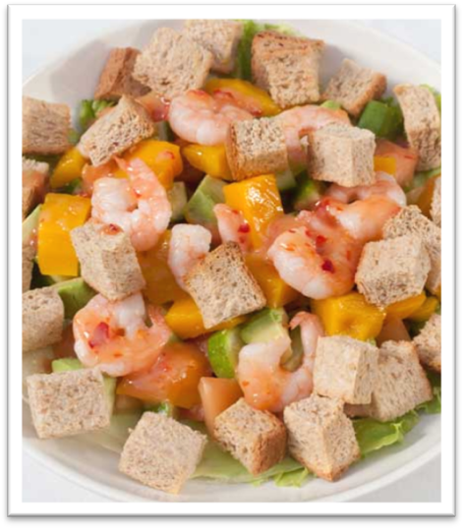 |  | 2 slices wholemeal bread  100g (~8 prawns) unpeeled, cooked prawns  200g mango in natural juice (¹/₂ 400g can; juice drained)  ½ avocado  1 medium tomato  1 small cucumber  4 iceberg lettuce leaves, torn into bite-size pieces  2 tbs fat-free coleslaw dressing  2 tsps sweet chilli sauce  Special tip  Why not try adding some of your other favourite salad ingredients such as sliced capsicum or other varieties of mixed lettuce.

Serves 2
Preparation Time 20 min
Cooking Time 10 min
Grilled fish fillet and Greek salad
Method |  | Ingredients
1. Chop olives half. Chop feta cheese and tomato into cubes. Combine olives, tomato, lettuce and feta cheese in a large bowl. Cover and place in the refrigerator.  2. Heat oil in a frying pan.  3. Cook fish for 4 minutes on each side (or until golden brown) and use a spatula to flip carefully.  4. Pour balsamic vinegar dressing over salad and toss salad to coat evenly.  5. Serve fish with salad.  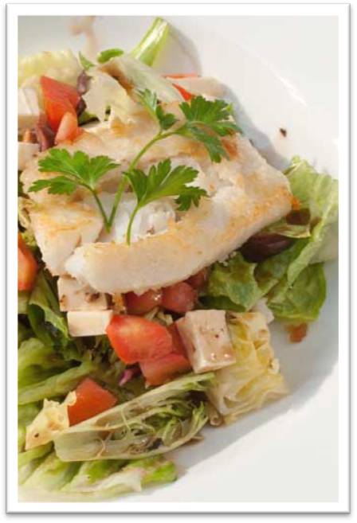 |  | 15 olives  1 medium tomato  100g reduced-fat feta cheese  200g bag of mixed lettuce leaves  1 tsp canola oil  2 x 80g white fish fillet (whiting, barramundi etc)  2 tbs reduced-fat balsamic vinegar dressing  Variation  Try pouring lemon juice over fish while cooking and sprinkle fish with dried herbs such as oregano, mint or basil.

Serves 2
Preparation Time 30 min
Freezing Time 4 hours
Mango ice-cream
Method |  | Ingredients
1. Freeze milk and yoghurt in separate ice cube trays for approximately 2 hours.  2. Using a food processor or strong blender, combine icing sugar and mango. Add the frozen milk and yoghurt and blend until ice is broken down as much as possible without melting it (approximately 30 seconds).  3. Pour into a plastic container, cover and place in the freezer for approximately 1½ hours.  4. Remove ice-cream from the freezer and serve.  5. Any leftover ice-cream can be returned to the freezer to use at a later time.  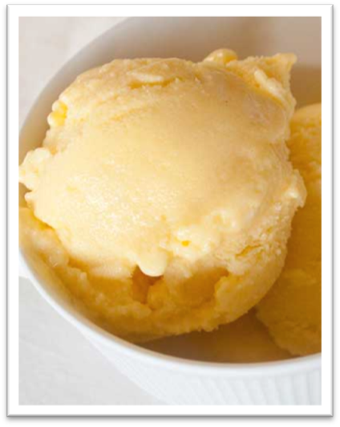 |  | 40g icing sugar  200g mango in natural juice (1/2 400g can)  200g low-fat yoghurt, frozen in ice cube trays  200ml reduced-fat milk, frozen in ice cube trays

Handouts

Handout 1: Transporting and storing seafood

Transporting
- When seafood is kept between 5°C and 60°C the risk of food spoilage and food poisoning is increased.
- If you are purchasing fresh or frozen seafood from the supermarket you should transport it home in an esky or cooler bag containing ice or freezer bricks.
- If you are purchasing your fish from a fish co-op, ask the vender to mix the seafood with ice before wrapping to ensure it remains cool.
- 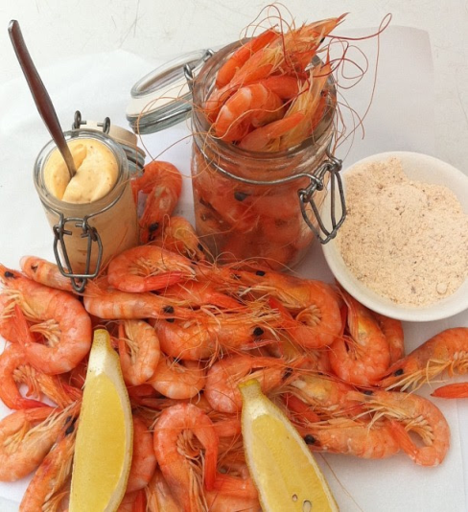Place seafood into a fridge or freezer as soon as possible to prevent any food spoilage

Storing seafood
- Seafood should be stored for a maximum of two days in the coldest, non-freezing section of your fridge.
- When storing fish or crustaceans (i.e. crabs and lobsters) in your fridge, it is best to unwrap time from plastic bags and store them on a non-plastic (glass or Pyrex).
- When freezing seafood is it a good idea to write a date on the packaging so you can be sure to use the oldest seafood first when cooking.

Defrosting from frozen
- When you plan on using frozen seafood it is best to thaw it in the refrigerator overnight. This prevents any harmful bacteria growth which can occur if food is defrosted on the kitchen bench.

Handout 2: How to peel a prawn

How to peel a prawn
1. To remove the head of the prawn hold the body of the prawn in one hand and the head of the prawn in the other, and twist the head off. Discard the head.
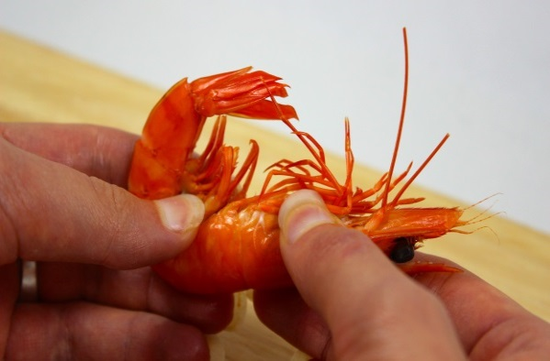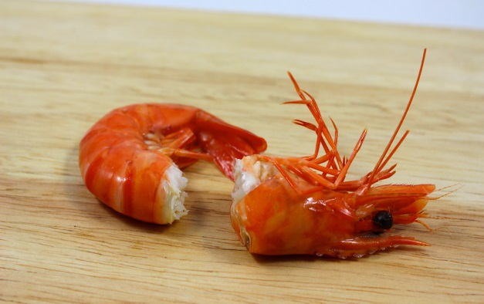
2. Grab hold of the legs between the thumb and the index finger, squeeze and pull shell away from body by peeling from the underside.
3. Repeat this step until only the tail section is left on the prawn.
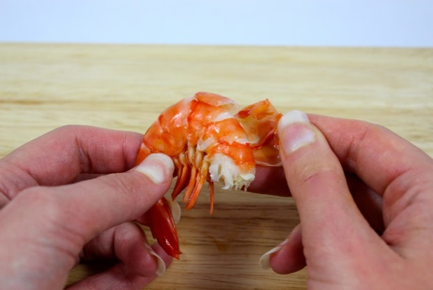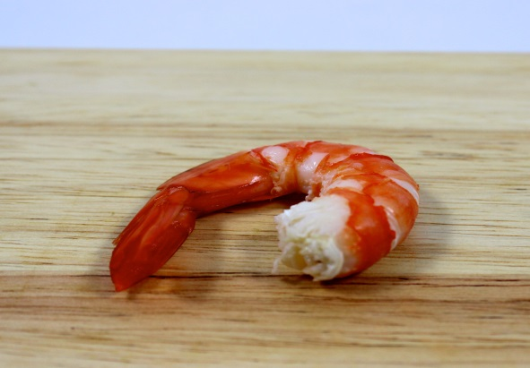
4. Squeeze the tail to remove it and the prawn will pop out.
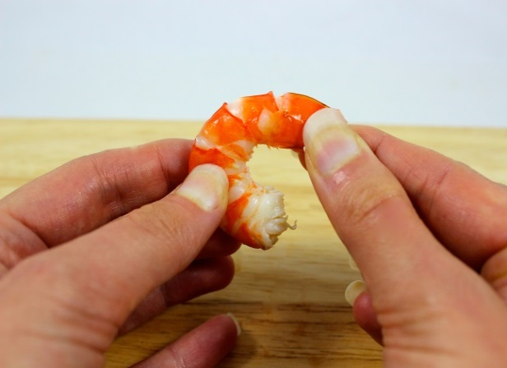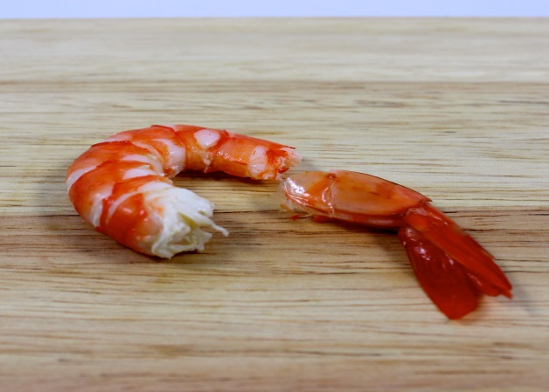

Handout 3: Additional recipes
Serves 2
Preparation Time 50 min
Cooking Time 20 min
Seafood kebabs with couscous tabouli
Method |  | Ingredients
1. Put 4 wooden skewers in a dish and cover with water and soak for 15 minutes.  2. Dice capsicum and thickly slice zucchini. Place in a bowl.  3. Place vegetable stock in a saucepan and bring to the boil. Add couscous, remove from the heat and stand for 10 minutes. After 10 minutes, use a fork to separate couscous and set aside.  4. Finely chop parsley and mint. Finely dice tomato. Mix herbs and tomato through couscous. Pour over half of the lemon juice.  5. Set oven grill at 180oC. Thread seafood, capsicum and zucchini onto skewers. Place kebabs under grill and cook skewers for 10 minutes on each side or until cooked through.  6. Serve skewers on couscous and drizzle with remaining lemon juice.  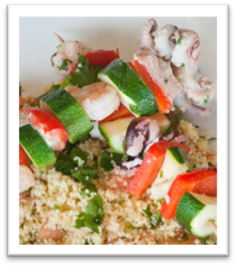 |  | 1 capsicum  1 zucchini  ½ cup salt-reduced vegetable stock  ½ cup dry couscous  ½ cup fresh parsley  ½ cup fresh mint  1 medium tomato (diced into small cubes)  Juice from 2 lemons  1 tb olive oil  200g seafood marinara mix

Serves 2
Preparation Time 20 min
Cooking Time 30 min
Green Thai fish curry
Method |  | Ingredients
1. Cut fish fillets into cubes and lightly cook in frying pan or wok. Remove from pan.  2. Lightly fry curry paste for about 30 seconds. Add coconut milk and reduced fat milk and mix to combine.  3. Add sugar, fish sauce, lemon zest and vegetables and cook for 5 minutes.  4. Add bamboo shoots and lemon juice and cook until vegetables become soft.  5. Return fish and warm through.  6. Serve curry with cooked rice 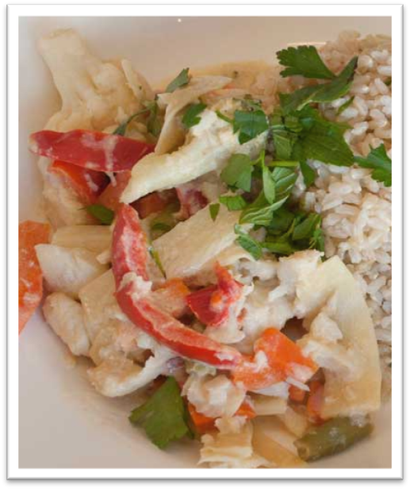 |  | 1 tsp canola oil  200g raw fish fillets (white fish) cut into cubes  1 tb green Thai curry paste  200ml lite coconut milk  200ml reduced-fat milk  ½ tsp raw or white sugar  2 tsps fish sauce  1 tsp lemon zest  2 cups frozen mixed vegetables  230g tin sliced bamboo shoots (drained)  juice of 1 lemon  Serve with:  2/3 cup dry brown rice (see separate recipe card)  Special tip  Lemon zest: tiny pieces of lemon peel. Grating the outer yellow layer of a lemon will give you lemon zest.

Serves 2 cups cooked rice
Preparation Time see options
Cooking Time see options
Cooked rice (makes 2 cups)
On the stove top |  | In the microwave
1. Place 1 cup (200g) of rice in a saucepan. Add 1½ cups (375mL) of cold water  2. Reduce heat and simmer covered for 12-14 minutes.  3. Remove from heat and set aside, covered for 5-10 minutes.  4. Use a fork to separate the grains and serve. |  | 1. Place 1 cup (200g) of rice in a microwave-safe bowl. Add 1½ cups (375mL) of cold water. Place lid on top.  2. Cook on High (800watts or 100%) for 5 minutes, then cook on Medium (500watts or 50%) for a further 7 minutes.  3. Set aside, covered, for 3 minutes. Use a fork to separate the grains and serve.

