Cooking for One or Two
Masterclasses

Fabulous fish and sensational seafood
Session 1

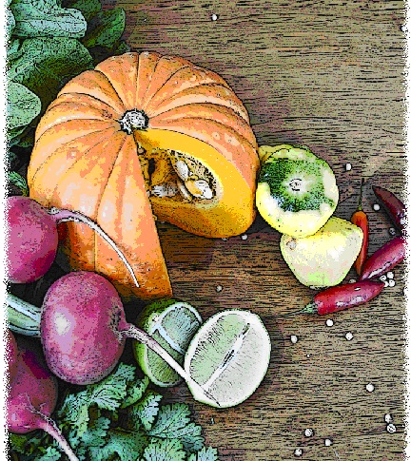

Contents
Objectives and overview 3
Session checklist 4
Ingredients list 5
Equipment 6
Room set up 8
Timeline 9
Introduction 10
Group agreement 12
Discussion: Seafood and nutrition 13
Discussion: Where to purchase seafood and the different types available. 15
Discussion: Purchasing seafood 16
Food preparation 18
Enjoy a meal together 20
Thank you and conclusion 20
Session clean up 20
Recipes 21
Handouts 25
Handout 1: Seafood and nutrition 25
Handout 2: What to look for when purchasing seafood 27

Objectives and overview
Session objectives
By the end of this session, participants will have:
- Understood the nutritional value of seafood and the benefits of including it in their regular diet.
- Learnt what to look for when purchasing seafood.
- Developed food preparation skills.
- Understood how to prepare and cook seafood.
- Enjoyed a meal with a group of new friends.

Session overview
Today’s discussion topics
- The importance of seafood as part of a regular diet
- Where to purchase seafood and the different types available
- What to look for when purchasing seafood
Today you will be cooking:
- Whole baked fish & sweet potato chips
- Salmon and sweet potato patties with green salad
- Pavlova smash

Session checklist
Facilitator |  |  | Assistant
Collect groceries using session shopping list |  |  | Assist with grocery shopping where required
Arrive approximately 45 minutes prior to the start of the session |  |  | Arrive approximately 30 minutes prior to the start of the session
Read first aid instructions |  |  | Conduct safety checklist for the venue
Set up cooking equipment |  |  | Help with set up of equipment
Set up room |  |  | Help with set up of room
Print handouts for each participant |  |  | Facilitate the program following all instructions in blue
Photocopy appropriate evaluation sheets for session (if required; Appendix A) |  |  | Help with washing up/cleaning
Facilitate the program following all instructions in green
Wash up/cleaning

Ingredients list
tsp = teaspoon
tb = tablespoon
 | To serve 2 people | To serve 4 people | To serve 6 people | To serve 8 people
Sweet potato (medium) | 2 | 4 | 6 | 8
Whole fish (100-150g each) | 2 | 4 | 6 | 8
Lemons | 2 | 4 | 6 | 8
Lemon juice | ½ tb | 1 tb | 1½ tbs | 2 tbs
Pepper | ½ tsp | 1 tsp | 1½ tsps | 2 tsps
Salt | To taste | To taste | To taste | To taste
Mixed green salad leaves | 1 cup | 2 cups | 3 cups | 4 cups
Sprouts | ½ cup | 1 cup | 1 ½ cups | 2 cups
Cucumber | ½ | 1 | 1 ½ | 2
Avocado | ½ | 1 | 1 ½ | 2
Sunflower and pumpkin seeds | 1 tb | 2 tbs | 3 tbs | 4 tbs
Olive oil | ¼ cup | ½ cup | ¾ cup | 1 cup
Wholegrain mustard | 1 tsp | 2 tsps | 3 tsps | 4 tsps
Salmon (210g can) | 1 | 2 | 3 | 4
Egg | 1 | 2 | 3 | 4
Wholemeal flour | ½ cup | 1 cup | 1½ cups | 2 cups
Frozen vegetables | ½ cup | 1 cup | 1½ cups | 2 cups
Canola oil | 1 tsp | 2 tsp | 3 tsp | 4 tsp
Raw oats | ¼ cup | ½ cup | ¾ cups | 1 cup
Fruit chopped (banana, kiwi fruit, strawberries or fruits that are in season) | 1¼ cups | 2½ cups | 3¾ cups | 5 cups
Meringues | 2 | 4 | 6 | 8
Reduced fat yoghurt | 2 cups | 4 cups | 6 cups | 8 cups
Cooking oil spray | Light spray | Light spray | Light spray | Light spray

Equipment
For table one
3 cooks knives |  | Measuring cups
3 vegetable knives |  | Measuring spoons
3 wooden spoons |  | Small, medium and large bowls
3 serving spoons |  | Colander
Vegetable peelers |  | Chopping boards / Chux
Spatula |  | Oven proof dishes
Can opener |  | Cling wrap and baking paper
Whisk |  | Foil
Juicer
For table two
Place dry ingredients on table; amount dependent on number of people in the group
For Refrigerator
Place ingredients that need to remain cool in the refrigerator; amount dependent on number of people in the group
For table three
Electric wok |  | Electric hot plates
Large saucepan |  | Oven
Heat proof mats |  | Oven Mitts
Thermometer |  | Oven proof dishes
Baking tray |  | Extension cord (if necessary)
For the kitchen and washing up area
Tea towels |  | Washing up liquid
Dish brush |  | Pot scrub
Dish cloths
For food safety and washing hands
Liquid soap |  | Paper hand towels
For dining
Cutlery (knives, forks & spoons) |  | Serviettes
Plates |  | Cups
Bowls |  | Jug (with water)
Table Cloth
For refreshments (to be set up wherever deemed suitable)
Tea |  | Sugar
Coffee |  | UHT Milk
For discussion sessions and miscellaneous items
White board |  | Name tags
White board markers |  | Attendance sheet
Pens |  | Recipe cards
Handout 1: Seafood and nutrition |  | Handout 2: What to look for when purchasing seafood
For occupational health and safety
St Johns First Aid Kit |  | Duct tape to tape down electrical cords

Room set up
TABLE TWO
Place one table to the side for all ingredients to be displayed on.
TABLE THREE
Place electrical equipment here.
Place on side closest to power points. If extension cord is used ensure it is taped to the ground to prevent participants tripping and injuring themselves.
TABLE ONE
Set up a table with enough space for participants to stand around for food preparation in the centre of the room.
Set up all equipment other than electrical appliances at this table.
This table can later be set up for dining.

Timeline
 |  | Set up room, including table with ingredients, food preparation area, dining area and chairs and whiteboard for discussion (45 mins before session)
Start
session
Start  session |  | Introduction and safety (10 mins)
 |  | Group agreement (5 mins)
 |  | Discussion: Seafood and Nutrition (10 mins)
30 mins |  | Discussion: Where to purchase seafood and the different types (10 mins)
 |  | Discussion: Purchasing seafood (20 mins)
1 hr |  | Food preparation (90 mins)
90 mins |  | Food preparation (90 mins)
2 hrs |  | Food preparation (90 mins)
150 mins |  | Enjoy a meal together (40 mins)
3 hrs |  | Enjoy a meal together (40 mins)
 |  | Thank you and conclusion
 |  | Session clean up (approx. 20-30 mins)
210 mins |  | Session clean up (approx. 20-30 mins)

Introduction |  | 10 minutes
The following section is to be conducted by the facilitator
1. Welcome the participants to Session One of the ‘Fabulous fish and sensational seafood’ masterclass as part of the Cooking for One or Two program. Ask all participants to sign the attendance sheet (see main manual for more information).
2. Introduce yourself and the assistant to the group.
3. Explain to the group that you will be facilitating both sessions of the seafood program.
4. Introduce the assistant. State they are kindly offering their time to assist with the sessions by helping with registration, evaluation, set up and clean up.
5. Read the following explaining to the group what the Cooking for One or Two masterclass is and the aims of the program:
 | What is the fabulous fish and sensational seafood masterclass?
- The Fabulous fish and sensational seafood masterclass is a two-session program.
- The program is designed for older people living in the community who have previously participated in Cooking for One or Two and want to develop additional cooking skills in seafood.
- Each session the group will cook an easy, quick and nourishing meal, including a light meal, a main meal and dessert. It is not a cooking demonstration, but an opportunity for you to develop your cooking skills in a supportive environment. We will then enjoy the meal together. A cooking skill and health related topic will be discussed in each of the sessions. The discussion aims to improve your cooking skills and teach you new techniques”.
6. Explain to the group that all sessions are well planned to reduce risks, but it is still important to point out the safety risks including:
- The exits [point out to group] in case of fire.
- Fire blankets and fire extinguishers [point out to group] in case of fire;
- Emergency rally points.
- Electrical equipment and cords have been firmly taped down [point out all].
- The location of the first aid officer (if the facility has one).
- Being mindful of safe procedures when cutting and chopping food.
- The bathrooms [give location].
7. Ask the group to inform you if there are any accidents or incidents or if they are feeling unwell.
8. Ask each participant to introduce themselves to the group and tell the group why they were interested in attending this seafood masterclass.
9. Thank the group for sharing their reasons for joining the program.
10. Outline the content of Session One:
- The nutrition of seafood and the value of including it as part of our regular diets.
- Where to purchase seafood and what types are available.
- What to look for when purchasing seafood.
11. Reintroduce the assistant who will now be speaking about the group agreement.

Group agreement |  | 5 minutes
The following section is to be conducted by the assistant
1. Read the following explaining to the group that throughout the program all group members are to follow these tips for working together as a group.
 | Group agreement
- It is very important that we all agree to follow the safe food practices outlined today as we cook each meal over the next two weeks.
- It is very easy to forget some of the important steps to ensure foods are prepared safely, so we will all have to work as a group to do this.
- There are also some other important things we can do to ensure the group runs smoothly. This includes:
  - Listening to each other; this means trying to talk one at a time, and letting everyone have their say.
  - Supporting each other; you are all here to learn new skills so support each other in this endeavour.
  - Take care (consider your own and others safety) when using knives, hot equipment and food; try to prevent slips, trips, falls and heavy lifting.
  - The most important thing is for us all to have fun, whilst learning. The sessions should be a time for you to make friends.
- It is important before we start the food preparation today that we all agree to work this way in our group.
2. Ask the group if they think these points sound fair.
3. If you have a whiteboard available, you might like to write the main points from the group agreement up so the group can review them throughout the session.
4. Ask the group if they can think of any other important things we can do to work together as a group or make the most of the group and add any new points to the whiteboard.
5. Hand back over to the facilitator.

Discussion: Seafood and nutrition |  | 10 minutes
The following section is to be conducted by the facilitator
1. Inform the group that we will be talking about the nutritional value of seafood, and what to look for when purchasing seafood.
2. Ask the participants to refer to Handout 1 “Seafood and Nutrition”. Read the following from the handout explaining the importance of seafood in our diet:
 | Seafood and nutrition
According to the Australian Guide to Healthy Eating, it is recommended that we eat approximately two serves of protein foods per day and aim to include at least two serves of fish in our regular diet per week.
One serve of fish is equal to a 100g cooked fillet (115g raw weight) or one small can of fish, no added salt and not in brine.
It’s probably fair to say that we’ve all heard that we should be eating more seafood, particularly fish, but what we may not know is why it is so important.
Seafood is an excellent source of protein, comparable with meat and chicken.
Seafood averages less than two percent fat, containing low total and saturated fat, which is beneficial for our heart health.
Seafood is considered the best dietary source of omega 3 fatty acids. All fish and shellfish contain omega 3, however the amounts vary, with fattier fish (i.e. salmon, sardines, blue-eye travella) containing more omega 3 than lean varieties. Our bodies cannot make omega 3, therefore we need to get it from the foods we eat.
Omega 3 is beneficial for our health. It may help to:
- lower the risk of dementia and Alzheimer’s disease
- reduce the symptoms of rheumatoid arthritis
- reduce depression symptoms
- reduce the risk of heart disease and stroke by lowering blood pressure, reducing blood clots and inflammation
Fish and other types of seafood are good sources of vitamins and minerals such as:
- B vitamins – good for the nervous system
- Vitamin A –for healthy eye sight and skin
- Vitamin D –for healthy and strong bones
- Zinc – gives us a stronger immune system
- Calcium found in fish with edible bones e.g. sardines, anchovies, canned salmon – important for strong bones
- Iron – helping our red blood cells transport oxygen around our body
- Iodine – helps our brains function
 | Remember: when choosing to add seafood into your diet it is best to purchase and cook your own fresh rather than purchasing ready-made battered or deep fried varieties that you get from your local fish and chip take-away shops. These battered and deep-fried varieties are high in saturated fat and don’t taste as good as the fresh varieties you make yourself.
3. Ask the group if they have any questions.

Discussion: Where to purchase seafood and the different types available. |  | 10 minutes
The following section is to be conducted by the facilitator
1. Inform the group that we will be talking about where you can purchase seafood and the different types available to purchase.
2. If you have a whiteboard available, you might like the assistant to write down the next lot of information generated in the discussion. Participants can write down the information at the end of the session.
3. Ask the group if they can think of the stores in the local area that supply seafood, and what types of seafood are available to purchase i.e. fresh, frozen, packaged, canned. Let the group know that they can write down this information at the end of the discussion as it will remain on the whiteboard.
 | Where to purchase seafood and the different types available?
There are many different varieties of seafood available to purchase, with the varieties depending on the time of year and region.
Seafood and fish can be purchased at your local supermarket, fish co-op and some fish and chip takeaway shops. Generally if you live near the coast you will have a greater variety of seafood available than those living inland. Wherever you may live, there should be at least one store where you can purchase seafood.
Generally there are a number of varieties of seafood available to purchase, however this will depend on your location.
Supermarkets are generally open seven days a week and stock a wide range of seafood products. These products may appear fresh at the deli, pre-packaged in the fridge or freezer section or within the aisles as canned varieties.
Fish co-ops are generally open daily, with the majority of the seafood available for purchase caught fresh daily. The co-ops sell a wide range of seafood such as: whole fish, filleted fish, crustaceans (i.e. crab, lobster, and bugs), prawns, and shellfish (i.e. oysters, mussels) frozen and marinated varieties of seafood.
Fish and chip takeaway shops are generally open seven days a week, however may or may not sell fresh varieties for you to purchase. You would need to check with your local shop.
Fresh fish can be expensive to purchase, depending on the type you want to buy as the supply of seafood is affected by many factors including the weather, season and demand. When the demand is high or the supply is limited the prices will generally be higher. However, if you purchase fish in season and ask your local fishmonger for recommendations you will generally get a bargain. Whole fish varieties are always better value than fillets or cutlets. However, if you want to buy fillets look out for varieties such as: gemfish, leatherjacket and dory. As an alternative to fresh varieties, you can reduce the cost by purchasing pre-packaged varieties such as canned salmon, tuna, and sardines to name a few.
4. Ask the group if they have any questions.
5. Ask the participants to go and find out the different varieties of seafood available to purchase at their local stores, whether it be the supermarket, fish co-op or takeaway store. Explain that the participants may want to purchase some seafood whilst they are exploring there options, or first have a look at what is available, find a recipe, and then purchase the seafood to cook a meal for a friend.

Discussion: Purchasing seafood |  | 20 minutes
The following section is to be conducted by the facilitator
1. Inform the group that we will be talking about what to look for when purchasing your seafood.
2. Explain that it is important to make sure that any seafood purchased is as fresh as possible, as this helps to prevent unwanted food poisoning.
3. Ask the group to refer to Handout 2 “What to look for when purchasing seafood”, and read out the following:
 | Purchasing seafood
When purchasing fresh seafood it is important to know what you’re looking for. There are a number of different ways to tell how fresh the seafood is that you are purchasing, with the recommendations varying depending on what you are purchasing.
When you purchase any seafood you want it to be as fresh as possible. This will ensure you have a longer shelf life and will also reduce the risk of food poisoning in conjunction with transporting and storing it correctly.
If you are purchasing fresh whole fish. The fish should:
Have a pleasant fresh sea smell (or smell like clean water if it’s a fresh water fish). Fresh fish should not smell fishy.
Have clear and bright eyes that bulge slightly.
Have bright pink-red gills. As a fish ages, the gills fade to a dull red/orange colour. There should not be any milky slim on or around the gills.
Have firm flesh that bounces back when touched. If the indentation remains do not purchase this fish.
Have bright and shiny skin or scales. Do not purchase if the skin is dull with discoloured patches.
If you are purchasing fresh fish fillets or cutlets, ensure that the fish has:
- Bright, shiny and firm flesh.
- Any visible dark muscles should be pink-red in colour.
- A pleasant fresh sea smell.
- No discolouration or bruising to the flesh.
If you are purchasing crustaceans and molluscs (i.e. prawns, oysters, crabs and lobsters), ensure that the seafood has:
- Brightly coloured, shiny shells or flesh.
- Firm, intact shells, heads, tentacles or flesh.
- Shells that are closed or close when you tap or gently squeeze them together.
- A pleasant fresh sea smell.
- No discolouration, particularly at the joints.
If you are purchasing pre-packaged varieties of seafood, ensure that:
- Frozen varieties are free from liquid or ice crystals either on the seafood or inside the package.
- Packages are not torn, open or have crushed edges.
- Cans are free from dints and unopened.
4. Ask the group if they have any questions.
5. Explain to the group that once you have purchased your seafood, it is important to transport and store it safely to avoid food poisoning, which will be covered in the next session.

Food preparation |  | 90 minutes
The following section is to be conducted by the facilitator
While the facilitator leads the food preparation, the assistant can help participants with meal preparation and washing any equipment.
1. Introduce the participants to the food preparation session:
- Firstly we will be cooking whole fish and sweet potato chips;
- Secondly we will be cooking salmon and sweet potato patties with a green salad;
- Thirdly we will be preparing the pavlova smash.
2. Explain to the group that:
- Each member of the group will be assisting with the cooking process;
- You are there to guide the food preparation, but the group will be doing most of the work;
- If anyone has any questions or problems, please ask for help.
3. Ask the participants to view the whole fish and sweet potato chips recipe card. Read the recipe card explaining step-by-step the recipe. Once you have read these instructions give each participant a role in preparing the recipe according to these steps.
4. Ask the group to wash their hands before commencing food preparation.
 | Whole fish and sweet potato chips
1. Preheat oven to 200°C.
2. Cover 2 large oven trays with baking paper.
3. Cut potatoes into chips, and put into a microwave safe bowl. Microwave until tender. Arrange chips in a single layer baking trays. Place in the oven for 45 minutes or until golden. Flip chips after 25 minutes and continue flipping every 10 minutes until cooked.
4. Tear off sheets of foil large enough to completely cover the fish. Place foil on bench with the shiny side facing down. Place 1 fish on each of the pieces of foil.
5. Juice half of the lemons and slice the other half. Pour lemon juice over the fish and season with pepper. Place lemon slices along the fish’s body.
6. Carefully wrap the fish in the foil, making sure that it is completely wrapped and that no juice escapes. Place on an oven tray and place fish in the oven. Cook for 30 minutes.
5. Ask participants to view the salmon and sweet potato patties and green salad recipe cards. Read the recipe card explaining step-by-step the recipe. Once you have read these instructions give each participant a role in preparing the recipe according to these steps.
 | Salmon and sweet potato patties with a green salad
1. Peel and dice the sweet potato.
2. Place sweet potato in a microwave safe bowl with some water, cover with cling wrap and microwave for 5-10 minutes or until sweet potato is soft. Drain and mash.
3. Once sweet potato has cooled slightly, add salmon, egg, flour (or breadcrumbs), and mixed vegetables and combine. Use hands to form into patties making them fairly flat and place in the refrigerator.
4. Place all ingredients for the salad in a large salad bowl and toss until combined.
5. In a medium screw-top jar, shake up ingredients for the dressing until smooth.
6. Place both salad and dressing in refrigerator, until ready to serve the meal.
6. Ask participants to view the pavlova smash recipe card. Read the recipe card explaining step-by-step the recipe. Once you have read these instructions give each participant a role in preparing the recipe according to these steps.
 | Pavlova smash
1. Lay oats in a single layer on an oven tray and toast in the oven at 180°C for approximately 5-10 minutes or until light brown.
2. Chop fruit into small pieces
3. Crush meringues into separate bowls (each participant should have their own bowl, alternatively make a large one and dish up separately once made). Evenly distribute the yoghurt between bowls. Evenly distribute the fruit among the bowls by layering on top of the yoghurt. Sprinkle each bowl with toasted oats. Cover and place in the refrigerator.
4. If one large pavlova smash was made up, distribute amongst bowls before serving to participants.
7. Ask the participants to cook the salmon patties. Give each participant a role in preparing the recipe according to these steps.
 | Salmon and sweet potato patties with a green salad (continued)
1. Heat frying pan to medium heat and spray with cooking oil. Cook patties for about 4 minutes on each side or until golden brown.
2. Take salad and salad dressing out of refrigerator. Shake dressing thoroughly and pour over salad, making sure you toss salad.
3. Serve.

Enjoy a meal together | 40 minutes
The following section is to be conducted by the assistant
1. Set each participant, the facilitator and the assistant a place at the dining table. Use the table cloth, serviettes, crockery and cutlery to create an inviting space to share the meal together.
2. Enjoy!

Thank you and conclusion | 5 minutes
The following section is to be conducted by the facilitator
1. Congratulate the group on a job well done.
2. Ask the group to reflect on what they have learnt in their first session of “Fabulous fish and sensational seafood”. Ask the group to share any new information or skills they have learnt.
3. Outline the next session’s content.
- Meal; Chilli, prawn and mango salad, grilled fish fillet, Greek salad, and mango ice-cream
- Discussion topic; transporting and storing seafood; and a basic guide to fishing.

Session clean up | 30 minutes
The following section is to conducted by the assistant
1. When cleaning up, it is important that you use hot soapy water, and refill the sink once the water has become either warm or discoloured (dirty). At all stages in the washing up process please be mindful of sharp objects being left in the water.
2. All equipment must be washed and sanitised prior to being packed away for the next session. It is also important that all equipment goes back to where it was found.

Recipes
Serves 2
Preparation Time 15 min
Cooking Time 25 min
Salmon and sweet potato patties
Method |  | Ingredients
1. Place sweet potato in a microwave-safe bowl with ½ cup of water. Microwave for 5-10 minutes or until sweet potato is soft.  2. Drain and mash the sweet potatoes. Put aside to cool.  3. Add salmon, egg, flour (or breadcrumbs), and mixed vegetables to sweet potato. Mix well until combined.  4. Use damp hands to shape mixture into four patties.  5. Heat oil in a fry pan over medium heat. Cook patties for about 4 minutes on each side or until golden.  6. Serve with green salad.  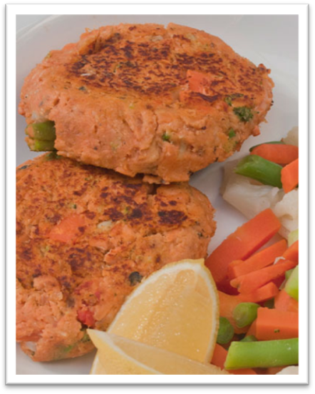 |  | 1 small sweet potato, peeled and diced  210g salmon (canned), drained  1 egg  ½ cup wholemeal flour or bread crumbs  ½ cup frozen small diced mixed vegetables (defrosted)  1 tsp canola oil  Serve with:  Green salad (see following recipe)  Variation  To add some variety to this recipe, why not make salmon and sweet potato burgers! Make the patties larger, toast a wholegrain bread roll and top with lettuce, tomato and tartare sauce.

Serves 2
Preparation Time 20 min
Cooking Time 1 hour 15 min
Whole fish and sweet potato chips
Method |  | Ingredients
1. Preheat oven to 200°C (180ºC fan-forced). Cover two large oven trays with baking paper.  2. Cut sweet potatoes into chips. Arrange chips in a single layer on 1 baking tray, spray with cooking oil and place in the oven for 45 minutes or until golden. Flip chips after 25 minutes and continue flipping every 10 minutes.  3. Tear off 2 sheets of foil large enough to completely cover the fish. Place foil on bench with the shiny side facing down. Spray foil lightly with oil before placing fish on top. Place one fish on each of the pieces of foil.  4. Pour lemon juice over the fish and season with pepper. Place lemon slices along the body of the fish.  5. Carefully wrap the fish in the foil, making sure that it is completely wrapped and that no juice escapes. Place on the other oven tray and place fish in the oven. Bake for 30 minutes.  6. Serve with green salad.  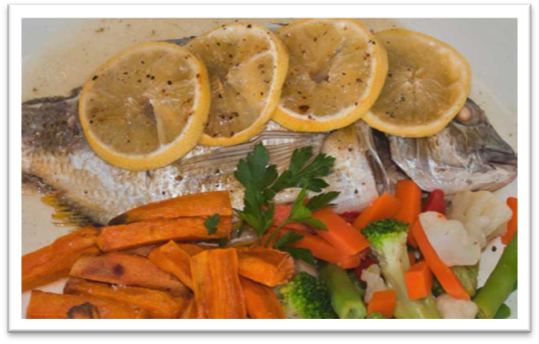 |  | 1 medium sweet potato, peeled and cut into chips  Cooking oil spray  2 whole fish (100-150g each), scaled and gutted  2 lemons (1 juiced, 1 sliced)  ½ tsp pepper  Serve with:  Green salad if having as a main meal (see following recipe)  Variation  This recipe is also suitable to be cooked on a barbeque. Pre heat barbeque on medium heat. Place fish lemon juice and lemon in foil (as above). Make sure fish is sealed tight in the foil. Place fish on barbeque for 10 minutes and turn over and cook for a further 8-10 minutes. Use a folk to test the fish and see if it flakes apart easily.

Serves 2
Preparation Time 10 min
Cooking Time Nil
Green salad
Method |  | Ingredients
1. Place all ingredients for the salad in a large salad bowl and toss until combined  2. In a medium screw-top jar, shake up ingredients for the dressing until smooth. Pour over salad, and toss thoroughly.  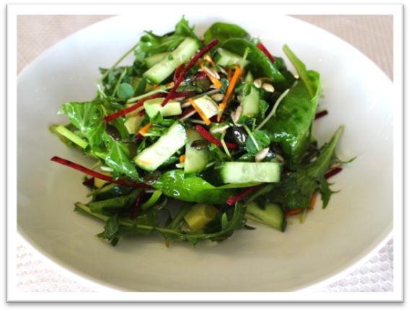 |  | 1 cup mixed green salad leaves  ½ cup sprouts (i.e. sunflower, snow pea, alfalfa or broccoli)  ½ cucumber, chopped  ½ avocado, cubed  1 tb sunflower and pumpkin seeds  Dressing:  ½ tb lemon juice  ¼ cup olive oil  1 tsp wholegrain mustard  Salt and pepper to taste

Serves 2
Preparation Time 25 min
Cooking Time 5 minutes
Pavlova smash
Method |  | Ingredients
1. Preheat oven to 180°C (160ºC fan-forced). Place oats on an oven tray in a single layer and toast for approximately 5-10 minutes or until golden.  2. Crush meringues into 2 separate serving bowls, and spoon the yoghurt on top.  3. Place chopped fruit on top of the yoghurt and sprinkle with toasted oats.  4. Serve.  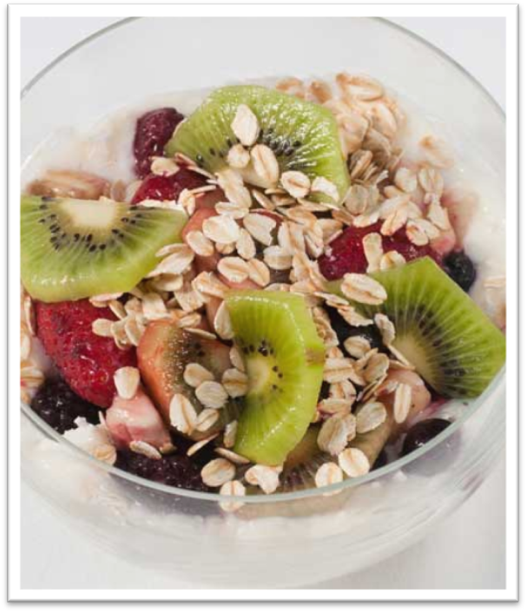 |  | ¼ cup raw oats  300g of fruit, chopped (banana, kiwi fruit, strawberries or defrosted mixed frozen berries)  2 meringues (plain or vanilla)  400g low-fat natural yoghurt

Handouts

Handout 1: Seafood and nutrition
According to the Australian Guide to Healthy Eating, it is recommended that we eat approximately two serves of protein foods per day and aim to include at least two serves of fish in our regular diet per week.
One serve of fish is equal to a 100g cooked fillet (115g raw weight) or one small can of fish, no added salt and not in brine.

Some facts about seafood:
It is an excellent source of protein, comparable with meat and chicken.
Seafood averages less than two percent fat, containing low total and saturated fat, which is beneficial for our heart health.
Seafood is considered the best dietary source of omega 3 fatty acids.
All fish and shellfish contain omega 3, however the amounts vary, with fattier fish (i.e. salmon, sardines, blue-eye travella) containing more omega 3 than other lean varieties. Our bodies cannot make omega 3, therefore we need to get it from the foods we eat.

Omega 3 is beneficial for our health. It may help to:
- lower the risk of dementia and Alzheimer’s disease
- reduce the symptoms of rheumatoid arthritis
- reduce depression symptoms
- reduce the risk of heart disease and stroke by lowering blood pressure, reducing blood clots and inflammation
Fish and other types of seafood are good sources of vitamins and minerals such as:
- B vitamins – good for the nervous system
- Vitamin A –for healthy eye sight and skin
- Vitamin D –for healthy and strong bones
- Zinc – gives us a stronger immune system
- Calcium found in fish with edible bones e.g. sardines, anchovies, canned salmon – important for strong bones
- Iron – helping our red blood cells transport oxygen around our body
- Iodine – helps our brains function
Remember: when adding seafood into your diet it is best to purchase and cook your own fresh rather than purchasing ready-made battered or deep fried varieties that you get from your local fish and chip take-away shops. These battered and deep-fried varieties are high in saturated fat and don’t taste as good as the fresh varieties you make yourself.

Handout 2: What to look for when purchasing seafood
List your local stores selling seafood:
_____________________________________________________________________________________________________________________________________________________________________________________________________________________________________________________________________________________________________________________________________________________________________________

Where to buy seafood:

Local supermarket
Generally open seven days a week and stock a wide range of seafood products. These products may appear fresh at the deli, pre-packaged in the fridge or freezer section or within the aisles as canned varieties.

Fish co-op
Generally open daily, with the majority of the seafood available for purchase caught fresh daily. The co-ops sell a wide range of seafood such as: whole fish, filleted fish, crustaceans (i.e. crab, lobster, and bugs), prawns, and shellfish (i.e. oysters, mussels) frozen and marinated varieties of seafood.

Fish and chip takeaway shop
Generally open seven days a week, however may or may not sell fresh varieties for you to purchase. You would need to check with your local shop.

What seafood should you purchase?
Purchase fish in season and ask your local fishmonger for recommendations to ensure you get a bargain on your purchase.
Whole fish varieties are always better value than fillets or cutlets. If you want to buy fillets look out for varieties such as: gemfish, leatherjacket and dory.
As an alternative to fresh varieties, you can reduce the cost by purchasing pre-packaged varieties such as canned salmon, tuna, and sardines to name a few.

What to look for when purchasing seafood?
When purchasing fresh seafood it is important to know what you’re looking for. There are a number of different ways to tell how fresh the seafood is that you are purchasing, with the recommendations varying depending on what you are purchasing.

Fresh whole fish
- Have a pleasant fresh sea smell (or smell like clean water if it’s a fresh water fish). Fresh fish should not smell fishy.
- Have clear and bright eyes that bulge slightly.
- Have bright pink-red gills. As a fish ages, the gills fade to a dull red/orange colour. There should not be any milky slim on or around the gills.
- Have firm flesh that bounces back when touched. If the indentation remains do not purchase this fish.
- Have bright and shiny skin or scales. Do not purchase if the skin is dull with discoloured patches.
- Fresh fish fillets or cutlets
- Bright, shiny and firm flesh.
- Any visible dark muscles should be pink-red in colour.
- A pleasant fresh sea smell.
- No discolouration or bruising to the flesh.

Crustaceans and molluscs (i.e. prawns, oysters, crabs and lobsters)
- Brightly coloured, shiny shells or flesh.
- Firm, intact shells, heads, tentacles or flesh.
- Shells that are closed or close when you tap or gently squeeze them together.
- A pleasant fresh sea smell.
- No discolouration, particularly at the joints.

Pre-packaged varieties of seafood
- Frozen varieties should be free from liquid or ice crystals either on the seafood itself or inside the package.
- Packages should not be torn, open or have crushed edges.
- Cans are free from dints and unopened.

