Cooking for One or Two
Masterclasses

Appendix

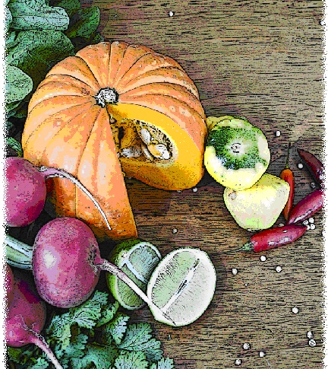

Appendix A: Masterclass evaluation survey
Cooking for One or Two masterclass evaluation survey
(To be completed at the end of the two week program)

How to complete this survey
If the facilitator would like to evaluate the program, please use the following survey. The purpose of this survey is to evaluate changes over time.
Please answer every question you can. If you are unsure about how to answer a question, please ask the facilitator or assistant.

1 Since completing the program, describe the ways in which the variety in your diet has increased or decreased?
____________________________________________________________________________________________________________________________________________________________________________________________________________________________________________________________________________________________________
2 Since completing the program, please describe how your cooking ability has changed:
____________________________________________________________________________________________________________________________________________________________________________________________________________________________________________________________________________________________________
3 Since completing the program, please describe any changes in your social interactions:
____________________________________________________________________________________________________________________________________________________________________________________________________________________________________________________________________________________________________
Thank you for taking the time to complete this survey.

