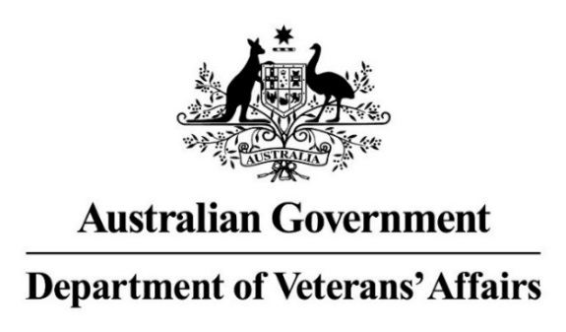

INFORMATION GUIDE
FOR
PRIVATE HOSPITALS
AND
PRIVATE MENTAL HEALTH
HOSPITALS
March 2025

Table of Contents

1. Overview 1
2. Hospital Services Agreement 1
3. Patient eligibility and entitlement to treatment 2
4. Admission and discharge 5
5. Contract Managers 7
6. Quality Standards 9
7. Private Hospital Quality Reporting 9
8. Mental Health Standards 10
9. Mental Health Quality Reporting 12
10. DVA’s Private Hospital Patient Experience Survey (PES) 12
11. Information management – submitting Hospital Casemix Protocol data 12
12. In Hospital Claims (IHC) 13
13. Billing arrangements 16
14. Discharge Advice and Hospital Claim (D653A) form 18
15. How to fill in the Discharge Advice and Hospital Claim (D653A) form 19
16. Examples showing how to complete your claim 21
17. Certificates and certification 28
18. Advertising 30
19. Percutaneous Coronary Intervention (PCI) Procedures 31
ATTACHMENT 1 – DVA quick contact list for providers 32
ATTACHMENT 2 – Claiming guide for Percutaneous Coronary Intervention (PCI) Procedures 33

1. Overview
The Repatriation Commission and the Military Rehabilitation and Compensation Commission (the Commissions) have entered into a Hospital Services Agreement (the Agreement) with your organisation to provide private hospital services to Entitled Persons. The Department of Veterans’ Affairs (DVA), on behalf of the Commissions, will work with you to ensure the best outcomes for Entitled Persons, and that the administrative effort required by Private Hospitals is minimised as much as possible.

The provision of Hospital Services under your Agreement is to be in accordance with the following legislative frameworks:
- the Treatment Principles and Private Patient Principles made under the Veterans’ Entitlements Act 1986 (VEA), or under the Military Rehabilitation and Compensation Act 2004 (MRCA), or under the Australian Participants in British Nuclear Tests (Treatment) Act 2006 (BNT); and
- the Safety, Rehabilitation and Compensation (Defence-related Claims) Act 1988 (DRCA).

In addition to its arrangements with Private Hospitals (including Private Mental Health Hospitals), DVA has arrangements in place with Day Procedure Centres (DPCs) and Public Hospitals in every State and Territory. These arrangements ensure that Entitled Persons have access to hospital services when and where they are needed.

While the Agreement uses and defines the term Entitled Persons, throughout this Information Guide the terms veteran or patient are used, but the same meaning is retained.

This Information Guide is regularly updated to provide guidance on DVA’s administration arrangements with Private Hospitals. In addition to the regular emails that are sent to all Private Hospital Contract Managers, DVA also uses the DVA Provider News | Department of Veterans' Affairs to communicate broadly to Private Hospitals on any updates that are of interest to providers.

Private Hospitals should note that this document is a guide only and that where questions arise, the Agreement takes precedence over this document.

2. Hospital Services Agreement

DVA has entered into an Agreement between DVA and your organisation that defines how the provision of, and payment for private hospital services and arrangements will work. You should familiarise yourself with the aspects of the Agreement relevant to your position.

The current Hospital Services Agreement (the Agreement) has no end date which reduces the administrative burden on hospital providers by avoiding the need to undertake a tender process on a regular basis.

While there is no end date to the Agreement, there is still the need to ensure that the arrangements reflect current legislation, government policy and broader industry trends. Under clause 12.7 DVA can vary the Agreement by providing three months written notice (the Notification Period) to hospital providers. DVA must act in good faith if there is a need to vary the Agreement.

It is DVA’s intention that clause 12.7 will be used in the following circumstances:
- where DVA is obliged by the Government or other Commonwealth agencies to reference and incorporate new legislation or policy into the Agreement;
- to correct typographical errors and to update references to other documents, and to websites and contact information; or
- where DVA wishes to change policy or standards for all contracted private hospital providers, to ensure hospital services continue to meet the treatment and care needs of veterans.

It is DVA’s intention that amendments would occur no more frequently than annually, bar exceptional circumstances.

Separate to this, DVA will continue to enter into deeds of variation with hospital providers to reflect mutually agreed changes. The offer of indexation to fees and charges is through the Annual Fee Review process under clause 7.1 of the Agreement is made by Letter of Exchange and will be implemented once agreed by both parties.

3. Patient eligibility and entitlement to treatment

DVA clients are issued with a Gold or White Veteran card (DVA Veteran Card) which entitles them to receive eligible health and medical treatment at DVA’s expense. There may be some instances where prior financial authorisation needs to be obtained before treatment is funded (see further below for more information on instances where prior financial authorisation will be required).
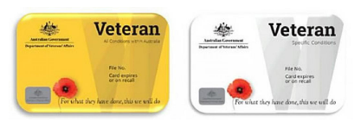

- Veteran Gold Card holders are entitled to clinically required treatment for all of their medical conditions (except those treatments listed under prior financial authorisation further below)
- Veteran White Card holders are entitled to clinically required treatment for the conditions for which DVA has specifically accepted financial responsibility.
- Veteran Orange Card holders are entitled to pharmaceutical benefits only. This card does not provide any other treatment entitlements (such as medical or allied health) and does not entitle a person to admission to a Hospital under DVA contractual arrangements.

Note: DVA will not be responsible for payment for the treatment of any person admitted to the hospital who, at the time of admission, was not an entitled veteran with eligibility for the treatment provided.

DVA advises veterans to present their Veteran Card, or their written letter of authorisation to hospital admission staff in order to access treatment under DVA arrangements. Hospital staff should note the colour of the card and the specific conditions that have been accepted for White Card holders.

Veteran Card holders are also able to present digital versions of their plastic White or Gold Cards to health providers if they wish. Veterans can access the digital version through the online DVA portal MyService.

Veteran Card holders may also elect to be treated outside DVA arrangements and choose to be treated as a Medicare or private patient. In those circumstances DVA is unable to accept financial responsibility for any part of the admission.

White Card Eligibility Check
Where eligibility for Veteran White Card treatment is uncertain, Private Hospitals must contact DVA’s Provider Line (1800 550 457 - Option 3) to confirm eligibility.

Prior financial authorisation
The Agreement includes clauses specifying where, prior to admitting an Entitled Person and before arranging treatment, a hospital is contractually obliged to obtain financial authorisation directly from DVA. Prior financial authorisation is required in circumstances including:
- where there is a doubt about a patient’s eligibility for treatment;
- funding of respite or Convalescent Care in a Residential Care Facility, noting this must be approved prior to the hospital discharge;
- surgical or medical procedures not listed on the Medicare Benefits Schedule (MBS);
- insertion of, or use of, medical devices and human tissue products which are not listed on the Prescribed List;
- specific treatments nominated in writing by DVA from time to time (e.g. cosmetic surgery or non-contracted mental health programs);
- provision of additional treatment in excess of four (4) weeks’ duration for non-admitted sessional rehabilitation services (where the treatment is not otherwise covered by a program agreed between the parties);
- to deliver services not covered under the Agreement; and
- prescribing pharmaceuticals not listed on the Pharmaceutical Benefits Scheme or Repatriation Pharmaceutical Benefits Scheme.
To seek prior financial authorisation hospitals should contact DVA’s Health Provider Line on 1800 550 457 (Option 3).

You can also seek authorisation by using our online form. To use this method, you should download and fully complete the DVA prescribed Prior Financial Approval form (D1328), ensuring that all sections of the form are completed. Please ensure that all required supporting documentation is attached and email the form and attachment to health.approval@dva.gov.au.

Alternatively, Private Hospitals may submit a written request that contains all the elements from the D1328 form on behalf of a treating doctor or medical specialist and email it with any supporting attachments to health.approval@dva.gov.au. The request will be considered and DVA will respond to the requestor.

Please send requests for non-listed medical devices and human tissue products or non-MBS services before arranging the treatment or organising the hospital admission so that requests can be considered in a timely manner.

Requests for prescribing pharmaceuticals not listed on the Pharmaceutical Benefits Scheme or Repatriation Pharmaceutical Benefits Scheme must be requested from the Veterans' Affairs Pharmaceutical Advisory Centre (VAPAC) via ppo@dva.gov.au.

In Emergency situations, treatment may be provided to an Entitled Person without seeking prior Financial Authorisation. However, in this situation hospital must confirm the Entitled Person’s eligibility with DVA on the next Business Day following the admission and obtain retrospective Financial Authorisation.

For additional information on telephone numbers to use to contact DVA refer to the listings at https://www.dva.gov.au/get-support/providers/contacts-providers or ATTACHMENT 1 – DVA Quick Contact List.

Holders of Letters of Authorisation
Holders of Letters of Authorisation may have treatment authorised under either the Veterans’ Entitlements Act 1986, the Military Rehabilitation and Compensation Act 2004, the Australian Participants in British Nuclear Tests (Treatment) Act 2006, or the Safety, Rehabilitation and Compensation (Defence-related Claims) Act 1988 (DRCA). As provision of services may vary amongst all four Acts, hospitals should contact the relevant DVA officers to clarify entitlements and any specific billing arrangements.

Department of Defence arrangements
All Australian Defence Force (ADF) personnel admissions require prior financial authorisation from the Department of Defence Local Joint Health Command Unit.

The contact details for the Local Joint Health Command Units are available by telephoning the Commander Joint Health Command on 1800 333 362. Claims for payment should be sent to the relevant Department of Defence Joint Health Command. They should not be sent to Services Australia or DVA.

Provision of a private room
Charges for inpatient treatment are based on veterans receiving private room hospital accommodation where available, and treatment by their doctor of choice, in accordance with the Repatriation Private Patient Principles (see clause 4.4 of the Agreement).

At admission, when determining access to a private room, DVA acknowledges that the Private Hospital will consider the competing clinical needs of a veteran and non-veteran patient if there are not two private rooms available. In the Agreement, Private Hospitals agree not to levy additional charges against DVA patients for accommodation in a private room.

4. Admission and discharge

The Agreement outlines admission, transfer and discharge requirements that apply to veterans. Under the Agreement between DVA and your hospital, you must complete a medical and nursing admission process with documentation for each veteran admitted to your hospital. Where veteran patients are admitted for mental health conditions, an intake assessment by a psychiatrist or psychiatry registrar is required.

Discharge planning should commence from the point of admission and be included in the admission documentation.

You must provide veteran patients with a copy of the information contained in the when we will pay for your hospital stay webpage on the DVA website. This information can be provided with the admission documentation or upon admission to the hospital.

DVA aims to minimise transfers between hospitals particularly for emergency patients. Consistent with clause 6.3 of the Hospital Services Agreement veterans should be directly admitted to an appropriate hospital where both theatre and accommodation can be provided. Hospitals should complete a risk assessment to determine if they are able to provide a complete service for the patient. If a private hospital only provides same day services, the private hospital should not admit patients for procedures where the expectation is an overnight admission will be required. If an overnight admission is anticipated then the patient should be admitted to a public or private hospital providing the treatment required.

Hospital Admission Voucher
A DVA Hospital Admission Voucher (form D0652B) (or a hospital’s own admission form which includes all data elements required by the DVA Hospital Admission Voucher) must be completed within two (2) Business Days of admission for each veteran patient. These must be kept with the patient’s clinical record to confirm patient identity and eligibility when required for audit and investigation of claims, and to document the veteran’s authorisation for disclosure of Clinical Information as shown by their signature.

Hospitals are reminded that they should not include the Hospital Admission Voucher with the claim sent to Services Australia. The (D0652B) DVA Hospital Admission Voucher (pdf version) is located here.

Resources to support the discharge planning process
The Agreement between DVA and the Private Hospital outlines the importance of good discharge planning which is to be undertaken as part of each hospital admission. To assist hospital staff who may be involved in discharge planning for veteran patients, DVA has produced the following resources which may be referred to for DVA specific information and guidance:
- The single page Discharge Planning Checklist identifies some of the important aspects to consider when discharging DVA clients.
- The DVA Discharge Planning Resource Guide provides information on DVA and community based services available to veterans. This information may be of assistance in accessing and arranging DVA or community based services to support an effective and sustainable discharge.

Where discharge planning staff in hospitals have questions or situations requiring information from DVA, they should contact the Health Provider Line (1800 550 457) or make contact with their DVA Contract Manager.

Death Certification arrangements for a deceased veteran – information for attending doctors
Private Hospitals are reminded that they must use their best endeavours to educate attending doctors that, when a veteran dies in the Private Hospital, the attending doctor should consult the veteran’s Local Medical Officer to obtain a full and complete medical history to inform the wording of the cause of death noted in the Death Certificate.

This is important to provide clarity in relation to the cause of death and to simplify subsequent claims by the veteran’s dependents for benefits potentially available through DVA, which can be affected by the recorded cause of death.

5. Contract Managers

Your organisation and DVA have both appointed Contract Managers (see clauses 12.1.1 and 12.1.2 of the Hospital Services Agreement) to ensure that services provided are consistent with the spirit of the arrangements. The respective Contract Managers will work together to establish and maintain a productive working relationship.

The Contracting Entity’s Contract Manager’s role is to:
- monitor the quality and review the outcomes of the Hospital Services provided at and from the Private Hospital to veterans;
- investigate any complaints by or on behalf of veterans;
- monitor the submission of invoices to DVA for the Hospital Services provided to veterans and DVA’s payment for those Hospital Services;
- initiate negotiations in accordance with clauses 7.1 and 7.2 of the Agreement;
- provide such information as is reasonably agreed, to meetings at the State based Consultative Forum if requested by that body (see clause 3.2 of the Agreement);
- promptly meet to attempt to resolve any disputes arising under the terms of this Agreement;
- facilitate the electronic transfer of invoices, statistical information or other data specified in this Agreement; and
- ensure the timely exchange of information, as agreed.

Additional information on the DVA website for private hospital staff:
General hospital related information is available on the DVA Hospitals webpage “Delivering Hospital based care”

On this web page you can find a range of information on:
- Online schedules and hospital-related information
- Forms and Certificates
- The current DVA Private Hospital Quality Report

Submitting Program proposals for private hospital services
We invite hospitals to submit proposals for programs that may improve health outcomes in the veteran population. We have created a number of guidelines to help you draft your proposal, which are available at https://www.dva.gov.au/get-support/providers/programs/hospitals#private-01

Please refer to the relevant guidelines when you write your proposal and make sure that you have entered all relevant information so that we may assess your proposal as quickly as possible. Forward your completed proposal and attached documents to: resp.priv.hospitals@dva.gov.au

Hospital data submission
Hospital Casemix Protocol (HCP) data must be submitted by all:
- private hospitals
- mental health private hospitals
- day procedure centres

The Hospital Casemix Protocol (HCP) Data Upload link connects to our secure services login page. More information on HCP data can be found in Section 11 of this document.

Forms and certificates
Links to all of our forms and certificates can be found online:
- Hospital Admission Form
- Discharge Advice and Hospital Claim Form (D653A)
- Acute Care Certificates to certify patients need acute care continuously thirty-five (35) days or more
- National Private Hospital Claim Form (please use section 4 to certify same day and overnight admissions for Type B and C procedures)

Critical Care Certificates
These certificates are used to clinically verify the need for accommodation in a Critical Care Facility, list the required interventions and level of nursing care
There are two critical care certificates:
- Coronary Care Certificate
- Intensive Care Certificate

The Rehabilitation Program certificate
The Rehabilitation Program Certificate (PDF 596 KB) is used when a patient is admitted for any of the following:
- inpatient rehabilitation
- admitted same day rehabilitation
- non-admitted sessional rehabilitation program

NB: The Rehabilitation Program certificate should be signed by a rehabilitation physician.

Keeping the patient certificates for audit
You must keep the original certificate(s) on the patient file for audit purposes. This includes the:
- coronary care certificate
- intensive care patient certificate
- rehabilitation program certificate
- same day or overnight certificate

NB: Do not send these documents to us or Services Australia. If you need any help with forms, call our provider helpline on 1800 550 457.

Online information for Hospital staff and contract managers
The Delivering hospital based care webpage contains other information to assist Contract Managers and hospital staff and includes links to particular schedules and tables including:
- the Group Accommodation and Theatre Banding (GATB) table;
- a list of contracted Private Hospitals;
- Quality Reporting templates; and
- Online resources to support Contract Managers and hospital staff.

6. Quality Standards
Quality management under the arrangement between the hospital and DVA is aimed at continuously improving the effectiveness of veterans’ hospital care and health care in terms of accessibility, appropriateness, efficiency, continuity, and satisfaction.

Hospital Accreditation
As outlined in clause 5 of the Agreement, Private Hospitals must comply with the accreditation requirements specified in the Australian Health Services Safety and Quality Accreditation (AHSSQA) Scheme, including any Commonwealth or state laws or policies introduced as part of the implementation of the AHSSQA Scheme.

The AHSSQA Scheme requires Private Hospitals to be assessed and to maintain accreditation to the National Safety and Quality Health Services (NSQHS) Standards (and where applicable, the National Standards for Mental Health Services). Noting that all healthcare facilities are transitioning to the 2nd Version of the NSQHS Standards, the DVA Quality Reports have been updated to reflect the transition arrangements.

Advice to DVA on changes to Accreditation Status
Private Hospitals must advise DVA immediately if there are any changes in their accreditation status.

7. Private Hospital Quality Reporting

Each year, Private Hospitals must complete and submit their annual Quality Report to DVA no later than four months after the end of the financial year i.e. by 31 October annually.

DVA’s Quality Reporting template can be used to fulfil all DVA’s hospital quality reporting obligations including reporting for Private Hospitals delivering Mental Health Services. As hospitals are transitioning to accreditation to the 2nd Version of the NSQHS Standards, hospitals will be able to check the boxes indicating their accreditation pathway.
The current Private Hospital Quality Report template is available on the Hospital webpage.

Private Hospital staff completing the Quality Report should read the Information tab in the Quality Report template and follow the instructions.

For information on the implementation of the 2nd Version of the NSQHS Standards, refer to the Australian Commission on Safety and Quality in Health Care’s Implementation of the NSQHS Standards.

Example of the Quality Report:

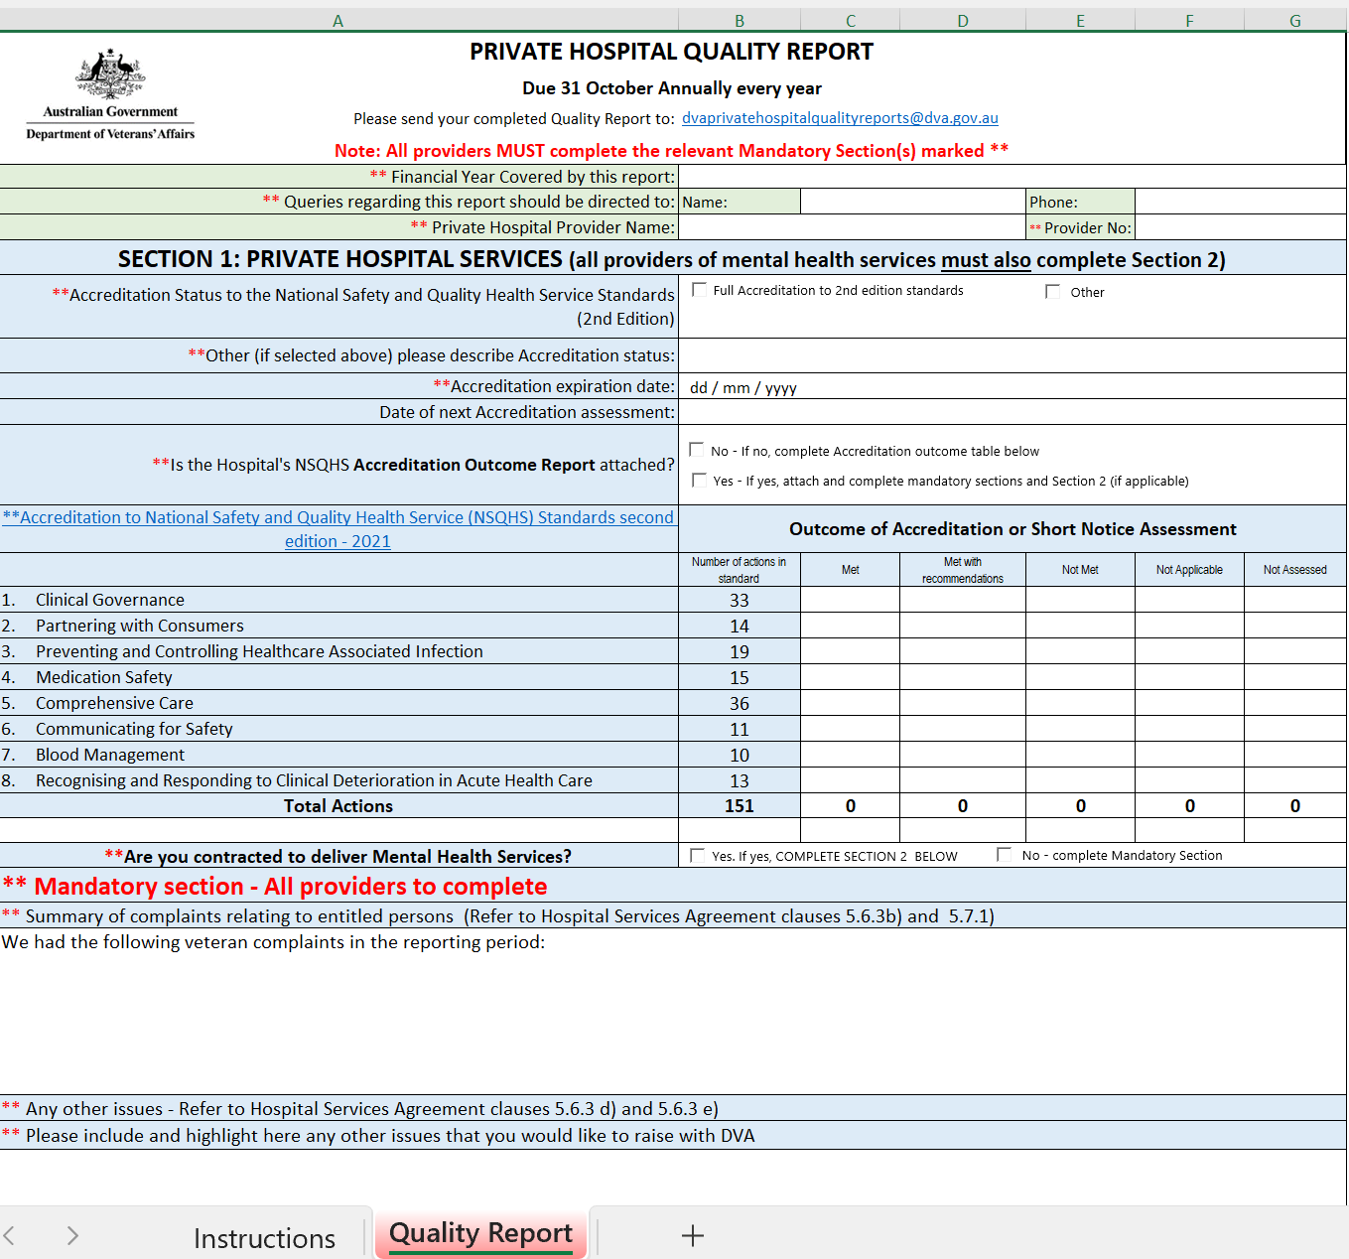

8. Mental Health Standards

Clauses 4.33 to 4.41 of the Agreement cover the requirements for Private Hospitals providing Mental Health Services to veterans.

Mental Health Services provided under the Agreement must be in accordance with the principles contained in the Guidelines for Determining Benefits for Private Health Insurance Purposes for Private Mental Health Care (2015 Edition) as amended from time to time.

In addition, Private Hospitals delivering Mental Health Services to veterans must:
- comply with the Commonwealth of Australia 2012 Mental Health Statement of Rights and Responsibilities;
- meet the National Standards for Mental Health Services 2010;
- comply with the requirements of the National Model for the Collection and Analysis of a Minimum Data Set with Measures of Outcomes and Patients Experiences of Care for Private Hospital-based Psychiatric Services; and
- Participate in the Private Psychiatric Hospitals Data Reporting and Analysis Service (PPHDRAS) to ensure all relevant data is included in quarterly reports generated for DVA.

Trauma Recovery Programs
Private Hospitals delivering Trauma Recovery Programs must be accredited against the current National Safety and Quality Health Service Standards (NSQHS Standards). Trauma Recovery Programs must be designed and delivered in accordance with the Australian Guidelines for the Prevention and Treatment of Acute Stress Disorder, Posttraumatic Stress Disorder and Complex PTSD (Phoenix Australia, 2020) (the Guidelines), as amended from time to time.

For Trauma Recovery Programs, Private Hospitals must:
- comply with the DVA accreditation requirements as detailed at clause 4.40 of the Agreement; and
- Collect additional outcome measures as directed by DVA.

DVA will evaluate the clinical effectiveness of the Trauma Recovery Programs by collecting outcome data from veterans through Phoenix Australia Centre for Posttraumatic Mental Health, under contract arrangements, at the following time points:
- assessment;
- intake;
- discharge;
- three (3) months post-discharge (relapse prevention); and
- nine (9) months post-discharge.

DVA’s Mental Health Standards are continually reviewed and hospitals will be advised where changes are planned. DVA will ensure that providers are given three (3) months written notification of any planned changes to Mental Health Standards or changes to program requirements.

9. Mental Health Quality Reporting

Hospital staff responsible for Quality Reporting should check the DVA website from time to time to ensure that the correct version of the Quality Reporting template is used. Private Hospitals delivering Mental Health Services are able to fulfil their quality reporting requirements by completing section 2 of the Private Hospitals Quality Report.

Mental Health providers should follow the instructions included in the Quality Report template and should check that all of the required attachments are included before the Quality Report is submitted.
Mental Health Quality Reports are due by 31 October each year and should be sent to DVA at Private.Hospital.Quality.Reports@dva.gov.au.

10. DVA’s Private Hospital Patient Experience Survey (PES)

DVA’s Private Hospital Patient Experience Survey was ceased on 1 Jun 2023. Hospitals are advised to destroy all paper survey forms and stop distributing these.

11. Information management – submitting Hospital Casemix Protocol data

Under clause 6.9 of the Agreement, each month Private Hospitals must provide to DVA in electronic medium and without charge, information in respect of each veteran separation during the preceding month. This information on each veteran separation is contained in the Hospital Casemix Protocol (HCP) data submission.

HCP data format requirements
The data must be supplied using the HCP format, as specified by the Department of Health and Aged Care (DoHAC), and split into monthly periods.

The HCP data provided will be:
- based on the current HCP version, or any future revisions as specified by DoHAC
- Supplied using DVA’s Secure File Transfer TIBCO managed File Transfer.

It is critical that the HCP data specification complies with the current DoHAC header and episode record, hospital-to-insurer layout. From time to time the specification of HCP data is altered and these changes will be advised by the DoHAC and made available via the DoHAC website.

Private Hospitals submitting HCP data will need to nominate a staff member within the hospital and contact DVA to obtain a copy of the DVA Secure Transfers Access Request for External Users form.

The nominated staff member will need to complete the form by:
  - Filling out the second part of the first page
  - Read the Terms of Use (pages 2 and 3)
  - Sign and date the bottom of third page (at External Party to sign here)
  - Scan all pages of the form and email to HospitalContracting@dva.gov.au

Once the nominated staff member has been registered, a secure file transfer logon and passphrase will be issued and the nominated staff member will be contacted with the unique USER ID details and will also be provided with assistance in accessing the HCP data transfer website.

If the hospital fails to provide HCP data for more than three (3) consecutive months, DVA reserves the right to withhold payment for services until such time as the data is supplied, as per clause 6.9.2 of the Agreement.

For this and further information please contact the DVA Secure Services Desk via the Helpdesk email address: DVASSHdesk@dva.gov.au.
QLD and NSW/ACT facilities – HCPDataNth@dva.gov.au
VIC SA/NT, WA and TAS facilities – HCPDataSth@dva.gov.au.

12. In Hospital Claims (IHC)

Your organisation has agreed to implement and/or maintain effective electronic billing and payment arrangements during the period of the Agreement. The In Hospital Claims (IHC) system is an electronic billing system available to Private Hospitals and DPCs. The IHC system is an extension of the Services Australia online claiming solutions which:
- enables Private Hospitals and DPCs to submit electronic claims for processing without the requirement to send additional paperwork to Services Australia
- offers a secure connection between Private Hospitals, Services Australia and DVA, and incorporates direct communication for providers with Services Australia and DVA in the one transaction.

What are the advantages for facilities that move to DVA IHC?
- Facilities are able to submit DVA claims electronically for processing and payment which should reduce the administration required to submit claims.
- DVA’s IHC component is consistent with the system used for health funds and contains an inbuilt automated veteran verification system that confirms whether a veteran’s patient details are correct.
- Electronic remittance advice statements detailing DVA’s payment of claims allows automated account reconciliation on request.
- Facilities can check the status of their hospital claim assessments and request processing and payment reports relating to claims through their claiming software.
- Certificate information (e.g. such as an Acute Care Certificate) can be submitted electronically.
The future ability to transmit HCP data via IHC is expected to eliminate the need for hospitals to supply separately.

What types of services are able to be claimed via IHC for DVA?
The following claim types can be claimed electronically using IHC:
Accommodation | Acute Care* | Critical care* | In patient
Interim claims | Miscellaneous charges | Overnight | Medical devices and Human Tissue Products
Psychiatry | Rehabilitation | Same day | Theatre
*Including Acute Care, Critical Care, Type C, Type B and Rehabilitation certificates

What types of services cannot be claimed via IHC for DVA?
- Public Hospital claims - existing payment arrangements for Public Hospital services will continue.
- ADF personnel claims - claims should continue to be sent to the relevant Defence Area Health Service for payment.
- Adjustments to previous claims - these claims should be manually submitted to Services Australia for payment.
- Some claims where Letters of Authority indicate other specific billing arrangements.

Is Electronic Funds Transfer mandatory for claims lodged through IHC?
Yes, Electronic Funds Transfer (EFT) is a mandatory part of the IHC registration process. Facilities are required to provide their EFT details as part of the IHC registration process. For more information on EFT, contact Services Australia on 1800 700 199.

Are remittance advices available electronically through IHC?
Yes, a facility can retrieve a remittance advice through their software for up to six (6) months from the date of payment. After six (6) months contact Services Australia Processing Centres on 132 150 to request duplicate statements.

What happens to paperwork when claiming via IHC?
Facilities must retain auditable records either in paper or electronic form. While Services Australia may not require paperwork to process the claims, the data elements captured in the various forms, including the Hospital Claim Form, Hospital Admission Voucher, Acute Care certificate and other certification including day only and overnight certification, must be kept with the veteran’s Clinical Record for audit purposes. Facilities must ensure that where certification by a treating professional is required, that this is also saved on the veteran’s Clinical Record.

Can a claim be submitted if IHC is unable to identify a veteran?
No, if a veteran verification request does not identify the veteran the claim will be rejected. To resolve this issue, the facility should either:
- check the details with the veteran, or
- contact DVA on 1800 550 457 (select Option 3) to confirm the veteran’s details, and then correct the details before submitting the claim.

Will a claim be paid if IHC identifies a veteran patient?
In most cases yes, however, the claim must meet all DVA’s business rules. The process does not check a veteran’s accepted conditions, and therefore a claim could still be rejected for reasons relating to the accepted condition.
Do facilities need to check a veteran’s accepted conditions?
Yes, under DVA contracting arrangements it is the facility’s responsibility to ensure that a veteran has eligibility for the requested treatment before admitting a patient at the expense of DVA. If a facility is unsure of a veteran’s eligibility, they should contact DVA on 1800 550 457 (select Option 3) for confirmation.

Are DVA prior financial authorisations required for IHC?
Prior financial authorisation requirements are specified within the Agreement for certain items. IHC has not changed any of DVA’s prior financial authorisation requirements. Please check your contract for these requirements.

In-Hospital Claims - Getting set up for IHC and getting help
For help with registering for IHC, organisations should contact the eBusiness section in Services Australia by:
- Telephone: 1800 700 199
- Email: ebusiness@services australia.gov.au

Obtaining a digital certificate
All hospital sites submitting claims electronically through IHC require a digital certificate that ensures the security of claims lodged online. Services Australia’s eBusiness Service Centre will assist with registering for digital certificates and the OTS Product Integration Team can help you test your software products to achieve a Notice of Integration or Notice of Connection by emailing: itest@servicesaustralia.gov.au.

Help for Software Developers
The Developer Support Team (previously known as the OTS Liaison team) is the first point of contact for developers to be registered with Services Australia as Software Developers. The Services Australia Developer Support team can be contacted by email at: devsupport@servicesaustralia.gov.au

Help for Software Vendors
IHC has specific software requirements. Services Australia provide support to Software Vendors through the Online Technical Support (OTS) team or OTS Software Vendor Technical Support who are contactable by email at:
- onlineclaiming@servicesaustralia.gov.au
- Or by telephone 1300 550 115 from Monday to Friday 8.30 a.m. to 5.00 p.m. AEST.

This team assists software vendors in diagnosing and resolving technical issues during the development and production stages, as well as resolving technical issues encountered in the vendor environment.

Incorporating IHC functions into existing software products
If your software vendor is registered and requires technical assistance, they should contact the OTS team via email in the first instance at eclipse.enq@servicesaustralia.gov.au or via telephone on 1300 550 115.

13. Billing arrangements

Where to send non-electronic claims
Services Australia is an agent for DVA and processes all DVA Veteran card admissions and payments in accordance with DVA’s policies and procedures. Amounts are paid in accordance with contracted or negotiated rates. Accounts for hospital accommodation, theatre fees, day only accommodation, fixed price items, case payments and medical devices and human tissue products supplies should be mailed to:

Hospitals in SA - NT - WA - NSW - ACT send claims to
Veterans’ Affairs Processing - Hospital Provider Claims
Services Australia Programs
PO Box 9917
PERTH WA 6848

Hospitals in VIC - TAS - QLD send claims to
Veterans’ Affairs Processing – Hospital Provider Claims
Services Australia Programs
PO Box 9917
MELBOURNE VIC 3001

Please refer to section 3 (Patient eligibility and entitlement for treatment) of this Information Guide for details of billing arrangements for non-DVA card holders and for information regarding Department of Defence arrangements.

Prompt payment
Claims submitted to Services Australia must be submitted using the DVA Discharge Advice and Hospital Claim Form (D0653A). Incomplete, inaccurate or illegible information can cause delays in payment. Please include sufficient information with your claim to ensure prompt and accurate processing. Claims must be itemised using the item numbers that apply at the date of service.

Claims which are incorrectly completed e.g. without item numbers, admission date or principal diagnosis code, will be rejected and returned to Private Hospitals.

Account enquiries
Private Hospital account enquires should be directed to Services Australia on 1300 550 017.
Where Private Hospitals have an ongoing issue with the timeliness of payment of correctly rendered invoices, this should be raised formally with their DVA Contract Manager.

14. Discharge Advice and Hospital Claim (D653A) form

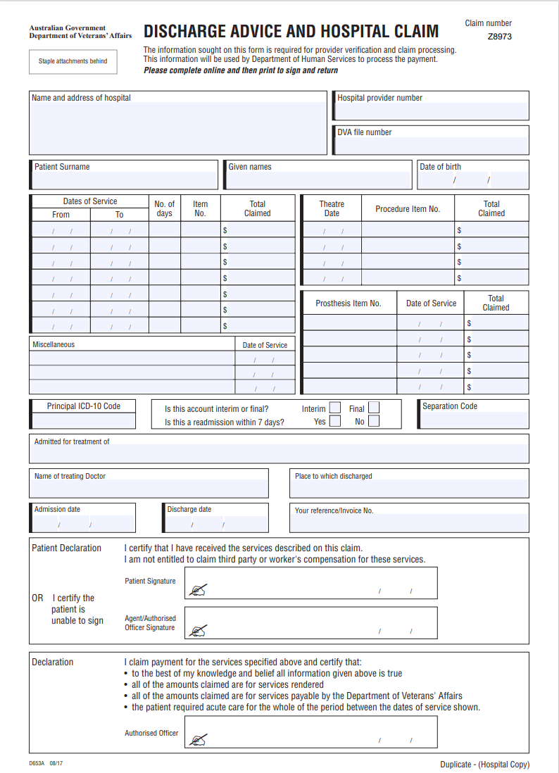

15. How to fill in the Discharge Advice and Hospital Claim (D653A) form

The DVA Discharge Advice and Hospital Claim form should be used for all hospital and medical devices and human tissue product claims. It is comprised of two (2) copies:
- departmental claim copy (to be sent to Services Australia for claiming purposes)
- Private Hospital copy (to be retained by the hospital for your records).

Hospital Details: | Contains the hospital name, address and provider number
DVA File Number: | Insert DVA file number from Veteran Card
Patient name
Date of Birth: | dd/mm/yyyy
Dates of Service: | Insert the date of service FROM (the admission date or continuation claim date) and the date of service TO (the day prior to discharge or continuation claim date)  Dates of service must not overlap. In cases where there is more than one accommodation line (e.g. because of a change in rate or patient classification) the FROM date will be the first day of the new classification or rate. Examples of a correct and an incorrect claim is shown below:  Correct claim   Incorrect claim
  Dates of Service
  From | To
  Admission date  / / | Day prior to discharge  / /
  Date of Service |  | No of Days | Item No | Total Claimed
  From | To | No of Days | Item No | Total Claimed
  29 /01/2021 | 30 /01/2021 |  |  | $
  31 /01/2021 | 04 /02/2021 |  |  | $
  Date of Service |  | No of Days | Item No | Total Claimed
  From | To | No of Days | Item No | Total Claimed
  29 /01/2021 | 30 /01/2021 |  |  | $
  30 /01/2021 | 04 /02/2021 |  |  | $
Number of days: | Insert the number of occupied bed days being claimed. The first and last day of an inpatient stay are counted as one day in total.
Item Number: | Insert the item number(s) from your Agreement. Please note that item numbers not within your Agreement cannot be claimed.
Total Claimed: | Insert the accommodation amount claimed in accordance with contracted or negotiated rates.
Theatre Date: | Insert the date the operation or procedure was performed.
Total Claimed: | Insert the theatre amount claimed for each MBS item. Payment will be made in accordance with contracted or negotiated rates.
Procedure Item No: | Insert the appropriate MBS procedure item number and procedure fee item that are relevant to the service provided.
Medical Devices and Human Tissue Products | Use the Item numbers for Medical Devices and Human Tissue Products as listed on the Department of Health and Aged Care's website and claim as per the Private Health Insurance (Medical Devices and Human Tissue Products) Rules - Prescribed List of Benefits for Medical Devices and Human Tissue Products (Prescribed List) (Schedule to the Rules).
Miscellaneous: | This section is used for DVA miscellaneous items e.g. all ‘M’ items. Do not include items of a personal nature such as newspapers, personal laundry, telephone calls and television charges as these are not paid by DVA.
Principal ICD-10 Code: | The Principal ICD Diagnosis Code describes non-surgical treatment and is always required where the Medical patient classification applies. This information is required to validate the group accommodation claimed within the Medical patient classification. This section should contain ICD-10 codes only (not DRGs).
Interim accounts: | Tick “Interim” if this is part of a continuation claim.  Tick “Final” if this is the only claim for the patient’s admission.
Separation code: | Include the relevant code from the following list:  A Discharge by Hospital  B Discharge own risk  C Transferred to nursing home  D Transfer to psychiatric hospital  E Transfer to other hospital  F Death with autopsy  G Death without autopsy  H Transferred to other accommodation  I Type change separation  R Deceased  S Still an in-patient  W Nursing home  X Other hospital  Z Home
Admitted for treatment of: | Insert the condition treated. Where additional space is required, please put details in miscellaneous box.
Name of treating doctor: | Insert the full name of the doctor providing treatment.
Place to which discharged: | Indicate the place to which the person was discharged, e.g. home, aged care facility, family care.
Admission date: | Insert the date the person was admitted. This information is also required for interim accounts.
Discharge date: | Insert the date of discharge. For interim accounts, leave blank.
Reference/invoice no: | This information is optional.
Patient Declaration: | The patient must sign to certify services claimed have been received. If the patient is unable to sign, the patient’s agent or Authorised Officer must sign.
Claimant Declaration: | The form must be signed by an Authorised Officer.

16. Examples showing how to complete your claim
Disclaimer - The scenarios, MBS items and rates included below are examples only and contain fictitious information developed to for the purpose of providing examples.

DVA’s GATB Schedule for item 32166
Item | Complex Procedure | Effective Date | End date | Type Indicator | Service Level Type | Group Code | Procedure Type | Nat Theatre Band
32166 |  |  |  | MBS | M | 1 | A | 1

The Service level Type is Medical
The Group Accommodation Code is 1
The Procedure Type is A
The Theatre Band is 1

Accommodation is taken from the Hospital Services Agreement Table 2: Accommodation for Acute Inpatient Services. The item number associated with Service level type -Medical, Group Code 1 Accommodation is H263. H263 has step-downs on day 3 and day 15+.
This means that the first two days are paid at the highest Accommodation rate and from day 3 onwards the rate paid is at the first stepdown rate.

Theatre is paid at the Theatre Band 1 rate which is taken from the Hospital Services Agreement Table 4: Theatre Charges.
Claiming a case payment for a Short Stay MBS Package (refer Agreement Schedule G: Table 1)

Case payments for Short Stay MBS packages include all theatre fees and expenses as well as consumables, together with same day or overnight accommodation not exceeding two days. MBS Short Stay Packages include two nights’ accommodation.
Example 1: Case Payment
In this example the patient has a Sigmoidoscopy (MBS item 32087) on 1 March 2022 and discharges on 2 March 2022. H458 is the DVA item number for the complete case payment (see Table 1 of the Agreement). The procedure item number should still be noted in the “Theatre” section but no amount is inserted as this is covered in the assigned package payment. (Note: Item 32087 is a Type B procedure. As per the Agreement (4.12.5), valid overnight certification would need to be provided.)

Date of Service |  | No. of Days | Item No | Total Claimed |  | Theatre Date | Procedure Item No | Total Claimed
From | To | No. of Days | Item No | Total Claimed |  | Theatre Date | Procedure Item No | Total Claimed
01/03/2022 | 02/03/2022 | 1 | H458 | $1550 |  | 01/03/2022 | 32087

Example 2: Claiming for Advanced Surgical, Group 5 procedure
In this example below, a veteran was admitted on 1 March 2022 for an Advanced Surgical, Group 5, procedure (e.g. Intracranial Haemorrhage (MBS 39604)). The veteran was discharged on the 20th day.

Dates of Service |  | No of Days | Item No | Total Claimed |  | Theatre Date | Procedure Item No | Total Claimed
From | To | No of Days | Item No | Total Claimed |  | Theatre Date | Procedure Item No | Total Claimed
01/03/2022 | 14/03/2022 | 14 | H255 | $7,000.00 |  | 01/03/2022 | 39604 | $800.00
15/03/2022 | 18/03/2022 | 4 | H255 | $1,600.00
19/03/2022 | 20/03/2022 | 1 | H255 | $300.00

This particular procedure attracts a fee for hospital accommodation item H255 which is Advanced Surgery Group 5.

For additional details, refer to refer to Table 2 of the Agreement: Accommodation for Acute Inpatient Services.

H255 has step-downs on days 15 and 19.

The primary rate is billed for the first 14 days (row 1 – 01/03/2022 to 14/03/2022), the first step-down rate is billed for the next 4 days (days 15-18, row 2 – 15/03/2022 to 18/03/2022) and the final day, day 19, is billed at the second step-down rate (row 3 – 19/03/2022 to 20/03/2022). The day of discharge is not payable.

Claiming for an acute mental health admission

Example 3:
In this example, the patient was admitted on 1 March 2022 for Acute Mental Health treatment and was discharged on the 28th day. The relevant item is H300 which has a step down at 22+ days.
Consequently, the primary rate is billed for the first 21 days (row 1 – 01/03/2022 to 21/3/2022).

The stepdown rate is billed for the next 6 days (days 22-27, row 2 – 22/3/2022 to 28/3/2022). The day of discharge is not payable.

Date of Service |  | No of Days | Item No | Total Claimed
From | To | No of Days | Item No | Total Claimed
01/03/2022 | 21/03/2022 | 21 | H300 | $9,000.00
22/03/2022 | 28/03/2022 | 6 | H300 | $1,800.00

Claiming a Continuation Claim

Example 4:
In the example below, the patient was admitted on 1 March 2022 for intracranial surgery, but did not discharge until the 17 March 2022. The Item Number H255 has step downs at days 15 and days 19. The initial period is claimed with the FROM date as 1/03/2022 to 14/03/2022 (see below).

Date of Service |  | No of Days | Item No | Total Claimed |  | Theatre Date | Procedure Item No | Total Claimed
From | To | No of Days | Item No | Total Claimed |  | Theatre Date | Procedure Item No | Total Claimed
01/03/2022 | 14/03/2022 | 14 | H255 | $7,000.00 |  | 01/03/2022 | 39604 | $1500.00

For the hospital to indicate that this is an interim account and the patient is still in hospital, the question “Is this account interim or final?” should be ticked as Interim . In the Separation Code section, an “S” should be placed in the separation code box indicating that the patient is still in hospital.
Is this account interim or final? Interim Final  Is this a readmission within 7 days? Yes No |  | Separation Code: S

The subsequent claim will have a FROM date of 15/03/2022.
Date of Service |  | No of Days | Item No | Total Claimed
From | To | No of Days | Item No | Total Claimed
15/03/2022 | 17/03/2022 | 2 | H255 | $1,000.00

Is this account interim or final? Interim Final  Is this a readmission within 7 days? Yes No |  | Separation Code: Z

Example 5: Claiming a Continuation Claim with a leave day
Patient was admitted on 1 March 2022 for surgery and on the 6 March 2022 had a leave day, returning to hospital on the 7 March 2022. The leave period is denoted by item H999.

Date of Service |  | No of Days | Item No | Total Claimed
From | To
01/03/2022 | 05/03/2022 | 5 | H266 | $1250.00
06/03/2022 | 06/03/2022 | 1 | H999
07/03/2022 | 12/03/2022 | 5 | H266 | $1250.00

Example 6: Claiming a Mental Health Package Service
In the example below, the patient was admitted on 1 March 2022 for Electroconvulsive Therapy (ECT).

To make this claim refer to Table 18 of the Agreement and select the package item H468. As the package for H468 includes a payment for both Accommodation and Theatre, these items are not claimed on top of the package.
Date of Service |  | No. of Days | Item No | Total Claimed
From | To | No. of Days | Item No | Total Claimed
01/03/2022 | 02/03/2022 | 1 | H468 | $500.00

Example 7: Claiming a same day dental procedure where the patient stays overnight
In this example. The veteran is admitted on 1 March 2022 for a same day dental procedure but does not discharge until on 02/03/2022.

As the dental package item in the Hospital Services Agreement is only for same day services, the claim needs to be unbundled and theatre and accommodation should be claimed separately. As the day of discharge is not paid, therefore there is only one day to be claimed under No of Days.
Date of Service |  | No. of Days | Item No | Total Claimed |  | Theatre Date | Procedure Item No | Total Claimed
From | To
01/03/2022 | 02/03/2022 | 1 | H257 | $400.00 |  | 01/03/2022 | M036 | $200

Item Miscellaneous M036 is the Procedure Fee for dental procedures. The accommodation item to be used is H257 (Surgical Group 1).
Note: Hospitals should not include ICD or MBS on claims for overnight dental admissions.
Example 8: Claiming Theatre Fees for multiple procedures
Outlined in clause 4.13 (Theatre Fees) of the Agreement, DVA will pay theatre fees which include the cost of pre-operative purgative preparations, imprest medications and pharmaceutical products, dressings and consumable items in Table 4 of Part C, Schedule G: Hospital Services Fee Tables. Table 4 refers to the multiple procedure rules for your organisation. Where multiple procedures are involved in an operation, the theatre fee will be payable as follows:
- the first procedure will be paid at 100% of the applicable fee
- the second, third and subsequent procedures will be paid at the percentages indicated in the Agreement (Table 4 of Part C, Schedule G: Hospital Services Fee Tables).

DVA Hospital Claims Business and Processing Rules for hospitals to note:

Short Stay MBS Procedures for three nights or more or where critical care is administered:
Where the admission is for two days, the package is claimed, however, where the admission is for three nights or longer (or where critical care is administered), the provider must use a per diem claim which separates the procedure and the accommodation. Private Hospitals would make an unbundled claim for a short stay MBS Procedure where the admission exceeds the two days included in the package fee.

Short Stay Outlier MBS Procedure Claim example – hospital to unbundle
For example, in the scenario below, the patient undergoes the same colonoscopy item (MBS item 32087) on 1 March 2022, but does not discharge for another three days (i.e. on 5 March 2022). As the total admission exceeds two days this episode needs to be claimed on an unbundled (or per Diem basis). The claim is to be made as follows:
Accommodation component is on the left and the Theatre (with the procedure item number are displayed on the right). Note: Item 32087 is a Type B procedure. As per the Agreement (4.12.5), valid overnight certification would need to be provided.)

Accommodation component Theatre component
Date of Service |  | No. of Days | Item No | Total Claimed |  | Theatre Date | Procedure Item No | Total Claimed
From | To | No. of Days | Item No | Total Claimed |  | Theatre Date | Procedure Item No | Total Claimed
01/03/2022 | 02/03/2022 | 2 | H263 | $800.00 |  | 01/03/2022 | 32087 | $800.00
03/03/2022 | 05/03/2022 | 2 | H263 | $1500.00

Admitted Same Day Rehabilitation Services
Admitted Same Day Rehabilitation Services must comply with the Guidelines for Recognition of Private Hospital-Based Rehabilitation Services, as amended from time to time. Programs for the delivery of same day rehabilitation services must be approved by DVA, and should be billed using the item numbers in Table 13: Admitted Same Day Rehabilitation in the Agreement.
Any changes to an admitted same day rehabilitation Program must be approved by DVA, for example changes to the length and frequency of the Program, the number of treatment hours, or the admission criteria.
Non-admitted Sessional Rehabilitation Services
Where a hospital has agreed non-admitted Sessional Rehabilitation Services in their Agreement with DVA, (under clause 4.26 of the Agreement), Private Hospitals should use the item numbers outlined in the table below and use the equivalent fee in DVA’s Allied Health Fee Schedule. The table below provides examples of the comparator item number and fee.
DESCRIPTION – Allied health modality | Item No.
Aquatic Physiotherapy (hydrotherapy) session – supervised individual  (Fee is equivalent to PH60) | HX021
Aquatic Physiotherapy (hydrotherapy) session – supervised group  (Fee is equivalent to PH61) | HX022
Outpatient – Exercise Physiology  (Fee is equivalent to EP19) | HX058
Outpatient – Physiotherapy  (Fee is equivalent to PH17 Subsequent Consultation) | HX027
Outpatient – Occupational Therapy  (Fee is equivalent to OT01, OT07) | HX028
Outpatient – Dietetics  (Fee is equivalent to DT12) | HX029
Outpatient – Psychology  (Fee is equivalent to e.g. US12, US15) | HX030
Outpatient – Speech therapy  (Fee is equivalent to E.G. SH04, SH14, SH24) | HX031
Outpatient – Diabetes educator  (Fee is equivalent to CD09, CD10) | HX065
Lymphoedema treatment inclusive of measurement and fitting of garments 1 set bandages – First Session (exclusive of the supply of the garments)  (Fee is equivalent to PH41 – Lymphoedema Treatment) | HX001
Lymphoedema Maintenance (Subsequent session)  (Fee is equivalent to PH41 – Lymphoedema Treatment) | HX002

Non-admitted Sessional Rehabilitation Services may only be delivered to veterans who have previously undertaken an inpatient rehabilitation Program or same day rehabilitation Program as part of the treatment of that condition or the same episode of care. Prior financial authorisation is not required for the delivery of non-admitted sessional rehabilitation services, unless treatment is in excess of four (4) weeks, or where the treatment is not otherwise covered by a Program as agreed between the parties will require prior financial authorisation.

Accident and emergency
Accident and Emergency item HX013 may be included in the Agreement where fees for these items have been negotiated with DVA. Item HX013 cannot be claimed if the patient is subsequently admitted to the Hospital for a related condition within the next twenty-four (24) hours.

High Cost Medical Consumable costs
DVA will meet the costs associated with the use of High Cost Medical Consumables (HCMC) where the cost is considered not reasonably included in the theatre fees. As a guide, items where the value of each item is over $250 may be considered (i.e. multiple items cannot be combined to cumulatively reach $250). Items less than $250 would not be considered high cost and will be rejected by DVA’s payment system. As most disposable and consumable items are included in the theatre fee that is payable for the procedure, the claims using M152 should only be used where the cost would not be reasonably expected to be included in the theatre fee. Claims for HCMC should only be made when a theatre or surgical package item is claimed.

Claims for HCMC do not require prior financial authorisation. To substantiate the claim validity, claims must specify the item to be funded and claims should be itemised (i.e. multiple items cannot be combined to cumulatively reach $250) and based on the invoiced price or cost from the supplier. No handling charge is payable for the items. DVA has implemented a post payment monitoring regime to examine the nature and type of items claimed and reserves the right to view the relevant supplier invoices. HCMC claims are to be made using the Hospital Item number M152.

High Cost Robotic Consumables
DVA will meet the cost of the specific consumables associated with the use of robotic technology, on the basis of invoice fee from the supplier, with a pro-rata amount for multi-use items. When raising a charge for the robotic consumables the Private Hospital must quote DVA Item number M201 for each item claimed. No additional HCMC claims under M152 will be paid when M201 is claimed. As a guide, items valued at $250 or less would generally not be considered high cost.

Calculating the day count
During some admissions there are circumstances where a patient might need to be reclassified, and as a result, the day count needs to be restarted.

For example:
If an Entitled Person in the same hospital… | Then……
is discharged and readmitted within 7 days for a condition that continues to be described by the ICD describing the first condition | the day count continues
is discharged and readmitted within 7 days for a condition that is not described by the ICD describing the first condition | the day count starts again
has a second more complex procedure | the day count starts again at the higher classification
has a second less complex procedure | the day count continues at the higher classification until the end of the first level period.
is interrupted during a rehabilitation program for either surgical or medical treatment and then returns to the rehabilitation program | the day count starts again for the continuation of the rehabilitation program
If an Entitled Person in a different hospital is | Then……
transferred to another hospital for a more complex procedure | the day count starts again at the receiving hospital
transferred to another hospital for the same condition | the day count continues at the receiving hospital
transferred to another hospital where classification has changed e.g. to rehabilitation | the day count starts again at the receiving hospital

17. Certificates and certification

There are a range of certificates available for Private Hospitals to use and these can be found on DVA’s Forms webpages (some examples are linked are below). Where the Agreement indicates that certificates must be provided, then it is the provider’s responsibility to ensure that a valid certificate is available for audit purposes.

D9076 - Acute Care Certificate (PDF 212 KB)
D6345 - Coronary Care Patient Certificate (PDF 169 KB)
D6346 - Intensive Care Patient Certificate (PDF 174 KB)
Rehabilitation Program Certificate
National Private Patient Hospital Claim Form
D0652B - Hospital Admission Voucher
D0653A - Discharge Advice and Hospital Claim Form

Acute Care Certificates
These certificates are required for acute care patients once they have been admitted for thirty-five (35) days. Leave days and periods between hospitalisation do not count towards the thirty-five (35) day period.

Acute Care beyond 35 days - Hospitals should note
If claiming an acute rate for a period beyond thirty-five (35) days, an Acute Care Certificate must be completed by the treating Medical Practitioner and forwarded to Services Australia with the account for that period of stay.

If Private Hospitals are using electronic billing, the Acute Care Certificate information can be submitted electronically, however, a hard copy must be retained on the Entitled Person’s Clinical Record.

Private Hospitals can either use the DVA Acute Care Certificate or a similar form. Please do not send Acute Care certificates to DVA.
Where Services Australia receive a claim for an admission longer than thirty-five (35) days without an accompanying Acute Care Certificate, the period up to thirty-five (35) days will be paid at the rate claimed by the hospital. The period over thirty-five (35) days will not be paid and the claim will be rejected. This allows the hospital to either resubmit the claim accompanied with an Acute Care Certificate or alter the claim to indicate the appropriate non-acute Nursing Home Type Patient rate.

A patient may be regarded as a Nursing Home Type Patient at any time after admission if the treating Medical Practitioner decides that the patient no longer requires acute care.
Please Note – Special treatment of ex-POWs: DVA will pay the basic daily care fee patient contribution for ex-Prisoners of War (ex-POWs) and Victoria Cross recipients even after they have been reclassified as receiving Nursing Home Type care in hospital.

Critical Care Certificates
These certificates clinically justify the need for accommodation in a Critical Care Facility and list the required interventions and level of Nursing Care. There are two Critical Care certificates available from the DVA website, the Coronary Care Certificate and the Intensive Care Certificate. Where a patient requires critical care for ten (10) days or less a critical care certificate is required. Where the length of stay in the Critical Care Unit exceeds ten (10) days a subsequent critical care certificate is required.

Certificates are to be kept on the patient file for audit purposes and should not be sent to either Services Australia or DVA.

Rehabilitation Program Certificate
When a patient is admitted for an inpatient rehabilitation, admitted same day or non-admitted Sessional Rehabilitation Program, an appropriate Rehabilitation Program Certificate must be completed and signed by a rehabilitation physician. At a minimum the Rehabilitation Program Certificate should contain details of the treatment goals and indicative timeframes for the patient’s rehabilitation treatment.

The Rehabilitation Program Certificate must be kept with the Entitled Person’s Clinical Record for audit purposes. (An example of the current Rehabilitation Program Certificate)
Please note: Rehabilitation certificates are to be kept on the patient file for audit purposes and should not be sent to either Services Australia or DVA.

Day Only Procedure Certification and Overnight Stay Certification (Type C and Type B Certificates)
When a patient undergoes a procedure that does not normally require treatment within an acute facility (Type C procedure) then “Valid Day Certification” must accompany an account. Valid certification can be provided as data elements in IHC or provided on the Common Claim Form (known as the National Private Patient Hospital Claim Form). An excerpt of the relevant section from the NPP Hospital Claim form is shown in Figure 2.

Figure 1 National Private Patient Claim form – Type B & C Certification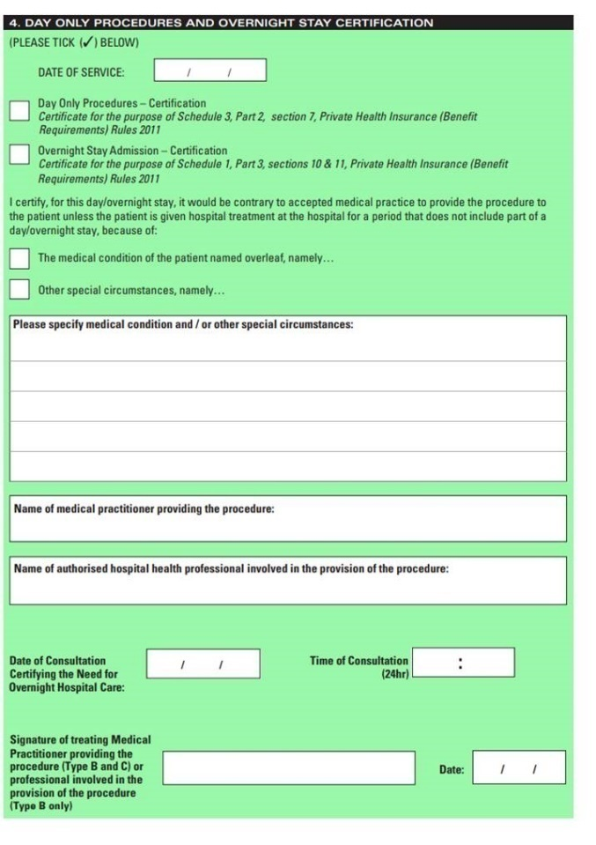
Valid Overnight Stay Certification is also required when a patient undergoing a Type B procedure requires an overnight stay in hospital.

NB: It is the hospital’s responsibility to ensure that the certification provided by the treating doctor is valid under the Private Health Insurance (Benefits Requirements) Rules 2011.

18. Advertising

Advertising requirements are set out in clause 1.5 of your Agreement.
No advertising relating to the awarding or operation of this Agreement must be published in any advertising medium without the prior written approval of DVA. This is to ensure that DVA can consider any information issued with reference to the arrangements which may be interpreted by DVA stakeholders as having reference to or the endorsement of the Department of Veterans’ Affairs.

Advertising includes (but is not limited to) the following:
Letters to:
- veterans
- Ex-Service Organisations
- specialists, medical practitioners and allied health providers.

Advertising in:
- print, electronic and social media
- journals and professional association newsletters
- Ex-Service Organisation publications
- any pamphlets and brochures.

You should discuss your advertising needs with your DVA Contract Manager, and once prior financial authorisation has been granted, you should provide your DVA contract manager with a copy of all material that is published.

19. Percutaneous Coronary Intervention (PCI) Procedures

Introduction to DVA’s PCI Funding Model
The Department of Veterans’ Affairs (DVA) developed an interim Funding Model to fund the procedure and accommodation for 12 new Percutaneous Coronary Intervention (PCI) procedures and MBS item numbers that commenced on 1 July 2021. These 12 MBS items were unable to be assigned a theatre band by the National Procedure Banding Committee (NPBC) and Hospitals and funders were advised to come to an agreed arrangement regarding payment for these services. Attachment 2 outlines the MBS items that were created and took effect from 1 July 2021, with guidance for claiming these procedures. The PCI funding model and claims rules are the result of DVA’s consultation with the Private Hospitals sector.

ATTACHMENT 1 – DVA quick contact list for providers
Department of Veterans’ Affairs  General Enquiry Line for veterans | 1800 VETERAN  1800 838 372  OR  1800 555 254
Department of Veterans’ Affairs  Health Provider Line | 1800 550 457 (follow prompts)  Press 0: Transport and Pharmaceutical Enquiries  Press 1: Rehabilitation Appliances Program Enquiries  Press 2: Home Care and Community Nursing Enquiries  Press 3: Health Prior Approvals and enquiries, Card Eligibility checks, Provider Registration  Press 4: Rehabilitation and Compensation Account Enquiries  Press 5: Daily Living Assistance and Household Services
Prior Financial Authorisation for medical services | Email: Health.Approval@dva.gov.au  Please email your request for prior financial authorisation to the Health Approval mailbox  Telephone: 1800 550 457 (follow prompts)  Press 3: Health Prior Approvals
Veterans’ Transport Services  Booked Car With Driver bookings and Travel Cost Reimbursements/Claims | 1800 555 455
Pharmaceutical Approvals  Veterans’ Affairs Pharmaceutical Approvals Centre (VAPAC) | 1800 552 580 (24 hours per day)
Counselling Services for veterans and their families  Open Arms - Veterans & Families Counselling (formerly Veterans and Veterans’ Families Counselling Service (VVCS) | 1800 011 046 (24 hours)  Open Arms provides free and confidential counselling to current serving, transitioning, ex-serving, partners and families of anyone who has served at least one day in the ADF. To check eligibility for Open Arms - Veterans & Families Counselling visit the Open Arms - Veterans & Families Website.

ATTACHMENT 2 – Claiming guide for Percutaneous Coronary Intervention (PCI) Procedures
This claiming guide has been developed for hospital claims staff to assist in submitting correct claims for PCI services.

Table 1: MBS items for PCI procedures from 1 July 2021
38307 | Percutaneous coronary intervention:  (a) for a patient:  (i) eligible for the service under clause 5.10.17A; and  (ii) for whom selective coronary angiography has not been completed in the previous 3 months; and  (b) including selective coronary angiography and all associated imaging, catheter and contrast; and  (c) including either or both:  (i) percutaneous angioplasty;  (ii) transluminal insertion of one or more stents; and  (d) performed on one coronary vascular territory; and  (e) excluding aftercare; other than a service associated with a service to which item 38200, 38203, 38206, 38244, 38247, 38248, 38249, 38251, 38252, 38308, 38310, 38311, 38313, 38314, 38316, 38317, 38319, 38320, 38322 or 38323 applies (Anaes.) (Assist.)
38308 | Percutaneous coronary intervention:  (a) for a patient:  (i) eligible for the service under clause 5.10.17A; and  (ii) for whom selective coronary angiography has not been completed in the previous 3 months; and  (b) including selective coronary angiography and all associated imaging, catheter and contrast; and  (c) including either or both:  (i) percutaneous angioplasty; and  (ii) transluminal insertion of one or more stents; and  (d) performed on 2 coronary vascular territories; and  (e) excluding aftercare; other than a service associated with a service to which item 38200, 38203, 38206, 38244, 38247, 38248, 38249, 38251, 38252, 38307, 38310, 38311, 38313, 38314, 38316, 38317, 38319, 38320, 38322 or 38323 applies (Anaes.) (Assist.)
38310 | Percutaneous coronary intervention:  (a) for a patient:  (i) eligible for the service under clause 5.10.17A; and  (ii) for whom selective coronary angiography has not been completed in the previous 3 months; and  (b) including selective coronary angiography and all associated imaging, catheter and contrast; and  (c) including either or both:  (i) percutaneous angioplasty; and  (ii) transluminal insertion of one or more stents; and  (d) performed on 3 coronary vascular territories; and  (e) excluding aftercare; other than a service associated with a service to which item 38200, 38203, 38206, 38244, 38247, 38248, 38249, 38251, 38252, 38307, 38308, 38311, 38313, 38314, 38316, 38317, 38319, 38320, 38322 or 38323 applies (Anaes.) (Assist.)
38311 | Percutaneous coronary intervention:  (a) for a patient:  (i) eligible under clause 5.10.17C for the service and a service to which item 38314 applies; and  (ii) for whom selective coronary angiography has not been completed in the previous 3 months; and  (b) including selective coronary angiography and all associated imaging, catheter and contrast; and  (c) including either or both:  (i) percutaneous angioplasty; and  (ii) transluminal insertion of one or more stents; and  (d) performed on one coronary vascular territory; and  (e) excluding aftercare; other than a service associated with a service to which item 38200, 38203, 38206, 38244, 38247, 38248, 38249, 38251, 38252, 38307, 38308, 38310, 38313, 38314, 38316, 38317, 38319, 38320, 38322 or 38323 applies (Anaes.) (Assist.)
38313 | Percutaneous coronary intervention:  (a) for a patient:  (i) eligible under clause 5.10.17C for the service and a service to which item 38314 applies; and  (ii) for whom selective coronary angiography has not been completed in the previous 3 months; and  (b) including selective coronary angiography and all associated imaging, catheter and contrast; and  (c) including either or both:  (i) percutaneous angioplasty; and  (ii) transluminal insertion of one or more stents; and  (d) performed on 2 coronary vascular territories; and  (e) excluding aftercare; other than a service associated with a service to which item 38200, 38203, 38206, 38244, 38247, 38248, 38249, 38251, 38252, 38307, 38308, 38310, 38311, 38314, 38316, 38317, 38319, 38320, 38322 or 38323 applies (Anaes.) (Assist.)
38314 | Percutaneous coronary intervention:  (a) for a patient:  (i) eligible for the service under clause 5.10.17C; and  (ii) for whom selective coronary angiography has not been completed in the previous 3 months; and  (b) including selective coronary angiography and all associated imaging, catheter and contrast; and  (c) including either or both:  (i) percutaneous angioplasty; and  (ii) transluminal insertion of one or more stents; and  (c) performed on 3 coronary vascular territories; and  (e) excluding aftercare; other than a service associated with a service to which item 38200, 38203, 38206, 38244, 38247, 38248, 38249, 38251, 38252, 38307, 38308, 38310, 38311, 38313, 38316, 38317, 38319, 38320, 38322 or 38323 applies (Anaes.) (Assist.)
38316 | Percutaneous coronary intervention:  (a) for a patient:  (i) eligible for the service under clause 5.10.17A; and  (ii) for whom selective coronary angiography has been completed in the previous 3 months; and  (b) including any associated coronary angiography; and  (c) including either or both:  (i) percutaneous angioplasty; and  (ii) transluminal insertion of one or more stents; and  (d) performed on one coronary vascular territory; and  (e) excluding aftercare; other than a service associated with a service to which item 38200, 38203, 38206, 38244, 38247, 38248, 38249, 38251, 38252, 38307, 38308, 38310, 38311, 38313, 38314, 38317, 38319, 38320, 38322 or 38323 applies (Anaes.) (Assist.)
38317 | Percutaneous coronary intervention:  (a) for a patient:  (i) eligible for the service under clause 5.10.17A; and  (ii) for whom selective coronary angiography has been completed in the previous 3 months; and  (b) including any associated coronary angiography; and  (c) including either or both:  (i) percutaneous angioplasty; and  (ii) transluminal insertion of one or more stents; and  (d) performed on 2 coronary vascular territories; and  (e) excluding aftercare; other than a service associated with a service to which item 38200, 38203, 38206, 38244, 38247, 38248, 38249, 38251, 38252, 38307, 38308, 38310, 38311, 38313, 38314, 38316, 38319, 38320, 38322 or 38323 applies (Anaes.) (Assist.)
38319 | Percutaneous coronary intervention:  (a) for a patient:  (i) eligible for the service under clause 5.10.17A; and  (ii) for whom selective coronary angiography has been completed in the previous 3 months; and  (b) including any associated coronary angiography; and  (c) including either or both:  (i) percutaneous angioplasty; and  (ii) transluminal insertion of one or more stents; and  (d) performed on 3 coronary vascular territories; and  (e) excluding aftercare; other than a service associated with a service to which item 38200, 38203, 38206, 38244, 38247, 38248, 38249, 38251, 38252, 38307, 38308, 38310, 38311, 38313, 38314, 38316, 38317, 38320, 38322 or 38323 applies (Anaes.) (Assist.)

38320 | Percutaneous coronary intervention:  (a) for a patient:  (i) eligible under clause 5.10.17C for the service and a service to which item 38323 applies; and  (ii) for whom selective coronary angiography has been completed in the previous 3 months; and  (b) including any associated coronary angiography; and  (c) including either or both:  (i) percutaneous angioplasty; and  (ii) transluminal insertion of one or more stents; and  (d) performed on one coronary vascular territory; and  (e) excluding aftercare; other than a service associated with a service to which item 38200, 38203, 38206, 38244, 38247, 38248, 38249, 38251, 38252, 38307, 38308, 38310, 38311, 38313, 38314, 38316, 38317, 38319, 38322 or 38323 applies (Anaes.) (Assist.)
38322 | Percutaneous coronary intervention:  (a) for a patient:  (i) eligible under clause 5.10.17C for the service and a service to which item 38323 applies; and  (ii) for whom selective coronary angiography has been completed in the previous 3 months; and  (b) including any associated coronary angiography; and  (c) including either or both:  (i) percutaneous angioplasty; and  (ii) transluminal insertion of one or more stents; and  (d) performed on 2 coronary vascular territories; and  (e) excluding aftercare; other than a service associated with a service to which item 38200, 38203, 38206, 38244, 38247, 38248, 38249, 38251, 38252, 38307, 38308, 38310, 38311, 38313, 38314, 38316, 38317, 38319, 38320 or 38323 applies (Anaes.) (Assist.)
38323 | Percutaneous coronary intervention:  (a) for a patient:  (i) eligible for the service under clause 5.10.17C; and  (ii) for whom selective coronary angiography has been completed in the previous 3 months; and  (b) including any associated coronary angiography; and  (c) including either or both:  (i) percutaneous angioplasty; and  (ii) transluminal insertion of one or more stents; and  (d) performed on 3 coronary vascular territories; and  (e) excluding aftercare; other than a service associated with a service to which item 38200, 38203, 38206, 38244, 38247, 38248, 38249, 38251, 38252, 38307, 38308, 38310, 38311, 38313, 38314, 38316, 38317, 38319, 38320 or 38322 applies (Anaes.) (Assist.)

Add on item: 38309 Percutaneous Transluminal Rotational Atherectomy
38309 | Percutaneous transluminal rotational atherectomy of one or more coronary arteries, including all associated imaging, if:  (a) the target stenosis within at least one coronary artery is heavily calcified and balloon angioplasty with or without stenting is not feasible without rotational atherectomy; and  (b) the service is performed in conjunction with a service to which item 38307, 38308, 38310, 38311, 38313, 38314, 38316, 38317, 38319, 38320, 38322 or 38323 applies | Applicable only once on each occasion the service is performed (Anaes.) (Assist.)
Background to the DVA PCI Interim Funding Model
DVA’s interim PCI Funding Model was developed using DVA Private Hospital data for the 2020/21 financial year and was shaped to be consistent with the Department of Health and Aged Care’s (DoHAC) “Restructure of Percutaneous Coronary Intervention items from 1 July 2021”. The DoHAC mapping of new items is illustrated below in Picture 1 and the breakdown of fields is as follows:

Clinical indicators are either acute coronary syndrome or non-acute coronary syndrome
The intervention type is either Angiography proceeding to PCI OR Standalone PCI.
Territories are either Single, double or triple.

Picture 2: DoHAC PCI Restructure 1 July 2021- NEW MBS ITEM NUMBERS
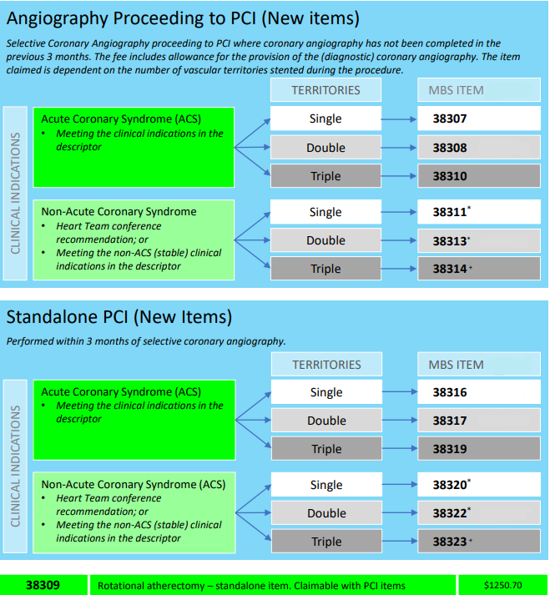
DVA PCI package items

Table 2 below lists the 24 DVA PCI packages that are to be used by Private Hospitals to claim for PCI procedures that are undertaken after 1 July 2021.

Table 2: DVA PCI Package items:
DVA PCI item | Description of PCI item | MBS item that describes the procedure | Number of Territories  (single/  double/  triple) | Number of Boundary days included in the payment for this package
HX507 | Standalone PCI (Package 1) Planned (Non-Acute) Single (one) Territory | 38320 | Single | 1-3
HX508 | Standalone PCI (Package 2) Emergency (Acute) Single (one) Territory | 38316 | Single | 1-7
HX509 | Standalone PCI (Package 3) Planned (Non-Acute) Double (Two) Territory | 38322 | Double | 1-5
HX510 | Standalone PCI (Package 4) Emergency (Acute) Double (Two) Territory | 38317 | Double | 1-8
HX511 | Standalone PCI (Package 5) Planned (Non-Acute) Triple (Three) Territory | 38323 | Triple | 1-6
HX512 | Standalone PCI (Package 6) Emergency (Acute) Triple (Three) Territory | 38319 | Triple | 1-10
HX513 | Angiography Proceeding to PCI without Rotational atherectomy (Package 7) Planned (Non-Acute) Single (one) Territory | 38311 | Single | 1-3
HX514 | Angiography Proceeding to PCI without Rotational atherectomy (Package 8) Emergency (Acute) Single (one) Territory | 38307 | Single | 1-7
HX515 | Angiography Proceeding to PCI without Rotational atherectomy (Package 9) Planned (Non-Acute) Double (Two) Territory | 38313 | Double | 1-5
HX516 | Angiography Proceeding to PCI without Rotational atherectomy (Package 10) Emergency (Acute) Double (Two) Territory | 38308 | Double | 1-8
HX517 | Angiography Proceeding to PCI without Rotational atherectomy Package (11) Planned (Non-Acute) Triple (Three) Territory | 38314 | Triple | 1-6
HX518 | Angiography Proceeding to PCI without Rotational atherectomy (Package 12) Emergency (Acute) Triple (Three) Territory | 38310 | Triple | 1-10
HX519 | Standalone PCI with Rotational atherectomy (Package 13) Planned (Non-Acute) Single (one) Territory | 38320/38309 | Single | 1-3
HX520 | Standalone PCI with Rotational atherectomy (Package 14) Emergency (Acute) Single (one) Territory | 38316 & 38309 | Single | 1-7
HX521 | Standalone PCI with Rotational atherectomy (Package 15) Planned (Non-Acute) Double (Two) Territory | 38322 & 38309 | Double | 1-5
HX522 | Standalone PCI with Rotational atherectomy (Package 16) Emergency (Acute) Double (Two) Territory | 38317 & 38309 | Double | 1-8
HX523 | Standalone PCI with Rotational atherectomy (Package 17) Planned (Non-Acute) Triple (Three) Territory | 38323 & 38309 | Triple | 1-6
HX524 | Standalone PCI with Rotational atherectomy (Package 18) Emergency (Acute) Triple (Three) Territory | 38319 & 38309 | Triple | 1-10
HX525 | Angiography proceeding to PCI with Rotational atherectomy (Package 19) Planned (Non-Acute) Single (one) Territory | 38311 & 38309 | Single | 1-3
HX526 | Angiography proceeding to PCI with Rotational atherectomy (Package 20) Emergency (Acute) Single (one) Territory | 38307 & 38309 | Single | 1-7
HX527 | Angiography proceeding to PCI with Rotational atherectomy (Package 21) Planned (Non-Acute) Double (Two) Territory | 38313 & 38309 | Double | 1-5
HX528 | Angiography proceeding to PCI with Rotational atherectomy (Package 22) Emergency (Acute) Double (Two) Territory | 38308 & 38309 | Double | 1-8
HX529 | Angiography proceeding to PCI with Rotational atherectomy (Package 23) Planned (Non-Acute) Triple (Three) Territory | 38314 & 38309 | Triple | 1-6
HX530 | Angiography proceeding to PCI with Rotational atherectomy (Package 24) Emergency (Acute) Triple (Three) Territory | 38310 & 38309 | Triple | 1-10

DVA PCI package rules:
- For all PCI procedures performed on or after 1 July 2021, hospitals will claim the DVA PCI package for the procedure. The package rate includes the cost of theatre and accommodation including critical care.
- Each DVA PCI package has a set number of boundary days that are included in the package. DVA designed the Model so that Private Hospitals will receive comparable funding for these procedures as was received prior to 1 July 2021.
- The Model includes both hospital accommodation and theatre costs however, other costs such as medical devices and human tissue products and high cost medical consumable items can still be claimed separately.

How to determine which DVA item to use:
When deciding which DVA PCI package to claim, hospitals should consider the following principles:
- What was the type of admission (Emergency or non-Emergency)
- What PCI procedure was performed? What MBS item describes the procedure that was performed?
- What other interventions were undertaken as part of the procedure? E.g.: Standalone PCI, Angiography proceeding to PCI with or without rotational atherectomy) and
- How many territories were involved?

Hospitals should apply these general principles when choosing the correct Hospital Item number to claim for a PCI procedure performed. Please use this claiming guide to understand how to correctly claim.

Rules for billing:
Where the surgeon has identified a PCI procedure was undertaken (see list of PCI items in table 1), the hospital MUST use one of the DVA PCI package items to make the claim.
- The hospital must not claim theatre costs (multiple procedure rule) for any other procedures performed in the same theatre event as the PCI, as the claim will be rejected.
- The hospital must not claim using the MBS item number, as the claim will be rejected.
- The start date for the DVA PCI package is the date that the procedure was undertaken.
- Where there has been a return to theatre on the same day a PCI procedure has been undertaken, send your DVA Contract Manager a manual invoice for the additional procedure for approval and payment where appropriate.
- Where the patient has been an inpatient and then requires a PCI procedure, the accommodation prior to the PCI procedure will be billed using the principal diagnosis ICD code to determine the level of accommodation or critical care accommodation (where certification has been provided) up to the day that the PCI procedure is performed. Once the PCI procedure is performed, the PCI package will pay for theatre and accommodation for all of the boundary days.

HX508 1-7 Days
DVA PCI Package
Procedure performed 6/11/22. DVA PCI Package starts day 5 of admission and includes up to 6 boundary days

1/11/22 5 Days
Medical 1 6/11/22

If the patient remains an inpatient after the PCI package boundary days have ended, the hospital will claim for additional days using H339 for the ‘outlier days’.

Procedure performed 6/11/22.
DVA PCI Package starts
6/11/22 7 Days
HX508

Outlier
13/11/22 3 Days and discharge
H339
1/11/22 5 Days
Medical 1 6/11/22

- Return to theatre after a DVA PCI Package within the boundary days for an unrelated procedure rule: An unrelated procedure performed on the third day of a six day package, the accommodation would be paid under the DVA PCI package until day 6. Accommodation would then be calculated at the accommodation appropriate to the theatre banding of the unrelated procedure, in this instance surgical. The surgical count starts from the date of the procedure but isn’t billed until the DVA PCI package has ended. In this scenario, the surgical accommodation is billed day 3 surgical as the procedure was performed 3 days prior.

DVA PCI Package starts (accommodation
includes up to 6 boundary days)

1/11/2022 4/11/22
HX508 Return to theatre 35303 (Band 9 Surgical)
(boundary day 4)

Day 7 of admission
start count at day 3 surgical (35303)
7/11/22
- Return to theatre during boundary day for a related procedure rule:

DVA PCI Package starts (accommodation
includes up to 6 boundary days)
1/11/2022 4/11/22
HX508 Return to theatre 35303 (Band 9 Surgical)
(boundary day 4)

Day 7 of admission
start count at day 3 surgical (35303)
7/11/22
Where hospital staff are unsure about how to implement these business rules, the following scenarios may assist. If hospital staff are still unsure, they should contact the DVA contract manager to obtain additional information and assistance.

PCI CLAIMING SCENARIOS

Scenario | Scenario description | Response – How to bill
 | Specialist does not perform a PCI procedure, but hospital claims for a DVA PCI package. | This is incorrect. The claim will be rejected and not paid.
 | PCI procedure performed but hospital has submitted DVA items to claim for theatre and accommodation separately. A DVA PCI package was not claimed in this scenario. | This is incorrect. The claim will be rejected and not paid.  The Hospital should claim the correct PCI package item. Do not claim theatre and accommodation separately.
 | Admission details  Date of admission: 10/7/22  Date of discharge: 16/7/22  Days in this admission: 6  Admission type: Emergency  Number of Territories: One  DVA client was admitted to hospital on 10/7/22 and was discharged on 16/7/22. A PCI procedure associated with MBS item 38307 angiography proceeding to PCI, single territory was performed on 10/7/22.  What PCI item should be claimed? | In this scenario, the correct item to claim is HX514.  The PCI item HX514 matches the procedure: Angiography leading to PCI without rotational atherectomy - one territory on an emergency basis. Unstable cardiac disease associated with 38307.  The boundary days for this HX514 package are 1-7.  As the patient was discharged inside the boundary days (6 days in total), no further accommodation is claimable.  Date that PCI should be claimed:  As the PCI was performed on the date of the admission, the PCI item should be claimed on 10/7/22.
  Date of service |  | No days | Item no
  from | to
  10/7/22 | 16/7/22 | 6 | HX514
 | Admission details:  Date of admission: 1/8/22  Date of discharge: 1/8/22  Days in this admission: 1  Admission type: Planned  Number of Territories: Single  PCI procedure associated with MBS item 38320 was performed on 1/8/22.  Q: What PCI item should be claimed? | In this scenario, the correct item to claim is HX507.  HX507 describes the procedure undertaken and the type of admission. The boundary days for this HX507 package are 1-3.  In this case, MBS item 38320 best describes the procedure. It was a planned admission and a single territory was involved. The correct item for a PCI procedure described by MBS item 38320 undertaken on a planned admission basis on a single territory is HX507.
  Date of service |  | No days | Item no
  from | to
  1/8/22 | 1/8/22 | 1 | HX507
 | Admission Details:  Date of admission: 10/6/22  Date of discharge: 18/6/22  Days in this admission: 8  Admission type: Emergency  Number of Territories: Single  DVA client admitted 10/6/22 and discharged on 18/6/22. PCI procedure best described by MBS item 38307 was performed.  Which PCI item is to be claimed? | In this scenario, the correct item to claim is HX514.  The PCI item HX514 matches the procedure: Angiography leading to PCI without rotational atherectomy - one territory on an emergency basis.  The boundary days for this package procedure are 1-7.  As the patient was discharged on day 9 (there were 8 days in the admission), the hospital will need to claim an additional day for accommodation. This will be claimed using H339 – Outlier Day.  Date that PCI HX514 should be claimed: 10/6/22  Date that Outlier day should be claimed:  H339: 17/6/22 – 18/6/22.
  Date of service |  | No days | Item no
  from | to
  10/6/22 | 16/6/22 | 7 | HX514
  17/6/22 | 18/6/22 | 1 | H339
 | Admission Details:  Date of admission: 01/08/22  PCI procedure: 02/08/22  Date of discharge: 03/08/22  Days in this admission: 2  Admission type: Planned  Number of Territories: Triple  Procedure Angiography leading to PCI without rotational atherectomy (described by MBS item 38314)  Planned (non-acute) triple territory  Which PCI item is to be claimed? | The correct PCI item to claim is HX517, but the PCI procedure was performed on day 2 of the admission.  The accommodation for the day prior to the PCI being performed is to be claimed in accordance with the ICD code* for admission or as critical care if certified by the admitting specialist.  The number of days in the package for HX517 is 1-6, therefore no outlier days are claimable as there were only 2 days in the admission.
  Date of service |  | No days | Item no
  from | to
  1/8/22 | 2/8/22 | 1 | * see above
  2/8/22 | 3/8/22 | 1 | HX517
 | Admission Details:  DVA client admitted: 01/08/22  PCI procedure: 02/08/22  Date of Discharge: 12/08/22  Days in this admission: 11  Admission type: Planned  Number of Territories: Triple  MBS item 38314 describes the procedure.  Planned (non-acute) triple territory  Which PCI item is to be claimed? | The correct PCI item to claim is HX517, but the PCI procedure was performed on day 2 of the admission.  The accommodation for the day prior to the PCI being performed is to be claimed in accordance with the ICD code* for admission or as critical care if certified by the admitting specialist. The number of boundary days in the package for HX517 is 1-6, so there will be outlier days to be claimed.  How to bill:  Accommodation claim: 1/8/22  HX517: 2/8/22 - 8/8/22 (boundary days 1-6)  H339: 9/8/22 – 12/8/22 outlier days
  Date of service |  | No days | Item no
  from | to
  1/8/22 | 2/8/22 | 1 | *See above
  2/8/22 | 8/8/22 | 6 | HX517
  9/8/22 | 12/8/22 | 3 | H339
 | Admission Details:  DVA client admitted: 01/08/22  PCI procedure: 07/08/22  Date of Discharge: 9/08/22  Days in admission: 10  Admission type: Planned  Number of Territories: Single  The MBS items 38320 & 38309 describe the procedure.  Which PCI item is to be claimed? | The correct PCI item to claim is HX519  The accommodation for the days prior to the PCI being performed is to be claimed in accordance with the ICD code* for admission or as critical care if certified by the admitting specialist.  The number of boundary days in the package for HX519 is 1-3.  The correct way to claim this scenario is:
  Date of service |  | No days | Item no
  from | to
  1/8/22 | 6/8/22 | 6 | *See above
  7/8/22 | 9/8/22 | 3 | HX519
 | Admission Details:  DVA client admitted: 01/08/22  PCI procedure with  procedure 35303  in same theatre event: 02/08/22  Date of Discharge: 08/08/22  Days in admission: 9  Admission type: Emergency  Number of Territories: Single  MBS item’s 38307 & 35303  Which PCI item is to be claimed? | The correct PCI item to be claimed is HX514  PCI item associated with MBS item 38307 – emergency – single territory is HX514.  Number of boundary days included with HX514 is 1-7 days.  The accommodation for the day prior to the PCI being performed is to be claimed in accordance with the ICD code* for admission or as critical care if certified by the admitting specialist.  In addition, procedure 35303 performed on 2/8/22.  Hospital can claim the PCI package on 2/8/22, other procedures in the same theatre event as the PCI procedure are covered by the PCI package.  The correct way to claim this scenario is:
  Date of service |  | No days | Item no
  from | to
  1/8/22 | 2/8/22 | 1 | *see above
  2/8/22 | 8/8/22 | 7 | HX514
 | Admission Details:  DVA client admitted: 01/08/22  PCI procedure: 01/08/22  Number of Territories: Two  2nd PCI procedure  emergency: 02/08/22  Number of Territories: Single  Date of Discharge: 03/08/22  Days in admission: 3  Admission type: Planned  MBS item 38322 & 38316  Planned (non-acute) double territory with emergency return to theatre on second day for single territory.  Which PCI item is to be claimed? | The correct PCI item to be claimed is HX509 & HX508.  HX509 best describes the procedure undertaken the planned admission and the double territory procedure. HX508 best describes the emergency procedure undertaken on day two of the admission with a single territory procedure.  The correct way to claim this scenario is:
  Date of service |  | No days | Item no
  from | to
  1/8/22 | 2/8/22 | 1 | HX509
  2/8/22 | 3/8/22 | 2 | HX508
 | Admission Details:  DVA client admitted: 01/08/22  PCI procedure: 01/08/22  PCI procedure: 07/08/22  Date of Discharge: 14/08/22  Days in admission: 13  Admission type: Planned  Number of Territories: Two  MBS item 38322  Which PCI item is to be claimed? | The correct PCI item to be claimed is HX509.  In this scenario the hospital will be able to claim the package HX509 for the PCI procedure associated with MBS item 38322 performed on 1/8/22  Number of boundary days included with HX509 is 1-5. Hospital to claim 1 outlier day (H339 for 6/8/22).  Hospital will also be able to claim a second HX509 package for the PCI procedure associated with MBS item 38322 performed on 07/8/22. Hospital to claim 1 outlier day (H339 for 14/8/22).
  Date of service |  | No days | Item no
  from | to
  1/8/22 | 5/8/22 | 5 | HX509
  6/8/22 |  | 1 | H339
  7/8/22 | 13/8/22 | 6 | HX509
  14/8/22 |  | 1 | H339

 | Admission Details:  DVA client admitted: 05/05/22  PCI procedure: 05/05/22  Date of Discharge: 07/05/22  Days in admission: 3  Admission type: Planned  Number of Territories: Single  Transferred to critical care 5/5/22 to 6/5/22  MBS item 38320  Which PCI item is to be claimed? | The correct PCI item to be claimed for this scenario is HX507. This package has 1-3 boundary days.  In this scenario, the hospital does not make an additional claim for the critical care days, as these days are included in the package payment for the item.
  Date of service |  | No days | Item no
  from | to
  5/5/22 | 7/5/22 | 2 | HX507
 | Admission Details:  DVA client admitted: 05/05/22  PCI procedure: 07/05/22  PCI procedure: 10/05/22  Transferred to  critical care 10 - 13/5/22  Date of Discharge: 20/05/22  Days in admission: 15  Admission type: Planned  Number of Territories: Triple  MBS item’s 38314 & 38309  Planned (non-acute) triple territory  Which PCI item is to be claimed? | The correct PCI item to be claimed for this scenario is HX529. This package has 1-6 boundary days.  The hospital will need to claim accommodation for 5/5 and 6/5. The accommodation for the days prior to the PCI being performed is to be claimed in accordance with the ICD code* for admission or as critical care if certified by the admitting specialist.  A second PCI procedure is undertaken on 10/5/22 and second PCI item is to be claimed.  The hospital does not make an additional claim for the critical care, as critical care accommodation is included in the PCI package funding.
  Date of service |  | No days | Item no
  from | to
  5/5/22 | 6/5/22 | 1 | *see above
  7/5/22 | 9/5/22 | 3 | HX529
  10/5/22 | 13/5/22 | 4 | HX529
  14/5/22 | 16/5/22 | 3 | Boundary
  17/5/22 | 20/5/22 | 4 | H339

