



Veteran, Family

and Stakeholder Engagement Strategy




CONTENTS
Secretary’s Foreword 3
Purpose 4
Overview 4
Principles 6
Engagement in Practice 7
Engage with the Right Stakeholders 8
Engage at the Right Time 9
Engage the Right Way 10
How DVA will Engage with Stakeholders 11
Case Studies 12
Resources for DVA staff 14

Acknowledgement of Country
The Department of Veterans’ Affairs acknowledges the Traditional Custodians of Country throughout Australia. We pay our respects to Elders past and present.
We recognise and celebrate Aboriginal and Torres Strait Islander people as the First Peoples of Australia and their continuing spiritual and cultural connection to land, sea and community.

Acknowledgement of Service
We respect and give thanks to all who have served in our Defence Force and their families.
We acknowledge the unique nature of military service and the sacrifice demanded of all who commit to defend our nation.
We undertake to preserve the memory and deeds of all who have served and promise to welcome, embrace and support all military veterans as respected and valued members of our community.
For what they have done, this we will do.






Secretary’s Foreword
I am proud to introduce the Department of Veterans’ Affair’s (DVA) Veteran, Family and Stakeholder Engagement Strategy (The Strategy). The Strategy represents DVA’s commitment to open, genuine and meaningful engagement with Australia’s veteran community and those that support it.
The purpose of DVA is to support the wellbeing of those who serve or have served in the defence of our nation, and their families.
As DVA undertakes this work, it is incumbent on us to be guided by the lived experiences of those within the veteran community. We understand that services and supports will only be effective if they respond to the practical needs of
the people who rely on them. DVA is committed to working in partnership with the veteran community to understand their concerns, listen to their views and embed their advice into our policies, programs and operational practices. The Stakeholder Engagement Strategy is just one tool to help us achieve this goal.
Practically, The Strategy will guide all DVA staff seeking to engage with the veteran community. It will prompt them to think carefully about the purpose of their engagement, their desired outcomes and how engagement can occur. The Strategy is a critical step in acknowledging the importance of identifying, designing and testing different solutions in partnership with the community.
The Strategy is also DVA’s pledge of commitment to transparent, meaningful engagement. The Strategy will form part of a foundation to build enduring trust between our agency and the community. Ultimately, DVA’s success will be measured against our actions, not our words. This is why The Strategy is publicly available. It is both our commitment to best practice engagement, and the standard by which we will hold ourselves accountable.
I encourage all staff to familiarise themselves with The Strategy as it will define how DVA conducts all future engagements.

Secretary, Department of Veterans’ Affairs 17/06/2024

3


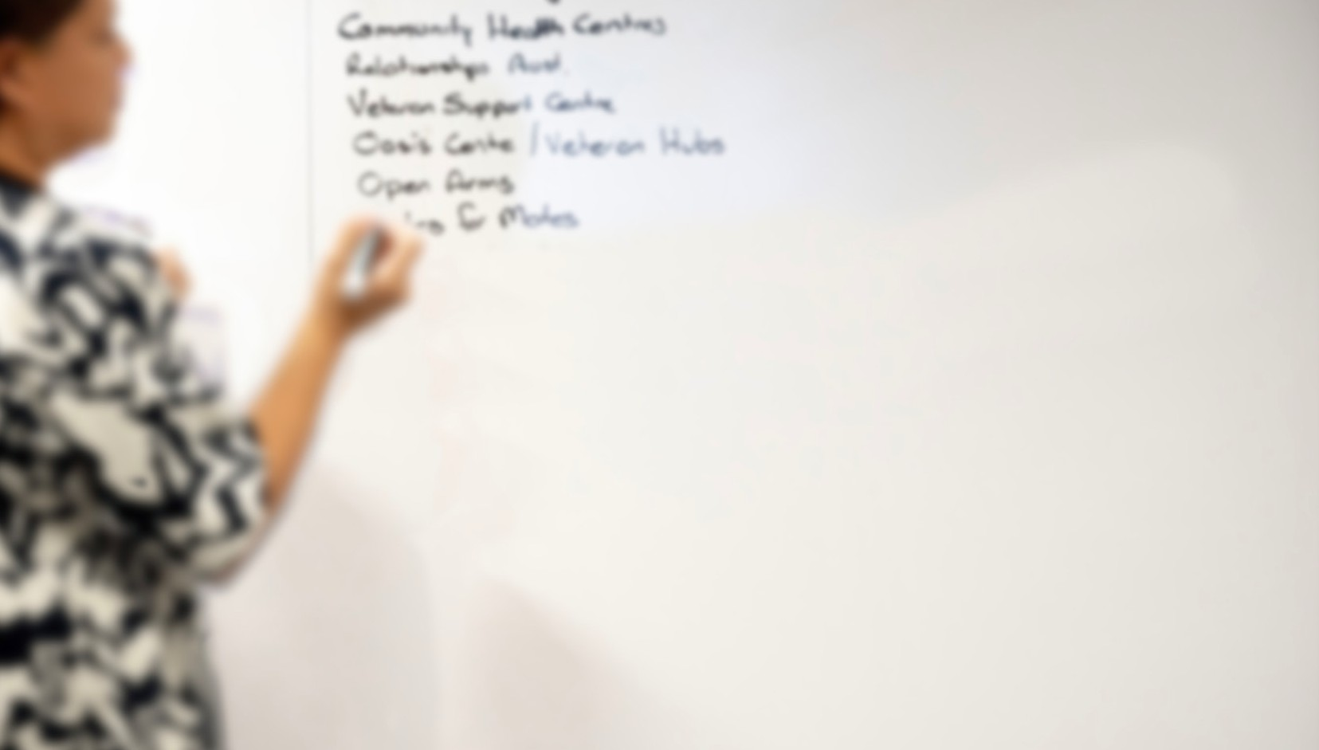

Purpose
The purpose of the Strategy is to promote a structured and consistent approach to engaging with the veteran community. Engagement is important as it allows us to make more informed decisions about how we design, develop and adapt our programs, services and policies. It also helps
build greater communication, transparency and trust. This results in better outcomes for veterans, families and stakeholders.
While this Strategy is primarily intended for internal DVA staff it is also being made available publicly. This helps everyone to better understand our approach and provides a common language for feedback on how engagement is undertaken.

Overview
Engagement with veterans and families was identified as a key part of our Strategic Framework in the DVA Corporate Plan 2023–24. This Strategy complements the establishment of a dedicated Veteran, Family and Stakeholder Experience Group in DVA.
Stakeholders in the context of this Strategy mean the individuals, groups or organisations who have an interest or concern in the policies, programs and services provided to veterans and their families. These groups include:
- Current and former members of the Australian Defence Force
- Family members of current and former serving ADF members
- Ex-Service Organisations (ESOs) and other organisations supporting the Defence community
- Providers including doctors, allied health professionals, educational institutions, training and job placement agencies
These diverse range of stakeholders provide invaluable contributions to the broader veteran community in a variety of ways. Incorporating the diverse range of views and interests they represent into DVA policies, programs and services is critical in improving outcomes and wellbeing for the veteran community.

4

This Strategy is consistent with related DVA frameworks and strategies including the Provider Engagement Framework. This Strategy will also inform development of any future related frameworks across DVA.
DVA also has a range of Government stakeholders including Department of Defence,
Services Australia and other agencies. A range of intra-agency mechanisms exist for engagement with these agencies and are not in-scope for this Strategy.
In developing this Strategy DVA reviewed and incorporated best practice engagement
design and methods from sources like the APS Framework for Engagement and Participation and the International Association for Public Participation. Feedback from stakeholders was also sought with a focus on engaging with a range of diverse groups and perspectives. This approach ensures the Strategy is well placed to help DVA support the wellbeing of those who serve or have served in the defence of our nation, and their families.
Underpinning the Strategy is a range of existing capabilities, protocols and tools that are available to assist staff in engaging with the veteran community. The Strategy brings a structured and consistent approach to using these with consulting when the veteran community.
The Strategy has three key components:
- The five principles that guide all engagement efforts across DVA.
- Activities staff need to do to ensure they engage the right stakeholders, at the right time, in the right way.
- Case studies to help staff understand and apply the principles and activities included in this Strategy.
The Strategy is intended to be a document that is updated over time as we find new and improved ways to partner with stakeholders to support the wellbeing of veterans and families.



5

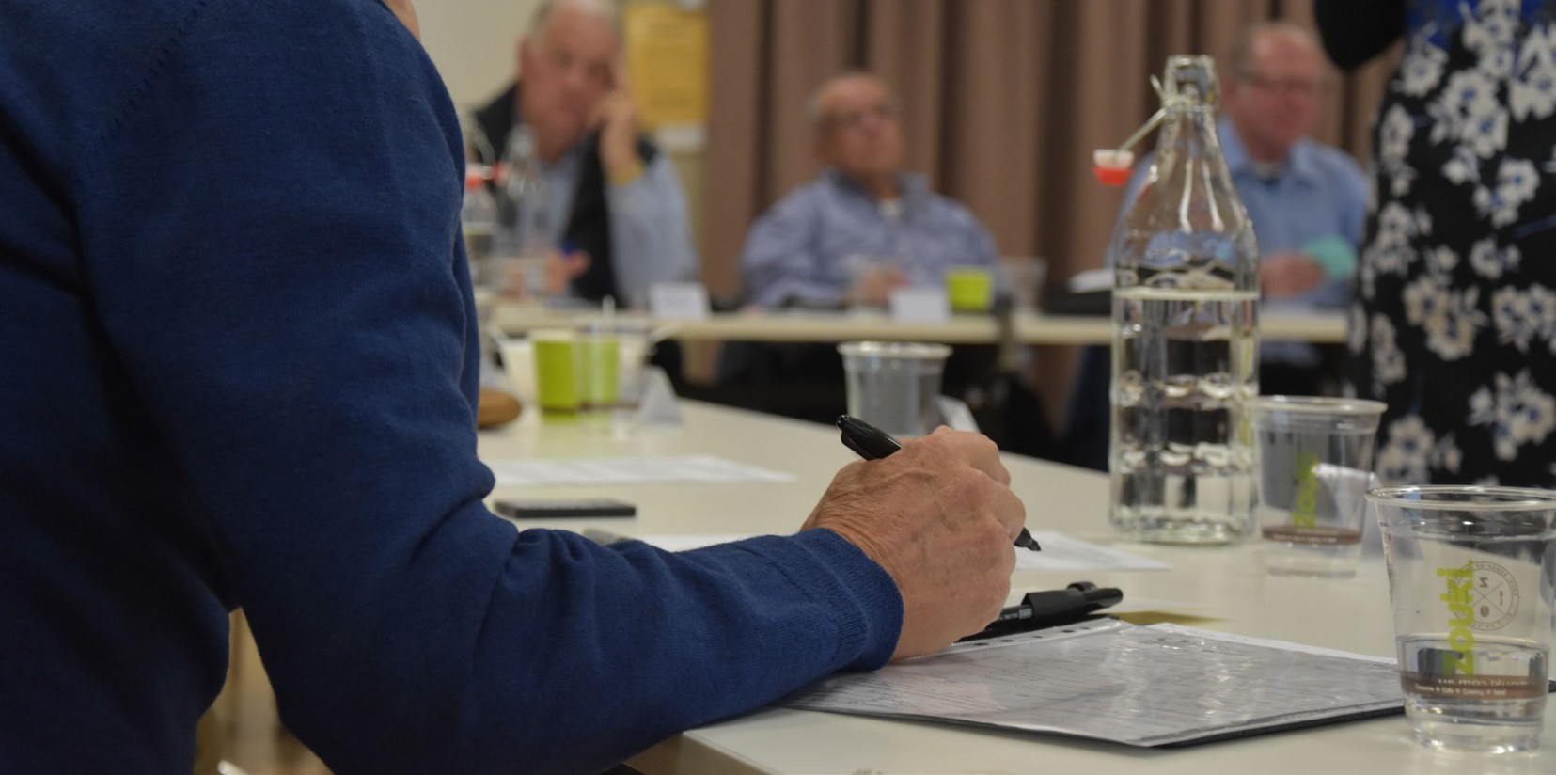

Principles
The underlying principles for engagement recognise and promote the breadth and variety of engagement opportunities. They are high-level, reflecting that every engagement is unique, varying in purpose, location, and participants involved.
These principles are underpinned by activities, resources, tools and case studies that are also included in this Strategy.
The principles are:
- Have a clear aim from the start – At the onset of any engagement, clearly outline the objectives and expected outcomes to stakeholders. This will give them clarity on the engagement’s purpose, ensuring more focused and productive discussions.
- Engage early and often – By actively involving stakeholders from the outset, we ensure that their perspectives shape our approach and decisions. This results in decision-making that is better informed and services that are better tailored to those receiving them.
- Consistent approach – There are a range of appropriate engagement activities that can be undertaken to receive feedback. Choose the right approach that best supports the outcomes being sought, expectations of stakeholders and time available.
- Focus on continuous improvement – By having a structured and consistent approach to seeking feedback and iteration, DVA will see its programs, services and policies continuously improve.
- Be transparent – engaging with stakeholders in an open and transparent way promotes our intent to create clarity, trust and accountability.
All principles receive fair consideration as we plan and carry out engagements. However, the level of consideration given to each of the principles may not be the same and will need to be adjusted according to the focus, nature and the stage of the engagement.
Adopting the principles in the planning and implementation of engagements gives confidence in our interactions with DVA’s external stakeholders.
6

ENGAGEMENT IN PRACTICE
DVA has identified key activities that should be undertaken when engaging with
stakeholders. These activities are listed below and underpin the principles listed above.

These activities are presented in such a way to help staff ensure they engage with the right stakeholders, at the right time, and in the right way. Additional resources available to staff include a practical staff guide
for implementing the strategy and important protocols around

engagement, conducting surveys and communicating with clients.
The protocols, for example include mandatory requirements that must be adhered to in all engagements. As other relevant material is developed, this will also be made available to staff.

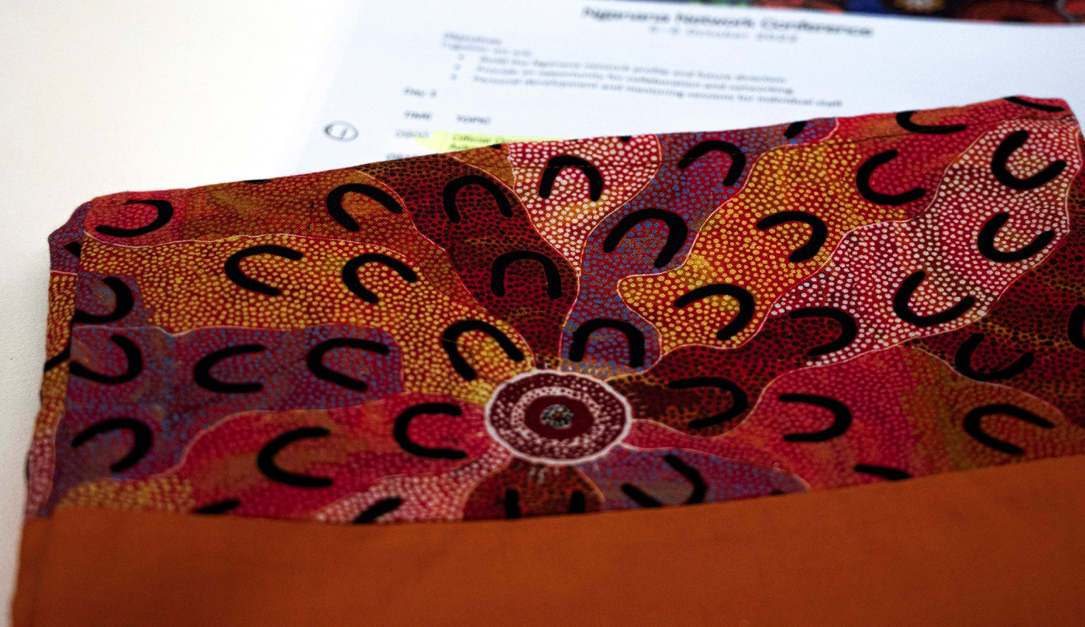


7

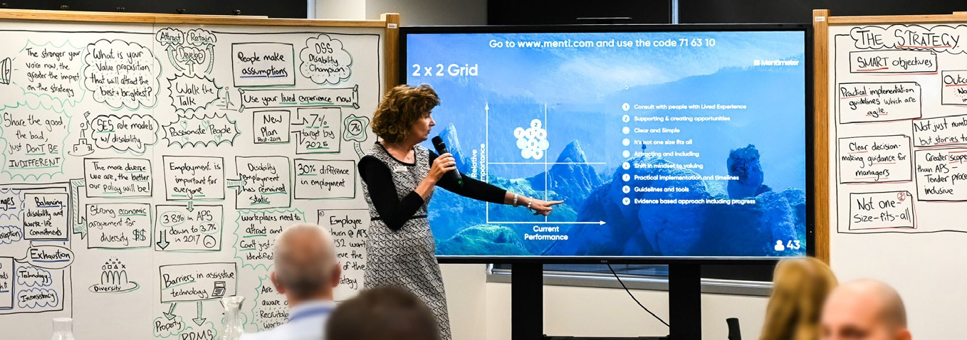



Engage with the Right Stakeholders

Services and Programs that deliver better outcomes for veterans and families is the primary purpose of engagement. To achieve this goal, identifying
the right stakeholders is critical. It means
striking the right balance between engaging
with the stakeholders most impacted, and ensuring a broad range of perspectives are considered.
Establish the purpose and objectives:
Before engaging with stakeholders, clearly define the objectives and purpose of engaging with them. Have a clear view of what you are engaging about, what
is within scope and what is out of scope. Ensure that these are clearly communicated to stakeholders.
Complete a stakeholder analysis:
Conduct a thorough stakeholder analysis to identify individuals, groups, or organisations that have a significant interest or influence on your project or initiative. Adjust the engagement approach according to the stakeholder’s level of impact and interest.
Invest time in understanding the priorities and culture of the organisations you are engaging. Undertake research to understand what feedback these
groups have provided previously. This helps reduce engagement fatigue.
Ensure diversity:
Engage a diverse range of stakeholders to capture a wide array of perspectives and experiences.
Stakeholder expectations of DVA can vary based on a range of demographic, geographic, economic and other reasons. Some stakeholders may be very familiar with DVA processes and legislation, others will not. It is important to capture a range of diverse views and experiences

8







Engage at the Right Time
Timing and frequency of involving stakeholders is important as it impacts the quality and extent of how they engage with DVA. It needs to balance project timeframes and restrictions with providing stakeholders the opportunity and time to respond and engage.

Early involvement:
Incorporate stakeholder engagement as a core part of your planning. This should include early engagement with stakeholders to better understand concerns, impacts and preferred approaches to being engaged. This fosters a deeper understanding of stakeholder perspectives. It aids in building robust relationships, and reduces the risk of significant issues emerging later in the project.
Consult at the right time:
Plan interactions to occur at logical stages of a solution design or project plan. Be aware of what other DVA engagements the stakeholder is involved in. Avoid engaging stakeholders when they have other commitments or during sensitive periods, as it may impact their participation. Engagement needs to form part of the project planning process.
Undertake ongoing communication:
Establish a communication plan that supports regular updates to stakeholders. This communication
should be scaled to the size and extent of the issue driving the engagement.
Communications could include updates on progress, milestones, and any changes that may impact stakeholders. This approach helps build trust, ensuring stakeholders feel valued and remain invested throughout the project’s lifespan.

9




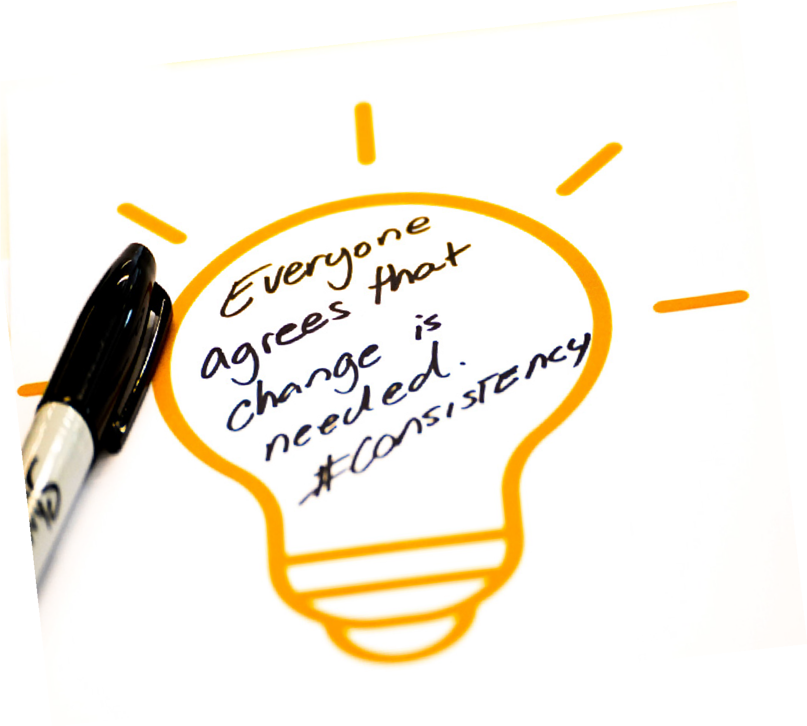

Engage the Right Way
Engaging the right way means finding the right balance between the engagement approaches listed under the next section, the outcomes you want to achieve and the interests of stakeholders.
These can all change over the life of the project. It is also important to let stakeholders know how their input will
be used during, and at the conclusion of a project.

Adopt the best engagement approach:
Use the engagement types listed in the next section to identify the best approach and type of engagement you should undertake. This should be based on the type and extent of input
being sought, stakeholder expectations and time available. These options
are adapted from the International Association of Public Participation and reflect best practice engagement.
Remain adaptable:
Recognise that stakeholder interests can vary based on other priorities and the impact your project may have on them. Tailor engagements to reflect these different levels of interest. Different types of engagements may also be required
at different stages of a project. Regularly assess and adapt your engagement and communication activities based on feedback and interests of stakeholders.
Close the loop:
At the conclusion of a project, provide stakeholders with enough information so that they understand how their input influenced the project. These actions acknowledge their contribution and builds trust. If feedback is provided about services, programs or policies that differ from the topic being discussed, this information should be sent to the relevant business area.

10

How DVA will engage with stakeholders
Adapted from IAP2 Public Participation Spectrum ©International Association for Public Participation www.iap2.org

 |  |       Communicate  Share  Focused on sharing information with stakeholders. This is a one-way communication approach.  It is used to provide updates, announcements, or relevant information to keep stakeholders informed.  The purpose is to enhance transparency and ensure stakeholders have access to accurate and timely information. |  |  | The Exchanging of Ideas  Consult Involve Collaborate    Consultative engagement Actively involve Collaborative engagement involves seeking stakeholders in decision- emphasises partnership stakeholder opinions, making processes. and co-creation between perspectives, or feedback Stakeholders have the DVA and its stakeholders.  on specific topics or opportunity to contribute Solutions, strategies decisions. ideas, suggestions, or or initiatives are jointly You should consider the proposals and collaborate developed.  input received and may in developing solutions or Stakeholders are actively use it to shape decisions strategies. involved in decision-  or refine plans. Stakeholders have making, planning, and  a meaningful role in implementation processes shaping outcomes and as equal partners.  their input significantly influences the final decisions.


 |  | Channels |  |  |  |  |  | 
 |  | Website announcements, social media posts, media releases, information sessions, informational videos and emails. |  |  |  |  | Workshops, roundtable discussions, working groups, collaborative platforms, brainstorming sessions, and online collaboration tools. |  | Joint taskforces, stakeholder advisory groups, participatory workshops, partnership agreements and  co-creation sessions.
Surveys, focus groups,
public consultations, comment periods, feedback forms, online forums, stakeholder interviews and interactive webinars.
 |  | Examples
 |  | Project updates, sharing organisational news, providing informational materials, conducting public  awareness campaigns, hosting informational webinars or town hall meetings. |  | Seeking stakeholder views, gathering feedback on specific issues, conducting targeted consultations, analysing stakeholder input and considering it in decision- making. |  |  | Collaborative discussions, involving stakeholders  in planning processes, co designing initiatives, inviting suggestions, exploring alternatives and incorporating stakeholder input into decision-making. |  | Collaborative decision- making, co-creating strategies or initiatives, joint problem solving, sharing responsibilities and actively involving stakeholders throughout the project lifecycle.
11

Case Studies
Case studies are intended to help staff understand the benefits of engagement and how it looks in practice.

Case Study 1:

Building empathy through engagement – Understanding the Veteran Experience
One of DVA’s roles is to deliver services and support to members of Australia’s veteran community.
If this support is to adequately meet the needs of the community, it is vital for DVA staff to understand the veteran experience.
Working in partnership with the Department of Defence (Defence), DVA facilitated several Understanding the Veteran Experience Workshops (UVE) in 2023.
These UVEs were established with the following clear objectives:
- Connect DVA staff with the veteran and current serving member experience
- Give veteran and current serving members a stronger voice in shaping DVA culture
- Understand the circumstances and needs of current serving members
- Identify and discuss current and preferred sources of information and assistance
- Develop and explore ideas for service improvement
- Understand the role and significance of DVA in meeting veterans’ needs
Five workshops took place in 2023 at various ADF bases across the country. DVA staff facilitated the workshops and Defence personnel were given the opportunity to share their experiences, record ideas and respond to questions using an online anonymous voting tool.
DVA staff were also invited to interact with some of the equipment Army

personnel use in their day-to-day. This included showing weaponry, packs and body armour carried on field exercises. This gave Army personnel the chance to show DVA staff the physical demands of army life and potential for injury.
Through the workshops, DVA staff gained key insights into the concerns of service personnel. These insights included attitudes to transitioning from the military, the reluctance many veterans experience when it comes to reporting injuries and concerns around claims processing.

Insights from the day helped to shape DVA staff’s approach to working with veterans. Understanding more about their concerns and challenges helps to build empathy in their work practices.


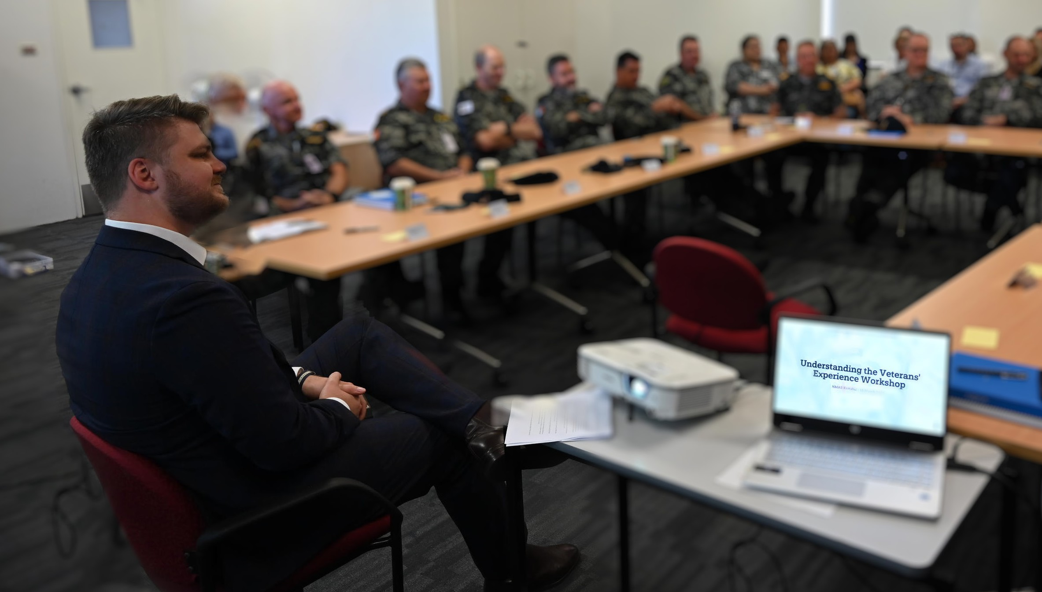
12



Case Study 2:
Female Veterans & Veterans’ Families Policy Forum
The Female Veterans & Veterans’ Families Policy Forum (the Forum) was established in 2016. It provides a platform for female veterans and female veteran family members to raise issues directly with the Australian Government and DVA.
The Forum is a high-profile event, garnering considerable interest across the veteran community. In 2023, 48 community members participated. Senior leaders from DVA and the Australian Defence Force also attended to hear first-hand from female veterans and veterans’ families.
Key topics explored in 2023 included housing and homelessness, veterans’ entitlements legislative reform, family and domestic violence, protective factors against female veteran suicide, the Defence and Veteran Family Strategy, and female veteran physical and mental health needs.
These forums are an example of how members of the veteran community and DVA can work together to explore policy areas of significance and develop community-driven solutions.
Participants had the opportunity to complete a Forum Evaluation Survey following their attendance.
Of the evaluation respondents, 97% felt attending the Forum was ‘very worthwhile’, and 91% felt the topics discussed were ‘very relevant’ to the community.
Input from the Forum has directly informed a range of policies including the Family Support Package, Veteran Mental Health and Wellbeing Strategy and National Action Plan, extended eligibility for Partner Service Pension, DVA Family and Domestic Violence Strategy and the Veterans’ Recognition Package.
In addition, male family members will be attending
the Veteran Families’ Policy Forum for the first time. This is in recognition of the unique perspectives that male family members can bring and better reflects  the diversity of contemporary veterans’ families. | In response to feedback from the veteran community, and recognising the contribution of women veterans to the defence of Australia, from 2024 this event will be replaced with a:  - Dedicated Female Veterans’ Policy Forum, and  - Veteran Families’ Policy Forum.

13

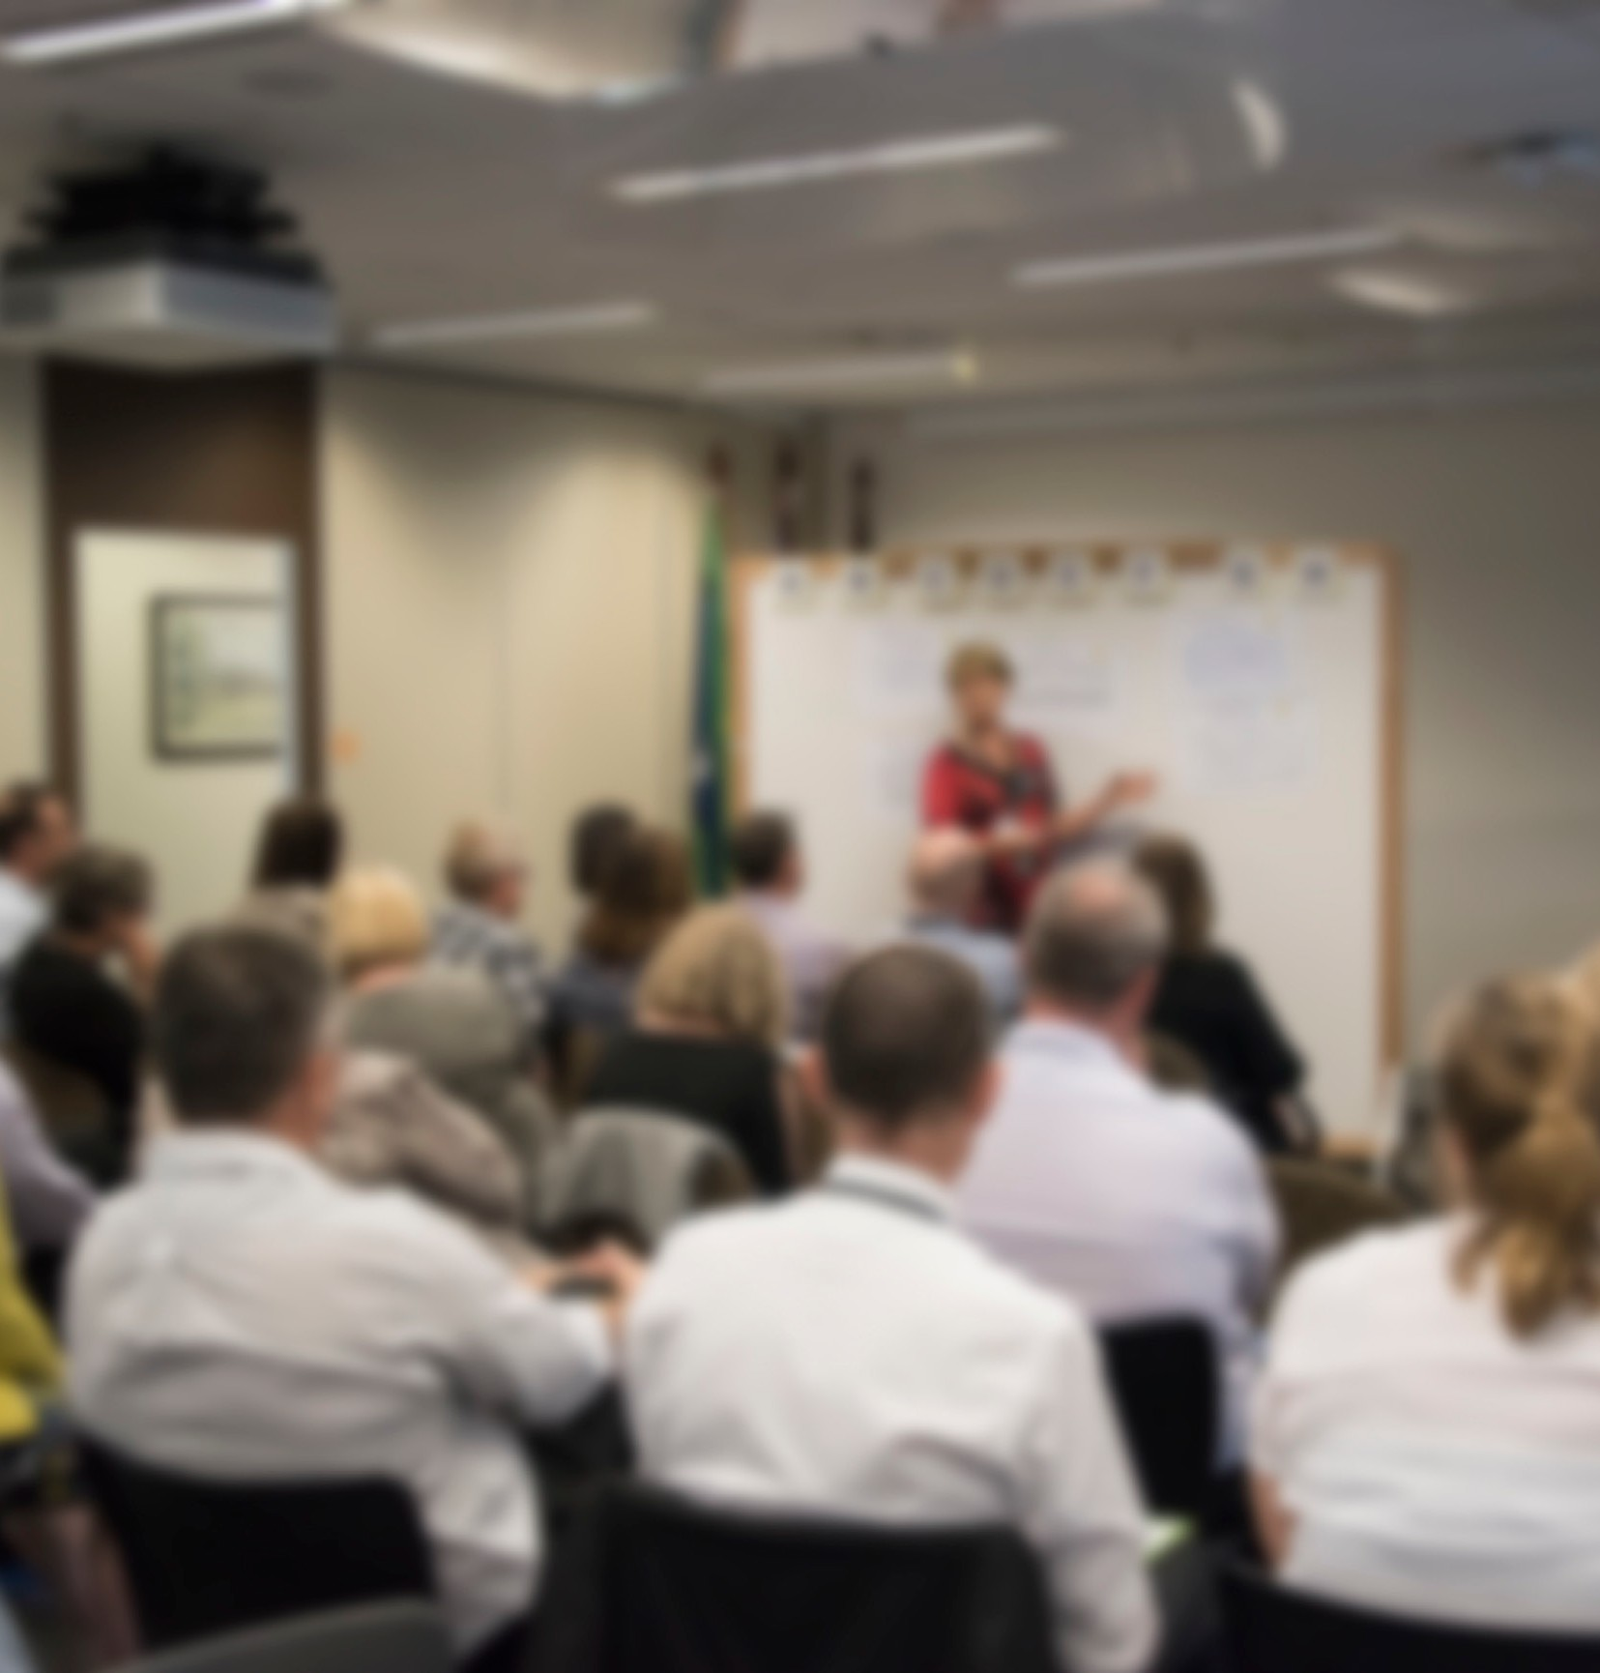
RESOURCES FOR DVA STAFF
This Strategy is one component of a range of initiatives DVA has in place to support a consistent and structured approach to engaging stakeholders. A staff guide provides the practical steps needed to meet the expectations of this strategy. Other support such as protocols and templates are also available. DVA staff will be able to access these through the DVA Intranet. These documents are updated regularly to reflect learnings, changes in best practice and feedback from users.

14

