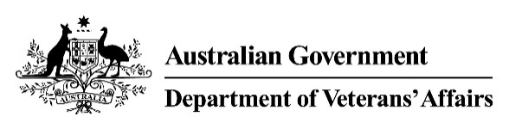 | Fistulae and Hernia Condition(s)  Medical Impairment Assessment
Veteran |  |  |  |  | UIN
Please assess the following conditions:
For this assessment, each condition needs to be assessed in isolation from all others. This means that when assessing a condition, you will need to assess the impairment as though only that single condition is present, and that the veteran is otherwise healthy and normal.
- Does the veteran currently have any of the following stomas?
Description | Select
None. | ☐
Oesophagostomy or gastrostomy. | ☐
Jejunostomy or ileostomy. | ☐
Colostomy. | ☐
- Please select all that apply in relation to any inguinal hernias.
Description | Right Inguinal | Left Inguinal
None. | ☐ | ☐
Surgically corrected hernia. | ☐ | ☐
Readily reducible hernia. | ☐ | ☐
Small recurrent hernia, operable but not readily reducible. | ☐ | ☐
Large recurrent hernia, inoperable and not readily reducible. | ☐ | ☐
- Please select the most accurate description of any ventral hernias present.
Description | Select One
None. | ☐
Surgically corrected hernia. | ☐
Well supported hernia. | ☐
Not well supported hernia. | ☐
Massive hernia, inoperable, with severe diastasis of recti. | ☐

Doctor's signature | Doctor's name | Date | Time to complete form

