COMMUNITY NURSING NEWSLETTER No. 44
December 2023


The Community Nursing Newsletter is issued to provide updates to Department of Veterans’ Affairs (DVA) Community Nursing (CN) providers about DVA’s CN program.
FEE INDEXATION  Annual fee indexation will be applied to the DVA CN Schedule of Fees and will take effect from 1 January 2024 for claim periods commencing on or after this date. The new schedule is attached for reference and will also be available on the DVA website from mid-December 2023.  CN providers who deliver services to clients under an Exceptional Case approval will receive updated letters to reflect the indexed fees for each client in the week commencing 22 January 2024. |  | 
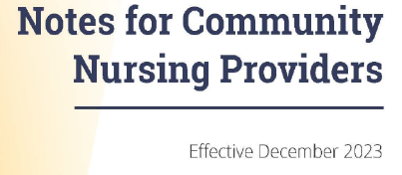
NOTES FOR CN PROVIDERS

A reminder that the Notes for CN Providers have been revised and the new version is effective 1 December 2023.

The Notes are available on the DVA website: Notes for Community Nursing providers - Effective December 2023 (dva.gov.au)

FAIR WORK COMMISSION ADJUSTMENT PAYMENT REMINDER


As advised in CN Newsletters June 2023 and September 2023(available on the DVA website at Community Nursing Newsletters), providers are able to submit invoices for a one off adjustment payment as part of the changes to the CN Schedule of Fees that took effect from 1 July 2023. Where Medicare claiming information was available for claim periods commencing between 4 June 2023 and 30 June 2023, providers were sent emails in October with the amount that could be claimed. If you have received an email with an amount that can be claimed and have not yet submitted an invoice to DVA, please submit the invoice by 15 December 2023 to community.nursing.contracts@dva.gov.au.

For providers who delivered CN services to DVA clients between 4 June 2023 and 30 June 2023 and have not yet received an email with an adjustment amount, a refreshed report with claims for impacted claim periods will be run in January 2024, and emails sent to any impacted providers.

INTRODUCTION TO QUALITY STANDARDS

- As advised in the November 2023 newsletter, the CN Program will align with the strengthened Aged Care Quality Standards and will provide clarity about service standards and expectations, and guide provider performance in delivering care for veterans.
- DVA is not a regulator, however providers are required to adhere to the Notes for Community Nursing Providers. DVA will accept providers accredited with the Aged Care Quality and Safety Commission (ACQSC) as meeting the CN Program quality standards.
- For CN providers who are not accredited with the ACQSC, DVA will work with those providers, through a collaborative review process for future alignment with the quality standards.
- Commencing February 2024, DVA will contact CN providers without accreditation with the ACQSC, to arrange a collaborative review of their current systems and processes for future alignment with the standards.
- DVA will communicate with providers ahead of the standards coming into effect for the Community Nursing Program. Providers can stay informed by reading the CN Newsletter and sharing with their staff.
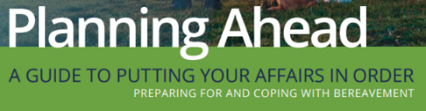
PLANNING AHEAD

The information in the DVA ‘Planning Ahead’ guide and checklist may be useful for veterans and their families.
We encourage CN providers to share this information with DVA clients where relevant. Planning ahead kit | Department of Veterans' Affairs (dva.gov.au)


DVA CHRISTMAS SHUTDOWN
DVA offices will be closed from midday Friday 22 December 2023 and will
reopen at 8:30am Tuesday 2 January 2024.

We wish you a safe and happy festive season, and thank you for continuing
to support veterans’ health and wellbeing.

