Men’s Health Peer Education Magazine

SENSORY GARDENS

There are many studies that show that being around plants can
be beneficial for our health and general wellbeing.

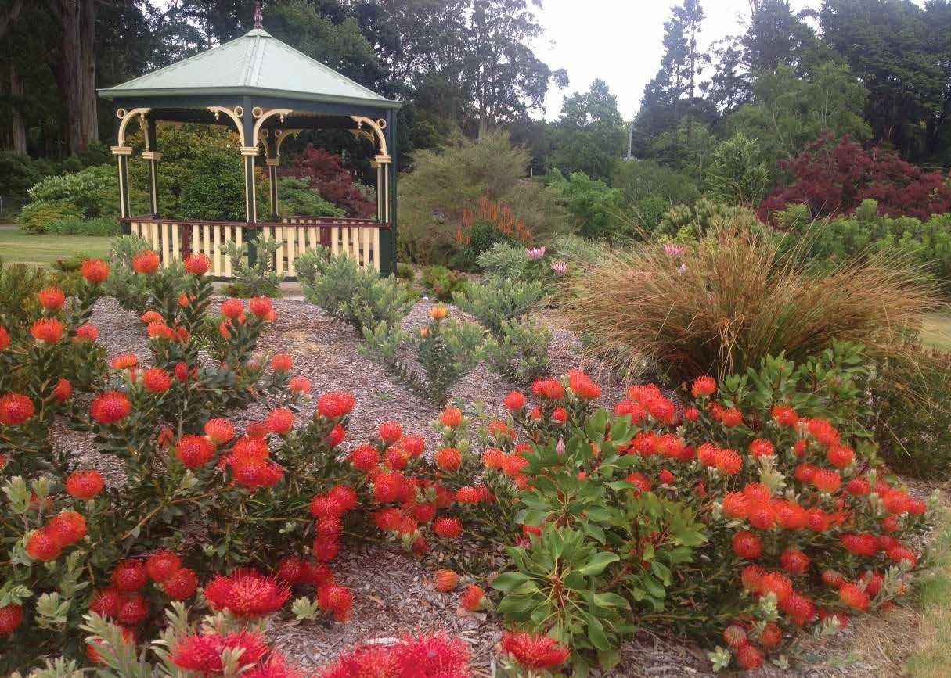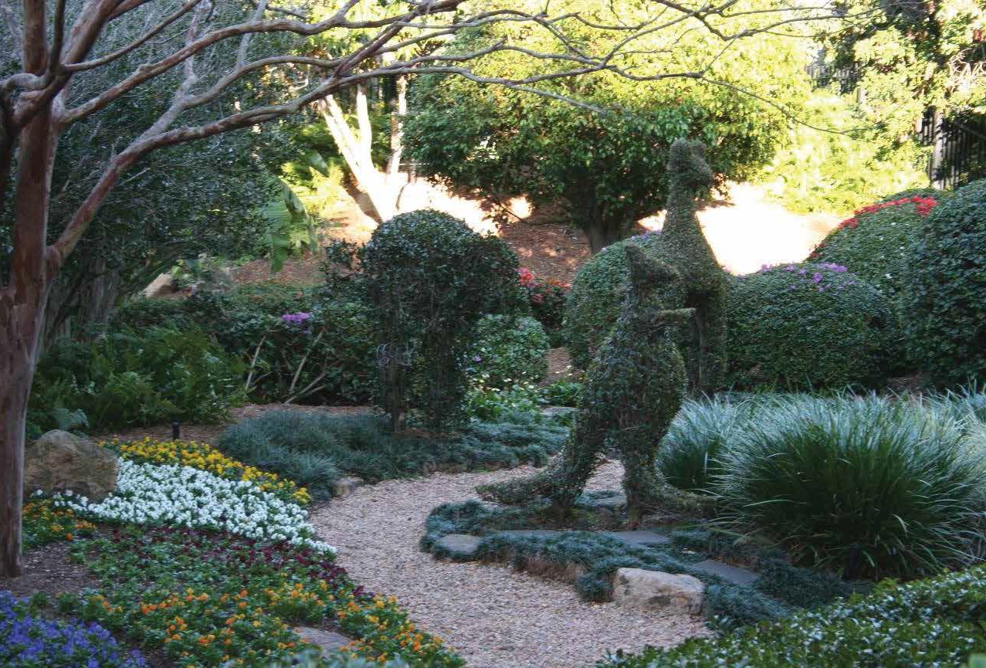These benefits can be summarised as follows:
- Gardens and gardening can improve our physical strength, flexibility, co-ordination, stamina and fitness.
- Gardens can also have a range of psychological benefits such as improved cognitive skills, improved self-esteem, reduced stress and improved confidence, to name a few. They can be a great distraction for those who are hospitalised, experiencing pain or undertaking rehabilitation.
- Gardens are also a great social setting, being a neutral zone in building and improving friendships and relationships.

SO WHAT ARE ‘SENSORY GARDENS’?
As the name suggests, they are gardens that have characteristics that stimulate the senses. Although all gardens have sensory characteristics, a true ‘sensory garden’ attempts to provide more enhanced features that cater for all the senses.
Here are some examples of what you can do:

SCENT / SMELL
Flowers, leaves of shrubs and trees, herbs etcetera. Having some of these near paths
so the scent comes after it is brushed against while walking.

SIGHT
Different colours of flowers, bark, leaves, lawn, water, features, flags, statues. When thinking of colour, have areas that have active colours (yellow, red, orange, royal blue) and areas that have calming colours (white, pink, mauve, sky blue, apricot).

TOUCH
Soft leaved plants, textured bark on trees,
shiny leaves, features with variations of textures.

TASTE
Grow some vegetables, fruit trees and vines. Citrus are also a great addition. Many herbs are easy to grow and great to eat. Many flowers have nectar that can add to the sensory experience.

Ferny Creek Horticultural Society Garden, Sassafras, Victoria

Bush Nursing Hospital, Yackandandah, Victoria

SOUND
Water features add sound. Allowing areas where the wind blows through the trees. Autumn leaves on the ground add sound. There are also many artificial features like wind chimes that can work. Always remember the plants that bring in butterflies, birds and other insects indirectly bring sounds

Vol.17 No.1 2018

SOME IMPORTANT POINTS
Sensory gardens often contain a large range of sensory plants, such as lavender, roses, daphne, wisteria, roses. They are often used as calming and relaxing places to simply stroll through or sit and enjoy.
The range of sensory experiences is important, so plants and features that enhance scent, colour, sound, touch and taste should be included. There should also be areas where people can sit and socialise with friends or family. Many gardens have places where social events can be had outside in
the garden. It is therefore important to include shade

SOME POPULAR SENSORY PLANTS:

and shelter.
Many gardens allow users to participate in gardening activities and to upkeep the garden.
This is where raised garden beds and careful design allows for the physical limitations experienced by many older users.
It is important for these types of gardens to also have safe surfaces and adaptive tools available. Some physical, mental and age-related conditions must be considered when older people work in the garden, but these should not prevent people from enjoying the garden.
Gardening is a healthy, stimulating physical activity that can be enjoyed by everyone. The garden, equipment and tools can all be modified to suit the needs of people.

HOW DO YOU START A SENSORY GARDEN?
Visit your local garden centre and ask them about colourful and sensory plants that suit your area. (It makes sense that many plants that do well in Queensland don’t do so well in Tasmania and vice versa).
1
Work out where you want to sit and enjoy your garden. Shade trees? Warm spots in winter? Close to attractive garden features like statues, fountains, ponds, etc?
2
Install safe and accessible paths. Create wide, even paths with minimal steps and wheelchair accessible if required.
3
Install some raised garden beds. There are now many different styles available from garden and hardware centres.
4
Add a range of features and structures around the garden such as climbing frames, urns, birdbaths, statues, ponds, fountains, murals,
5
  - All herbs
  - Daphne and Gardenia
  - Lemon tree
  - Roses (shrubs and climbers)
  - Lavender
  - Mountain Marigold (Tagetes)
  - Sheoaks
- Japanese Maple
(varieties)
- Callistemons
- Wisteria
- Cyclamen
- Orchids
- Old Man’s Beard (Tillandsia)
- Foxtail grasses
- Correas

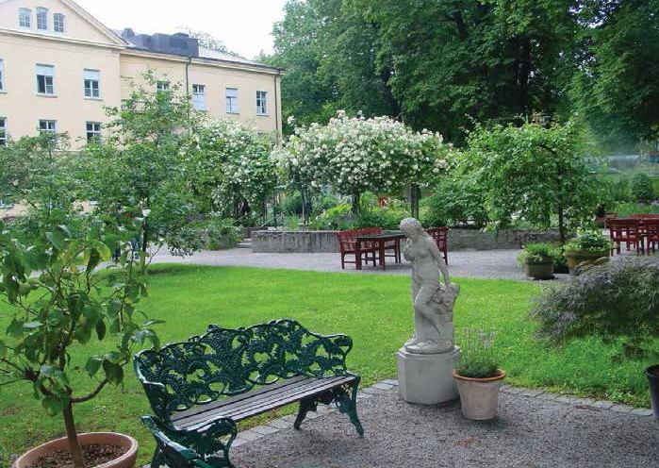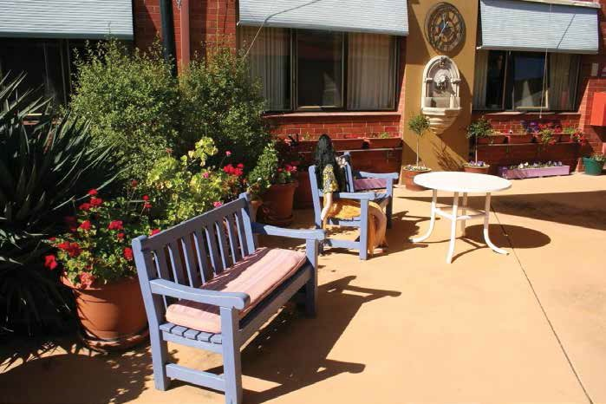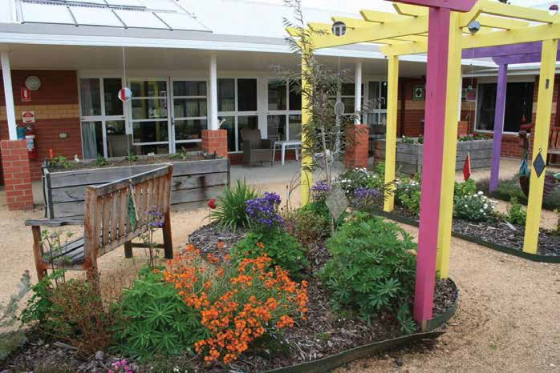decorated pots, wind chimes, bird feeders etc.
Consider consulting a good designer to blend all the elements.
6
From Top: Mirridong Retirement Home, Bendigo;
Garden of the Senses, Sabbatsburg Hospital, Stockholm, Sweden; Roma Street Parklands, Brisbane, Queensland. All photos by Paul de la Motte.

