

COMMUNITY NURSING NEWSLETTER No. 39
The Community Nursing Newsletter is being issued to provide updates to Department of Veterans’ Affairs (DVA) Community Nursing (CN) providers about DVA’s CN program.
CN Newsletters  DVA regularly sends out CN Newsletters, previously referred to as Bulletins, to CN providers. Previous CN Newsletters (Bulletins) can be found on the DVA website at Community Nursing Bulletins. The most recent Newsletters include:  - Information on the SCHADS award changes (Bulletin No. 37)  - Changes to the COVID-19 pandemic provisions in the Notes for Community Nursing Providers (Bulletin No. 38) |  | 
 | CN Schedule of Fees – 2023 Indexation  Annual fee indexation has been applied to the DVA CN Schedule of Fees. Indexation will take effect from 1 January 2023 for claim periods commencing on or after this date. CN providers who deliver services to clients under an Exceptional Case approval will receive updated letters to reflect the indexed fees in the week commencing 23 January 2023.  The new schedule will be available on the DVA website from early January 2023.
Request for Information on Insurances and Accreditation  DVA has recently requested information from CN providers on the following:  - Copies of current insurance certificates.  - Copies of current accreditation, if applicable.  - Responses to questions regarding the use of the COVID pandemic provisions.  Thank you to those of you who have already responded. For those who haven’t, please send your responses to the DVA CN Contract team at cn.agreement@dva.gov.au |  | 
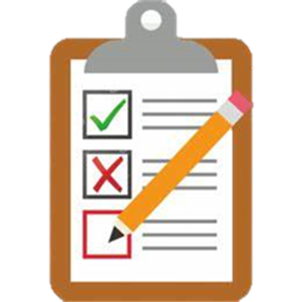 | Implementation of Contract Management Compliance Plan Process  DVA will soon be implementing our updated contract management compliance plan. As part of this plan, you may be contacted by the CN Contract team and asked to provide documentation and respond to questions. A new round of contractors will be contacted each quarter to participate in the process.
Requests to Update or Confirm Information  DVA will be making regular requests for CN providers to update or confirm information. You will be contacted in early 2023 when we will ask you to confirm the regions you service. This will also be an opportunity to add any new regions. |  | 
 | Christmas Shut-Down  DVA offices, including those managing the Community Nursing program, will be closed from 5pm (AEDT) Friday 23 December 2022, reopening 8.30am (AEDT) Tuesday 3 January 2023.  We wish you a safe and Merry Christmas.

